Title in English
Title in Spanish
Name Surname(s), Name Surname(s) & Name Surname(s)³
(The information highlighted in red will be completed by the journal once the article has been accepted for publication)
Submitted: xx/xx/20xx; Revised: xx/xx/20xx; Accepted: xx/xx/20xx
How to cite this article:
Surname(s), Initial(s), Surname(s), Initial(s), & Surname(s), Initial(s). (20xx). Title of the article. Revista de Innovación y Buenas Prácticas Docentes, x(x), pp-pp.
Corresponding author: xxxx@xxxxxx.xx

Abstract:

The abstract in English will have maximum 200 words and must be written as a single paragraph. It must follow the following structure, without including headings: introduction, objectives, methodology, findings, and conclusions.

Keywords: Include four keywords in English separated by commas.

Resumen:

The abstract in Spanish will have maximum 200 words and must be written as a single paragraph. It must follow the following structure, without including headings: introduction, objectives, methodology, findings, and conclusions.

Palabras clave: Include four keywords in Spanish separated by commas.

- INTRODUCTION
All paragraphs must be indented by 1.25 points. This section must establish the theoretical framework of the proposal.
Lorem ipsum dolor sit amet, consectetur adipiscing elit, sed do eiusmod tempor incididunt ut labore et dolore magna aliqua. Lorem ipsum dolor sit amet, consectetur adipiscing elit, sed do eiusmod tempor incididunt ut labore et dolore magna aliqua. Lorem ipsum dolor sit amet, consectetur adipiscing elit, sed do eiusmod tempor incididunt ut labore et dolore magna aliqua.
- OBJECTIVE(S)
Both main and specific objectives may be included. Specific objectives may be included using the following format:
- Lorem ipsum dolor sit amet.
- Lorem ipsum dolor sit amet.
- Lorem ipsum dolor sit amet.
Lorem ipsum dolor sit amet, consectetur adipiscing elit, sed do eiusmod tempor incididunt ut labore et dolore magna aliqua. Lorem ipsum dolor sit amet, consectetur adipiscing elit, sed do eiusmod tempor incididunt ut labore et dolore magna aliqua. Lorem ipsum dolor sit amet, consectetur adipiscing elit, sed do eiusmod tempor incididunt ut labore et dolore magna aliqua.
- METHOD
  - Title of subsection 1
This section must describe the innovation experience presented, including the following information: participants, design and variables, procedure, and data analysis.
Lorem ipsum dolor sit amet, consectetur adipiscing elit, sed do eiusmod tempor incididunt ut labore et dolore magna aliqua. Lorem ipsum dolor sit amet, consectetur adipiscing elit, sed do eiusmod tempor incididunt ut labore et dolore magna aliqua. Lorem ipsum dolor sit amet, consectetur adipiscing elit, sed do eiusmod tempor incididunt ut labore et dolore magna aliqua.
- RESULTS
This section must include the findings of the innovation, which should be confused with the evaluation of participant satisfaction after the proposal. The evaluation of participant satisfaction can also be included, but it is not the only information that should be included in this section.
If necessary, subsections must be written in the same way as in previous sections.
If a table is included, it must follow this format:
Table 1 shows xxxxxxxx.
Table 1
Title of the table
 | In bold | In bold | In bold | In bold
Regular style
Regular style
Regular style
Note. Xxx.
If a figure is included, it must follow this format:
Figure 1 shows xxxxxxxx.
Figure 1
Title of the figure
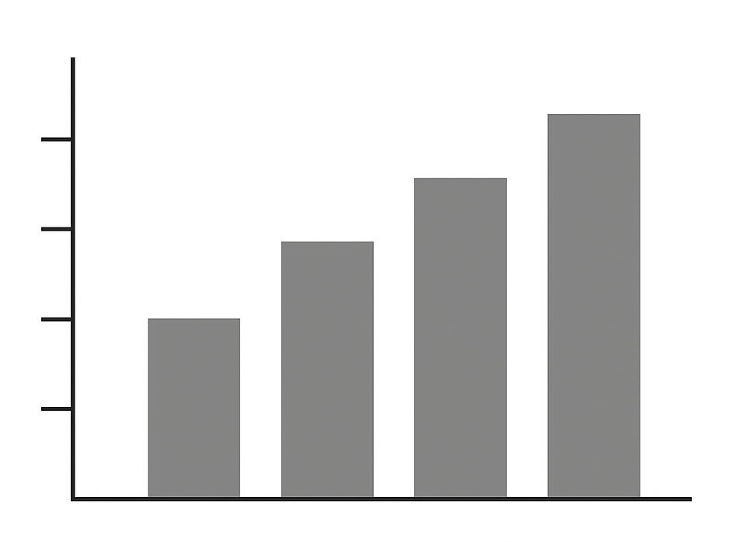
Nota. Xxx.
Lorem ipsum dolor sit amet, consectetur adipiscing elit, sed do eiusmod tempor incididunt ut labore et dolore magna aliqua. Lorem ipsum dolor sit amet, consectetur adipiscing elit, sed do eiusmod tempor incididunt ut labore et dolore magna aliqua. Lorem ipsum dolor sit amet, consectetur adipiscing elit, sed do eiusmod tempor incididunt ut labore et dolore magna aliqua.
- DISCUSSION
This section must begin with the main finding of the innovation, followed by a discussion of the results, including limitations and future lines of innovation/research, as well as future possibilities for improvement.
Lorem ipsum dolor sit amet, consectetur adipiscing elit, sed do eiusmod tempor incididunt ut labore et dolore magna aliqua. Lorem ipsum dolor sit amet, consectetur adipiscing elit, sed do eiusmod tempor incididunt ut labore et dolore magna aliqua.
- CONCLUSIONS
This section must summarise the key findings of the innovation.
Lorem ipsum dolor sit amet, consectetur adipiscing elit, sed do eiusmod tempor incididunt ut labore et dolore magna aliqua. Lorem ipsum dolor sit amet, consectetur adipiscing elit, sed do eiusmod tempor incididunt ut labore et dolore magna aliqua.
- REFERENCES
References must follow APA 7th edition. If the referenced publication has DOI, it must be included as a link (https://doi.org/...). If a URL to the referenced publication is included, a URL shortener must be used to standardise the use of links (e.g., bit.ly, TinyURL, n9 o ShortURL). Some examples are shown below:

Cebrián, M. (coord.) (2003). Enseñanza virtual para la innovación universitaria. Narcea.
Esteves, D. (2018). Colaborar para innovar: Contribuciones desde un caso portugués para rediseñar la noción de innovación educativa. Revista Educación, Política y Sociedad, 3(1), 7–30. https://doi.org/10.15366/reps2018.3.1.001
Fueyo, A., Rodríguez-Hoyos, C., & Linares, C. (2015) La innovación docente de la formación de los profesionales de la educación: El papel de la educación mediática. In J. Ferrés & M. J. Masanet (Eds.), La educación mediática en la universidad española (pp. 31–51). Gedisa.
García-Peñalvo, F. J. (2015). Mapa de tendencias en Innovación Educativa. EKS, 16(4), 6–23. https://doi.org/10.14201/eks2015164623
Green, B. P. (2018). Ethical reflections on artificial intelligence. Scientia et Fides, 6(2), 9–31. https://tinyurl.com/vds4b3dt
Ley Orgánica 3/2020, de 29 de diciembre, por la que se modifica la Ley Orgánica 2/2006, de Educación. Boletín Oficial del Estado, no. 340, 30 December 2020, 122868–122953. https://tinyurl.com/4kyw9bn2
Salinas, J. (2004). Innovación docente y uso de las TIC en la enseñanza universitaria. Revista de Universidad y Sociedad del Conocimiento (RUSC), 1(1), 1–16. https://doi.org/10.7238/rusc.v1i1.228

Name of institution (Country), email, ORCID
Name of institution (Country), email, ORCID ³ Name of institution (Country), email, ORCID

