Rhetoric and marketing in tourism websites through visual figures
La retórica y el marketing en los sitios web de turismo a través de elementos visuales

Ganna Zakharova*

Abstract
The persuasive influence of tourism promotional materials is very much experienced today. To gain the attention of viewers, the travel companies choose various techniques in their digital texts. Non-linguistic elements play an important role in tourism discourse; they hold a persuasive function. Pictures are essential elements for attraction and seduction; they are the trigger elements to tourists. There exist different visual techniques in tourism marketing to engage and convince potential tourists to book a tourism product. The present article discusses visual solutions for tourism websites to allure potential tourists. The paper reviews the influential elements of persuasive web tourism marketing pictures. These components provide useful information, create additional experiences in the viewers and help them finalize their decisions. The article highlights how these components as persuasive strategies of tourism promotional materials can influence the decisions of tourism websites’ users. The result section provides the real examples of deployment of the mentioned techniques to convince the audience by the website of “Karpaty” resort (Ukraine). All these techniques are worth attention as they play a decisive role in the promotion of tourism services. The data collection of this study will provide updated information in relation to the rhetoric of tourism.
Keywords: tourism discourse; tourism promotion; persuasive discourse; persuasive pictures; influential images in marketing.

Resumen
Hoy en día, los materiales de promoción turística tienen mucha influencia persuasiva. Para atraer la atención de los turistas, comercializadores seleccionan numerosas técnicas en sus textos digitales. Existen diferentes componentes no verbales en el marketing turístico para involucrar y convencer a los turistas potenciales de que compren un producto turístico. La selección de contenido no verbal es fundamental, ya que ayuda a finalizar las decisiones de los turistas. El presente artículo examina los componentes visuales utilizados para ganar turistas potenciales. El artículo destaca cómo estos elementos persuasivos de los materiales promocionales del turismo pueden influir en las decisiones de comprar los productos turísticos. El estudio proporciona los ejemplos reales del despliegue de elementos visuales para convencer a los usuarios de la web del sanatorio “Karpaty” (Ucrania). Estas técnicas visuales juegan un papel importante en la promoción de los servicios turísticos. Debido a esto, la colección de datos de este estudio proporcionará información actualizada en relación a la retórica del discurso del turismo.
Palabras clave: discurso turístico; promoción turística; discurso persuasivo; componentes no verbales persuasivos; imágenes influyentes en marketing.

1. Introduction
Tourism marketing materials are an important source of information for the potential tourists. They help a destination to differentiate itself from others and construct its own identity. Since tourists cannot try a destination before booking, promotion plays an essential role in tourism. Travellers purchase a holiday on the basis of symbolic expectations realized promotionally through words, pictures, signs, sounds, etc. (Morgan and Pritchard, 2000).
Nowadays, tourism discourse highly relies on various visual techniques, the functionality of which can lead to the desired effect. The websites using attractive pictures become more powerful and more effective. Pictures may transport potential customers to a hotel or travel destination. Such visualising data give a quick summary and overview of the place. Pictures simplify communication and are effective in portraying reality. Due to the implication of the images, tourism websites become a multi-levelled environment involving verbal and non-verbal elements. The marketers appropriately select pictures in order the tourism websites to stay relevant and engaging. For this reason, visual engaging techniques for websites are of paramount importance in tourism industry.
Tourism advertising mostly includes images and text; however, depending on the medium can also include video, music and other useful promotional elements (Walters, Sparks, and Herington 2007). Images are highly helpful tools in reaching the objective of tourism promotion. Being a combination of linguistic and supporting visual elements, tourism promotional materials create certain mythical experiences (Echtner and Prasad, 2003). Generally, the language of tourism speaks through pictures and verbal messages. As van Raaij (2002) claims, a good advertisement uses both text and images, and these components match one another. An advertising that contains verbal text only looks boring and does not gain much attention. Images and verbal messages must complement and reinforce one another to successfully attract the attention of tourists.
Dann (1996) claims that tourism promotional materials rarely consist of pictures only. In the article “Rhetoric of the Image”, Roland Barthes’ (1964) states that pictures in tourism discourse are most likely to be followed by a verbal messages. He proposes that a verbal text with respect to a picture can serve as an anchorage or relay. If a verbal message functions as an anchorage, this text guides the reader’s interpretation of a picture in a specific direction. In this case, the verbal text is a supplement to the picture. If the verbal message functions as a relay, the text is part of the entire message, where the picture and text are interpreted together. In this case, the picture provides new information that is not presented in the text (Barthes, as cited in Innis, 1986).
Images provide information the tourists need before they book tourism services. Rather than reading through descriptions, pictures provide customers the chance to watch reality. For example, photos allow customers to see a recreation of rooms within a resort or to take a look at nearby attractions. Photos present the spots of interest to would-be customers. They help the users of a website to understand how a particular place looks like and become familiar with this place. Advertisers often use rhetorical techniques and strategies in visuals to achieve their goals of moving target audience and influencing tourists’ decisions.
The visual elements in tourism promotional materials usually catch the eye immediately. The reason is that the visual elements form almost 75% of the semiotic space in tourism advertisements (Dann, 1996). According to Francesconi (2014), visual components of verbal language are important elements in the meaning-making process. It captures and keeps the attention and evokes distinct emotions and connotations.
Tourists look for communicative indications to find out whether the destinations suit their desires and needs. Images are considered to be crucial for providing these indications. As Urry (1990: 140, as cited in Costa and Melotti, 2012) states, “photographic images organize our anticipation or daydreaming about the places we might gaze on”. Moreover, visual messages are able to communicate with tourists in a personal way that is very effective manner to persuade the viewer. Hence, tourism images convey necessary information in order to arouse tourists’ interests and establish the communication between destinations and tourists that can encourage the actions from them.
The visual mode is typical for tourism texts; it provides the channel for communicating realistic content. Image represents qualities much better than language. Indeed, a picture may be worth a thousand words. As Kress and van Leeuwen claim: “Pictorial structures do not simply reproduce the structures of “reality”. They produce images of reality which are bound up with the interests of the social institutions within which the pictures are produced, circulated and read” (Kress and van Leeuwen, 2006: 45). Therefore, tourism materials are presented their t in a positive way.
Images are effective in showing key features of tourism products and services. They can present elements that are difficult to express by words (van Raaij, 2002). Therefore, destinations are always illustrated by means of photographs that can perfectly depict tangible features of a touristic place. Morgan and Pritchard (1998) state that photographs are an evident issue in tourism promotion, because these are regarded to be objective and examples of reality. Photography pictures can truly and accurately describe the characteristics of tourism destinations. Moreover, colours that feature in images are effective way to convey emotion. Different colours give tourists different visual perceptions. The implication of colours can express feelings and associations. The influence of colours can cause associations that marketers want to convey.
Therefore, visual narratives can affect tourists’ decisions. A picture can influence on subconscious level. The pictures function as means to support, to visualize, to explain and to approve the quality of the commodity presented in tourism advertisements. The intensity of emotion within images generates rhetorical richness in texts that results in added power within the overall meaning of a text. Thus, the use of pictures is an important visual rhetorical strategy applied to tourism materials that eases the process of conversion on tourism websites.

2. Methodology
As all languages have to be learned, the language of tourism also requires a process of examination for those who generate it. For better understanding tourism information from the persuasive viewpoint, it is more than necessary to consider pictorial aspects which tourism texts involve creating persuasive units. Paying attention to the visual components will give an opportunity to look at the nature of tourism promotion and realise how these technological tools are used nowadays from which this persuasive effect come from.
The purpose of this paper is to examine the visual content of health tourism website and to offer a general view on the some visual components of this type of discourse in order to better understand their main persuasive features. Visual techniques of different types employed to attract the potential clients will be investigated. I will undertake an explanatory study from which we will see examples of the use of these techniques in tourism promotional material with the intention of persuading. I will consider the visuals deployed by the website of “Karpaty” hotel and resort accessed from https://san-karpaty.com/ in order to encourage visitors to choose this place as their travel destination. The selection of this website is purposeful. It officially represents health tourism and describes its varied tourism locations, healthcare services, nature attraction, and culture in an attractive language using various visual strategies. The data compiled was taken during 2019-2020.
For conducting the analysis, Kress and van Leeuwen’s (2006) work Visual Grammar on visual representation will be helpful in determining the specific points of visual influence. Visual Grammar allows the realization of meaning making through the analysis of visual images, making it possible to understand the images without linguistic assistance.
According to the studies of Kress and van Leeuwen (2006), images present narrative and/or conceptual structures. Narrative structures convey actions and events; they always present a depicted element or a participant that forms vector, indicating directionality (Kress and van Leeuwen, 2006).
As Kress and van Leeuwen (2006) state pictures lead to various relations with viewers. The interactive meaning of images can be realized through the gaze direction of the represented participants. Images can directly or indirectly address their viewers. A demand image addresses viewers with a direct gaze from represented participants in the image. On the other hand, an offer image engages the viewers without a direct gaze. Demands are regarded to construct an imaginary relation with the viewer (Kress and van Leeuwen, 2006).
Salience is also an important issue in the composition of visual meaning. It makes a difference among the components of any picture, since some of them are depicted as more important or attractive than others. Size, sharpness of focus, tonal and colour contrast, placement in the visual field, perspective and specific cultural factors are features that help make the represented participants to be salient (Kress and van Leeuwen, 2006).
Attention will be paid to the interaction between texts and images taking into consideration the theory expressed by Roland Barthes (1964) in his essay Rhetoric of the Image, where he explains how a text directs a reader to a specific interpretation of a picture. Barthes provides an analytical system to discuss the interpretation of an image.
Visual techniques will be discussed in relation to their contribution to the persuasive effects. It will be observed how pictures shape tourists’ attitudes and evaluation towards the services and influence their purchase decision. Hence, I will identify the pictorial tools used to enhance the tourist experience during the search phase, prior to the travel. I will give a complete view on these strategies employed in order to persuade.
Thus, a closer look at the visual techniques will help understand the way the discourse of tourism operates in promotional materials. I will investigate how these strategies applied in the tourism discourse form the persuasive discourses of tourism. Hence, this paper will study how tourism promotion, from a visual perspective, depends on certain elements in order to promote a healthy break away from everyday life.
Hence, this paper focuses on the concept of persuasion and how persuasion is established in tourism communication through images. The results of this study could be helpful for those who design tourism websites or create tourism promotional materials.

3. Results and discussion
The representation of the website is not only linguistically codified but also enriched visually through the accompanying pictures. Together with the text, they help to deliver a more accurate message. The photographs play a substantial role in this website. Embedding the high quality pictures, the marketers are trying to direct tourists by implying what is worth seeing and doing in the resort.
The first five images displayed on the website are full-screen pictures featuring the main attributes of the destination (Figure 1). The viewer is offered to look at the resort from a distance, to learn about the commodities inside it, to meet happy people who are receiving treatment by drinking mineral waters, and to view the photo of two lynxes representing the element of nature in the website.
Figure 1. Homepage main images in the corpus of “Karpaty” resort website
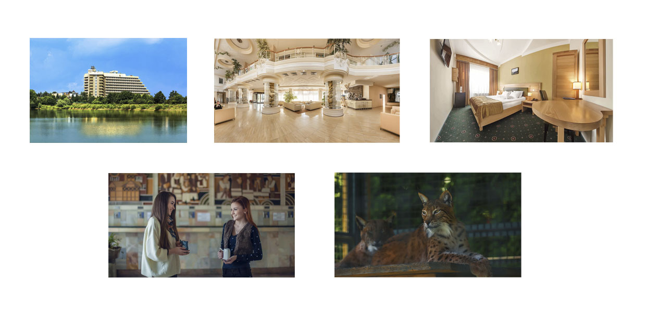
The first picture is a spectacular glimpse of “Karpaty” resort during daytime. The photo presents conceptual structure through iconic visual signs, namely, lake, sky, building, and trees. The building is a main represented participant due to its central position in the picture. This building is “Karpaty” resort itself. The plastic signs play an important role here. The light brown colour of the hotel is distinctly notable against the azure coloured water and bright blue sky, visually putting more emphasis on that part. The lake reflects the building and nature round it; hence, the viewer can see the building together with ecological-green environment on both sides.
The visual representation of pleasant nature scenery evokes emotional responses akin to those experienced in pleasant natural environments. By using the image of pure nature around the building, the marketers have produced an advertisement which is likely to give rise to one plausible interpretation: “Karpaty” resort is surrounded by untouched nature allowing visitors freedom, total liberty. There are no people visible in the photograph; therefore, the viewer has an offer to enter the represented place.
The second picture is taken inside the institution. The represented participant is a luxury hotel lobby. The viewer perceives the dimension of luxury through plastic sings, such as forms of the depicted iconic messages, e.g., vast space, three columns, and the balcony of the second floor. The picture is a shot from an eye angle that creates a more familiar contact with the viewer. The photo is taken from a frontal angle, representing its components as a part of the viewers’ world (Kress and van Leeuwen, 2006).
The third photo is a hotel room. The conceptual structure of it is represented through iconic signs, such as table, bed, window, etc. All this messages bears the symbolic meaning of comfort that comes from plastic signs, such as forms of depicted iconic messages, e.g., the big bed and the way it is made. The scene is depicted with warm yellow, brown, and green colours that transmit the symbolic meaning of calmness. The viewer is indented to be involved into the scene, as the picture is an eye-angle shot. The image portrays no characters; therefore, the viewer is invited to enter featured space.
The fourth photo displays female characters. It has a narrative structure showing an action process. The presence of vectors (Kress and van Leeuwen, 1996: 57), i.e. the “diagonal lines of action” between the faces of the interlocutors, can be detected in this photo that indicate two girls chatting happily. The photo conveys a sense of rapport and connection between the participants. The picture features “pleasing” participants who wear a broad smile, looking contented and satisfied with their experiences. The facial expressions of image participants are factors that can convert the viewer.
The section, sparking the most interest, is the hands of the ladies. The girls are holding special cups for drinking therapeutic mineral waters from springs. On the visual plane, there seems to exist invisible arrows departing from the cups to mean that the girls are taking a treatment. The plastic sign, such as the form of the cups, let the viewer understand that the represented participants are drinking mineral water. This form of cup is designed in order not to damage the teeth of patients, as the components of mineral water can harm enamel.
The fifth picture captured two lynxes to bring the element of nature to the site. The represented participants are in a cage. The picture arouses an interest in the viewers, as they want to understand why this image is positioned among the main pictures. Later on, they will realize how big the resort is as it possesses its own mini zoo.
The pictures’ silent element is their size. This area keeps visitors' attention, as the pictures are presented as more important than others. These first photos let the visitor view the main attributes of the resort and arouse an interest to read on.
Scrolling down the homepage, the viewer is offered three different units of information, namely, recreation, treatment, and nutrition. The information is presented with linguistic and iconic messages. The verbal texts here have a function of anchorage to direct the reader through the signified of the images. The images are three separate demand pictures (Figure 2), in which the represented participants, human beings, engage the viewer with a direct gaze. These pictures generate strong engagement between the receiver of the message and represented participants. The viewer is invited to interact as imaginary relation is established with him/her.

Figure 2. Human images on the homepage of “Karpaty” resort website
The photographs of these people generate emotional responses from the viewer. For example, in the first photo, the represented participant, who is supposed to be a client/guest of the resort, is smiling, uncovering themes of pleasure. According to Thompson (2012: 416), “happy-looking people promote the normalization of disorder”. Therefore, healthy people are usually depicted with smiles expressing the feelings of happiness. The next two photos uncover themes of support featuring the resort staff within the images: two doctors and one cook have welcoming smiles. The photos make the emotional connection with represented participants. The colours of the pictures make the focus on face that provides much better impact, as the emotional connection is stronger.
By using photos of people, the website becomes more personable and relatable and have a positive impact on visitor’s first impression of trustworthiness. The main issue online is a trust. Associating photos of people with the services engenders trust. Thus, the human photos may increase conversion rate. They get the viewers to focus more and this causes them to draw towards a point of interest.
The homepage presents the photos of rooms according to their types (Figure 3). The pictures depict the main features and amenities applying to each room category. The differentiation is obtained with plastic visual signs, such as the forms and colours of furniture, size of the rooms, etc. Variously sized and styled rooms are shown from very simple to luxury one. It means that tourists are addressed to choose one and enjoy the stay according to their criteria and budget.

Figure 3. Images “Types of Accommodations” in the corpus of “Karpaty” resort website
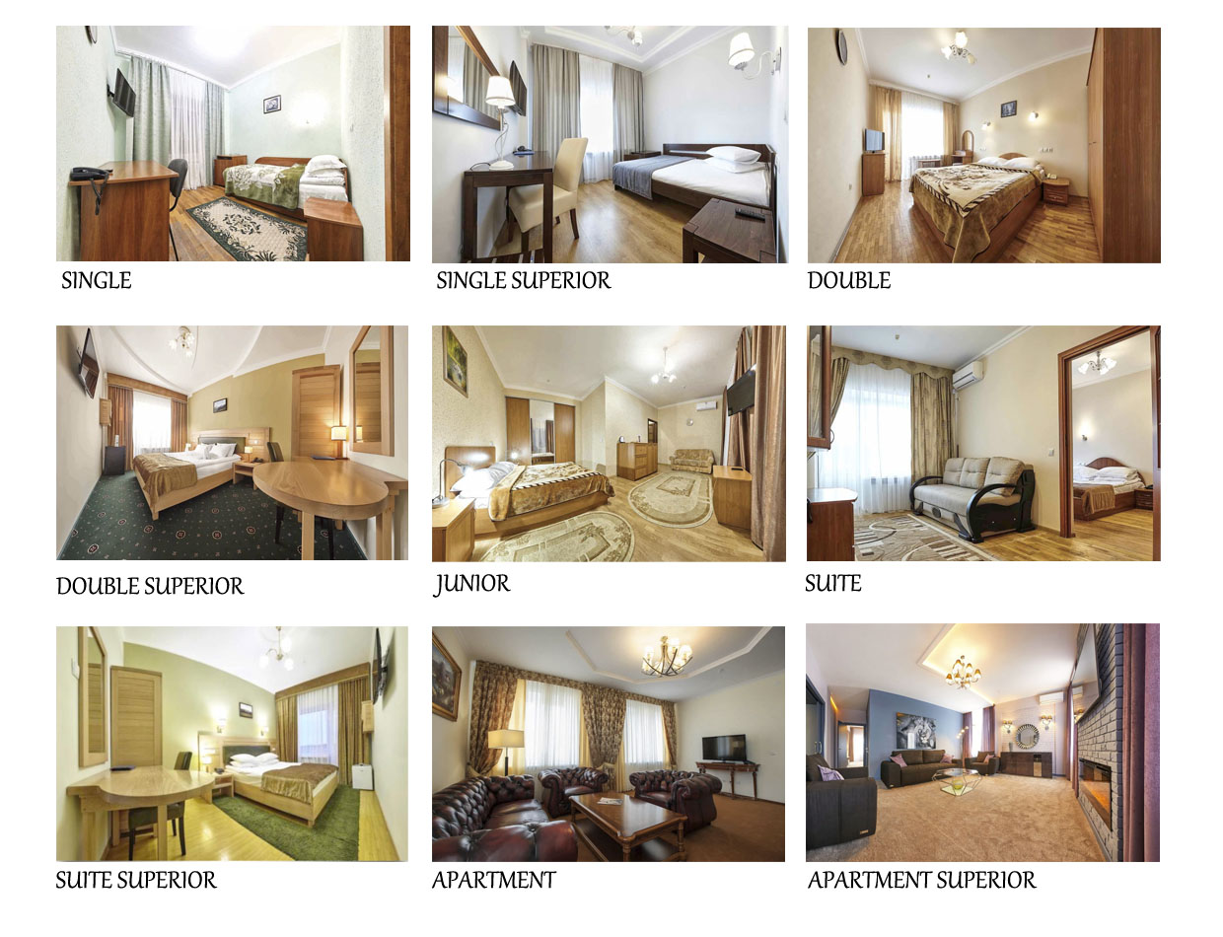
The pictures have the accompanying linguistic messages that act as anchorage to denote the name of the rooms. Thus, the reader can select one without any additional questions that makes the conversion rate much quicker.
The pictures themselves seem welcoming. An eye angle and middle distance shots invite the viewer to look at the accommodations from a close viewpoint, from within. Moreover, the absence of people creates an invitation to participate in and enjoy the scenes. The viewer is offered to enter the spaces illustrated and value the conveniences depicted.
As far as the colour system is concerned, each room has its own shade of brown. It is sensual, sensitive and warm colour, arousing a feeling of calmness and comfort in the viewer. Brown is loyal and trustworthy, friendly and approachable. Hence, these shades may signify the friendliness of the host. The colour brown relates to quality in everything. In the case of these photos, it is comfortable rooms. Various shades of brown in the photos create different mood and peculiarize each room according to its category.
The next page, which gives general information about “Karpaty” resort, presents the same image that had been seen on the homepage (Figure 4). However, if we take a closer look, it is notable that we have two different shots. The main difference is the weather conditions.
Figure 4. Image of the hotel and resort complex “Karpaty”
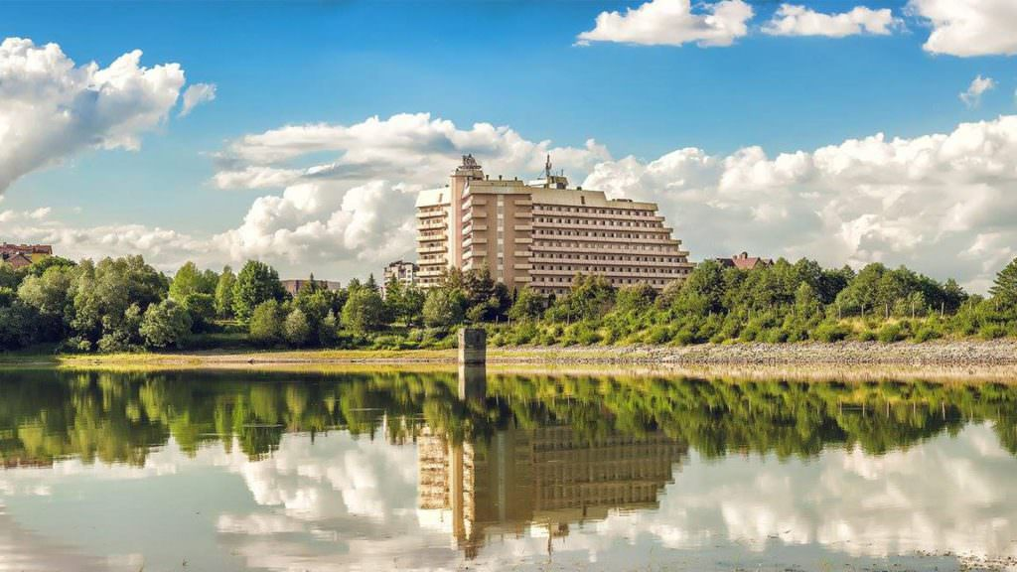
The photo is taken from a long distance and illustrates the resort and its surroundings “from a lookout position, a place not itself in the landscape but affording an overview of it” (Kress and van Leeuwen, 2006: 108). The picture “invites a reassuring act of contemplation” (Giannitraphani, 2010, as cited in Francesconi, 2014: 94). It offers to appreciate the picturesque scenery. Hence, the long shot of the picture suggests impersonal relations (Kress and van Leeuwen, 2006); and the subjects in these pictures are inviting to observe them from a distance.
The building is salient in the picture because of its foreground position (standing out from the background sky), relatively large size and contrast of colour. Therefore, the main carrier of meaning is the building of the resort. The picture features the sanatorium against the skyline and composed of the iconic signs of nature. The trees are the symbol of nature representing the destination as an ecological place. The photo shows a clear blue sky filled with fluffy white clouds. The sky is a bright blue that is in stark contrast to the green surrounding and the building. Furthermore, even though three colours, namely blue, green and light brown, have been used to create the iconic messages, it is the colour green that dominates, which indicates that the advertisement follows the current trend towards green and ecological services and products. The bright colours create a peaceful and relaxing atmosphere.
People do not appear in the image, so the viewer is invited to enter an enchanted world (Dann, 1996). The beautiful and attractive destination is presented in order to be visited by the viewers of the picture.
This highly suggestive picture displays the resort building and depicts the environments in which this institution is situated in order to provide information about the destination. It helps the website create a strong image of relaxing and peaceful place in their audience’s mind.
Figure 5. Images “Sanatorium Benefits” in the corpus of “Karpaty” resort website
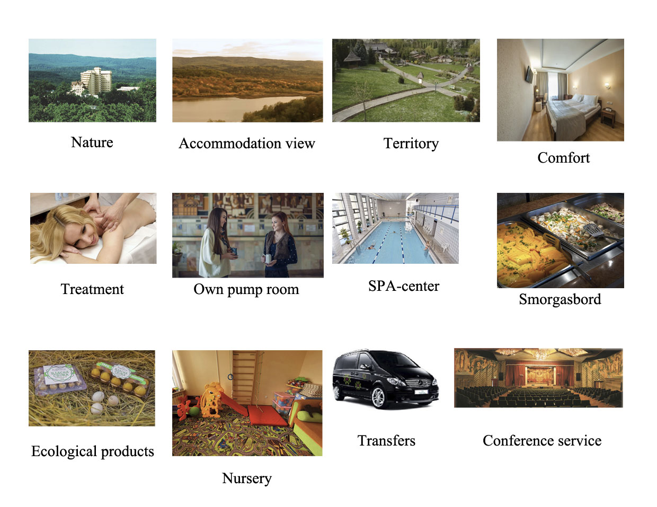
The section “Benefits” provides the reader with a series of pictures (Figure 5). The focus here is clearly the attributes of the resort presented through iconic visual signs and linguistic messages. The first three photos features nature settings and are visual clichés. They depict the main quality of resort. The brand creators chose to use trees images to represent the nature aspect of “Karpaty” resort. The tree icons function as signifiers of forests and greenery of the Carpathians’ landscape. Meanwhile, forests have always been a symbol of a mystery and wilderness. The lake illustration is common signifier of the vacation destinations. The decision to represent the nature with greenery symbols shows that the authors are aiming to appeal to people living in the cities and for whom greenery may seem as something exotic. Nature surrounds the resort building to express the profound relationship between the establishment and the natural surroundings. This suggests that the place is different from the ones in the countries, where the viewer lives.
The high camera angles make these objects in the photos appear to be in an inferior position (Kress and van Leeuwen, 2006). The distance and the point of view do not invite visitors to learn about these objects because the representation makes the viewer distant and uninvolved. These pictures create an impression of convergence of wilderness and civilization. Moreover, they are represented without human presence.
The distance shows that the visitor cannot have power over these the objects depicted and he/ she is only welcome to passively observe rather than interact or engage with them. Low angle suggests that the viewer is provided an opportunity to gaze to the landscape from the sky.
The frontality of the elements depicted in the fourth photo engages the viewer (Kress and van Leeuwen, 2006) by suggesting that the resort is inviting visitors to explore the space. Only three images are represented with pictures that include people. These pictures create vector lines to depict the action process. Through the actions departing from the represented participants, the viewer is informed about the services the resort offers and invited to experience them.
The represented participants in the following pictures are food, playroom, car, and a hall with chairs. All of them stand for a certain kind of beneficial services. The pictures maintain viewers’ attention to the objects; meanwhile, the linguistic messages function as anchorages for them to direct the reader towards the meanings chosen by the author. The salient objects in the representations are the carriers of the linguistic meanings (Kress and van Leeuwen, 2006).
The next section shows the scans of various certificates and diplomas (Figure 6). These images mainly provide linguistic messages that are delivered in Ukrainian and Russian. There is no translation into English, so the reader who does not have any command of these Slavic languages can only view the pictures without receiving the meaning of the content. The name of the section together with the plastic visual signs in the scans, namely, documents’ texture, create the understanding in the English-speaking reader that the documents are some kind of certification.
Figure 6. Images “Rewards” in the corpus of “Karpaty” resort website
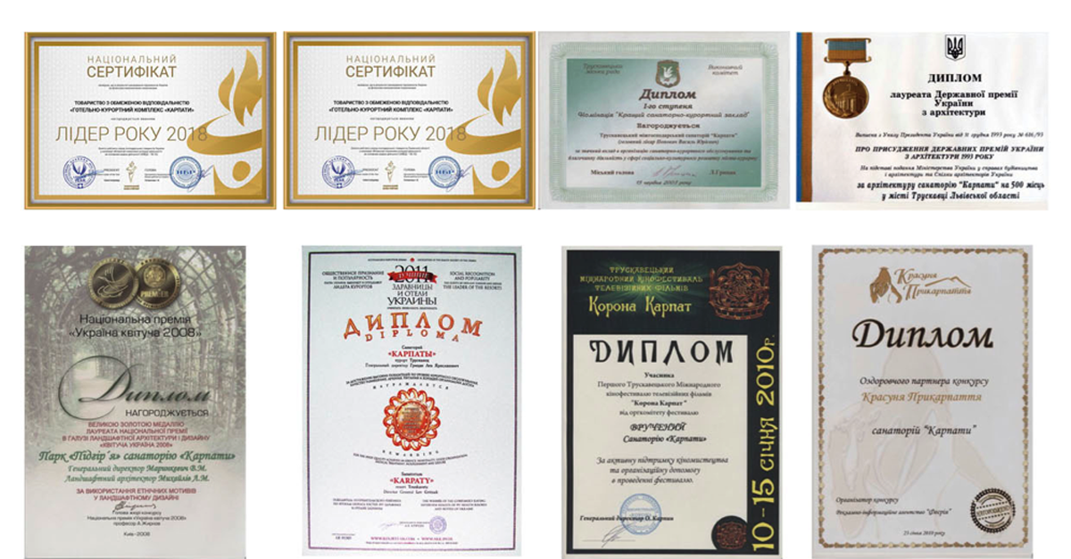
By providing this section, the author wants to confirm certain characteristics of organization and associate the resort with external parties. This confirmation is provided in the form of external reviews and assessments. These documents can be considered as trust indicators, as such professional accreditation build confidence by certifying a qualification. So, embedding this section into the website can boost credibility and trustworthiness.
The represented participants of the photos introduced on the page “Famous Guests” are well-known singers, celebrities, and public figures (Figure 7). They are familiar to the people from the countries of the former Soviet Union. The images have accompanying linguistic messages functioning as an anchorage to them. According to the title of the page, they are the guests of “Karpaty” resort. The author gives the names of these people and some quotes from them that are their success experiences and testimonials.
Figure 7. Images of famous guests in the corpus of “Karpaty” resort website
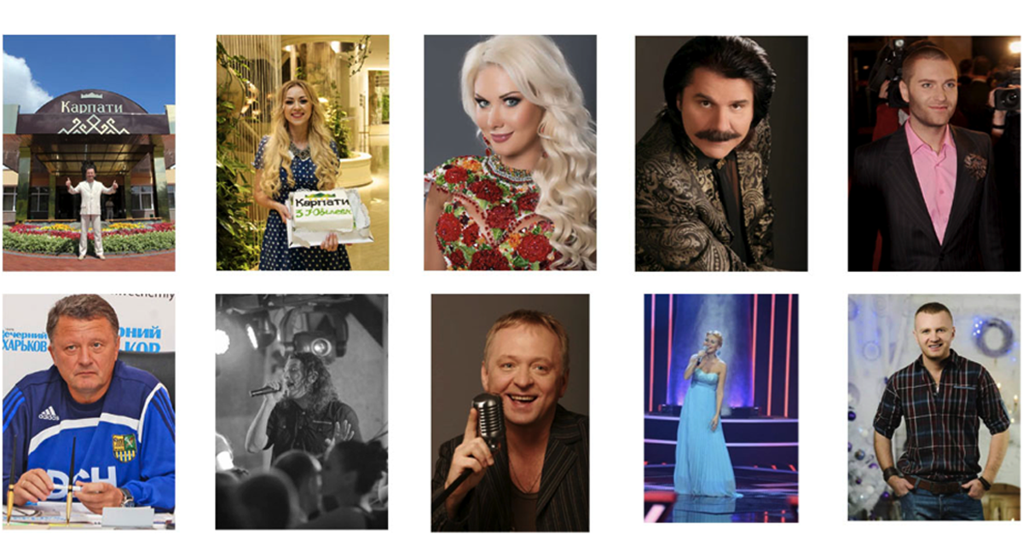
The first two pictures are taken in the territory of “Karpaty” resort. They feature an abstract image, the sanatorium’s logo. The sign indicates that the guests are inside the territory of the complex. The smiles on their faces leave an impression of happiness. The symbolic message of these photos is that they are the satisfied clients.
The pictures directly and indirectly address the viewers, thus providing demand and offer. The photos are close-ups, medium and long shots. The close-ups, which are the focused images, lead to a close social distance and involve the participants in a friendly relation. The first photo, which is a long shot, invites to view the resort’s beautiful entrance.
The photos featuring celebrities are high-impact marketing tools and work as trust indicators. They can grab attention immediately and build credibility, as popular celebrities naturally generate lots of attention. They are generally well trusted by their fans. Moreover, celebrities in promotion build brand awareness, and they build it much more quickly than traditional types of promotion. They make the brand stand out. Using the celebrity in the website to represent the services helps to differentiate the resort from competitors.
Hence, the celebrities in the photos can greatly influence conversion rates. They reassure the reader of the quality of the services. The reader realizes that the services are worth using. Such photos also can improve recall, making the viewers remember the resort and that it is connected to a celebrity.
“SPA and sports” section features eight photos providing information about indoor areas and facilities for swimming, taking different saunas or bathes and enjoying sport activities (Figure 8). The main represented participants here are the clients of the resort. The long shots invite the viewer to observe well-equipped spas and feel their relaxing atmosphere delivered through the images of women captured in the photos. The viewer is offered to take a break from everyday duties and calm the body relieving it of stress with the SPA services as the women in the photos does. The plastic visual signs, e.g. colours and forms of the depicted rooms, together with the women’s body posture present the perfect balance of luxury, comfort, and tranquillity.
Figure 8. Images “Spa and Sports” in the corpus of “Karpaty” resort website
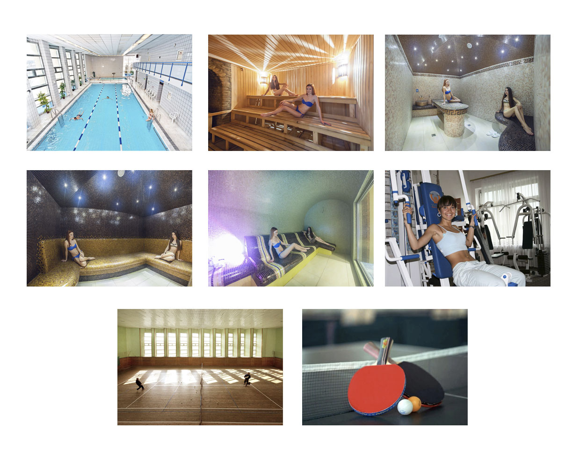
On the other hand, the photos featuring sport activities are narrative structures. The action processes are depicted here through invisible arrows departing from the represented participants that are the guests. The viewer is offered to have a rest with the dynamic activities. The photo, where the woman is captured in the gym, involves the participants in a friendly relation. The picture of this smiling girl leaves an impression of happiness and verbally implies the message from her: “If you use these services, you shall feel like I do”.
The images used here clearly expresses joy and happiness. The author gives the viewer a fair idea of what they can experience. They could have simply shown pictures of the facilities without someone using them. But they took it a step further to show the relaxing and pleasing effect of the services.
Figure 9 gives a view of different free time activities available for tourists. The activities and services displayed vary from the relaxation to extreme entertainment. It signifies that quiet stay can sometimes be turned into the funny spending time, hanging out, celebrations, cultural events, etc. Some activities are represented with people appearing in the pictures. The groups of people are portrayed engaging and actively participating in the activities. The participants of the events are the focal points of the photographs as they are at the centre of each image.

Figure 9. Images “Leisure time in “Karpaty”
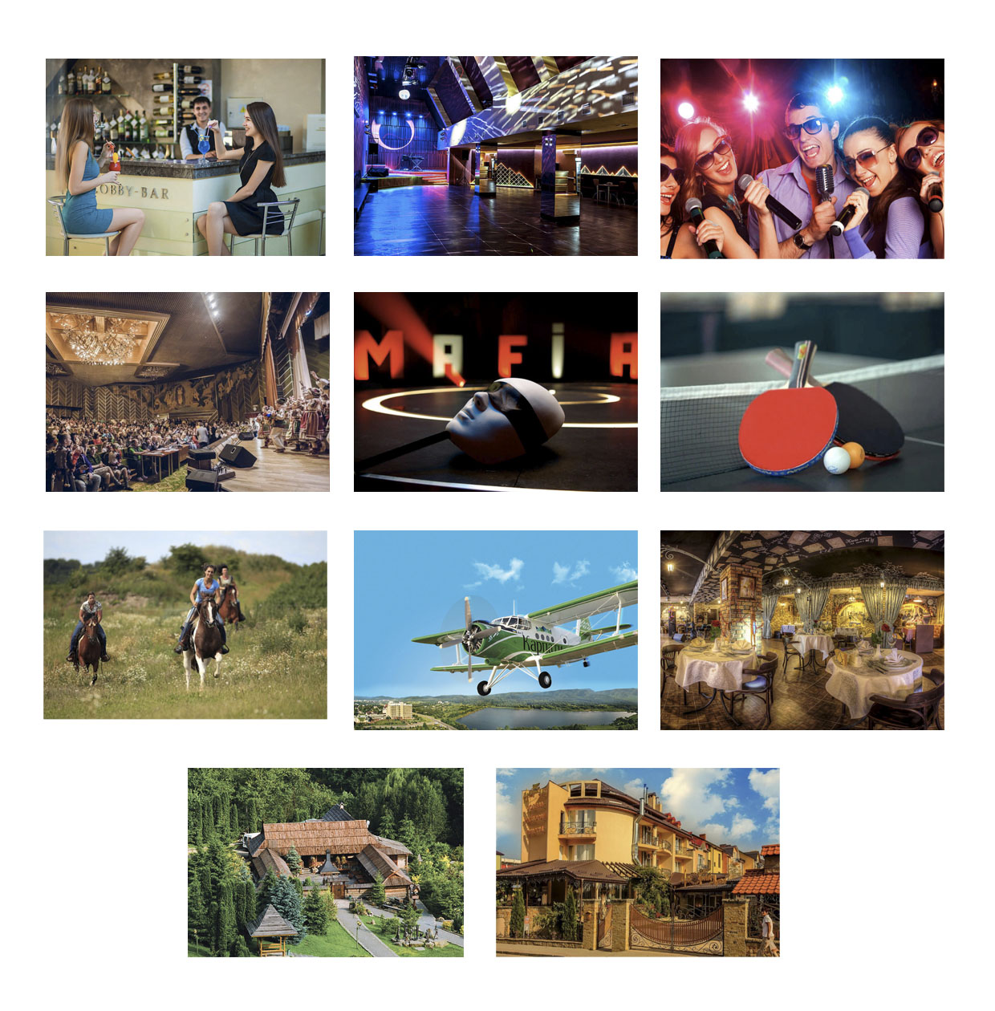
In some photos, the represented participants do not make any contact with the viewer. Thus this implies that the viewer is the passive observer, who is not invited to make interaction with them. However, other photographs are interactive and engaging as the viewers are positioned as if they would be in the crowd of the people. Hence, they are inviting visitors to participate in the activity. The photographs are depicted at an eye level, so the power relations are equal and more personal.
The most vibrant atmosphere is depicted in the photographs, which portrays dynamic activities. Thus, by suggesting staying active while in this resort complex, the author may create a positive appeal for some tourists. Picture representing cultural event depict the calmer and reserved atmosphere with people quite passively listening to the concert.
The photograph representing cultural life, namely concert, feature narrative structure. The depicted elements are actors and spectators. Different vectors are formed by these elements that help the reader understand that it is a concert, a traditional folklore event. The picture depicts participants in traditional folk costumes, dancing and singing folklore songs. One can see, that there are a lot of people participating in this event. Thus, it shows that the folklore traditions are still very much alive and popular even among young people. It connotes that Ukraine is a very archaic country, which managed to preserve the folklore traditions. The photo reveals that author regards traditional events as important and potential to attract tourists.
The next section “For Children” presents four images: three photos and a cartoon picture “Minions” (Figure 10). The children’s room is a medium shot which invites the viewer to enter this place. The lovely outdoor play area for kids is a long shot featuring this place in full. The surrounding space is green glass and tree image. It is the message with a code. It signifies that the play area is located in green space. The photograph is not engaging or interactive. The family, which is depicted, is not trying to make any contact with the viewer. The represented participants are depicted as the subjects to be observed. The passive observers can see what they are doing, but they are not invited to become a part of that family activity. The picture of a girl is representation of water activities for children. The facial expression transmits the emotion of joy and happiness meaning that young guests can enjoy water sports together with their parents. The target audience for these photos are families with small children, who are searching for a calm and revitalizing vacation.

Figure 10. Images “Facilities for Children” in the corpus of “Karpaty” resort website
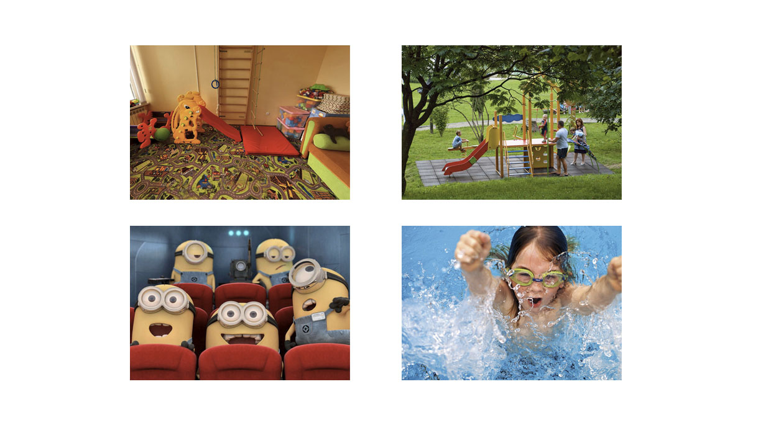

The photographs illustrating health tourism stand out from others as they seem very professional and the settings seem to be carefully staged (Figure 11). The good lighting and high level of detail and colour suggest high modality. Almost all photos portray people. Thompson (2012: 412) states that “the deployment of faces on health websites influences ideological notions about health and wellness”.

Figure 11. Photos of medical facilities of the hotel resort “Karpaty”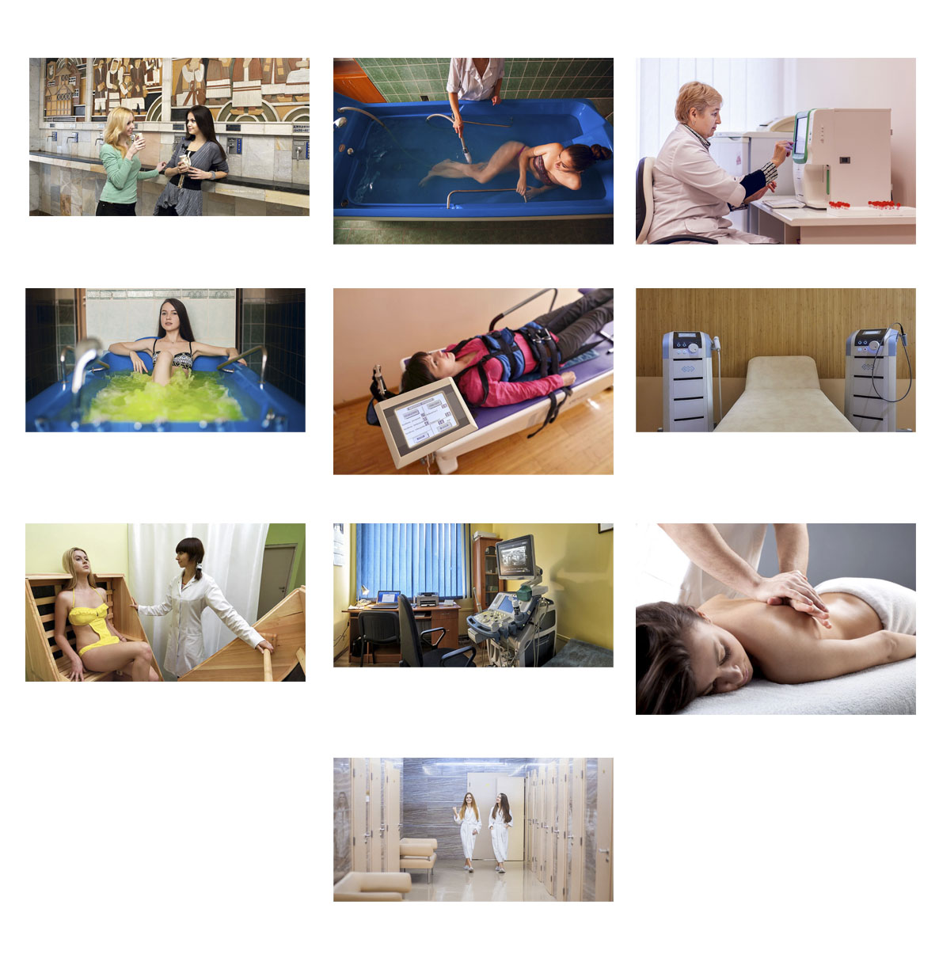
The pictures in “Treatment” section are mainly presented at close and medium distance, displaying the resort’s medical facilities and services. At this distance, these components seem to be accessible for the viewers, and they can experience these facilities and services physically. By projecting the images this way, the destination offers the viewers to see what they can have while staying in this institution.
On the other hand, people in these pictures do not create any contact with the viewer, thus this implies that the tourist is welcome to come and observe the events rather than interact with the represented participants. However, the photographic image of woman taking a bath implies demanding engagement from viewers and establishes an imaginary relation with the viewer. It suggests the friendly invitation and transmits satisfaction.
From the perspective of narrative process, these pictures adopt invisible vectors formed by the depicted medical staff. The viewer can perceive the action processes realized by them. The personnel is presented as trained experts which are on hand with anything the clients need to help them relax and unwind and get professional treatment. The tourists are offered to view a range of refreshing spa treatments and other therapies. As the photographs promote rehabilitation services, they signify the relaxation and the peaceful environment in “Karpaty” resort. Thus, the pictures can help users contextualize and better understand what this establishment can help them accomplish.
The last image captured two women, and as it is a final image, the viewer understands that they have already experienced the treatment. The photo conveys a sense of rapport and connection between the participants. The photo features the content facial characteristics of represented participants and is positively received by users. The facial features increase viewer engagement. Adding the photo of shiny happy people boosts trustworthiness of the treatment depicted in the previous photos. Overall, the images are able to activate affective responses of pleasure and transmit the meaning that, staying in this health resort establishment, the visitors can optimally combine treatment and recreation.
Demands are established with the photos featuring the medical staff of the establishment (Figure 12). An imaginary relation is created with the viewers, as the represented participants address them directly. Due to the close distance, it seems as if the viewer is able to converse with the doctors.
Figure 12. Pictures of the section “Doctors of Karpaty Sanatorium”
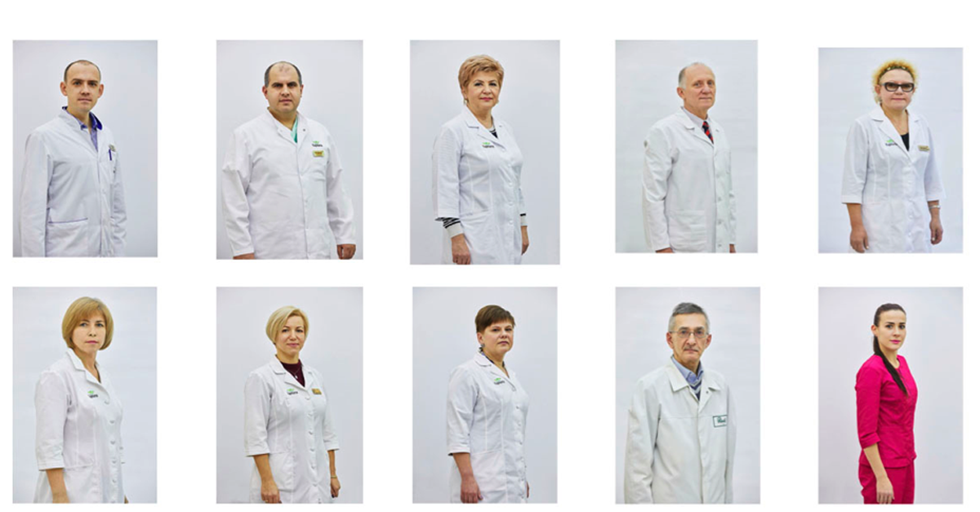

The act is also emphasized by the facial expressions of represented participants. We can see from the photo that they look friendly, warm and professional at the same time. Moreover, the photographs are depicted at an eye level, thus it signifies the engagement and equal power relations between people depicted in them and the viewer. All the viewers see are the professionals that they can trust and feel comfortable with. They create a certain professional image of themselves. A high-quality image creates a sense of trust and reliability with the viewer.
The linguistic messages, functioning as an anchorage to the pictures, deliver information on the doctors’ specialties. The doctors wear white coat with the logo of destination, however the cosmetologist has a crimson scrub, as she is not a physician. Cosmetologists are trained and licensed to perform cosmetic treatments and work to improve client aesthetics. By providing these photos, the author establishes credibility. Using real photos of the resort’s employees adds credibility to this resort complex.
Much attention is given to the representation of gastronomy. The section “Nutrition” offers to view the restaurants of the resort complex. The first one, which is also the main one, is depicted as empty and waiting for tourists’ presence (Figure 13). The viewer is offered to enter the depicted space and taste the food represented in the following pictures.

Figure 13. Photos of the restaurant “Play” in the corpus of “Karpaty” resort website
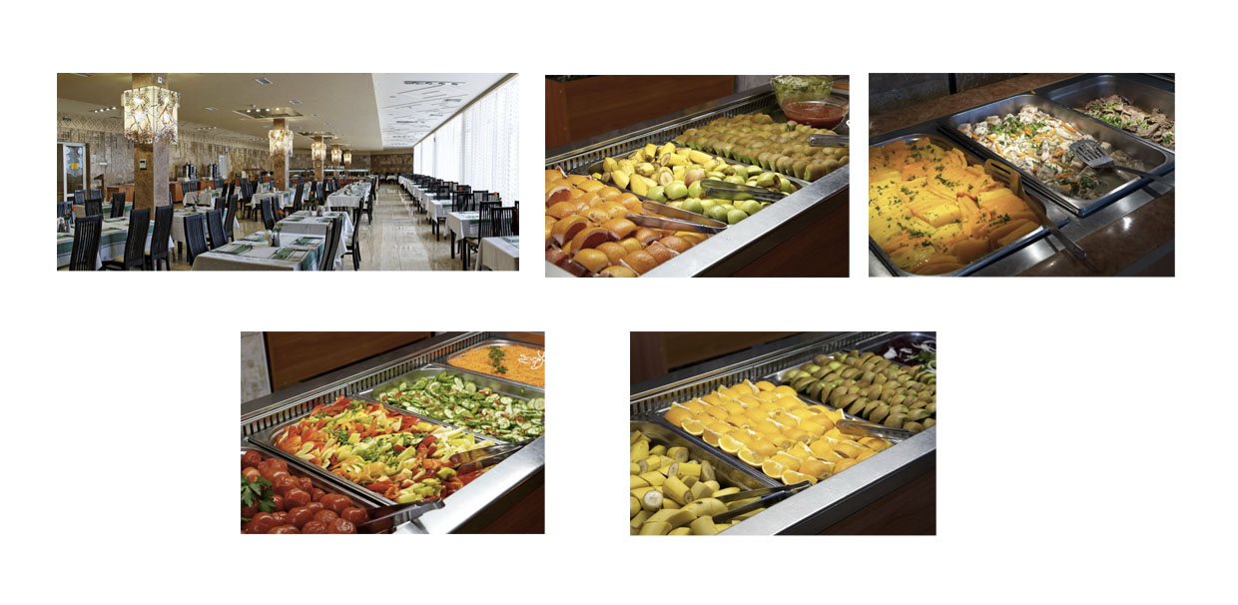
The food is the salient object of the photographs due to its size, colour palette, and central placement in the visual field; therefore, it is important and attractive. The warm colours are engaging and elicit positive and inviting feelings. The objects in the images are brought close to the viewer that enhances engagement and invites personal relationships between the viewer and the drawn elements. It indicates that the author is suggesting enjoying and sensing the taste of the food.
The way the food is portrayed elicits the meaning that the guests are offered to serve themselves the food that they want. By providing a wide variety of foods, the author tries to transmit the meaning that the resort can meet the needs of a large variety of customers, as they are offered vast range of food selection.
There are two more restaurants represented in the photographs (Figure 14 and Figure 15). They again are depicted as empty and waiting for tourists’ presence. The frontality and medium shots invites a viewer to engage and enter these spaces.
Figure 14. Photos of the restaurant “Ya i Ty” in the corpus of “Karpaty” resort website
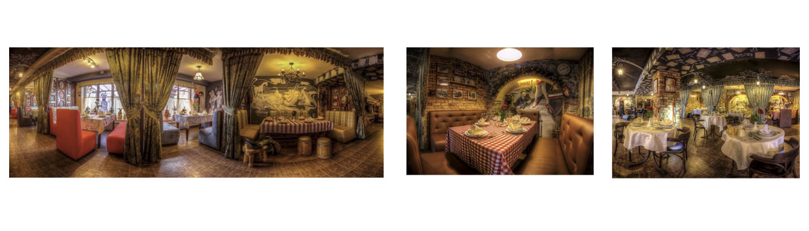
Figure 15 is a representation of ethnic restaurant. The plastic visual signs, such as colours and forms, together with linguistic message “Grazhda” imply Hutsul culture. The interior of the restaurant presents vivid natural colours that are an inherent characteristic of this ethnographic group. The lively hand-woven textiles, colourful kilims (carpet), and embroidery have dominant black and dark red colours. The towels are a cultural symbol representing Hutsul tradition. Moreover, the Hutsuls are known for their creative wood carving that is also observed in the picture.

Figure 15. Photos of the ethno-café-museum “Grazhda” in the corpus of “Karpaty” resort website
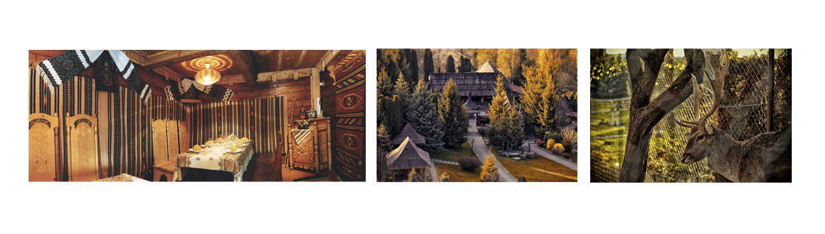
The restaurant is not described linguistically; the images are the main source of information. Certain information is best delivered by means of image then words. This is true with this traditional place, of which linguistic description alone will make it difficult for readers to decipher. The traditional decoration is an identity signifier and is used here to represent Hutsul ethnic culture. The decoration of the restaurant signifies that the recipes and preparation of food are very traditional as well. Therefore, the images express local culture and cuisine to convince the potential visitor to explore it.
The author draws the tourist’s attention on typical and authentic aspects of the local culture, on something that is unique. Culture is part of social semiotic resources that is used as a tool for meaning making. In the website, Hutsul culture is employed as a tourism commodity in realizing “Karpaty” destination image. Therefore, the viewer can expect to experience the meaningful trip.
The following images (Figure 15) suggest for the visitor that the restaurant is next to the wild nature. The long shot establishes a far social distance between participants. The photo invites the tourist to enjoy the view of distinctive wooden folk architecture surrounded by nature. The deer in the last picture is the symbol of untouched beauty of nature.
The representation of two restaurants juxtaposes traditional and contemporary atmosphere. This signifies that both traditional and contemporary culture are valued and highly appreciated by the resort complex. The pictures imply that tourists can enjoy the cultural diversity.
The images located on the page “Prices” mainly contain linguistic message (Figure 16). Both images imply benefits for the guests. The first image can be read as: “This autumn, the prices drop like leaves from the trees”.

Figure 16. Images on “Prices” page in the corpus of “Karpaty” resort website
The second image is a traditional family illustration. The family image creates an appeal for those tourists who travel with children. The depiction of the family at an eye level suggests the equal, social relationships with the viewer (Kress and van Leeuwen, 2006). The frontality of the picture signifies engagement. The people depicted in it have happy facial expressions; they are smiling. The represented participants address the viewer with the gaze directed at them what shows that it is an demand image (Kress and van Leeuwen, 2006), which means that the viewer is involved in personal relations with this family. The eye contact with the viewer establishes an imaginary relation and the smiles suggest the friendly invitation. Therefore, the family is trying to make a contact with the viewer and transmit the linguistic message of the picture.
Overall, the pictures in the website convey information that while visiting this establishment tourists can find the balance between the treatment and pleasure, nature and culture, tradition and modernity, solitude and entertainment.

4. Conclusion
To promote destinations and attract potential tourists is one of the most important keys to success in tourism marketing. In other words, the success in tourism industry depends on the way tourist destinations are advertised, that is, to the content of tourism promotional texts. For this reason, tourism discourse enriched with engaging visual choices is of paramount importance.
The communication of a desirable image of tourism destination to potential tourists is a predominant factor in convincing them to visit a destination. Hence, the promotional materials use a number of techniques to reach their goal that is to persuade tourists to book their services. Generally, good advertising strategies are the successful promotion of any kind.
The present article has detected the visual techniques of tourism persuasive language to influence people. The corpus under analysis has shown how the marketers heavily rely on the visuals in the web design that can engage and convince a reader. The analysis of visual corpus has revealed that the pictures not only express accurate messages, but they are also able to create feelings, add interactivity, provide engaging experiences and serve as trust indicators. These features are ably used to convince the target audience to book the services of “Karpaty” resort.
The art of persuasive website design implies the power of author over viewer. The use of promotional material with the help of visuals in websites has an enormous influence over the addressees due to the information they provide and the features displayed in them. The article identifies the enticing strategies employed in the tourism visual materials to achieve persuasion and to establish social control.
This article makes a contribution to the area of tourism studies by investigating how persuasion is realized through health tourism communication. Specifically, the goal was to understand what visual techniques of tourism website communication could be considered as persuasive ones. The results of this study could be helpful for those who create tourism marketing materials.

References
Barthes, R. (1964). Rhetoric of the image. Oxford University Press (2012).
Costa, N, and Melotti, M. (2012). Digital media in archaeological areas, virtual reality, authenticity and hyper-tourist gaze. Sociology Mind, 2, 53-60.
Dann, G. M. (1996). The Language of Tourism – A Sociolinguistic Perspective. Oxford: CAB International.
Echtner, C., and Prasad, P. (2003) The Context of Third World Tourism Marketing. Annals of Tourism Research, 30, 660–682.
Francesconi, S. (2014). Reading tourism text: A multimodal analysis. Bristol: Channel View Publications.
Innis, R. (1986). Semiotics – An introductory reader. London: Hutchinson
Jorgensen, L. G. (2004). An analysis of a destination’s image and the language of tourism. The Aarhus School of Business.
Kress, R. G., and Van Leeuwen T. (2006). Reading images: The grammar of visual design. London: Routledge.
Morgan, N., and Pitchard, A. (1998), Tourism Promotion and Power – Creating Images, Creating Identities. West Sussex: John Eiley & Sons Ltd.
Morgan, N., and Pritchard, A. (2000). Advertising in tourism and leisure. Butterworth-Heinemann Publications, Oxford.
Salim, M. A. B., Ibrahim, N. A., and Hassan, H. (2012). Language for tourism: A review of literature. Procedia-Social and Behavioral Sciences, 62, 136-143.
Thompson, R. (2012). Looking healthy: Visualizing mental health and illness online. Visual Communication, 11(4), 395 - 420. doi: 10.1177/1470357212453978
van Raaij, W. F. (2002). Stages of behavioural change: Motivation, ability and opportunity. In G. C. Bartels, and W. J. A. Nelissen (Eds.), Marketing for Sustainability. Towards Transactional Policy-Making, 321-333. Amsterdam: IOS Press.
Walters, G., Sparks, B., and Herington, C. (2007). The effectiveness of print advertising stimuli in evoking elaborate consumption visions for potential travellers. Journal of Travel Research, 46(1), 24 - 34.

PhD student, Malaga University (UMA), Spain. E-mail: anyaifali@gmail.com Orcid Id: 0000-0002-4219-411X *The corresponding author.

