Industrial heritage, a new tool for Olympic promotion? A comparative analysis
El patrimonio industrial, ¿una nueva herramienta para la promoción olímpica?. Un análisis comparativo

Helena Roux *

Abstract
Faced with the controversies surrounding the Olympic Games (OG), they are moving towards a greater integration of local challenges – economic, social and environmental. Associating the hosting of such event with the urban regeneration policies appears to be a way to include them in longer planning periods, as well as ensure they are remembered. Presented as engines of transformations, they contribute to promotion of requalified and re-invested spaces that correspond better with the image of a competitive global city. The development of tourism strategies stems from this land promotion and appears as one of the economic outlets of the post-industrial transition. On the other hand, the reuse of industrial buildings helps build a positive image and a lasting legacy for the OG, as catalysts for regeneration of brownfields in crisis – as can be seen in the official Olympic narrative. Through the analysis of three case studies, this article aims to identify how does tourism development fit into these strategies that link industrial and Olympic heritage.
Keywords: industrial heritage, regeneration, Olympic Games, tourism, heritage, territorial

Resumen
Entre los debates desatados en torno a la oportunidad que suponen los Juegos Olímpicos para la imagen y desarrollo de las ciudades, hoy día se avanza en la idea de una mayor integración de estos eventos deportivos en los programas de planificación local en términos económicos, sociales y ambientales. Asociar la celebración de un evento de este tipo a las políticas de regeneración urbana parece ser una forma de incluirlas en un periodo de planificación más largo, así como de preservar su memoria. Presentados como motores de transformación, los Juegos Olímpicos contribuyen, sin duda, a promover espacios urbanos reinvertidos y recalificados, que se corresponden mejor con la imagen de la ciudad global competitiva. El desarrollo de estrategias turísticas, en este sentido, parte de esta promoción territorial y aparece como una de las alternativas económicas de la transición posindustrial. En contrapunto, la reutilización de los edificios industriales de interés patrimonial refuerza la imagen de un legado positivo y duradero para los Juegos Olímpicos, como desencadenantes de la renovación de los brownfields en crisis, como se puede describir en la narrativa olímpica oficial. A través del análisis de tres casos de estudio, este artículo tiene como objetivo identificar cómo el desarrollo turístico encaja en estas estrategias que vinculan el patrimonio industrial y el patrimonio olímpico.
Palabras clave: patrimonio industrial, regeneración, Juegos Olímpicos, turismo, patrimonio, ideología territorial

- Introduction

The Olympic Games (OG), and the possibilities they open up in a given space, are analysed as triggers or accelerators of urban transformation (Essex and Chalkley, 2004; Smith and Fox, 2007; Ferrari and Guala, 2015). The means and investments they mobilise, the defined time frame they impose, the media coverage and promotion they allow (Deng et al., 2019) are all tools for promoting the host city. The event is what creates the before and after, and opens up new possibilities for the place in question, including its tourism development (Vierhaus, 2018), despite the nuanced outcomes and long-term impacts on the post-event tourism sector (Gaudette et al., 2017; Jones and Ponzini 2018). P. Duran (Duran, 2002) shows that they are an opportunity to highlight a decisive factor: the state of the city's tourist policies, beyond the sports sector alone, or the temporality of the event itself (Weed, 2008). They act as a marketing tool to shape a new image of the host cities (Gold and Gold, 2008; Gignon, Delaplace, 2021), and operate through "aesthetic interventions" (Broudehoux, 2020), and production of urban images presenting a more attractive and unified vision of the site. In the most recent editions of the OG, the creation of pleasant images gives way to the transformation of already existing images, with the idea to showcase territorial continuity. From spectacular architectural constructions, we move on to projects of adaptive reuse of the built environment.

It is indeed the urban regeneration policies that allow to respond to the controversies surrounding the OG (Gold and Gold, 2008), perceived as disconnected from the local social, economic and environmental realities1. With this in mind, the International Olympic Committee (IOC) proposed Agenda 2020, launched in 2014 and updated in 2021 with Agenda 2020+5. This new roadmap requires cities to include the organization of the Olympics in a long-term vision, in response to environmental, economic and social objectives. Avoiding the phenomenon of ‘white elephants’ (Deng et al., 2020), and enhancing existing buildings rather than building a new infrastructure adds to the idea of a “positive legacy” of the OG, which we will translate here as heritage (positive).

These new objectives integrate logics similar to those of heritagisation. Here heritage becomes a vector of attractiveness and development to the benefit of tourist activity and territorial renewal (Fagnoni, 2013). Ponzini and Jones (2018) show how heritage policies and the organisation of mega-events are both integrated into long-term urban planning, with tourism as a common economic outlet. While their work is focused on urban heritage, the industrial heritage is analysed less, mostly within research more interested in the historic centre, as well as the ECoC2. However, the peripheral character of industrial spaces, the ongoing evolution of this type of heritage, recognised as such for only a few decades, the history and culture to which it is linked, the functionality and nature of this building (Jevremovic, Vasić, 2012), are all specific issues to explore. J. Gardner (2017, 2019), in his work on the archaeology of London's mega-events between 1851 and 2012 was interested in the modern history of future Olympic sites beyond the processes of urban regeneration, and including the production of a dominant narrative that legitimises the event. Promoting a certain image of the past, makes it possible to prove a continuity, or on the contrary, show a necessary break with it. This was particularly the case of the industrial brownfield of the future Olympic site in London, perceived as polluted and disinvested (Gardner, 2017), which justified the saving intervention of the Games at the expense of a great complexity of lived experiences. Industrial areas and the values attached to them are promoted for greater attractiveness driven by the OG. This article aims to understand how the Olympic paradigm shapes the image of the post-industrial city. To do this, it will analyse the integration of industrial heritage as a new territorial ideology3 which is gradually imposing itself in the organisation of one of the most publicised events in the world. C.H. Houllier-Guibert and C. Mortelette have already shown how industrial heritage now embodies a territorial ideology that is becoming widespread, particularly as a lever of attractiveness, to offset economic decline (Houllier-Guibert, Mortelette, 2020). E. Fagnoni (2015) also analyses this “new look at the past” embodied by the heritage and tourism development of industrial wastelands.

In the case of the OG, however, the host cities are not necessarily lacking in tourism or economic dynamism. For this study, three examples were chosen, given the role of industrial heritage in the organisation of the Games. Turin 2006, London 2012 and Beijing 2022 are three cities whose industrial history and culture form a major element of their local identity, which is reflected in the Olympic event. However, the place it occupies in the urban hierarchy, as well as their land characteristics, differ.

Before 2006, Turin, a city in Piedmont region, was struck by deindustrialisation, following the automobile crisis that began in the 1980s. It used the opportunity of the Winter Olympics to redefine its identity and its image (Dansero, Puttilli, 2010). The place given to industrial heritage in the design of these OG is embodied in a very specific way in terms of time and space by highlighting the Lingotto building, and - in a more diffused way - as a nervous system of urban revitalisation. London, the former industrial capital of the world, has established itself for several decades as a globalised financial centre with around ten million inhabitants. For its 3rd edition of the OG, it was the first city to integrate the Olympic heritage into all stages of design and organisation of the OG, before Agenda 2020. Urban regeneration became a condition for the Olympic candidacy, supported by the mayor at the time, Ken Livingstone (Davis, 2011), and the site of Lower Lea Valley, London's industrial heart, was chosen. It stretches along the Lea River, and is home to a series of warehouses, and factories of chemical and polluting industries (Evans, 2016). Finally, Beijing, the former capital of 21 million inhabitants, became the first city to have hosted both Summer and Winter Olympics. In 2022, the ambition of the renovation project of the northern part of Shougang stood out in technical, economic and infrastructural terms. This former iron and steel factory in the west of the capital was designed as a new urban hub, in a city deeply marked by industrialisation, particularly from the 1950s onwards (Wu, 2015).

These three periods reflect a dual development, one of a better understanding of post-event territorial issues, and the other of recognising industrial heritage as an asset to be valued. This paper aims to explore the way in which they combine the revival of a former industrial district, now integrated into the tertiary economy, and the legacy of the OG, which left more or less tangible marks on the urban landscape and the social fabric. The first part will analyse the spatial reorganisation or labelling measures that affect these spaces, and the second will focus on the promotional strategies developed for the occasion of the OG, as well as their underlying objectives.

The official Candidature Files, the reports of each Olympic committee, and the concomitant urban planning documents constitute the main body of analysis, making it possible to interrogate the set objectives, and the image that they present for the city, before and after the event. The promotional documents (flyers, brochures, websites of the sites concerned) made it possible to complete this analysis. An understanding of the heritage policies of these cities is necessary, in particular the status of industrial buildings, and the evolution of their perception. Confronting these readings with the adaptive reuse strategies developed for the OG led to rethinking of industrial heritage within particular urban planning frameworks. Two three-month fieldworks were carried out in London and Turin between February and September 2022, bringing together participant and non-participant observations by means of a field diary. Fieldwork in Beijing is still pending given the policies linked to Covid-19, although some data was collected remotely between 2021 and 2022, in particular observations and photographs as part of a collective collaboration (see author's notes). Finally, this research is also fed by a few long semi-structured interviews (1 to 2 hours) conducted with IOC members between November 2021 and April 2022, in order to better understand the main issues of each Olympic edition, the evolution of conditions for organising the OG, and the territorial impact.

- Concrete measures to promote sites
2.1. Local industrial heritage for a global event
In these three cities, the OG are organised on sites where parts are recognized as heritage, local or national, which must be preserved. This element contributes to enriching the Olympic narrative with a cultural aspect, as well as to the enhancement of the existing buildings, through a long-term integration in the planning of the OG.

In Turin, the Lingotto is the first building recognised as industrial heritage in Italy (De Pieri, Fassino, 2008). Emblematic of Fiat's presence in the city, it is considered an innovation in industrial architecture for its time, combining modernity and technology (Colombino, Vanolo, 2017). After the end of production in 1982, following a crisis that hit the company hard, the question of destroying or saving the building arose. In 1985, Renzo Piano was appointed to renovate the site, maintaining the initial structure while adapting the interior for new activities. Since then, and after 15 years of work, the site has housed a shopping centre, a congress centre, offices, two hotels, an art gallery as well as part of the premises of the Polytechnic University of Turin (Colombino, Vanolo, 2017). Calling on this architect, after the failure of a prior competition in 1983, shows the attention paid to the renovation of the site. A true symbol of Turin's industrial identity focused on the automobile, its conversion and labelling were part of an initial desire to preserve it. Its integration into the 2006 OG, which embody Turin's economic revival, and the construction of the nearby Oval Lingotto to host the skating events, aim to prove the resilience of the site, from a single production activity to a set of leisure and consumption activities.

In 2012, the London OG were organised, after those of 1908 and 1948, in a country considered a pioneer in the conservation of industrial heritage since the second half of the 20th century (Falconer, 2006; Simeon, 2014). The choice of East London implies a clear objective of urban regeneration. The majority of the most polluting factories around the Lea River were relocated, freeing up the land for the creation of a perimeter controlled by the London Legacy Development Corporation (LLDC), responsible since 2012 for the post-Olympic management of the site. The neighbourhoods of Hackney Wick and Fish Island (HWFI) which we focus on here, adjoined the new Queen Elizabeth Olympic Park (QEOP). Industrial buildings have greatly diminished there, but still retain their imprint on the urban landscape. Inherited from Victorian and Edwardian architecture, they were the subject of a heritage classification in 2008 and 20094, between the success of the London bid and the event itself. The perimeter of the Conservation Area and the few buildings listed indeed attest to these traces of the spatial use and development of the district, recognised at the local level. Others are designated as Non-Heritage Assets5, i.e., recognised for their historical value, without belonging to an official list6.

The Shougang site is closely linked to the organisation of the 2022 Olympics. This former steel factory built in 1919, one of the largest in the Beijing regional area, is managed by the Shougang Group, a state-owned company (Figure 1). Following the success of Beijing's bid for the 2008 Summer Games, its industrial production was relocated to Hebei (Deng et al., 2020; Cestaro, 2022), in order to show a more pleasant image of the capital. During the 2000s, the first attempts to reuse the site appeared, but it was really the decision to integrate it into the organisation of the 2022 Olympics that allowed this project to move forward. In 2018, Shougang was included in the Chinese industrial heritage protection list, without benefiting from a stronger national label (Cestaro, 2022). The development plan for the district of Shijingshan7, in which Shougang is located, nevertheless describes it as a new reference point and marker of the Beijing urban landscape.

Figure 1: Location of Shougang in the Beijing metropolitan area

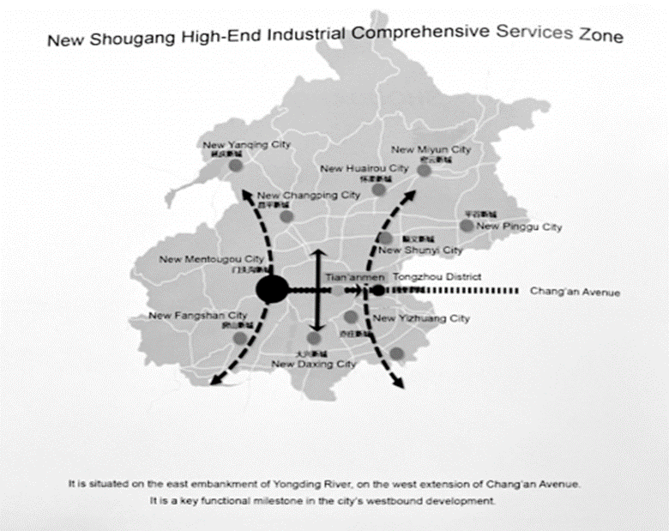
Source: Shougang promotional brochure, "New Capital City Renaissance landmark in the new age", published in 2019. Photo : Giorgia Cestaro

Attention paid to labelling and heritage conservation, from the building to the site, was here grafted into the organisation of the OG, with more or less prominence, depending on the context.

2.2.The spatial event, for controlled urban growth

The OG as a spatial event (Augustin, 2009) have a role in the reorganisation of mobility networks and transport infrastructures, making the host sites more accessible, and having a lasting impact on the organisation of the land.

The first Strategic Plan launched by the Municipality of Turin8 in 2000, announced the objective of opening the city's first metro line, put in service in February 2006, and extended to Lingotto in 2011. This plan, drawn up after the IOC's decision to grant the 2006 OG hosting to the city of Turin in 1999, positioned the event as an instrument for confirming future urban policies. The metro promoted the integration of Lingotto into tourist circuits, allowing users to reach the site in less than 15 minutes from Porta Nova station. The construction of the Olympic Arch, designed to connect the Olympic Village to the Lingotto and Oval sector (Figure 3), also connected this industrial space to the rest of the city. Today, the Village is partially divested. L'Arche is still a passage area used by the inhabitants, and visited by those who venture into the neighbourhood. It is also visible from the roof of the Lingotto, open to visitors, as a mark inherited from the Olympics on the urban landscape (Colombino, Vannolo, 2017).

In London, the Olympic Delivery Authority (ODA) published its Transport Plan in 2009, with a revised version in 2011 after consultation9. The objective was to ensure a sufficient supply of public transport so that travellers can access the venues of the events. In the longer term, the Municipality was taking the opportunity to develop the multimodal node of Stratford10, and to strengthen the existing network, with an improvement of the Overground which links Hackney Wick to the city centre. This project also included the opening of the Elizabeth Line in summer 2022, which completes the connection of Stratford to the London metropolitan network, and to Heathrow International Airport - a series of measures which strengthened the links with the centre of the capital, rather than really opened up HWFI. This strategy reinforced the attractiveness of these rapidly changing districts, faced with strong demographic tensions, with the aim of remedying the development imbalance between the western and eastern districts of the capital (Figure 2).

Shougang is located about an hour from downtown Beijing, between the 5th and 6th ring roads of the city, and benefits from a series of measures similar to the two previous cases. The Chang'An Bridge11 - which is reminiscent of the shape of the Olympic arch in Turin - was inaugurated in September 2019, in the extension of the axis of Chang'An street (Figure 1). Its design has also integrated the view it could offer of Shougang, thus making it possible to enhance the landscape as a whole. Then, the creation of a new Metro line, the "Olympic Branch Line" tested in 202112, made it possible to serve the site more quickly with two different stations. Counterbalancing the growth of the capital is also one of the major objectives of the Olympic legacy, as stated by a member of the IOC13. Nearly half a million people by 2035 are expected in this new urban hub14. The development of adapted transport therefore prepares the ground for the redevelopment of this area around the industrial site as an urban marker.

These measures make it possible to reintegrate areas that were once peripheral to central urban dynamics, in cities that continue to grow and evolve towards a polycentric model – which is not new, but contributes to refocusing industrial heritage within the local territorial organisation. In particular, the capitals of London and Beijing are accelerating, via the impact of the OG, the development of a polycentric model, as illustrated by the two figures below.

Figure 2: Location of the London 2012 Olympic site, ‘LLDC Area’

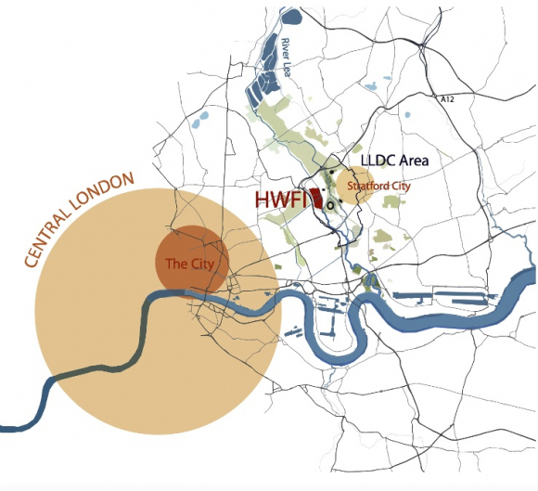
Source: Hackney Wick et Fish Island Design Planning Guidance, LLDC, 2014

  - The transformation of the urban landscape: a post-industrial aesthetic for the OG
The entire land and urban landscape are now affected by the Olympic urban regeneration projects. The reuse of existing industrial buildings is accompanied by a discourse that promotes a form of sustainability of the Olympic event, embodied by revegetation processes. The three choremes below (Figure 4) schematically represent the spatial organisation of each case study. If the choice of this type of visualisation does not allow scalar accuracy, the author has tried to represent the change of scale of a relatively small building (70,000m2 of surface for the Lingotto of Turin) to a much larger area (2.9 km2 for the northern part of Shougang, in Beijing). We also see the intertwining of the existing industrial building with the spatial modifications generated for the sake of the OG, as well as the place given to vegetation.

In Turin, the separate elements are interconnected by an emblematic infrastructural axis, the Olympic Arch. The Lingotto building is a pre-existing landmark, affixed to the new sports and Olympic constructions. This schematic reflects the general organisation of the space inherited from the OG, insofar as few major developments have been carried out in this area since. The Olympic facilities are partly abandoned, partly converted into housing, despite the quality being widely questioned. These OG were marked by the attention paid to environmental protection (Gold and Gold, 2008; Frey et al., 2008), with a series of tools designed for this purpose, developed by the Turin Olympic Committee15. A large part of these tools was concerned with areas outside of the city of Turin, since the Winter Olympics were largely taking place in the surrounding Alpine resorts. At Lingotto, it was rather post-OG that the greening of the roof developed, now open to tourism, henceforth perpetuating this association between environmental aesthetics and industrial heritage. These small spaces dedicated to local biodiversity offer an improved experience to the visitor, more than they add to a profound transformation of the urban landscape.

In London, the transformation of a part of the Lower Lea Valley into green space was an integral part of building an Olympic legacy (Evans, 2016). Once the industrial land has been freed from its initial function, the prospect of creating the park opened up - the QEOP, which hosted the Olympic stadium and swimming pool, the BMX tracks and the VeloPark, connected by leisure areas, lawns, playgrounds, and access to the banks of the River Lea. To the east, near Stratford, the Athletes' Village was partly converted into housing, pending new residential developments. Opened to the public in 2013, the QEOP was relayed as one of the major successes of the facilities linked to the OG16. The industrial buildings were more fragmented and surrounded the park which hosted the main sports facilities. The roads and canals framed the space, but it was the park itself that connected all these elements into a whole, as a central figure of transformation of the landscape designed and developed for the OG (Figure 3).

Figure 3: Old Ford Locks, view from the QEOP

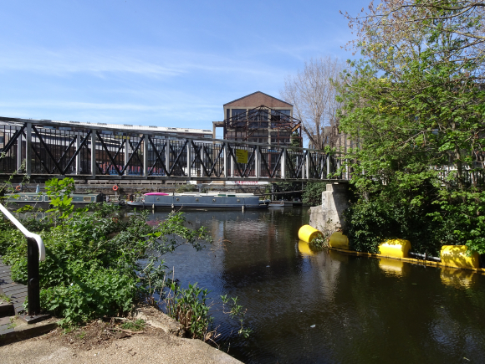
Source: Helena Roux, April 2022

In Shougang, the industrial buildings formed a delimited perimeter which accommodated the sports and Olympic infrastructures within it. Justifying the organisation of winter sports events in a post-industrial context, and promoting the attractiveness of this urban landscape, while claiming to respect environmental objectives was a risky and controversial gamble. The image of ski jumping in a landscape of cooling towers has indeed drawn strong media criticism internationally, calling Shougang “dystopian"17. Vegetating the heavy industrial remains was one of the strategies to feed this environmental facade and place promotion. At the district level, the Shijingshan Plan announced the concomitance between the renovation of Shougang, and the requalification of the banks of the Yongding River, which runs along the site from the west18. This project echoed that of the Green Belt Strategy, as a process of depollution of the capital which already preceded the 2008 OG (Sun et al., 2000; Deng et al., 2020). Near Shougang, access to a river landscape with spaces designed for sitting and stopping contributed to the new amenities of the place. Inside the industrial park, the aquatic and botanical elements were enhanced, from plants and lawns around the Big Air and to the Xiuchi artificial lake, and offered visitors an enriched experience (World Architecture, 2020) of this metallic landscape.

Vegetation, in addition to beautification and recreation functions (Bourdeau-Lepage, 2019), became a privileged tool in the territorial ideology that made up the Olympic landscape. On the one hand, it acted as a guarantee of attractiveness, by creating amenities that add value to the industrial land concerned, for the benefit of tourism development and future investments. On the other hand, it fed the environmental narrative promoted by the Olympic actors, making it possible to justify, in appearance, a positive impact of the Games on the transformation of the urban landscape. These strategies nurtured a renewed image of industrial buildings, more than they translated a fundamentally sustainable urban planning. In the case of London (Davis, 2011) and Beijing (Cestaro, 2022), industrial production has also been relocated a little further from the capital.

Figure 4: Industrial heritage and Olympic facilities: examples of spatial organisation

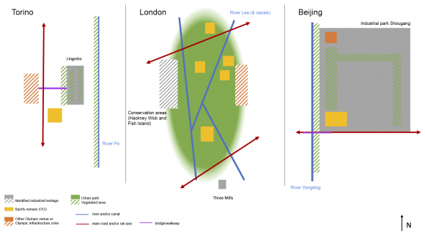
Fuente: Helena Roux, 2022. Diagrams produced from a summary of the data collected (analysis of urban planning documents and field observations)

- Tools and objectives of territorial attractiveness
3.1. Destination as a result of Olympic promotion

In each of the cases, the question of the reuse of the industrial heritage or local urban regeneration could also be seen independently from the organisation of the Games, but their Olympic documents always attested to a vision which linked the event to the processes of adaptive reuse.

We consider here the definition of destination “as a dynamic set of projects conceived as intention (...)

The affirmation of Turin as a tourist destination19 has been an integral part of the city's post-industrial transition, with the OG acting as a catalyst (Bondonio and Guala, 2011). Showing the diversity of assets of Turin and the Piedmont region in architectural, gastronomic and landscape terms also involved highlighting its industrial history. The Piano Strategico20 announced in particular, among its main objectives, the ambition to make Turin a city of culture, tourism, commerce, and sport21, thus combining heritage, the legacy of the OG, and tourism. 2006 was an opportunity for the city and the region of Piedmont to invest in the development of this sector, drawing inspiration from the 1992 Olympic Games in Barcelona (Otgaar, 2010) and the adaptive reuse of the docklands. This municipal document states more precisely that the Lingotto represented an attraction of "international renown"22, especially by being better connected to the rest of the city by the new metro. It was a development that therefore recalled its central place in Turin’s story and its integration into the renewed image of the city, broadcast in relation to the OG.

In 2012, the British Government's Department for Culture, Media and Sport published Beyond 2012, the Legacy Story, which presented East London as "London's Newest District", thanks to the unrivalled scale of urban regeneration methods. This document showed a “revitalised” and “vibrant”23 space, which contrasted the previous descriptions of a space in crisis (Gardner, 2017). Tourism was also designated as one of the major growth opportunities for the United Kingdom as a whole, even if, at the local level, attractiveness policies were aimed above all at residential development in the Olympic district. The Hackney Government website states that Hackney Wick has grown in popularity since the 2012 OG24. This discursive strategy is also found on the QEOP site, linking the success of the transformation of HWFI to the Olympics, and a new look at these industrial vestiges which fuelled the development of residential, creative and tourist activities.

Finally, the last case illustrates a real staging of industrial heritage, at its peak in winter 2022. Shougang was presented as an industrial park, now open to visitors. The construction of the Big Air, a ski ramp intended to host the Olympic jumping events, completed this urban landscape, all carefully designed to offer the best view to the visitor. This is part of the “Tourism Belt” strategy, from Beijing to Zhangjiakou25, a mountain town that also hosted winter events. Documents from the Beijing Olympic Committee indicate that this belt was at the same time cultural, sporting, and touristic26 - elements reminiscent of those set out for Turin in the 2000s - and that the objective of the Shougang regeneration project lies in the construction of a “post-industrial scenic recreation area”27, thanks to the site's heritage architectural elements, such as the blast furnaces and the desulphurisation plant.

The Olympic heritage, as it was presented in anticipation and later retrospectively, was invoked as a central element in the construction of these industrial spaces as tourist destinations. This story placed the OG in the defining role in transition of these revitalised and multifunctional places.

3.2. A juxtaposition of urban signage

The valorisation of heritage was also carried out, in a concrete way, by the urban signage, which indicated keys of reading and interpretation to the visitor (Gravari-Barbas, 1998). It made it possible to transmit, in the public space, part of the history of the place, and to expose the Olympic and heritage narratives beyond the mere physical preservation of the building.

By visiting the Lingotto in Turin, and in particular its roof, the proposed reading of the building obviously refers to the OG - because they were a milestone in the recent history of the city, and because it was a preferred viewpoint to observe the Olympic Arch. The tourism development of Lingotto therefore superimposed industrial history, with the Olympic heritage, as the starting point for a post-industrial revival. The history of the building since its foundation, and its ability to adapt to the changing demands of its time are related there, however without really dwelling on the human and social history of the place (Colombino, Vanolo, 2017). The Lingotto site contrasts with, on the other side of the arch, the abandoned Olympic buildings, still bearing the inscription "Torino 2006" engraved on the concrete, although nothing remains of their initial function.

In the case of London, the industrial heritage was dispersed in the urban environment, without the emblematic evidence of Lingotto, nor the well-defined scale of Shougang. Urban signage insists more on the Olympic heritage and the 10 years since the event. As soon as you exit the Hackney Wick Overground station, there are signs indicating the Stadium or the QEOP. The redevelopment projects feature the logo of the Park, managed by the LLDC. Since these projects are now happening well after the Olympic Games, the choice of vocabulary and logo still links these transformations to the initial event, despite a more complex actual reality. The industrial heritage serves as a backdrop to justify the revitalisation of an entire neighbourhood after 2012. The new residential buildings of Hackney Wick and East Wick imprint certain colours and materials, such as red metal and brick, for the sake of harmony with the rest of the built environment, and in line with the current popularity of industrial aesthetics in our urban lifestyles (see Jevremovic, Vasić, 2012).

In Shougang, explanatory panels in Mandarin and English describe the main industrial elements of the site. This space is truly thought of as an industrial park that you visit, focusing on several specific points, between pipes and blast furnaces which stand as spatial landmarks and milestones in industrial history. The Olympic signage completes the picture, as evidenced by the few reproductions of the two Olympic and Paralympic mascots throughout the site (Figure 5). The BOCOG offices, housed in a former silo, are also shown as an additional link between the industrial space and the event. The Big Air, highly publicised during the Olympics at national and international level, bears the Olympic logo and now imposes its silhouette between the cooling towers as the main Olympic marker, symbol of the renewal of the place (Graezer Bideau, Theurillat 2022a). Without necessarily having the same cultural function, the industrial heritage and the Olympic heritage therefore both serve as justification for the tourism development of Shougang.

The Olympic and heritage signs are superimposed, like two layers of reading of the place. This is particularly the case in London and Beijing, where the urban signage linked to the Olympic Games is still very present and structuring the space.

3.3. After the event, different transition plans

This last part questions the tourist activity as the primary vocation of these promotional policies linked to the OG. While tourism is always an underlying objective, economic, political and social goals may take different directions depending on the local context.

Figure 5: BOCOG offices and Olympic mascots, Beijing

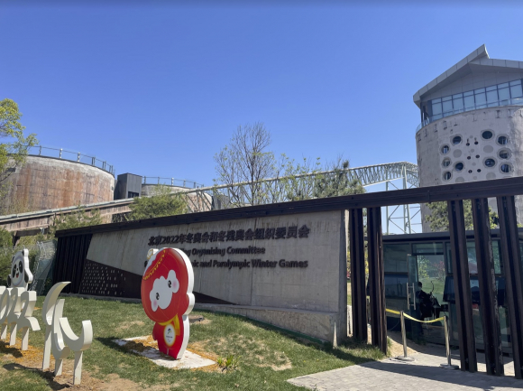

For Turin, the desire to develop as a tourist destination was really one of the major objectives that followed the post-Olympic redevelopment. The launch of the Made in Torino Tour in 2005 was an attempt to prepare the tourist revival of the city by also including its industrial past. This was a dual initiative of the local tourism agency created for the OG, Tourismo Turino and the Chamber of Commerce (Otgaar, 2010). This direct cooperation between tourism actors and industrial actors was built as an expression of local expertise, and the city of Turin juggled between the need to renew its image, and that of not neglecting its culture and its industrial past (Otgaar, 2010). Today, industrial tourism is mainly developed around the Lingotto and the Eataly gourmet store, opened in 2007 in the former Carpano factory (Colombino, Vanolo, 2017), which combines local food trade, restaurant, and museum. This Olympic, industrial and gastronomic tourism aims to illustrate the multiple facets of Turin's post-industrial identity, in the construction of an eclectic metropolitan destination.

In London, the 10th anniversary of the Olympic Games in 2022 was the occasion for several festive and cultural events intended for residents, which perpetuated the storytelling of the Olympic event, highlighting the changes made in a decade. At HWFI, part of the industrial heritage now blends into the urban setting where the creative cluster flourishes, the warehouses are transformed into studios, workshops, and community spaces. There is a narrative of creativity that the LLDC took up as a consequence of the policies carried out in East London since 2012, despite its role contested by the residents. The remaining industrial buildings face two distinct residential dynamics. A small part is now reused as shared housing, mainly housing young people gravitating around the creative sector, who value the flexibility of the place, as well as a relative saving in rent. At 22 Smeed Road, in Fish Island, a cluster of colocations maintains what remains of industrial buildings as a common living space. In the same street stand a series of cranes, which mark the destruction of a good part of the prior buildings for the benefit of real estate development. Some facades have been integrated into projects, such as Omegaworks or Ironworks, intended to provide high-end apartments, using the industrial heritage value as an additional selling point.

The case of Shougang is special, since due to the framework of the policies linked to Covid-19, the 2022 Olympic Games took place without an external audience. Currently, we can mainly observe local tourism of a city population in search of leisure, in line with the development of domestic consumption and tourism already identified (Taunay, 2010), but certainly reinforced during the years 2020 and 2021. The images of the Olympic ski jumping events in this industrial setting have massively contributed to the visibility of the site. Blast furnace No. 3 can be visited, promoted as a panoramic site28 (see Nyiri, 2008). However, even more than an opportunity for tourist development, the Shougang site testifies to Chinese expertise in the reuse of industrial heritage as well as an industrial culture and know-how, in line with a plan for economic rehabilitation of the national manufacturing sector (Cestaro, 2022). A didactic aim is therefore added to the project designed for Shougang, whose restored heavy industrial elements embody industrial power.

- Conclusion
Each of these examples involves a set of more complex realities, which cannot be represented solely through the prism of the OG and associated actors. They share the way in which the Olympics feed a new reading of these industrial spaces, as much as they serve as a heritage framework in a tied, dialectical relationship. The Olympic image renews that of the post-industrial wasteland, turned towards the future and an international scale. At the same time, heritage serves as a local anchor, to promote the sites and host cities, and to justify a positive impact of the Olympics in terms of sustainability and authenticity. Projecting a vision of the post-industrial city, embellished with greenery and promises of economic renewal is not enough to defend a truly ecological and sustainable balance sheet, which we doubt can really result from this type of event.

In Turin, the Lingotto gives value to the urban landscape and the architectural identity of the city. Its use is focused on commercial and leisure functions, modelled on a development dating back more than fifteen years, breaking with the social and cultural history of the place. Its heritage identity remains distinct from the heritage of the OG, even if these have made it possible to accelerate the renovation and accessibility of the site. In London, the urban buildings bordering the Olympic Park are used as a marketing tool for residential development, and the preferred backdrop for a major creative cluster. The latter embodies a widespread trend of industrial upgrading (Evans, 2009) although it participates in the process of gentrification. The dominant discourse is that of a redevelopment by and thanks to the Games, leaving little room for other alternative narratives (Gardner, 2017). Finally, the Shougang site became one of the main stages of the Winter Games. As the 2008 Games led to the relocation of factories to promote a better image of Beijing, the opposite choice in 2022 shows the paradigm shift around industrial heritage that is taking place. The use of the creative cluster has also dominated the reuse of industrial heritage in China over the past decade. It gives way here to what is presented as a new model for industrial heritage, in terms of uses and technical ambitions (Graezer Bideau, Theurillat, 2022a), even if its post-event development remains to be analysed.

The objectives of this promotion are multiple and the tourist activity, although underlying in the Olympic planning and heritage strategies, is not always the main objective. From a new residential development framework, to the need for cultural and technical reaffirmation, these three examples show the ambivalence of the roles attributed to industrial heritage, as a territorial ideology promoted in Olympic planning. The industrial wasteland thus valued becomes a heritage asset, even in towns that have already previously been considered international tourist destinations.

Funding: This work is part of the research project “Uses of Cultural Heritage at the Beijing Winter Olympic Games of 2022” led by Florence Graezer Bideau, Thierry Theurillat, with the contribution of Mengke Zhang and Huishu Deng.

References

Associazione Torino Internazionale (2000). Piano Strategico per la promozione della Città. Torino: Associazione Torino Internazionale.
Augstin, J.P. (2009). Les Jeux Olympiques, l’évènement spatial par excellence (The Olympic Games, the quintessential spatial event). Bulletin de l'Association de géographes français, 3, 303-311.
Beijing Organizing Committee for the Olympic Games (BOCOG) (2019). Beijing Legacy Plan. Beijing: BOCOG.
Beijing Organizing Committee for the Olympic Games (BOCOG) (2020). Beijing Sustainability Plan. Beijing: BOCOG.
Beijing Organizing Committee for the Olympic Games (BOCOG). Beijing Legacy Report, Beijing: BOCOG.
Bndonio, P. and Guala, C. (2011). Gran Torino? The 2006 Olympic Games and the tourism revival of an ancient city, Journal of Sport & Tourism, 16, 303-321. DOI: 10.1080/14775085.2011.63501
Bourdeau-Lepage, L. (2019). De l’intérêt pour la nature en ville, Cadre de vie, santé et aménagement Urbain. Revue d’Economie Régionale & Urbaine, 5, 893-911.
Broudehoux, A. M. (2020). Mega-Events and Urban Image Construction, Beijing and Rio de Janeiro. London: Routledge.
Cestaro, G. (2022). Protection and management of industrial heritage in China. History, practice and meaning. PhD thesis, Politecnico di Torino & Tsinghua University of Beijing, Supervisors: Prof. F. De Pieri & Prof. L. Zhou, Torino-Beijing.
Colombino, A. and Vanolo, A. (2017). Turin and Lingotto: resilience, forgetting and the reinvention of place. European Planning Studies, 25, 10-28. DOI : 10.1080/09654313.2016.1254598
Dansero, E. and Puttilli, M. (2010). Mega-events tourism legacies: the case of the Torino 2006 Winter Olympic Games – a territorialisation approach. Leisure Studies, 29, 321-341. DOI : 10.1080/02614361003716966
Davis, J. (2011). Urbanising the Event: how past processes, present politics and future plans shape London’s Olympic Legacy. PhD thesis, LSE Cities Programme of the London School of Economics & Political Science, under the supervision of F. Tonkiss, London.
De Pieri, F. and Fassino, G. (2008). The Olympic Sites, The architecture of 2006 in the urban landscape of Turin. Torino: Allemandi.

Deng, H., Mancini, M., Zhang, L., and Bonino, M. (2020). Beijing 2022 between urban renovation and Olympic sporting legacy: the case of Shougang. Mov Sport Sci/Sci Mot, 107, 53–65. DOI : 10.1051/sm/2019040
Department for Digital Culture, Media, Sports (2012). Beyond 2012: The London 2012 Legacy Story.
Duran, P. (2002). The impact of the Olympic Games on tourism, Barcelona: the legacy of the Games 1992-2002. In Moragas M., Botella M., (eds.). Barcelona: l’herència dels Jocs. 1992-2002. Barcelona: Centre d’Estudis Olímpics UAB, Planeta.
Essex, S. and Chalkley, B. (2004). Mega-sporting events in urban and regional policy: A history of the Winter Olympics. Planning Perspectives, 19, 201–204.
Evans, Gr. L. (2009). Creative Cities, Creative Spaces and Urban Policy. Urban Studies, 46, 1003-1040. DOI : 10.1177/0042098009103853
Evans, G. (2016). London’s Olympic Legacy: The Inside Track. London, Palgrave Macmillan.
Fagnoni, E. (2013). La dialectique patrimoine/modernité, support de la ressource territoriale. Bulletin de l’association de géographes français, 90, 117-126.
Fagnoni, E. (2015). L’industrie versus patrimonialisation : questionnement autour d’une transition vers une économie culturelle. Bulletin de l’association de géographes français, 92, 556-564. DOI : 10.4000/bagf.1110
Falconer, K. (2006). The industrial heritage in Britain – the first fifty years. La revue pour l’histoire du CNRS, 14, accessible at : http://journals.openedition.org/histoire-cnrs/1778, (accessed September 18 2022).
Ferrari, S. and Guala, C. (2017). Mega-events and their legacy: Image and tourism in Genoa, Turin and Milan. Leisure Studies, 36, 119-137. DOI : 10.1080/02614367.2015.1037788
Frey, M., Iraldo, F. and Melis, M. (2008). The Impact of Wide-Scale Sport Events on Local Development: An Assessment of the XXth Torino Olympics Through the Sustainability Report. SSRN Electronic Journal, available at : https://papers.ssrn.com/sol3/papers.cfm?abstract_id=1117967 (accessed August 30 2022).
Gardner, J. (2017). The archeology and heritage of mega-events in London, 1851-2012, PhD Thesis, UCL Institute of Archeology, under the supervision of B. Butler, and G. Moshenska, London.
Gardner, J. (2019). Recurring Dreams: Mega Events and Traces of Past Futures. Archeology International, 22, 86-99. DOI : 10.5334/ai-399
Gaudette, M., Roult, R. and Lefebvre, S. (2017). Winter Olympic Games, cities, and tourism: a systematic literature review in this domain. Journal of Sport & Tourism, 21, 287-313.
Gignon, A. and Delaplace, M. (2021). Préparation de Paris 2024: Tourisme et image des quartiers populaires en Seine-Saint-Denis. Bulletin de la Société Géographique de Liège, 76, 103-120.
Gold, J. and Gold, M. M. (2007). Olympic Cities, City Agendas, Planning, and the World’s Games, 1896-2020. London: Routledge, 2016 edition. DOI : 10.4324/9781315735887
Graezer Bideau, F. and Theurillat, T. (2022 (a)). Shougang ou la nouvelle icône du patrimoine industriel chinois, 25 Mars 2022, Le Temps, available at : https://www.letemps.ch/opinions/shougang-nouvelle-icone-patrimoine-industriel-chinois (accessed 22 September 2022).
Gravari-Barbas, M. (1998). Belle, propre, festive et sécurisante : l’esthétique de la ville touristique. Villes et Tourisme, 178, 175-193.
Houllier-Guibert, C.-E., and Mortelette, C. (2020). La patrimonialisation de l’héritage industriel comme stratégie de revalorisation : vers la généralisation d’une idéologie territoriale. Ethnologies, 42, 217-234.
Jevremovic, L. and Vasić, M. (2012). Aesthetics of industrial architecture in the context of industrial buildings conversión. PhiDAC, IV International symposium for students of doctoral studies in the fields of civil engineering, architecture and environmental protection, Nis, Servia, available at: https://www.academia.edu/1977965/AESTHETICS_OF_INDUSTRIAL_ARCHITECTURE_IN_THE_CONTEXT_OF_INDUSTRIAL_BUILDINGS_CONVERSION (accessed August 21 2022).
Jones, Z. and Ponzini, D. (2018). Mega-events and the Preservation of Urban Heritage: Literature Gaps, Potential Overlaps, and a Call for Further Research. Journal of Planning Literature, 33, 1-18.
Kadri, B., Khomsi, M. R. and Bondarenko, M. (2011). Le concept de destination : diversité sémantique et réalité organisationnelle. Téoros, 30, 12-24.
London Legacy Development Corporation (LLDC) (2014). Hackney Wick & Fish Island Design Planning Guidance. London: LLDC.
London Legacy Development Corporation (LLDC) (2014). Hackney Wick Heritage Conservation Appraisal. London: LLDC.
Mayor of London (2007), Lower Lea Valley, Opportunity Area Planning Framework, Greater London Authority, London.
Nyiri, P. (2008), Scenic Spots: Chinese Tourism, the State, and Cultural Authority, University of Washington Press, Seattle.
Olympic Delivery Authority (ODA) (2011). The Transport Plan for the London Olympic and Paralympic Games. London: ODA.
Otgaar, A. H.J. (2010). Industrial Tourism in Turin, in Otgaar A. H.J., van den Berg L., Berger C., Xiang Feng R. Industrial Tourism, Opportunities for City and Enterprise. Rotterdam: Ashgate E-Book.
Simeon, O. (2014). Quel patrimoine industriel pour quelle vision de l’histoire ? Le cas de la Grande Bretagne. L’Homme & la Société, 192, 15-30.
Smith, A. and Fox, T. (2007). From “event-led” to “event-themed” regeneration: The 2002 Commonwealth Games legacy programme. Urban Studies, 44, 1125–1143. DOI: 10.1080/00420980701256039
Sun, L., Fertner, C. and Jørgensen, G. (2021). Beijing’s First Green Belt – A 50-Year Long Chinese Planning Story ». Land, 10, 969.
Beijing Municipality (2019). Shijingshan Zoning Plan (Territorial Spatial Planning), 2017-2035, 石景山分区规划（国土空间规划） （2017 年 — 2035 年, available at : http://ghzrzyw.beijing.gov.cn/zhengwuxinxi/ghcg/fqgh/202002/P020200213611540861582.pdf, accessed October 3 2022.

Taunay, B. (2010). Le Tourisme intérieur chinois : approche géographique à partir de provinces du sud-ouest de la Chine. Mondes du Tourisme, 1, 81-84.
Torino Organizing Committee (TOROC) (2006). Sustainability Report. Torino: TOROC.
Vierhaus, C. (2018). The international tourism effect of hosting the Olympic Games and the FIFA World Cup. Tourism Economics, 25, 1009-1028. DOI: 10.1177/1354816618814329
Weed, M. (2008). Olympic Tourism. Oxford: Elsevier Ltd. DOI: 10.4324/9780080554594
World Architecture (2020). Beijing Shougang Big Air, Inside and outside stories, 首钢滑雪大跳台:台前与幕后的故事, 1994-2020. China Academic Journal Electronic Publishing House.
Wu, F. (2015). Planning for Growth, Urban and Regional Planning in China. London: Routledge. DOI : 10.4324/9780203067345

Lumière Lyon University, France. Expert in Urban Geography. Email: helena.roux@epfl.ch Id. Orcid: https://orcid.org/0000-0003-2262-9857 * Corresponding author.

