The tourist transformation of seaports. Cases from Spain and UK

La transformación turística de los puertos marítimos. Casos de studio de España y Reino Unido

Daniel Barrera-Fernández
Marco Hernández-Escampa ²
Eva María Gómez Bachiller

Abstract
Many cities around the world have transformed their old industrial ports to introduce new tourist uses. From the pioneer example of Baltimore (United States), the model has been repeated and adapted in cities on the five continents, given the obsolescence of the facilities and the demand for new consumption spaces. This paper analyzes the cases of Malaga (Andalusia, Spain) and Plymouth (England, United Kingdom) to adapt them to the visit of cruises and yachts, as well as commercial and leisure activities. The methodology is based on fieldwork and analysis of documentary sources. Five approaches have been taken into account: external accessibility, internal mobility, activities, heritage protection, and integration in the urban context. The results are presented in comparative maps and a reflection on the degree of integration achieved in both cases is included. The conclusions and methodology can be applied in other cases of cities that are currently adapting their port areas to attract a larger number of visitors.
Keywords: waterfront, historic city, urban regeneration, heritage, urban tourism, urbanism, planning

Resumen
Numerosas ciudades en todo el mundo han transformado sus antiguos puertos industriales para dotarlos de usos turísticos. Desde el ejemplo pionero de Baltimore (Estados Unidos), el modelo se ha repetido y adaptado en ciudades de los cinco continentes dada la obsolescencia de las instalaciones y la demanda de nuevos espacios de consumo. El presente trabajo analiza los casos de Málaga (Andalucía, España) y Plymouth (Inglaterra, Reino Unido) para adecuarlos a la visita de cruceros y yates, así como a actividades comerciales y de ocio. La metodología se basa en trabajo de campo y análisis de fuentes documentales. Se han tenido en cuenta cinco enfoques: accesibilidad externa, movilidad interna, usos, protección del patrimonio e integración en el contexto urbano. Los resultados se presentan en planos comparativos y se incluye una reflexión sobre el grado de integración conseguida en ambos casos. Las conclusiones y la metodología pueden servir de aplicación en otros casos de ciudades que se encuentran actualmente adaptando sus recintos portuarios para la atracción de visitantes.
Palabras Clave: borde marítimo, ciudad histórica, regeneración urbana, patrimonio, turismo urbano, urbanismo,planeamiento

Introduction
The waterfront has its special characteristics as a unique urban piece for cities intending to renovate their historic centres to attract visitors. Its conversion has some complexity due to the difficulty in reusing its facilities and port heritage. In many cases, the same global models have been followed when renovating former industrial ports, giving rise to some repetition, which is why today a greater integration of local character and intangible values is sought. Given the ports’ strategic location between the monumental area and the sea, they are the natural growth zone of the tourist-historic city (Ashworth and Tunbridge, 2000), which is the urban area with heritage values that has acquired a prominent tourist use.
The conversion of obsolete industrial ports has certain complications due to the coincidence of institutions and public policies sometimes with mixed interests, among which we highlight tourism promotion, urban planning, and cultural policy. Renovation operations consist of replacing facilities that have become obsolete, but occupy a valuable central space, with new tourist, commercial, residential, and cultural attractions. The process of planning and management of these areas is usually autonomous from the rest of the historic city. In them, public-private organizations usually play a key role.
This article analyzes the transformations carried out in the cases of Malaga (Andalusia, Spain) and Plymouth (England, United Kingdom), chosen for representing examples of two geographical areas characteristic of the European continent in terms of coastal tourism. On the one hand, the Mediterranean, more oriented to the sun and beach segment thanks to its mild climate. On the other hand, the Atlantic, more focused on sports activities. Despite these differences, both contexts share a commitment in strengthening activities such as cruises, together with a historically consolidated tourist tradition, which has produced an important built heritage often difficult to incorporate to tourist activities.

Transformation of former industrial ports into tourist attractions
The growing interest in the renovation of ports is directly related to the significant increase in cruise traffic. Cruises became more affordable and proliferated in the Caribbean in the 1970s and in the Mediterranean in the following decades. The current trend is the increase in the number of larger ships, with capacities between 3,000 and 5,000 people and more than 250 meters in length, this entails new infrastructure and service requirements for ports, especially for base ports (Alemany Llovera, 2009). In Europe, the main regions visited by cruise ships are the Mediterranean, followed by the Baltic, and the British Isles in third place.

Generally, the operation carried out in the Inner Harbor of Baltimore in the 1960s-1970s is considered as the first major successful initiative in transforming an industrial port into a tourist attraction (Ward, 2006). The operation consisted of creating the sensation of shopping streets instead of a closed mall, following the previous experiences of Quincy Market in Boston and San Francisco. The novelty was that this time the operation was carried out at the waterfront. Due to problems to finance the construction of dwellings, the leading role was taken by tourist-cultural attractions, and that was the model that would be repeated globally until today. An urban scene was created combining traditional urbanism with cultural attractions, where large crowds could gather in an apparent urban centre without the problems of decay, crime, and social and racial tension. It is interesting to note that the promoter, James Rouse, was an admirer of Walt Disney and they both shared the same vision about the ideal community in the United States.
The innovation was that Baltimore was a city without tourist attraction, so the model was seen as a solution for all industrial and port cities in decline. In 1983, 4,000 representatives from 87 cities visited the city to learn about the model, which at that time already presented management problems. In addition, private investment was much smaller than it looked like due to the opacity of public investment, and thus creating the illusion that the model could be an alternative in a context of drastic reduction of public funding in the 1980s. During that decade, a good number of cities copied the model in the United States, such as Bayside in Miami or Riverwalk in New Orleans, although many failed due to the lack of public funding and a sufficient mass of foreign visitors to make the operations profitable. The reaction of the Rouse company was to look for opportunities in countries where there was still public funding for this type of projects, and thus the Sydney Darling Harbor, Royal Albert Dock in Liverpool, Salford Quays in Manchester, Port Vell in Barcelona, and Tempozan Harbor Village in Osaka emerged, among many other examples. These cities contributed to extending the model to cases such as Puerto Madero in Buenos Aires, Historic Dockyard in Portsmouth and Victoria and Alfred Waterfront in Cape Town. As a result, the model ended up becoming global.
In general, these projects are very similar to each other, local stores have ended up being chains and the global economic impact and employment have not resulted as announced. In Portsmouth, for example, the 600,000 visitors a year in the 1990s generated the equivalent of 500 full-time jobs, much less than the 6,000 port maintenance workers a decade earlier (Pinder and Smith, 1999); and in Liverpool, the remodeling of Royal Albert Dock and the new Tate Gallery created numerous poorly paid and unstable works (Williams, 2004).
Cities that want to convert their port facilities into tourist attractions often face some common difficulties. One is the existence of fast roads along their coastline, acting as a physical border between the city and the waterfront (Law, 1996). In addition, depending onthe country, two types of public policies converge in these spaces: urban planning, responsibility of local authorities; and port administration, depending on the port’s authority (Alemany Llovera, 2005). On the other hand, after the terrorist attacks of September 11, 2001 in New York and the intensification of security regulations, controls at these facilities have increased, which, in addition to fiscal requirements, have resulted in an even more physical separation between the port spaces and the rest of the city. The most complex case arises at cruise terminals and docks, where access to people without a boarding pass is only allowed up to a certain point (Estrada Llaquet, 2006). However, the use of more or less restrictive measures to prevent the entrance of visitors without a boarding pass varies significantly according to countries and cities.
One of the aspects that involve the greatest difficulty in this type of operations is the integration of the port heritage. Many converted ports include a maritime museum, replicas of historic ships, and rehabilitation of warehouses for homes or offices. However, the integrated elements are usually only a small part of the heritage that housed the port, reduced in many cases to some facades and sculptural and decorative elements. According to Pinder and Smith (1999), only when the preservation of heritage was decided at the first stage in decision-making, these elements have been finally integrated into the renovation operation. In this sense, Gunay and Dokmeci (2012) consider that integration can only be effective if cultural policy is related to other urban policies, to the needs of the residents, and to the local identity. There are large differences in the heritage assets that can be found in ports depending on whether they are military or commercial ports. This is due to the fact that the first ones were created by the State outside the market forces and their style had to be imposing. They are massive construction buildings designed for very specific uses, so their tourist adaptation reverses great difficulty (Pinder and Smith, 1999). On the other hand, mobile assets, such as ships, constitute a complement for which all cities compete. Finally, one aspect that is often not considered is the existence of a built heritage and a natural heritage (Howard and Pinder, 2003). It is a delicate relationship since attempts to save the built heritage can endanger the communities that inhabit the docks and nearby waters.
Currently, several cities are trying to integrate the port heritage as part of the set of meanings that the port has in the city’s history and culture, the so-called soft values. According to Van Hooydonk (2009), these can only be recovered with strong public support and a well-conceived plan. Soft values are divided into intangible and tangible. Intangible soft values include the importance of the port as an object of veneration, place of myths and legends, sanctuary or refuge, gate between different historical eras, place where goods arrive, catalyst for the development of human intelligence, home of a cosmopolitan community, source of artistic inspiration, and civic pride. Soft tangible values refer to the function of the port as a set of architectural heritage, streetscape, scenario to experiment with urban planning and architecture, tourist attraction, and recreation and leisure area. The management of soft values serves to improve the level of public support for the regeneration operation, and also increases its attractiveness by adding personality and uniqueness to the project (Warsewa, 2012). To integrate soft values in the renovation operation, Van Hooydonk (2009) proposes measures such as telling the history of the port from all possible perspectives, reincorporating port activities in city life and urban planning, and maintaining the historical fabric of the port and its built heritage. In addition, the author proposes to integrate not only small boats into the remodeled port, but also the large offshore vessels, fishing boats, tugboats, ferries, etc., which constitute an essential component of any port landscape. Examples that the author considers successful for integrating soft values are Hamburg, Marseille, and Cape Town.

Objectives, methodology and case studies
The research focuses on analyzing the process of partial transformation of two industrial ports to adapt them to tourism-related activities. The chosen case studies are the cities of Plymouth and Malaga, representative of two European coastal tourism contexts in Europe, as discussed above. Plymouth has a long history of leisure activities in its ports and visiting cruise ships date back to the 19th century. In Malaga, the phenomenon is more recent, but it has undergone an accelerated transformation since the beginning of the 21st century, being currently one of the most visited Spanish cities. In both cases, a section of the industrial port was obsolete and has been renovated to incorporate new recreational uses. Below, each case study is contextualized.
The sea and port activities are decisive for understanding the history, urban evolution, and character of Plymouth. The difficult topography of the coastal zone and its exposure to storms and enemy ships caused the creation of inner ports to safeguard commercial and fishing activities. These areas have been the most historically transformed by land reclamation, construction and installation of gates. Instead, the area that protrudes from the bay was largely destined for military uses, which still have a relevant presence today. Unbuilt areas for military reasons gave rise to the free spaces of The Hoe, Devil’s Point, and Mount Wise, some of the city's current main tourist icons. These characteristics have resulted in Plymouth maintaining a relatively little transformed waterfront, with great value from the point of view of cultural and natural heritage and recognized for its scenic beauty, making it the main tourist resource and the representative image of the city.
In the city of Malaga, the current waterfront is the result of a series of very deep changes in the coastline, which has been modified in successive times, both for natural causes and through land reclamation. The extensions of the port have been carried out entering the sea and the city has appropriated the contact areas. Due to its urban impact, the most decisive transformation was the one carried out at the end of the 19th century and the beginning of the 20th century, when the port handed over the soils on which the Park and the Ensanche de Heredia were created. With this operation, the port and the city were physically separated. During the 20th century, both of them evolved autonomously and gates and fences were installed. In addition, much of the intangible relationship was lost, as fishing and port activities ceased to be visible from the rest of the city.
The methodology of this research combines analysis of documentary sources and direct observation. The sources analyzed are current urban plans, past urban plans, which serve to contextualize ongoing operations, tourism plans, and cultural policy documents. Only municipal public policy documents have been taken into account. Direct observation served to verify in situ what operations have really been carried out, the result and the use that citizens and visitors give to the transformed spaces, as well as the consequences for the whole of the port area and its articulation with the rest of the city. The results are presented synthetically grouped into five categories: external mobility, internal mobility, uses, incorporation of heritage, and integration in the urban context. The most outstanding results of both case studies are presented below.

Case study: Plymouth
External accessibility. Unlike other cities, there is no road or rail infrastructure in Plymouth acting as a barrier between the waterfront and the rest of the city. The historical reasons are the already cited aspects of the difficult topography, military uses, and the zigzagging shape of the coast. These reasons are not enough to explain this characteristic, which is also due to the recurring decision in urban and tourist plans not to intervene aggressively to preserve the uniqueness of this space. Nowadays, the waterfront is only accessible by car on secondary roads, surface parking is very limited and there are not large parking buildings on the front line, being much more practical to arrive by bus, taxi, walking or cycling (Image 1).

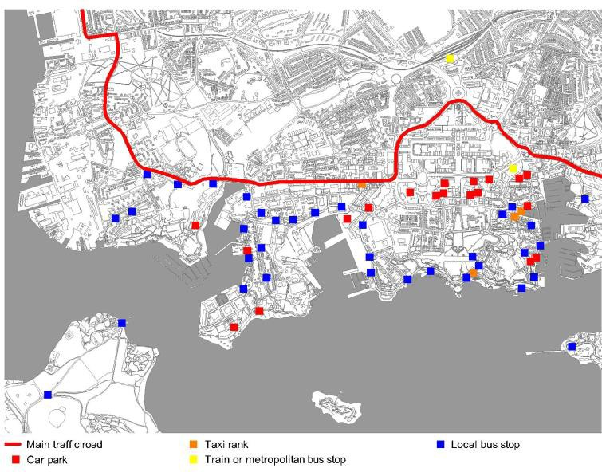
Image 1. External accessibility in Plymouth’s waterfront.
Source: the authors.

Internal mobility On the waterfront, there are various connections by ferry; all the services transport both pedestrians and bicycles. In general, bike lanes are not independent, but are shared with pedestrians or vehicles, although properly marked ((Image 2). It is possible to cross all the ports by bicycle or on foot following the urban section of the South West Coast Path, the national path that runs along the coast of South West England. To achieve the continuity of the trail, several unique works have been executed in recent years, such as the Sutton Harbor swing bridge, the Coxside and Stonehouse walkways and the stairs that connect Royal William Yard with Devil’s Point. Apart from the longitudinal route, pedestrians can enter through paths and stairs along practically the entire waterfront except in military and industrial areas. Achieving pedestrian access to the entire coastline above territorial or property divisions is a repeated objective in all regeneration policies since it was included in the Local Plan 1991-2001 (Plymouth City Council, 1996).

Image 2. Internal mobility in Plymouth’s waterfront.
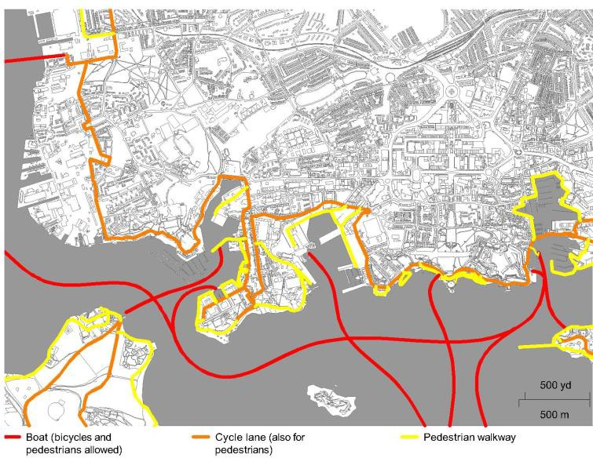
Source: the authors.

Activities. The mix of land uses has been an objective of municipal policies related to urban regeneration since the 1990s, as reflected in documents such as Tomorrow's Waterfront (Plymouth City Council, 1990), the Local Plan (Plymouth City Council, 1996) and The Vision for Plymouth (Plymouth City Council, 2003) (Image 3). Military activities are concentrated today in Devonport and The Royal Citadel. Although port uses such as shipyards, auxiliary industries, freight transport, and fishing do not have the weight of before and it is necessary to implement new ones, regeneration policies emphasize maintaining and creating jobs in these sectors, reserving adequate spaces for them in all ports. In Plymouth, there is the objective of promoting the tourist use of the waterfront, but without depending excessively on it. The City Council is aware of the failure of waterfront regeneration strategies based solely on tourism and leisure, as it is reflected in strategies such as Tomorrow's Waterfront (Plymouth City Council, 1990) and The Plymouth Local Economic Strategy 2006 - 2021 & Beyond (Plymouth City Council, 2011). Today, the Plymouth Waterfront Business Improvement District initiative is responsible for carrying out this mission. Tourist-commercial uses have been enhanced in two sensitive spaces: Royal William Yard and Sutton Harbor. Royal William Yard is an old military precinct of great heritage value, rehabilitated to house restaurants, exhibition halls, and homes. The place lacks the desired multifunctionality and has a uniform appearance, tending to the picturesque; however, it must be taken into account that it was built for a very specific use and since it was closed it remained unchanged. In Sutton Harbor, the old obsolete docks have been occupied by high-level residences, offices, and restaurants. Although there are tensions, tourist activities do not generally cause the exclusion of residents and heritage values and character of these areas are maintained. This is achieved thanks to the long-term negotiation effort among all the stakeholders involved, the joint treatment of the entire waterfront in municipal policies, and the commitment to events and promotion instead of aggressive and spectacular physical interventions (Blue Sail, 2011). We agree with Willey (1998) when he states that the city's tourism policies have placed emphasis on the development of the waterfront in a sustainable way and thinking about the future, in harmony with the environment and the aspirations of the local community.

Image 3. Activities in Plymouth’s waterfront.
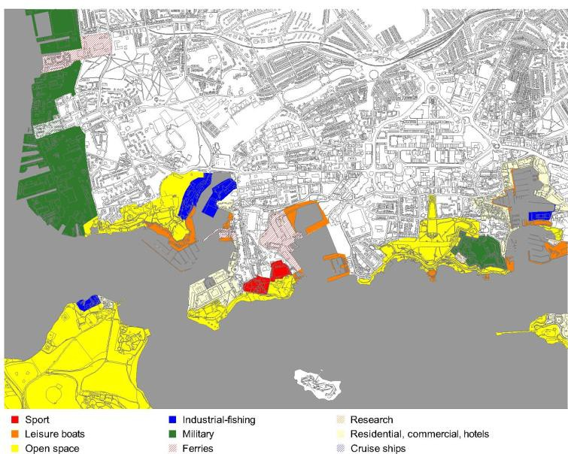
Source: the authors.
Heritage protection. As mentioned above, Plymouth’s tourist and economic growth policies always begin with a recognition of the cultural, natural, and landscape value of the seafront. These aspects are seen as a profitable resource while ensuring its conservation, as reflected in the Culture Board strategy (SERIO, 2011) to enhance artistic and creative activities in underused heritage buildings (Image 4). A relevant aspect is that the protection of heritage, whether built or natural, is not hampered by the ownership of the property, as reflected in the numerous listed assets located in the military base of Devonport, which is still in use. The reconversion operations for tourist, residential, and open space uses have integrated heritage, have maintained the line of contact with the sea, and have incorporated measures to improve environmental quality. In relation to built heritage, the ports of Plymouth present a great variety of listed assets, such as docks, walls, defensive elements and installations of all kinds. In addition, there is a wreck, several protected gardens and parks, and four Conservation Areas include sections of waterfront in their boundaries. Plymouth’s waterfront also houses a wide variety of ecosystems. The underwater area of Plymouth Sound has environmental protection, as well as several tidal plains and cliff sections. The open spaces of the seafront are part of the biodiversity protection system that crosses the entire city, connecting Plymouth Sound with Dartmoor National Park (Plymouth City Council, 2007). Finally, the intangible values associated with the ports, the so-called soft values, are central to the cultural life of the city and are reflected in its scientific research centers, economic and tourism development initiatives, and marketing strategies. The city brand “Plymouth, Britain’s Ocean City” synthesizes the close relationship that this city has with the sea.

Image 4. Heritage protection in Plymouth’s waterfront.
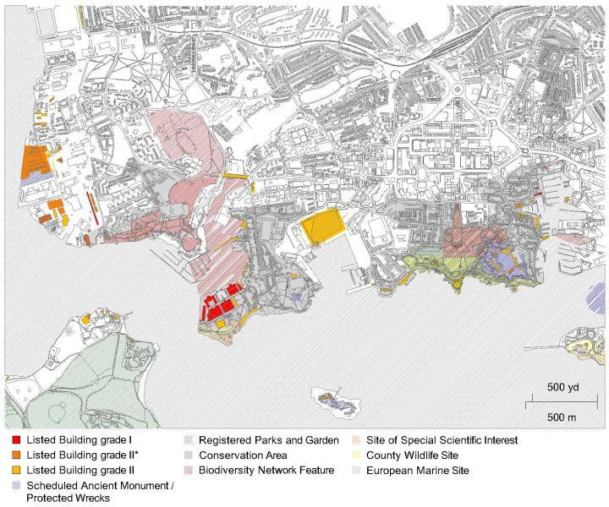
Source: the authors.

Integration in the urban context. We can consider that Plymouth’s waterfront is quite integrated with the rest of the city, meaning that the access from other neighborhoods is easy, there are not many interior barriers, the area has a socially inclusive character, it is used intensely, and there are not particularly restrictive regulations (Image 5). The areas where unauthorized access to citizens is prevented are Devonport military base and the shipyard and fishing facilities. In contrast, in Sutton Harbor the waterfront is treated as a neighbourhood’s main street, fully integrated in the land uses, architecture, and character of the surroundings.

Image 5. Integration in the urban context in Plymouth’s waterfront.

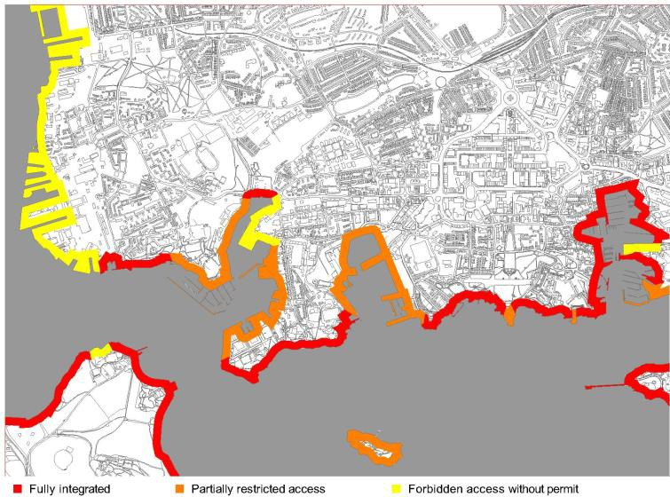
Source: the authors.

Case study: Malaga
External accessibility. Malaga has a main road that acts as a barrier between the seafront and the rest of the city. Since it was decided to promote tourist-commercial uses in the port, proposals to reduce this barrier have been followed, especially at Pier 2. These include the tunnelling of Paseo de los Curas and the creation of an elevated platform in Plaza de la Marina, which was part of the winning proposal for the remodeling of Pier 2 (Image 6). None of these solutions has been carried out, nor was it a simpler one that would have been to eliminate the fence on Pier 2, complying with the historical demand of the citizens, introducing measures to calm traffic on Paseo de los Curas and promoting the connection with the Alameda and Paseo del Parque, where almost all bus lines stop. In fact, the solution applied was in the opposite direction, an underground car park was created under Pier 1 and a new traffic lane on Paseo de los Curas was created. On the other hand, the new promenade of Pier 2, the so-called Palmeral de las Sorpresas, rose 1.5 m above the level of the pier and Paseo de los Curas, making it necessary to maintain the fence due to the risk of falls. As a result, the port is not accessed on an ongoing basis but through wide gates. The physical separation of the port and the rest of the city is the realization of the division and the lack of coordination between the administrations involved when planning these spaces. In fact, the Local Urban Plan does not fully enter the port and derives this space to a Special Plan in which the Port Authority, the Andalusian Government and the Spanish Government intervene.

Image 6. External accessibility in Malaga’s waterfront.
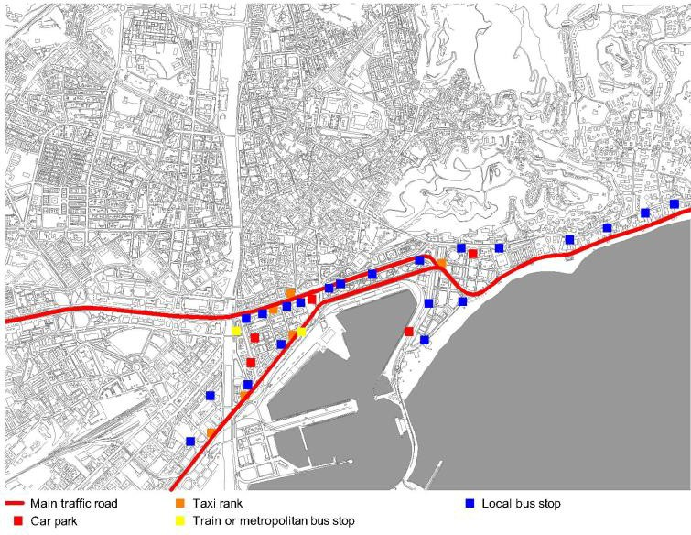
Source: the authors.

Internal mobility The only fully accessible pedestrian pier is Pier 1, where an open shopping centre has been installed. In the Eastern Pier, two levels have been created, it is only possible to walk through the upper one until a gate is reached that allows only cruise passengers and staff to pass through (Image 7). Two levels have also been created at Pier 2, pedestrians can walk along the upper one while the pier itself is reserved for luxury cruise ship docking. From the entrance of Plaza de la Marina to the west it is possible to drive along the main road but it is not allowed to access the rest of the port facilities. Bicycles have it even more complicated than pedestrians, since in the tourist-commercial area there are no bike lanes. In much of the rest of the port area it is forbidden to go by bike. Pedestrian and bicycle mobility within the port has worsened after the tourist-commercial adaptation of the eastern sector. Before, cyclists and pedestrians could circulate easily because there were few people going for a walk or riding on the docks. Today, fences, prohibition signs, police control, and security cameras have multiplied to prevent visitors from leaving the area defined for them. This situation is possibly due to the safety requirements, discussed above, although we have also mentioned how there is an interpretation component so that these requirements can be balanced with the ease of transit. This situation has led to results as extravagant as preventing citizens from accessing the final stretch of the Eastern Pier, from which one of the best views of the city can be enjoyed, or that people arriving from the city centre to the port they find that the access to the pier is forbidden and they must look at it behind a screen.

Image 7. Internal mobility in Malaga’s waterfront.
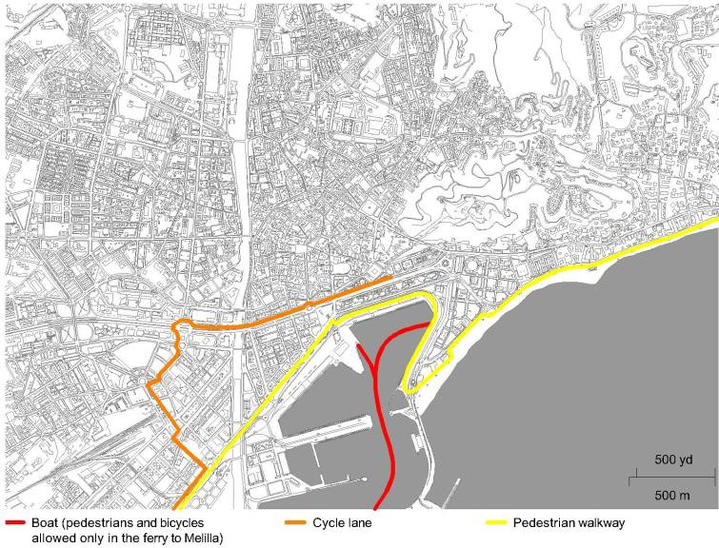
Source: the authors.

Activities. In the western sector, industrial activities, fishing and ferries are maintained. Cruise ships dock at the Eastern Pier. Pier 1 is an area of restaurants, clothing and accessories stores and Pier 2 consists of a luxury cruise ship dock and a promenade with gardens, restaurants, a museum, the luxury cruise terminal and an administrative building (Image 8). The interest in converting part of the port and achieving greater integration with the rest of the city began after the construction of the Cartagena-Puertollano pipeline, which left the Malaga terminal obsolete. The objectives were reflected in the Port Special Plan, whose elaboration began in the 1980s. In 2004 an agreement was reached between the City Council and the Port Authority for the regeneration of piers 1 and 2. Unlike the Plymouth case, the transformation of the port of Malaga to boost tourism-commercial activities has not been balanced with a recognition of the importance of the actual port activities and an effort to make them more present in the life of the city. There are also hardly any auxiliary industries such as ship repair or scientific research. Rather it has been decided to hide the marine life. On piers 1 and 2 virtually any trace of its port past has been removed, these activities taking place hidden from the eyes of the passersby behind a fence. The separation of uses is due to the division between administrations, already commented, to the decision to take out the different piers to tender independently, and in general to the search for private benefit over other interests. In general, the Malaga’s waterfront is characterized by the determinism of its spaces. Each section is designed to house practically a single function and these are physically segregated. In addition, there are no uses at the waterfront that attract citizens beyond when they behave like tourists in their leisure time. Finally, specific regulations for the tourist-commercial area of the port have contributed to the rigidity and artificiality of the spaces. Among other aspects, it is forbidden to sell and consume drinks and food except inside the authorized premises and their open-air sitting places. It is also forbidden to go on roller skates, skateboards and the like, play in the fountains or lie on the benches and a permission is needed to perform music and art performances.

Image 8. Activities in Malaga’s waterfront.
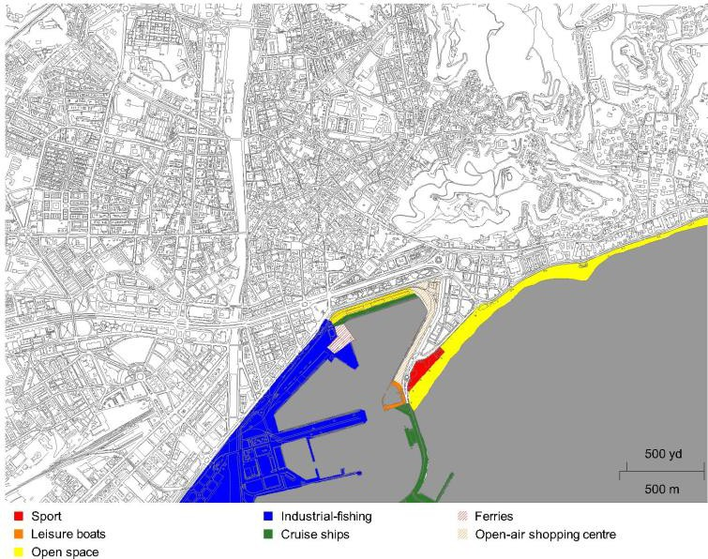
Source: the authors.

Heritage protection. Malaga’s waterfront is very poor in terms of cultural assets and protected natural areas. A factor that explains this situation is its historical evolution reclaiming land to the sea, which has resulted in the fact that the Customs House or the historic wall today are inland (Imagen 9). Another cause is again the division and lack of agreement between administrations, since the Andalusian Government cannot list assets assigned to services managed by the Spanish Government and this has scarcely exercised its functions in this regard. In this sense, the port enclosure was part of the delimitation of the Historical Heritage Area, but in the 2012 modification it was left out. As a result, the only listed asset is the chapel of the Virgen del Puerto. Due to this situation, the remodeling of the tourist-commercial area meant the loss of the silo, warehouses, cranes, other port facilities, pavements, and even the ships. The demolition of the silo became the symbol of the loss of port heritage, which could well have been converted to house a cultural use, following examples such as those in Antwerp and Hamburg. In the tourist-commercial area there is
practically nothing to remember that we are in a port, rather it is an open shopping centre and a promenade with gardens that could have been created anywhere else. The opportunity was lost to integrate this legacy for the knowledge of residents and visitors and to use it so that the immaterial values of marine life became part of the city's identity, an objective that was part of the II Strategic Plan of the city (Malaga City Council, 2006), but which, as we have seen, did not apply.

Image 9. Heritage protection in Malaga’s waterfront.
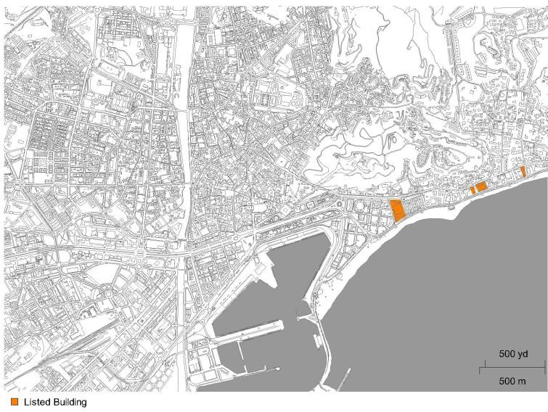
Source: the authors.

Integration in the urban context. We can consider that the integration of the port with the rest of the city is quite improvable. The tourist-commercial area of the port is partially accessible. It is not possible to go to the Boat House of the Mediterranean Club or to the cruise ships pier without authorization (Image 10). The Eastern Pier was redesigned as a road. Pier 1 was rebuilt as an open-air shopping centre, such as the one in the immediate vicinity of the airport, with corporate image, ambient music, private security, and organization of events. Pier 2 is divided into the pier itself, only for passengers, and the garden, raised and separated from the pier by a screen and from Paseo de los Curas by a fence. These gardens have acquired a certain condition of a backyard as the organization of the space makes people be guided towards the longitudinal walk. In the tourist-commercial port, users are encouraged to act in accordance with the intended uses and not to go beyond the permitted areas, creating an environment of artificiality and a socially exclusive character, more typical of a shopping centre than of a city. As a reaction to the “danger” that the increase of people walking can entail, new fences and controls have been installed in the rest of the port, inviting pedestrians and cyclists not to continue there; as a result, the port in operation has moved away even more from the rest of the city. In the port reconversion operation there is a lack of global planning that results in rigid pieces, unconnected to each other, outside their environment and impossible to trespass without authorization. In addition, the recognition of the heritage value of the port is pending, as well as the integration of port activities in the life and identity of the city.

Image 10. Integration in the urban context in Malaga’s waterfront.
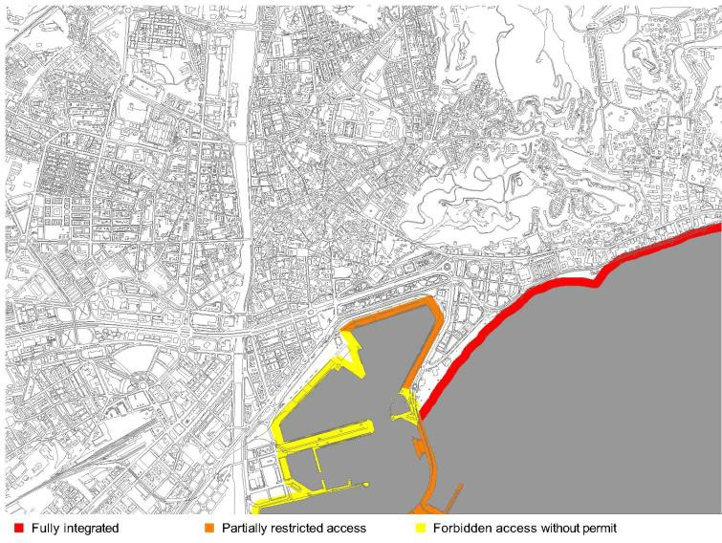
Source: the authors.

Conclusions
Tourist activities have become an alternative to the obsolescence of port facilities. However, the physical transformation operations of these sectors carry important challenges related to public policies. Firstly, the interest of the tourism sector must be combined with urban planning and cultural policy to achieve fully planned spaces where not only economic activity is encouraged but also integration with the rest of the city, the maintenance of compatible port activities with the new uses, and the conservation of the port heritage. The most successful renovation projects are those that combine economic exploitation with other citizen uses that are not measured by their profitability but, instead, achieve greater identification of residents with their port and greater support for renovation projects. In this sense, among the cases analyzed, the contrast of the Plymouth model, inclusive and flexible, stands out when it houses many activities simultaneously, compared to the Malaga model, which rigidly segregates the spaces according to each specific activity.
The generalization of this type of projects throughout the world has made tourist ports lack singularity on many occasions. To avoid this risk, it is advisable to enhance local values, especially highlighting heritage and soft values. In a context of global economic competition, the roots of projects in these components allow a differentiation of cities and a greater integration of the new tourist port into local history and culture. Another complicated factor in the renovation of ports is to combine the growing security requirements with the ease of transit. This is possibly one of the biggest challenges for cities that wish to carry out operations of transformation of their port facilites in the coming years. Likewise, in a context of changing paradigms of mobility and the fight against climate change, guaranteeing sustainable mobility to the waterfront and along it is already one of the main objectives in the tourist adaptation of ports.

References
Alemany Llovera, J. (2009). Dossier: cruceros, puerto y ciudad. Portus, 17, 4-5.
Alemany Llovera, J. (2005). El frente marítimo, entre el urbanismo y la planificación portuaria. Portus, 10, 2-3.
Ashworth, G., & Tunbridge, J. E. (2000). The tourist-historic city. Retrospect and the prospect of managing the heritage city. Oxford: Pergamon.
Malaga City Council. (2006). Málaga, metrópoli abierta. II Plan Estratégico. Malaga: Fundación CIEDES.
Blue Sail. (2011). Plymouth Visitor Plan, report for Destination Plymouth.
Estrada Llaquet, J. L. (2006). Las exigencias de protección obligan a un cambio cultural de la explotación portuaria y de las relaciones puerto-ciudad. Portus, 11, 12-17.
Gunay, Z., & Dokmeci, V. (2012). Culture-led regeneration of Istanbul waterfront: Golden Horn Cultural Valley Project. Cities, 29, 213-222.
Howard, P, & Pinder, D. (2003). Cultural heritage and sustainability in the coastal zone: experiences in south west England. Journal of Cultural Heritage, 4, 57-68.
Law, C. M. (1996). Urban tourism. Attracting visitors to large cities. London: Mansell Publishing.
Pinder, D., & Smith, H. (1999). Heritage and change on the naval waterfront:opportunity and challenge. Ocean & Coastal Management, 42, 861-889. Plymouth City Council. (2003). A Vision for Plymouth. Final copy.
Plymouth City Council. (1996). City of Plymouth Local Plan 1991-2001. First alteration.
Plymouth City Council. (2007). Local Development Framework, Core Strategy. Plymouth City Council. (2011). Plymouth Local Economic Strategy 2006 – 2021 & Beyond. Appendices.
Plymouth City Council. (1990). Tomorrow’s waterfront: a strategy for Plymouth waterfront.
Rivera Mateos, M. (2010). Los puertos deportivos como infraestructuras de soporte de las actividades náuticas de recreo en Andalucía. Boletín de la Asociación de Geógrafos Españoles, 54, 335-360
Serio, J. (2011). Culture and regeneration: opportunities for Plymouth. Plymouth: University of Plymouth.
Van Hooydonk, E. (2009). Port city identity and urban planning. Portus, 18, 16-23, 2009.
Ward, S. V. (2006). Cities are fun! Inventing and spreading the Baltimore model of cultural urbanism. In J. Monclús y M. Guardia, M. (eds.). Culture, urbanism and planning (pp. 271-286). Aldershot: Ashgate.
Warsewa, G. (2012). The role of local culture in the transformation of the port-city.
Portus, 23, 1-13.
Willey, D. (1998). Two tales of one city: alternative accounts for leisure and tourism in urban renewal in Plymouth, England, UK. World Leisure & Recreation, 40(2), 22-29.
Williams, R. J. (2004). The anxious city. New York: Routledge.

Professor and Researcher at the Autonomous University of Oaxaca "Benito Juárez. Faculty of Architecture “5 de Mayo”, Mexico. Email: barrera.uabjo@gmail.com Id. Orcid: https://orcid.org/0000-0002-2670-5370 * Corresponding author.
Professor and Researcher at the Faculty of Architecture of the Autonomous University of Oaxaca "Benito Juárez", Mexico. E-mail: escampa.uabjo@gmail.com Id.Orcid: https://orcid.org/0000-0002-4741-410X
Technical Architect and Autonomous Professional. Faculty of Edification Ingeneering, University of Seville, Spain. E-mail: egbachiller@gmail.com. https://orcid.org/0009-0004-9049-3298

