Reseña bibliográfica/Bibliographic Review

Overtourism. Causes, Implications and Solutions
H. Séraphin
Business School, University of Winchester, Winchester, UK
e-mail: Hugues.seraphin@winchester.ac.uk

T. Gladkikh
AFG College, University of Aberdeen, Doha, Qatar
e-mail: Tatiana.gladkikh@winchester.ac.uk

T. Vo-Thanh
Excelia Group, La Rochelle Business School, La Rochelle, France
e-mail: vothanht@excelia-group.com

E-book “Overtourism”.

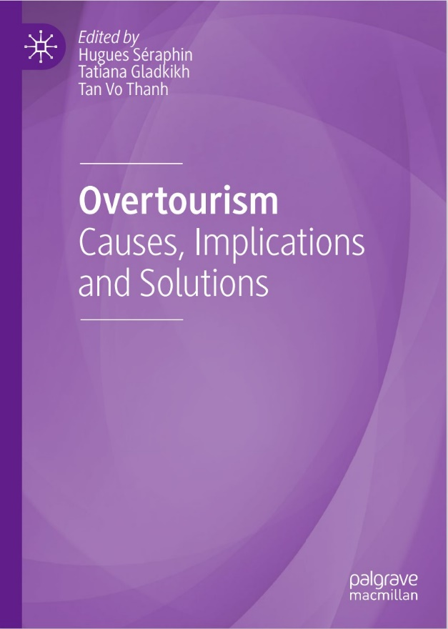

The concept of sustainability is getting ground in tourism as we are more and more aware of the negative impacts of the industry on the environment and local communities. A destination is considered to be sustainable if responsible actions are taken in order to ensure that the tourism industry does not impact negatively on the locals, interactions between locals and visitors and on the environment. It is equally important that all three of these areas benefit from tourism. This is all the more important as visitors are more and savvier of sustainability not only in their daily life but also when going on holiday. The industry, therefore, needs to follow the path to meet their needs. Consequently, private and public sector organisations are putting in place strategies to reduce their negative impacts and maximise their positive contributions. Education providers are also taking the path of sustainability by incorporating sustainable/ responsible tourism modules in their curriculum. Imbedding Principles of Responsible Management Education in the curriculum is a specific example of strategy adopting by some institutions in order to achieve Sustainable Development Goals (Séraphin and Nolan 2019).

Overtourism, Related Perverse Impacts and Strategies

Overtourism is ‘the excessive growth of visitors leading to overcrowding in areas where residents suffer the consequences of temporary and seasonal tourism peaks, which have enforced permanent changes to their lifestyles, access to amenities and general well-being’ (Milano et al. 2018 cited in Dodds and Butler 2019:1). Overtourism is a worldwide issue that is impacting destinations from different parts of the world (Milano et al. 2019). In Europe we could mention Venice (Visenti and Bertocchi 2019); in South-America, Costa Rica (Canada 2019); in Asia, Kyoto (Abe 2019); in the Indian Ocean, Australia (Canosa et al. 2019) and so on. The strategies suggested to tackle overtourism are all industry related and are all about immediate actions. For instance, Gretzel (2019) suggests the use of social media to address the issue. Cruz and Legaspi (2019) have identified the closing of popular natural sites. Joppe (2019) stresses the development and implementation of policy, planning and governance as a solution.

This edited book takes a step further by proposing another H. Séraphin et al. 3 non-tourism industry approach, namely tourism education, which also suggests long-term return on investments regarding the impacts of this strategy. Education of the future generation of leaders and tourists is extremely important as they have an important part to play in the longterms sustainability of the industry (Poria and Timothy 2014; Radic 2019; Séraphin and Yallop 2019a, b).

The Structure of the Book

This book serves to provide tourism academics, students (and even practitioners) with examples of potential strategies from a range of tourism organisations and contexts. Each chapter is unique and offers practical solutions that could be implemented by Destination Marketing Organisations (DMOs) and Companies, but also by other type of tourism businesses. The structure of this book reflects the Janus-faced character of tourism (Sanchez and Adams 2008; Séraphin 2012) by considering it as an industry and as a field of study. Indeed, the strategies suggested by the book are both industry (Part I and Part II) and education related (Part III). Part I reframes overtourism as a field of research. Indeed, chapter “Overtourism: Definitions, Enablers, Impacts and Managerial Challenges” provides an overview of the evolution of overtourism as a concept highlighting its enables and its impacts, and then discusses the resulting managerial challenges.

Chapter “Overtourism in Rural Areas” reviews the issue of overtourism in rural areas and identifies key characteristics and impacts of the phenomenon in non-urban settings. Chapter “Between Overtourism and Under-Tourism: Impacts, Implications, and Probable Solutions” highlights the discrepancy between destinations in terms of popularity with visitors. On the one hand, there is a growing number of destinations which are receiving too many tourists (overtourism) while on the other hand, there is quite a number of destinations which are struggling to receive their share in the tourism market (under-tourism). This chapter, therefore, investigates the impacts and implications of overtourism and under-tourism and proposes a number of solutions. Chapter “The Construction of ‘Overtourism’: The Case of UK Media Coverage of Barcelona’s 2017 Tourism Protests and Their Aftermath” considers the way ‘overtourism’ has rapidly become an established part of the lexicon in Introduction 4 critiques of tourism. Its premise is that the term is more of an orientation towards problems rather than a description of those problems per se. As for chapter “Tourist Tracking Techniques as a Tool to Understand and Manage Tourism Flows”, its aim is to discuss the importance of using tourist tracking techniques to gather data which tourism managers could use to address overtourism issues. And finally, chapter “Case Study 1: Overtourism in Valletta—Reality or Myth?” sets a clear context for establishing criteria for a destination to be considered overvisited. Taking Valletta as a case study, the purpose of this chapter is to consider whether or not this destination is subject to overtourism. Part II focuses on initiatives taken by different stakeholders to tackle overtourism and related perverse impacts. Thus, chapter “Tackling Overtourism and Related Perverse Impacts Using DMO Website as a Tool of Social Innovation” illustrates how DMOs could use their websites as a tool for social tension mediation. As for chapter “Overtourism: How the International Organisations Are Seeing It?”, its aim is to show the ambiguities of four key international organisations, UNWTO, UNESCO, OECD and WTTC, in their information (and strategies) concerning overtourism. Chapter “Overtourism at Heritage and Cultural Sites” provides an overview of the negative impacts associated with overtourism on heritage and cultural sites, as well as best practices utilised by establishments around the world to combat this issue. Chapter “Overtourism: Creative Solutions by Creative Residents” highlights the challenge faced by academics and practitioners. Indeed, overtourism is currently a topic of high interest to tourism researchers and stakeholders as tourism growth in city centres is causing social effects perceived as negative by some residents as it impacts their quality of life. Tourism scholars and stakeholders are challenged to develop policy to address this perceived excessive number of visitors. Some options previously discussed include diverting tourist flows to less frequently visited areas and preventing tourist actions perceived as misbehaviour. Chapter “Case Study 2: Broadly Engaging with Interaction Between Visitors and Locals—Towards Understanding Tourismphobia and Anti-tourism Movements ” conceptualises the idea of “tourismphobia” by exploring the interactions between visitors and locals in the context of overtourism in order to understand the growth of anti-tourism movements. Finally, chapters “Case Study 3: “Overtourism” on Scotland’s North Coast 500? Issues and Potential Solutions”, “Case H. Séraphin et al. 5 study 4: Overtourism—The Case of the Palace of Versailles,” and “Case Study 5: A Paradox of the UNESCO “World Heritage” Label? The Case of the Way of St James of Compostela in France” offer case studies. Chapter “Case Study 3: “Overtourism” on Scotland’s North Coast 500? Issues and Potential Solutions” explores the phenomenon of “overtourism” in relation to the North Coast 500 (NC500)—a hugely popular “road trip” route around Scotland’s Northern Highlands—and to highlight potential solutions. Chapter “Case study 4: Overtourism: The Case of the Palace of Versailles” focuses on Versailles where the Palace of Versailles (known in France as the Chateau de Versailles), with eight million visitors a year, faces a problem of overtourism. The heritage is threatened and the public reception conditions may deteriorate, therefore the chapter aims to determine a management model of overtourism in order to tackle the issue. As for chapter “Case Study 5: A Paradox of the UNESCO “World Heritage” Label? The Case of the Way of St James of Compostela in France”, its objective is to highlight the paradox of labelling in the tourism field by adopting the perspective of sustainable tourism. Indeed, if the label helps to save tourist sites by a lack of notoriety and therefore attendance, it causes inconvenience related to overtourism. This is particularly the case of the “World Heritage of UNESCO” label. In fact, by definition the tourist sites benefiting from this label are fragile or even threatened, but the labelling can generate an over-satisfaction damaging to the sustainability of the site in question. Part III, the third and final section of the book, presents ‘tourism education’ as a strategy for tackling overtourism. Chapter “ABC of Overtourism Education” aims to address the gap in literature on utilising tourist education to address overtourism. It introduces the concept of overtourism education (OE) defined as the process of increasing awareness among tourists about how their behaviours and choices could alter the sociocultural and environmental aspects of the destinations that they visit. Chapter “PRME: The Way Forward to Deal with Overtourism and Related Perverse Impacts” reflects the importance of management education in managing the impacts of overtourism through the application of six elements of United Nations Principles of Responsible Management Education (PRME). This is a platform, which provides guidelines and a learning network in order to transform curriculum, research and pedagogy, and therefore develop responsible attitude amongst students. Introduction 6 Chapter “Education as a Strategy to Tackle Over Tourism for Overtourism and Inclusive Sustainability in the Twenty-First Century” offers a debate on the pros and cons of employing education to mitigate the negative impacts of Overtourism. In doing this, the authors approach the phenomenon in all its dimensions and complexity. Chapter “Education as a Way to Tackle Overtourism: The Application of the Principles of Responsible Management Education (PRME)” aims to provide an additional perspective to how PRME could be used by practitioners towards achieving the SDGs, while dealing with the issue of overtourism through education. Chapter “Case Study 6: Mainstreaming Overtourism Education for Sustainable Behavioral Change in Kenya’s Tourism Industry Context” is a case study that examines Kenya’s tourism management education pedagogies and sustainable tourism curricula design for sustained behavioral change in Kenya’s tourism sector. It also explores how overtourism education can be mainstreamed and be implemented in the current tourism education pedagogy in Kenya. Last but not least, chapter “Case Study 7: Principles of Responsible Management Education as a Tool to Tackle Overtourism—Potentials and Limitations for the University of Catania”, taking Catania (Italy) as a case study, adopts a similar stand to chapter “Case Study 6: Mainstreaming Overtourism Education for Sustainable Behavioral Change in Kenya’s Tourism Industry Context”.

