The Impact of Managing Carbon Footprint Reduction and Sustainable Development in Airports on Tourism Revenues
El impacto de la gestion de la sostenibilidad y la reducción de la huella de carbono en los aeropuertos en los ingresos por turismo

Asmaa Ali Shogaa
Usama Basiony
Zaki Zaki Abu Refaie

Abstract
The objective of this study is to enhance policy and regulatory frameworks for airport operations and improve environmental quality at airports in preparation for the upcoming Green Airport initiative. Additionally, the study aims to support airports in achieving their environmental and governance goals, including net-zero targets. So, the Risk of Climate Change should be mitigated at airports to keep both the tourism environment and sustainable development. In addition, providing the Egyptian aerodromes with the preliminary guidelines for the preparation of the relevant Carbon Footprint to avoid any potential problem, explains the different technology for sustainable development and, providing the optimum solutions to manage the data used are primary and secondary data. The main objectives of this study are the sustainability of Egyptian airports. Sharm El-Sheikh International Airport was chosen as a model airport, and it is one of the most important airports in Egypt. The process of analyzing carbon footprint data to reduce it with green techniques and technology that are beneficial to tourists and compared to 2022, after using sustainable methods and technology, this resulted in reducing the carbon footprint of the airport and increasing green tools and technology for tourists. While secondary data is based on data collected from various agencies. In general, the study results show that the airport operator has given enough attention to the environmental management., The adoption of the Green Airport concept can provide airport operators with a sense of reassurance in managing airports, allowing them to improve their operational and environmental quality control systems. The Green Airport concept serves as a model for airport operators to ensure that their activities do not have adverse effects on the environment. Implementing the Green Airport concept can lead to an improvement in environmental quality, while significantly reducing environmental management costs. huge efforts regarding any issues related to impact of Climate Change at Airports, Tourism Environment and Sustainable Development are still yet to come; as well as increasing the research and development endeavor has in order to find the best ways and means to ensure a safe and clean sky to fly.
Keywords: Green Airport, Environmental Quality, Airports Carbon Accreditations, Carbon Calculator, Footprint Airports.

Resumen
El objetivo de este estudio es mejorar los marcos normativos y regulatorios de las operaciones aeroportuarias, así como la calidad ambiental en los aeropuertos de cara a la implantación dr la iniciativa internacional “Aeropuerto Verde”. Además, el estudio persigue ayudar a los aeropuertos a lograr sus objetivos ambientales y de gobernanza, incluidos los objetivos de emisiones netas cero. El riesgo de cambio climático debe mitigarse en los aeropuertos para mantener tanto el entorno turístico como el desarrollo sostenible y en el caso de los aeródromos egipcios conviene definer unas directrices preliminares para la medición de la Huella de Carbono correspondiente para evitar cualquier problema potencial, explicar las diferentes tecnologías aplicables para el desarrollo sostenible y proporcionar las soluciones óptimas para gestionar la información y datos primarios y secundarios disponibles para el aseguramiento de la sostenibilidad de los aeropuertos egipcios. El aeropuerto internacional de Sharm El-Sheikh fue elegido como aeropuerto modelo y es uno de los aeropuertos más importantes de Egipto. El proceso de analizar los datos de la huella de carbono para reducirla con técnicas y tecnología verdes que sean beneficiosas para los turistas y en comparación con 2022, luego de utilizar métodos y tecnología sostenibles, ha de conducir a la reducción de la huella de carbono del aeropuerto y aumentar las herramientas y tecnología verdes para los turistas. En general, los resultados del estudio muestran que el operador aeroportuario ha prestado suficiente atención a la gestión ambiental y la adopción del concepto de Aeropuerto Verde puede proporcionar a los operadores aeroportuarios una sensación de tranquilidad en la gestión de los aeropuertos, permitiéndoles mejorar la calidad operativa y ambiental de sus sistemas de control. El concepto de Aeropuerto Verde sirve como modelo para que los operadores aeroportuarios garanticen que sus actividades no tengan efectos adversos sobre el medio ambiente, pudiendo conducir a una mejora de la calidad ambiental, al tiempo que reducir significativamente los costos de gestión ambiental. En cualquier caso, aún están por llegar unos mayores esfuerzos en relación con cualquier cuestión relacionada con el impacto del cambio climático en los aeropuertos, el medio ambiente turístico y el desarrollo sostenible, por lo que ha de incrementarse el esfuerzo de investigación y desarrollo con el fin de encontrar las mejores formas y medios para garantizar un cielo seguro y limpio para volar.
Palabras claves: Aeropuerto Verde, Calidad Ambiental, Acreditaciones de Carbono en Aeropuertos, Calculadora de Carbono, Huella Aeroportuaria.

Introduction
Airports are a vital infrastructure for the tourism industry, playing a major role in facilitating the movement of tourists and goods. However, airports are also a significant source of carbon emissions that have a significant impact on the environment, and consequently on the tourism industry. Therefore, managing carbon footprint reduction and sustainable development in airports is necessary to ensure sustainable development and maintain tourism revenues. This article aims to study the impact of managing carbon footprint reduction and sustainable development in airports on tourism revenues.
The tourism industry is one of the largest industries in the world and heavily relies on transportation, especially air travel. However, air travel is a major contributor to carbon emissions, which have a significant impact on the environment. Therefore, reducing carbon emissions and managing carbon footprint reduction in airports is a crucial step towards sustainable development and maintaining tourism revenues. Managing carbon footprint reduction and sustainable development in airports includes using renewable energy sources, improving energy efficiency, promoting sustainable transportation, reducing waste, managing water consumption, and other sustainable practices.
The impact of managing carbon footprint reduction and sustainable development in airports on tourism revenues has been explored in many studies, and the results have shown that implementing sustainable practices in the aviation industry can improve the competitiveness of the tourism industry and increase tourism revenues. It can also attract more environmentally conscious tourists who prefer sustainable travel. Additionally, airports that implement sustainable practices can achieve increased passenger satisfaction and loyalty, ultimately leading to improved tourism revenues.
Helsinki Airport in Finland provides a good example of managing carbon footprint reduction and sustainable development in airports, achieving carbon neutrality by 2020 and implementing many sustainable practices in the airport. This has ultimately led to an improvement in tourism revenues in Finland, attracting more environmentally conscious tourists who prefer sustainable travel.
Overall, managing carbon footprint reduction and sustainable development in airports can improve the competitiveness of the tourism industry and make it more attractive to environmentally conscious tourists. It can also lead to increased passenger satisfaction and loyalty, ultimately leading to improved tourism revenues. It is important for airports, airlines, and governments to collaborate to achieve the common goal of sustainable development and carbon emission reduction in the aviation and airport industry. This can contribute to achieving economic, social, and environmental benefits for local and global communities.
It is also important to educate tourists and travelers about the importance of sustainable travel and how they can contribute to reducing carbon emissions by choosing sustainable tourism destinations and using environmentally friendly transportation. Overall, managing carbon footprint reduction and sustainable development in airports is crucial for ensuring the sustainability of the tourism industry and increasing its revenues. This step is also important for achieving sustainable development goals related to environmental preservation and carbon emission reduction. Through joint efforts, these goals can be achieved and tourists and travelers can be educated on the importance of sustainable travel and how to achieve it.
While certain aspects of an airport's carbon footprint may seem beyond control, there are effective ways to make a positive impact. Here are our top 5 tips for significantly reducing the carbon emissions of your airport.
- Priorities Sustainable Transport
There are many vehicles involved in day-to-day airport operations, from passenger shuttle buses to runway vehicles and ground handling equipment. Replacing your fleet with electric, hybrid, gas, or even biomass powered alternatives will drastically reduce this aspect of your carbon footprint.
You could also look to influence passenger behavior by prioritizing sustainable transport to and from the building. This might include providing regular and reliable shuttle buses, installing electric charging hubs, developing public transport links, and providing preferential access to electric or low carbon fuel powered taxis. You could also increase the cost of parking on site and use the extra profits to invest in sustainable initiatives or offset schemes.
- Use Energy Efficient Lighting
Airports need to be well-illuminated and comfortable for occupants, but inefficient lighting can be a key contributor to energy consumption and therefore emissions. To tackle this problem, consider replacing lighting throughout the building with LED bulbs which require far less energy to function whilst providing more than adequate illumination. Outside the building, runway signage and other exterior lighting can also be replaced with LEDs. To avoid disruption, it might be best to undertake this replacement over a period of time, in several stages.
- Choose Green Managed Growth
Our next tip is to aim for green managed growth. Of course, every airport business wants to expand and scale up over time, but this doesn’t have to come at the expense of the environment. Green managed growth is essentially about compensating for expansion at all stages of growth. This might mean installing green roofs, planting onsite in a way compatible with aviation, or offsetting with a local focus – tree planting in your area or investing in sustainable initiatives for your community, for example.
Of course, when it comes to the physical expansion of your site, this can be sustainable too. Using recycled, organic, or natural materials to construct your building will mean the project has a significantly lower carbon footprint. The new expansion should also be designed to limit heating and air conditioning requirements, with any HVAC usage that is required monitored and managed automatically by advanced AI.
- Invest in Sustainable Energy
Many airports are cutting their carbon footprint through addressing the problem at its source. Changing the energy used to power your building entirely is tricky and may require a large investment, but reducing your reliance on fossil fuels even a small amount is useful. This can be done through changing energy provider or generating renewable energy onsite using solar panels, for example. Heathrow airport has reported being powered by 100% renewable electricity, and since 2018, Terminal 2 has been heated by biomass or renewable gas. In other parts of the world, Cochin International Airport in India is renowned for being the first solar airport, powered by 46,000 solar panels.
- Optimize Building Management Systems
In 2018, Heathrow Airport's utilities generated 23,604 tons of CO2 emissions, and other airports around the world report similar levels of emissions. Therefore, improving the management of building management systems is essential for sustainable airport operations. A smart technology solution for addressing this issue is optimizing HVAC system performance through the use of AI. AI-optimized HVAC systems can proactively respond to changes in environmental conditions, taking into account building construction materials and occupancy rates. With the power of AI, airport buildings can decrease their energy usage by up to 30%. Additionally, airports experience more extreme thermal peaks and troughs than other buildings due to irregular surges of occupancy in different areas. AI can combat this issue by responding to environmental conditions in real-time, restoring user comfort when pre-programmed HVAC systems fail.
- Reduce Your Airport’s Carbon Footprint with Arloid a smart technology solution for reducing carbon emissions in airports. By utilizing AI trained with Deep Reinforcement Learning, Arloid has successfully assisted airports of different sizes in reducing their utility bills by optimizing HVAC performance. Our advanced AI technology is highly efficient and precise, enabling you to limit the environmental impact of your airport building while enhancing passenger comfort.

Definition of Managing Carbon Footprint:
Carbon footprint is the total amount of greenhouse gas emissions, specifically carbon dioxide (CO2), associated with an individual, organization, event, or product. It is a measure of the impact that human activities have on the environment in terms of the amount of greenhouse gases produced, and is usually measured in units of carbon dioxide equivalent (CO2e). Carbon footprint takes into account all the emissions produced directly and indirectly, such as those from transportation, energy consumption, and waste disposal. The goal of measuring and reducing carbon footprint is to mitigate climate change by reducing greenhouse gas emissions and promoting sustainability.
- Managing carbon footprint refers to the process of measuring, reducing, and offsetting the amount of carbon emissions produced by an organization, industry, or individual. It involves implementing strategies and practices that minimize the carbon footprint, which is the total amount of greenhouse gas emissions generated by human activities, including transportation, energy production, and industrial processes. Managing carbon footprint usually involves a combination of reducing energy consumption, using renewable energy sources, improving energy efficiency, and implementing carbon offset programs. The goal of managing carbon footprint is to reduce the impact of human activities on the environment and mitigate the effects of climate change.

Approach & Proposed Solution:
In the current study, an integrated system to Managing Carbon Footprint Reduction and Sustainable Development in Airports on Tourism Revenues. without negative impact on environmental tourism, climate change through follows up to record carbon footprint yearly strategy, draft an effective management plan, and apply such pattern at aerodromes.
I proposed the following steps to enforce an effective solution (Figure 1):
- Personnel assignment.
- Collecting and recording the data of Air quality station.
- Data analysis and assessment.
- A mount of greenhouse gases (GHG) Emitted directly or indirectly by a person, product, company or organization.
- Managing Carbon Footprint Reduction and Sustainable Development in Airports on Tourism revenues.
- Carbon footprint Monitoring & management System by used Airports Carbon Calculators.

Figure 1: Proposed solution
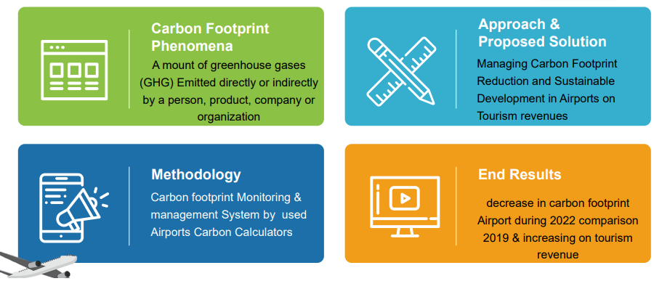

Main objective study
Provide the Egyptian aerodromes with the preliminary guidelines for the preparation of Carbon footprint Airports to avoid any potential problem without Impact on Biodiversity, Climate change & Tourism revenue. 2. Create a database that briefly enumerate and explains the different of source electric and its Consumption, respectively to help of control climate change.
The main significant contribution the study makes is achieving the Win-Win situation strategy between both processes,
- ecological system protection and conservation and;
② aerodromes safety operation & Tourism revenues.
through the following:
Managing carbon footprint at the airport’s vicinities;
2. Budling management system;
3. Renewable energy -use planning and management;
4. Promoting the communication channels between the aviation industry stakeholders and local authorities and;
5. Integrating between 4 trends and approaches, A) Rules and Regulations, B) Technological solutions, C) Training and human resources development, and D) Renewable energy planning and management; in such way, this study is different from previous, similar, or reviewed studies. Such study is significant and important since it integrates the most possible approaches to manage and control carbon footprint at airports, and emphasize the role of both, BMS controller awareness promotion and Renewable energy planning and management.
Sharm EL-Shiekh Airport could use a variety of low-emission vehicles and equipment to reduce their environmental impact. Some examples include:
- Electric vehicles (EVs) - EVs are powered by electricity and produce zero emissions. They can be used for ground transportation, baggage handling, and other airport operations.
- Hybrid electric vehicles (HEVs) - HEVs combine a conventional gasoline or diesel engine with an electric motor and battery. They produce lower emissions than traditional vehicles and can be used for ground transportation and other airport operations.
- Compressed natural gas (CNG) vehicles - CNG vehicles use natural gas as fuel, which produces lower emissions than gasoline or diesel. They can be used for ground transportation and other airport operations.
- Propane-powered vehicles - Propane is a clean-burning fuel that produces lower emissions than gasoline or diesel. Propane-powered vehicles can be used for ground transportation, maintenance, and other airport operations.
- Ground support equipment (GSE) with electric or hybrid engines - GSE, such as baggage carts and tugs, can be equipped with electric or hybrid engines to reduce emissions.
- Uses led lights to saving energy and solar energy light lamp park.
By using low-emission vehicles and equipment, airports can reduce their environmental impact and promote sustainable practices. Additionally, these vehicles and equipment often have lower operating costs and can provide long-term cost savings for the airport.

Literature Review
The impact of managing carbon footprint reduction and sustainable development in airports on tourism revenues has been a topic of interest for many researchers in recent years. Several studies have explored the relationship between sustainable practices in the aviation industry and the tourism industry, and their impact on tourism revenues.
A study conducted by Gössling et al. (2012) investigated the relationship between aviation emissions and tourism demand, and found that climate change concerns and environmental awareness can influence tourists' travel decisions. The study concluded that the aviation industry needs to implement sustainable practices to attract environmentally conscious tourists and maintain tourism revenues.
Another study by Scott et al. (2013) examined the relationship between aviation, carbon emissions, and tourism competitiveness. The study found that implementing sustainable practices in the aviation industry, such as using alternative fuels and reducing carbon emissions, can improve the competitiveness of the tourism industry and increase tourism revenues.
A study by Tapper and Font (2014) examined the impact of sustainable tourism practices on destinations and found that sustainable practices can improve the quality of the tourism experience, attract environmentally conscious tourists, and increase tourism revenues. The study also found that airports play a critical role in promoting sustainable tourism practices, and can contribute to the economic and environmental sustainability of destinations.
In a study by Hajibaba and Rezvani (2016), the authors examined the impact of sustainable practices in airports on passenger satisfaction and loyalty. The study found that implementing sustainable practices, such as reducing carbon emissions and waste, can improvepassenger satisfaction and loyalty, leading to increased tourism revenues.
A case study by Sánchez-Lozano et al. (2017) analyzed the sustainability practices of three major airports in Spain and found that implementing sustainable practices, such as using renewable energy sources, reducing carbon emissions, and waste management, can improve the environmental performance of airports and attract environmentally conscious travelers. The study also found that sustainable practices can lead to increased passenger satisfaction and loyalty, contributing to the economic sustainability of airports and the tourism industry.
Sure, here are some additional studies that explore the impact of managing carbon footprint reduction and sustainable development in airports on tourism revenues:
A study by Jiang et al. (2018) examined the impact of airport carbon management on tourism demand in China. The study found that carbon management strategies, such as carbon reduction policies and carbon offset programs, can have a positive impact on tourism demand and contribute to sustainable development.
A study by Ampountolas and Mavridou (2019) examined the impact of sustainable practices in Greek airports on passenger satisfaction and loyalty. The study found that implementing sustainable practices, such as reducing energy consumption and waste, can improve passenger satisfaction and loyalty, leading to increased tourism revenues.
A case study by Tang et al. (2020) analyzed the sustainability practices of airports in Asia and found that implementing sustainable practices, such as using renewable energy sources and reducing carbon emissions, can attract environmentally conscious travelers and improve tourism revenues.
A study by Kim and Yoo (2021) examined the impact of carbon reduction policies in Korean airports on passenger demand and airfare. The study found that carbon reduction policies can have a positive impact on passenger demand and airfare, and that airlines that implement sustainable practices can attract more environmentally conscious travelers and increase tourism revenues.
A study by Fasanya et al. (2021) examined the impact of carbon footprint reduction in the aviation industry on tourism competitiveness in South Africa. The study found that implementing sustainable practices, such as using biofuels and reducing waste, can improve tourism competitiveness and contribute to sustainable development.
Overall, these stuies provide further evidence that managing carbon footprint reduction and implementing sustainable practices in airports can have a positive impact on tourism revenues. Sustainable practices in the aviation industry can attract environmentally conscious tourists, improve passenger satisfaction and loyalty, and contribute to the economic and environmental sustainability of destinations. Collaboration between stakeholders, including airports, airlines, and governments, is crucial for achieving sustainable development and carbon reduction in the aviation and airport industry. Furthermore, educating tourists and travelers about sustainable travel options is important for promoting sustainable tourism practices and achieving sustainable development goals.
In a more recent study, Fu et al. (2020) investigated the impact of carbon reduction policies in aviation on tourism demand in China. The study found that carbon reduction policies can positively affect tourism demand, and that environmentally conscious tourists are willing to pay more for sustainable travel options. The study suggests that implementing carbon reduction policies in the aviation industry can improve tourism revenues and contribute to sustainable development.
Overall, these studies suggest that managing carbon footprint reduction and implementing sustainable practices in airports can have a positive impact on tourism revenues. Sustainable practices in the aviation industry can attract environmentally conscious tourists, improve passenger satisfaction and loyalty, and increase the competitiveness of the tourism industry. It is important for airports, airlines, and governments to collaborate to implement sustainable practices, reduce carbon emissions, and promote sustainable tourism to ensure the sustainability of the tourism industry and the environment.

Materials (Figure 2):

Figure 2: Proposed solution.

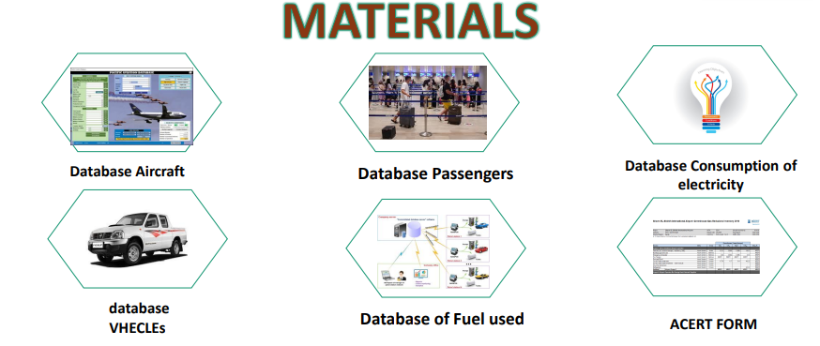

Methodology
The following steps have been taken and are still ongoing to maintain an integrated system to observe, monitor, and be environmentally friendly to disperse birds out of the airport vicinity.
- Qualified and well-trained personnel;
  - Initial training courses and materials;
  - Intermediate training course;
  - Specific training course;
  - Position’s relevant tasks assignment;
  - Recurrent training;
  - Key performance indicators through the daily inspections and patrolling form (On-Airport & Off-Airport), monthly reports of the wildlife situation at airport vicinity, minutes of meetings that are conducted with internal & external stakeholders, bird strike investigation reports, and the pest control evaluation form.
- Database formation (Figure 3 and Figure 4);
  - Database formation (Aircraft – Vehicles –GSE – Passengers - …etc.);
  - Database formation consumption of energy at Sharm El-Sheikh International Airport;

Figure 3: Database formation (Aircraft – Vehicles – Electricity Consumption – Passengers-,etc.)

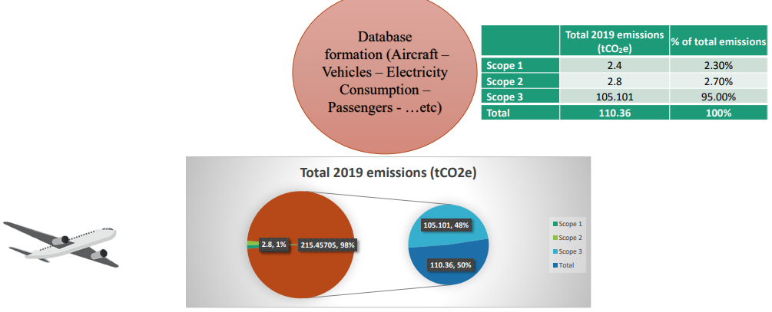

Figure 4: Carbon Footprint Control & Technology
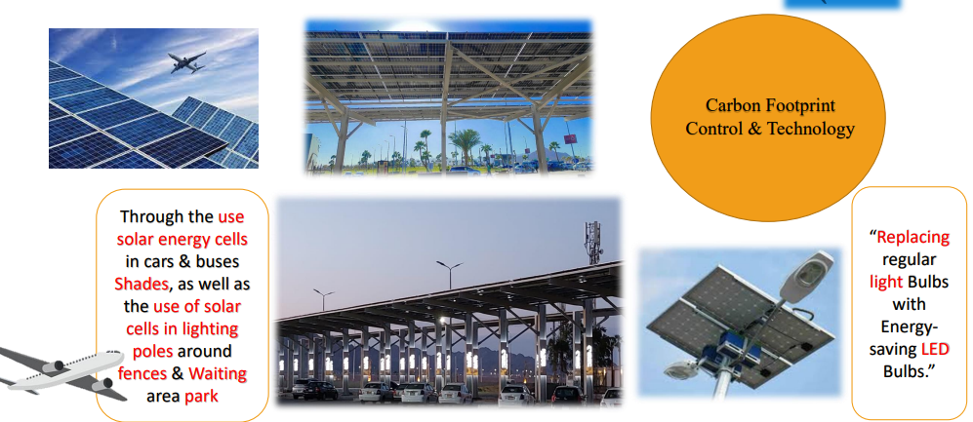

"Certainly! Reducing energy consumption is an important aspect of sustainability in airports. By creating awareness among employees and operators, we can encourage them to adopt energy-saving practices and reduce waste. This can be achieved through various initiatives such as training sessions and workshops, where employees and operators can learn about the benefits of energy efficiency and how it can be achieved. These initiatives can also provide practical tips and best practices that can be implemented across the airport to reduce energy consumption. Ultimately, by reducing energy consumption, airports can save on costs, reduce their carbon footprint and contribute to a more sustainable future.
Sure! Safety and environmental culture promotion refers to the efforts made by organizations to create a culture of safety and environmental awareness among their employees, stakeholders, and the public. This includes promoting best practices for safety and environmental protection, providing training and education on these topics, and implementing policies and procedures that prioritize safety and environmental sustainability. The goal is to create a culture where safety and environmental protection are top priorities and where everyone understands their role in promoting these values. By promoting a culture of safety and environmental awareness, organizations can reduce accidents and environmental harm, improve their reputation and brand image, and contribute to a more sustainable future (Figure 5).

Figure 5: Creating Carbon Footprint Airports
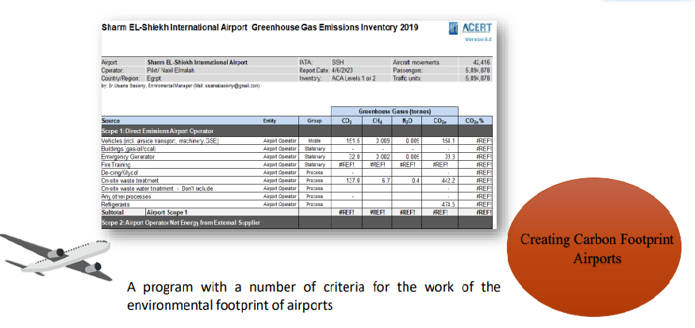

- Safety and environmental culture promotion.
- Stakeholders' (internal and external communities) engagement.
- Workshops & training.
- Creating competitive Carbon Footprint Airports;

Results
- Significant decrease in Carbon footprint SSH Airport.
The figure below shows a significant decrease air traffic operating in 2020 by 24% contributed positively Impact to reducing the rate of pollution.
The carbon footprint was reduced in 2022 compared to 2019 by using green technology such as solar energy, increasing green spaces, using vehicles and equipment powered by clean energy, and utilizing Building Management System (BMS) for building shading control(Figure 6 y Figure 7).
Figure 6: Comparison of air traffic operation and number of passengers
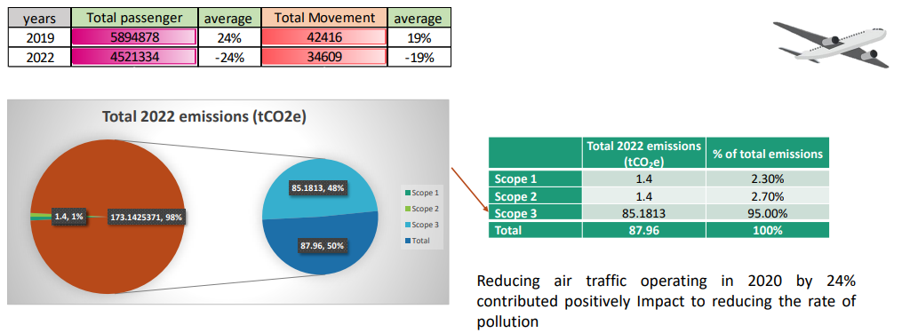
Figure 7: Comparison between the highest operating rate from 2019 to 2022 and this period witnessed a decline in tourism due to Covid-19

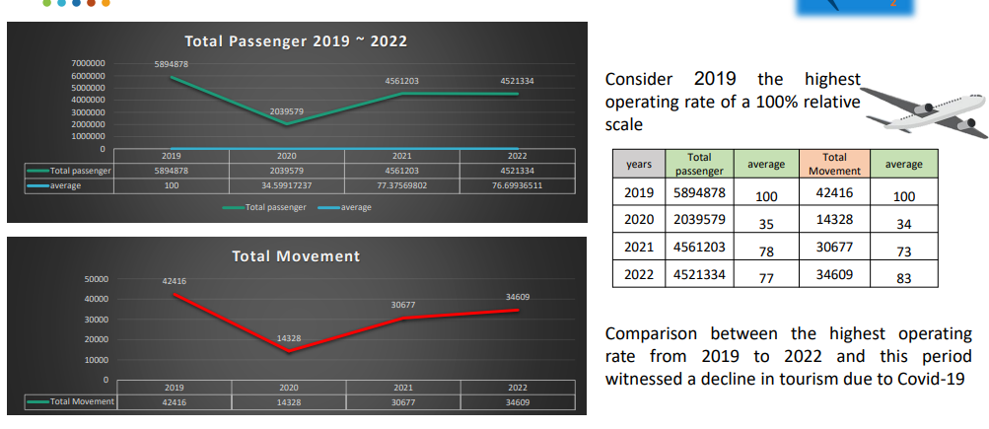

- As can be seen, Scope 3 emissions have always been the largest contributor to Sharm El-Sheikh international Airport carbon footprint. The majority of which are from aircraft activities and passenger access to the airport (Figure 7).
"We were able to achieve a savings rate of approximately 20%."

Figure 7: Scope 3 emissions have always been the largest contributor to Sharm El-Sheikh international Airport carbon footprint
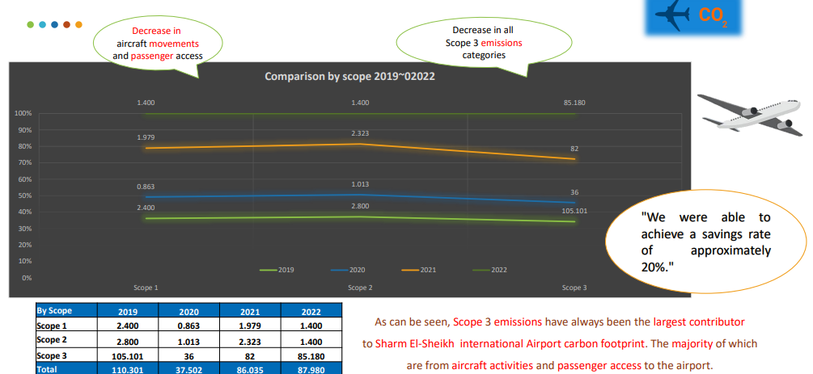

- Sharm El-Sheikh Airport emissions can be broken down by activity as seen in this table (Figure 8).

Figure 8: Carbon Emissions by Source and Activity 2022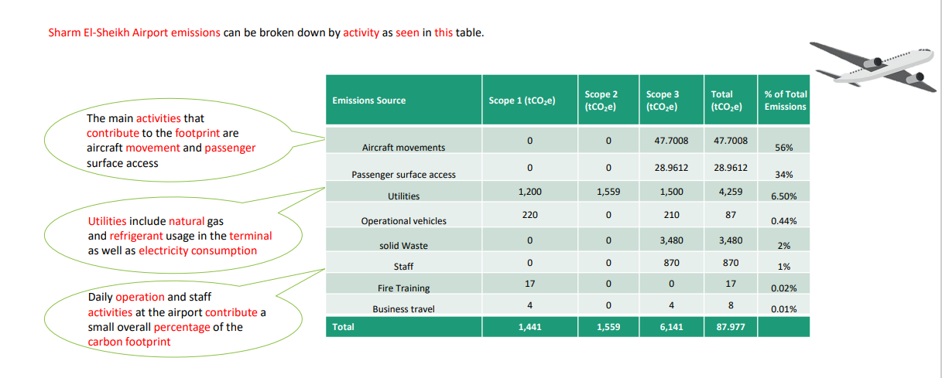
- Scope 1 and Scope 2 emissions have seen an overall decrease of –50 % since 2019.while scope 3 decreasing of 20 % This is largely due to changes in methodology and emission factor intensities (Figure 9).

Figure 9: All Scope emissions 2019 = 110,020 tCO2e

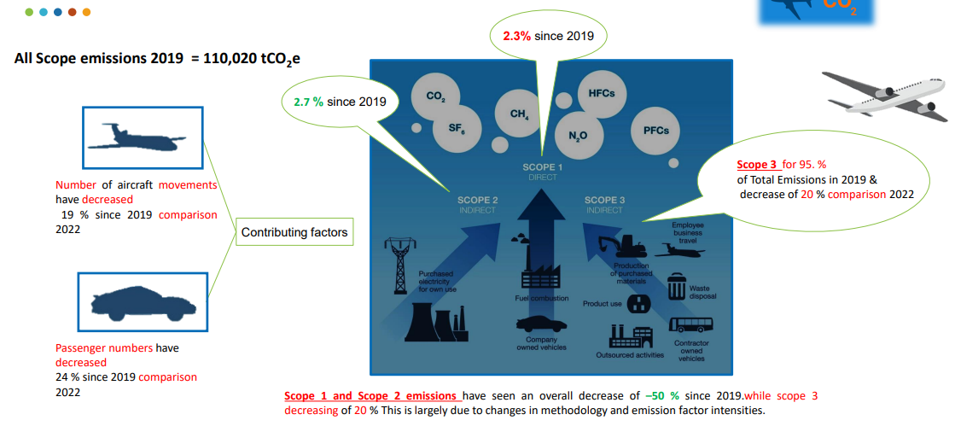

- There has been a small deviation in total electrical consumption since 2019. The majority of savings in emissions is due to the increase of renewables on the national electrical grid or purchasing electricity that is high in renewable energy (Figure 10).

Figure 10: Comparison of Electricity Consumption and Carbon Emissions
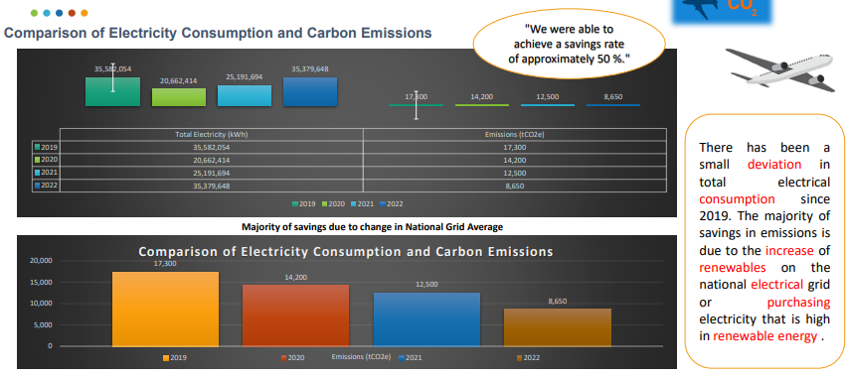

Recommendation The Impact of Managing Carbon Footprint Reduction and Sustainable Development in Airports on Tourism revenues
1. Airports should prioritize sustainable development practices and carbon reduction strategies to attract environmentally conscious tourists and reduce operational costs.
2. Conduct regular surveys to assess the impact of sustainable development practices on tourism revenues.
3. Managing carbon footprint reduction and sustainable development in airports can have a positive impact on tourism revenues.
4. Further research is needed to explore the long-term impact of sustainable development practices on airport operations and tourism revenues.

Figure 11: recommendation to target audience’ stockholder & Premium service

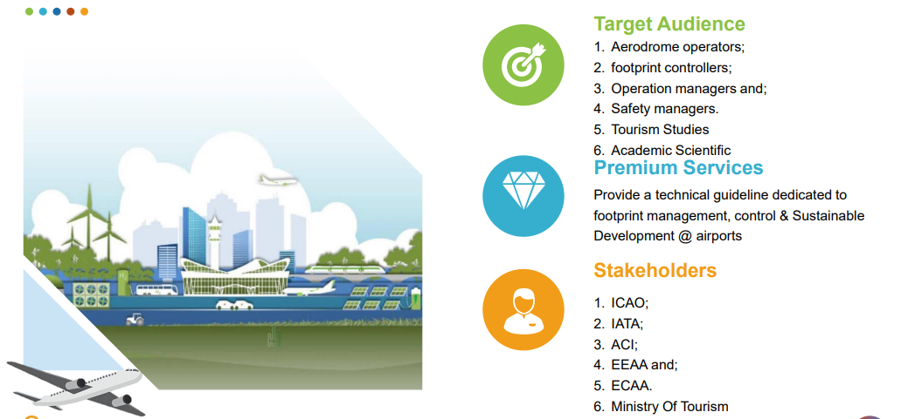

References:
Ampountolas, K., & Mavridou, E. (2019). Sustainable practices in airports: Impact on passenger satisfaction and loyalty. Journal of Air Transport Management, 77, 1-7.
Fasanya, I. O., Oyewole, O. O., & Iyoha, F. O. (2021). Carbon footprint reduction in aviation and its impact on tourism competitiveness in South Africa. Journal of Cleaner Production, 283, 124633.
Gössling, S., Scott, D., & Hall, C. M. (2012). Tourism and water: Interactions, impacts and challenges. Channel View Publications.
Hajibaba, H., & Rezvani, Z. (2016). The impact of sustainable practices on passenger satisfaction and loyalty in airports. Journal of Air Transport Management, 57, 66-73.
Jiang, R., Luo, W., & Chen, Y. (2018). The impact of airport carbon management on tourism demand: Evidence from China. Journal of Cleaner Production, 198, 1058-1067.
Kim, Y., & Yoo, S. (2021). The impact of carbon reduction policies in Korean airports on passenger demand and airfare. Journal of Sustainable Tourism, 29(4), 487-502.
Sánchez-Lozano, J. M., García-Cascales, M. S., & Plaza-Úbeda, J. A. (2017). Sustainable airport management: The case of three Spanish airports. Journal of Cleaner Production, 166, 1423-1433.
Scott, D., Hall, C. M., & Gössling, S. (2013). Tourism and water: Interactions, impacts and challenges. Channel View Publications.
Tang, R., Zhang, Y., & Huang, X. (2020). Sustainability performance of airports in Asia: An empirical study. Journal of Air Transport Management, 87, 101865.
Fu, X., Zhang, Y., & Zhang, X. (2020). The impact of carbon reduction policies in aviation on tourism demand in China. Journal of Cleaner Production, 260, 121067.

Lecturer, Tourism Studies Department, The Higher Institute for Tourism and Hotels, King Mariott, Egypt. Email: asmaashogaa223@gmail.com.
Director of the Environment Department and Wildlife & Bird Hazard Control at Sharm El-Sheikh Airport, Egypt. Email: usama.basiony@eac-airports.com .
Director of Customer Service Department at Sharm El-Sheikh Airport, Airport Duty Manager, and Lecturer at The Higher Institute for Tourism and Hotels king Mariott, Egypt. Email: zakizaki@eac-airports.com . Id. Orcid: https://orcid.org/0009-0007-3933-527X.

