The Camino de Santiago: From Religious Route to Inclusive Tourism Attraction
El Camino de Santiago: de ruta religiosa a atractivo turístico inclusivo

Yolanda María de la Fuente Robles
Almudena García de la Fuente

Abstract
The completion of the Camino de Santiago is a great and significant experience that we have been able of the path and with pilgrims with different abilities and different reasons for traveling the path. I met along the different stages of the way, pilgrims with different capacities and different reasons for walking the trail. It was interesting to see the multifaceted offerings of what has become a generator of tourism attracting a wide variety of visitors. The route I took was the Portuguese one, on which I walked from Valença do Minho (Portugal) to Santiago de Compostela, through forests and small towns, enjoying history, culture, etc. I witnessed how the towns through which the route passed opened up to support and even assist the hikers in this process, showing the same enthusiasm and dedication every day, as if it were the first, not losing their enthusiasm and sincerity with the passage of time. I am sure that, to a large extent, the Way's success is thanks to those citizens who open their doors and businesses and share their traditions. All this leads me to analyze how the pandemic has affected the Camino, the strategies to deal with its negative effects, and the important role that technologies play in transforming this tourism experience into one that is more inclusive and characterized by empathy and friendliness.
Keywords: Camino de Santiago, tourist experiences, inclusive tourism, social inclusivity.

Resumen
La realización del Camino de Santiago es una gran y significativa experiencia que hemos podido conocer en las diferentes etapas del camino y con peregrinos con diferentes capacidades y diferentes motivos para recorrer el sendero. Ha sido interesante ver la oferta multifacética de lo que se ha convertido en un generador de turismo que atrae a una amplia variedad de visitantes. La ruta que hemos podido analizar fue la portuguesa, desde Valença do Minho (Portugal) hasta Santiago de Compostela, a través de bosques y pequeños pueblos, disfrutando de la historia, la cultura, etc. Los pueblos por los que pasa la ruta se abren para apoyar e incluso ayudar a los senderistas en este proceso, mostrando cada día la misma ilusión y dedicación, como si fuera el primero, sin perder la ilusión y la sinceridad con el paso del tiempo. Estamos seguros de que, en gran medida, el éxito del Camino se debe a aquellos ciudadanos que abren sus puertas y negocios y comparten sus tradiciones. Todo esto nos lleva a analizar cómo la pandemia ha afectado al Camino, las estrategias para afrontar sus efectos negativos y el importante papel que juegan las tecnologías para transformar esta experiencia turística en una más inclusiva y caracterizada por la empatía y la simpatía.
Palabras claves: Camino de Santiago, experiencias turísticas, turismo inclusivo, inclusividad social.

- What is the Camino? The evolution of a tradition
The Camino de Santiago is deeply rooted in the history of Christianity, dating back twelve centuries. It came about as a pilgrimage to the tomb of the apostle Saint James, and was initially associated with illness and disability. For all these reasons, the Camino, despite the passage of time, stands out for its diversity.
The evolution of pilgrimage tourism illustrates the multiple ways in which post-secular aims are realized through this modality. Contemporary pilgrimage tourism to Santiago de Compostela is versatile. Pilgrimages should not be construed as unequivocally religious, secular, or post-secular. Rather, pilgrimage tourism spaces are open, such that the identity and meaning of the place are continually being reworked (Nilsson & Tesfahuneym, 2016).
The truth is that the Camino is considered one of the most successful pilgrimages; it is the first European Cultural Itinerary, and one of the most important medieval pilgrimage routes in the world. The term "path" is used to refer to a network of itineraries that many pilgrims take to reach the city of Santiago de Compostela, the final destination. The UNESCO has named Santiago's historic urban center and some of the “Caminos” a World Heritage Site. First, in 1993 the French Way was declared a World Heritage Site of Humanity, and in 2015 the Caminos del Norte (Ways of the North) received the same international distinction. Since 1993 the Camino has been strongly promoted by the regional government, and recent years have seen continuous growth in the number of pilgrims arriving in Santiago, rising from 99,436 in 1993 to 347,578 in 2019 (Oficina del Peregrino/Pilgrim’s Office 2020).
One of the key aspects making the Camino known both nationally and internationally has been the various communication and promotional campaigns implemented to this end (Mondelo & Rodríguez, 2011)
If we focus exclusively on Galicia, adding the different alternative routes, it accounts for approximately 1,500 km of the Camino de Santiago, which mostly crosses rural areas featuring very low population densities, but with highly diverse geographical, physical, environmental and social characteristics. This phenomenon, and the fact that today's pilgrim does not conform to a homogeneous profile (differences in age, nationality, educational level, income, motivation, etc.), which may differ depending on the route taken, prevents an analysis of the Camino's impact that can be applied to all the localities through which it passes (Fernández, et al., 2021).

- The routes
The Camino de Santiago is, actually, made up of several different routes. The different ones are: the French Way, which is that with the greatest historical tradition; the Vía de la Plata (Silver Way), which begins in Andalusia and Extremadura and enters Galicia through the Portelas do Padormelo and A Canda; the Camino de Fisterra and Muxía, originating in the city of Santiago and finishing at Cape Finisterre; the English Way, which is the maritime route followed by the Icelanders and Scandinavians who made pilgrimages to Santiago; the Primitive Way, identified as the very first route to Santiago; the Camino del Norte (Northern Way), which starts from the coast bordering Asturias and Galicia; the Ruta del Mar (Sea Route) of Arousa and the Ulla River, a maritime-fluvial route through the Arousa estuary that commemorates the arrival in Galicia, by sea, of Saint James' body after his martyrdom in Jerusalem; the Portuguese Way, a route that gained importance in the twelfth century; and, lastly, the Portuguese Way of the Coast, which enters Galicia through the fishing village of A Guarda, after crossing the Miño River. Each one has different stages and paths. Following this consideration, tourists know that it is possible to start from any point, follow the path of their choosing, and stop wherever they want. In fact, a pilgrim must travel at least 100 km on the Camino de Santiago in order to obtain the Compostelana, a certificate of participation in the Camino. The most important cities through which the route passes are Pamplona, Logroño, Burgos, León and Astorga (Romanelli, et al, 2021).

Figure 1. Explanatory table of the different routes of the Camino de Santiago on the Iberian Peninsula.
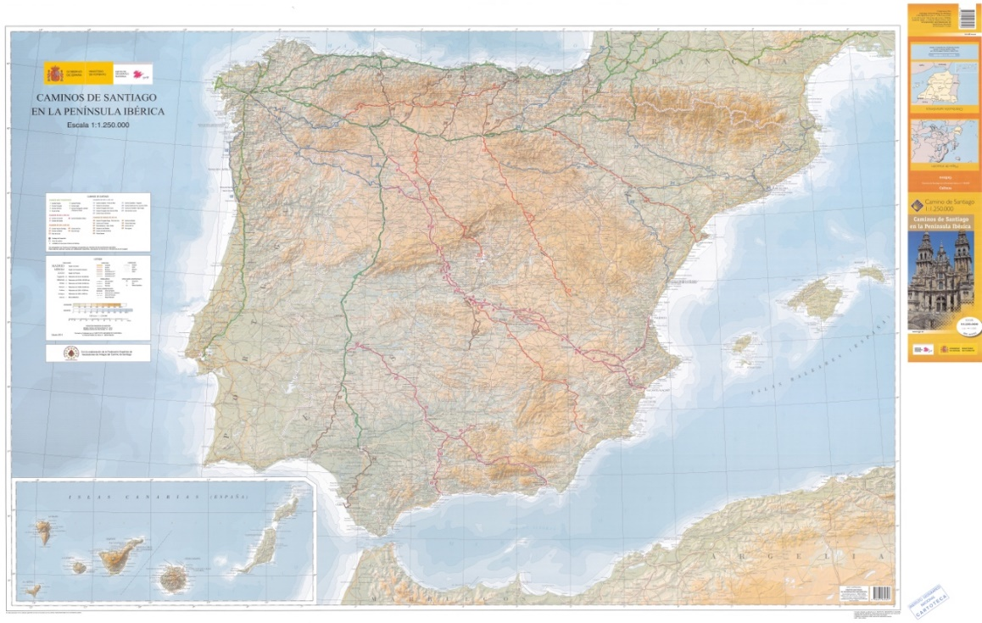
Source: Map library catalog. National Geographic Institute, 2019.

But this religious and medieval pilgrimage route has also become a contemporary tourism "product" with tremendous pull and appeal (Lois-González & López, 2021). "Tourism" is a broader term, and "pilgrimage" is a narrower one; that is, a pilgrimage is a subtype or form of tourism (Ron, 2009), such that the terms "pilgrim" and "tourist" must be deconstructed to unmask contradictions and ambiguities (Eade, 1992).

- The Camino is the axis of all tourism strategies. The Master Strategic Plan of the Camino de Santiago (2015-2021), the Xacobeo Strategic Plan (2019) and the Xacobeo National Tourism Plan (2021-2022)

With this obviously positive trend, and its relevance in Galician tourism planning, the 2015-2021 Master Strategic Plan of the Camino de Santiago in Galicia (Xunta de Galicia, 2015) sets guidelines designed to favor of the conservation and protection of the Camino (with a total budget of €56,119,805 and an estimated per-pilgrim budget of €70.66). This management tool was especially useful for the Xacobeo 21 (Jacobean Year), for which the total estimate was 464,000 pilgrims, with an average daily expenditure of €44/day and €264/week (Xunta de Galicia, 2015). These already positive forecasts were even more positive in the Xacobeo Strategic Plan (Xunta de Galicia, 2019), which was the result of a participatory process. The Plan's main objectives are transversality and quality, internationalization and local talent, decentralization and participation. It is interesting to highlight the six axes of the plan.

Figure 2. Axes of the 2019 Xacobeo Strategic Plan

Source: Author's own, based on the 2019 Xacobeo Strategic Plan

The 2015-2021 Master Strategic Plan of the Camino de Santiago was devised with the firm objective of protecting and preserving the Camino to guarantee the survival of its identity and the enhancement of its cultural and natural heritage, to respond to the needs of 21st-century pilgrims, offering them excellent hospitality, favoring a quality experience throughout their pilgrimages, and promoting social cohesion and territorial balance, all while enhancing the universal identity of Galicia and Europe.

In addition, the different regional policies are linked to the 2021-2022 Xacobeo National Tourism Plan and to the Reactivation Plan for two cultural and Tourism Sectors dealing with the effects of COVID-19 (Xunta de Galicia, 2020), which included a set of measures to recover the upward trend that the Camino had enjoyed, since it has not been immune from the impact generated by the COVID-19 pandemic. These steps included ones related to the enhancement of the Camino's cultural program, and the adaptation of the public network of inns to the new health regulations.
Although we can consider the Camino de Santiago a product in itself, it encompasses so much that it can easily be broken down into a multitude of by-products. In reality, it constitutes a sweeping spectrum of experiences capable of bringing together and structuring a sum of extremely varied travel practices, to the point of representing one of the great structural elements of Spain's tourism architecture.
The actions of the authorities in charge of promoting a destination or product must address the factors that make up its image - related to quality and satisfaction with services and resources - so that visitors emit an organic message that favors others visiting the destination and bolsters the social capital on which organic communication rests (Peppers & Rogers, 2011).

- The result of the unification of all policies: a competitive and inclusive destination
In a context of intense competition between destinations, tourism images emerge as an important element of differentiation. While the perceived image is associated with the tourist's set of beliefs about and impressions of a destination, the projected image is consolidated as a phenomenon of notable importance in the face of its proper promotion and marketing (Andrade & Caamaño, 2016).
Today's tourist seeks to break with everyday life, and feels very attracted by respect for nature and the practice of healthy habits; therefore, the enormous force of the Xacobeo appears in the framework of today’s new tourism (Lois-González & Santos, 2011).
This route's success is based on the fact that the new tourist mixes pilgrimage motivations (travel for religious or spiritual reasons) with tourism-related ones, such as a search for varied landscapes, and the need for mental relaxation, and to escape the pressures of daily life (Lois-González & Santos, 2015).
Key to the development of this aspect has been the inclusion of universal accessibility and a tourism image design accommodating all the people on the routes of the Camino de Santiago, thereby masterfully integrating different elements of the Sustainable Development Goals to modernize the tourism offering, rendering it inclusive and, thus, making it possible to expand the economic returns of the different places through which it passes. Tourism appears in Goals 8, 12 and 14, on sustainable and inclusive economic development, sustainable production and consumption, and the sustainable use of the oceans and marine resources, respectively. Now, thanks to its scope and impact, tourism can directly or indirectly help to achieve any of the 17 Goals (UNWTO, 2018). Thus, it is essential to refer to SDG 11: making cities more inclusive, safe, resilient and sustainable. It cannot be ignored that tourism has the capacity to contribute significantly to achieving broad-based, inclusive growth and generate more opportunities for citizens.

- The role of the non-profit sector in the inclusion of universal accessibility and design for all people. State Representative Platform for People with Physical Disabilities (PREDIF) and Spain’s National Organization for the Blind (ONCE), drivers of change
Non-profit entities, such as PREDIF, carried out an accessibility audit, drafting a report for each route of the Camino de Santiago providing information on the sections considered suitable for People with Reduced Mobility. The results are presented in the Accessible for All Camino de Santiago Guide, a project carried out in 2015 with the support of the ONCE Foundation and the Vodafone Spain Foundation.
In addition, this year the Fundación ONCE conducted an accessibility diagnosis of the French Way, examining a sample of physical facilities that pilgrims use during the route, such as hostels, so that they can plan and proceed with normality.
The project promotes the accessibility of widely-used mobile applications, focusing its efforts on the National Geographic Institute app, and publicizing apps designed for the orientation and guidance of people with disabilities, such as Blind Explorer and Microsoft Soundscape.

Figure 3. Visually-impaired pilgrim
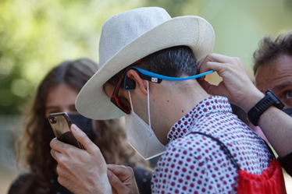
Source: Fundación ONCE, 2021
The app, named "Camino de Santiago: Your Companion on the Camino", provides accessible tourism information for all pilgrims along the route (individuals with visual disabilities, or reduced mobility; or senior citizens), reporting on the characteristics of the terrain in each stage, and the presence of hazards or obstacles, etc. It also guides users with respect to the direction of their travel, and informs them about the points of interest that they will find on the Camino, such as fountains, public transport stops, rest areas, accommodations, shops, restaurants, monuments, tourism offices, pharmacies and health centers.

- Conclusions
- The Camino de Santiago has undergone major changes for various reasons, but mainly in order to adapt to the new demands of its "customers" (whether they are religious pilgrims or tourists).
- As a tourism offering, today it offers a range of experiences that have been revamped with the help of the different government entities (local, regional and national) involved.

- Inclusion has been the key to this new stage, with "Tourism for All" entailing great benefits, as it is associated with non-seasonal tourism and an absence of limiting factors, making it attractive year round.

- The main challenge that public managers involved in the Camino de Santiago must tackle is forging a general, homogeneous brand that includes, in the short and medium term, the presence of universal accessibility and a design for all people in physical, virtual and social environments. For this they have had to readjust their different offerings - for example, the Turgalicia, Xacobeo and Santiago Turismo websites - and apply technology to the management of the inns, which has been very important to the management of the Camino during the pandemic.

- It is essential to promote the Camino de Santiago as a Smart Tourism Destination, since it is offering innovative solutions featuring modern technological infrastructures, such as Beepcon, designed by the ONCE Foundation, which connects to the blind person's mobile phone via Bluetooth and informs him of his location and surroundings, with beacons that can emit sounds so that users can more easily get their bearings.

- ICTs are the key to a 21st-century Camino de Santiago, both for the promotion of the destination and for the generation of user-friendly virtual environments for all citizens, especially those with different abilities. As the Accessibility and Independent Living Observatory indicated, it should be noted that accessibility is essential for 10% of the population, necessary for 40%, and is convenient and improves quality of life for 100%.

References
Andrade, M. J.& Caamaño, I. (2016) La imagen del Camino de Santiago: Análisis de su representación promocional como producto turístico. Tourism & Management Studies, 12 (2), 38-46.
Eade, J. (1992). Pilgrimage and tourism at Lourdes, France. Annals of Tourism Research, 19(1), 18–32.
Fernández, M., Fernández, D. & Riveiro, D. (2021). El impacto del Camino de Santiago a escala local: La percepción de los residentes en los municipios gallegos. Cuadernos de Turismo, 47, 37-63. https://doi.org/10.6018/turismo.474001
Fernández, J., López, C. & Iglesias, L. (2016). Turismo cultural y nuevas tecnologías de la información: El caso del Camino de Santiago y el fomento de la marca país. Revista Especializada en Periodismo y Comunicación. 1 (49), 241–251
Instituto Geográfico Nacional. (2019). Península Ibérica. Camino de Santigo. https://www.ign.es/web/catalogo-cartoteca/resources/html/032075.html
Lois-González, R. C & Santos, X. M. (2011). El Camino de Santiago en el contexto de los nuevos turismos. Estudios Turísticos, 189, 95-116.
Lois-González, R.C. & Santos, X. M. (2015). Tourists and pilgrims on their way to Santiago. Motives, Caminos and final destinations. Journal of Tourism and Cultural Change, 13(2 9, 149-164.
https://doi.org/10.1080/14766825.2014.918985
Lois-González, R.C. & Lopez L. (2021) The Singularity of the Camino de Santiago as a Contemporary Tourism Case. In: Pileri P., Moscarelli R. (eds) Cycling & Walking for Regional Development. Research for Development. Springer, Cham. 221-233. https://doi.org/10.1007/978-3-030-44003-9_15
Observatorio de la Accesibilidad y Vida Independiente (15 de diciembre de 2021). Accesibilidad Universal. https://observatoriodelaaccesibilidad.es/accesibilidad-2
Oficina del Peregrino. (2020). Informes estadísticos 2009-2020. https://oficinadelperegrino.com/estadisticas/
Mondelo, S. & Rodríguez, M. (2011). Análisis de la comunicación en la promoción del Camino de Santiago como producto turístico. RedMarka. Revista Académica de Marketing Aplicado, 1 (6), 59-83.
https://doi.org/10.17979/redma.2011.01.06.4720
Nilsson, M. & Tesfahuney, M. (2016). Performing the “post-secular” in Santiago de Compostela. Annals of Tourism Research, Volume 57, 18-30, https://doi.org/10.1016/j.annals.2015.11.001.
Organización Mundial del Turismo (2018). El turismo y los Objetivos de Desarrollo Sostenible. Buenas prácticas en las Américas. https://www.e-unwto.org/doi/pdf/10.18111/9789284419937
Ministerio de Industria, Comercio y Turismo del Gobierno de España (2021). Plan Turístico Nacional. Xacobeo 2021-2022. https://www.lamoncloa.gob.es/serviciosdeprensa/notasprensa/industria/Documents/2021/Plan_Turistico_Nacional_Xacobeo_2021_2022.pdf
Peppers, D. & Rogers, M. (2011). Managing Costumer Relationships: A Strategic Framework. NJ: Wiley.
Romanelli, M., Gazzola, P., Grechi, D. & Pollice, F. (2021). Towards a sustainability-oriented religious tourism. Systems Research and Behavioral Science, 38, 386-396. https://doi.org/10.1002/sres.2791
Ron, A. S. (2009). Towards a typological model of contemporary Christian travel. Journal of Heritage Tourism, 4(4), 287– 297.
https://doi.org/10.1080/17438730903045548
Xunta de Galicia. (2015). Plan director y estratégico del Camino de Santiago en Galicia 2015-2021. https://www.turismo.gal/canle-profesional/plans-e-proxectos/plan-director-camino-de-santia-go?langId=es_ES#:~:text=El%20Plan%20Director%20del%20Camino,privados%2C%20implicados%20en%20el%20mismo
Xunta de Galicia. (2019). Plan estratégico del Xacobeo 2021. https://www.turismo.gal/osdam/filestore/1/8/0/5/3_66c1f535732692d/18053_e66ed12a82097c3.pdf
Xunta de Galicia. (2020). Plan de reactivación de los sectores cultural y turístico frente a los efectos derivados de la COVID-19. https://xacobeo2021.caminodesantiago.gal/es/institucional/plan-de-reactivacion-de-los-sectores-cultural-y-turistico

Catedrática de Trabajo Social y Servicios Sociales. Universidad de Jaén (España). Id. Orcid: https://orcid.org/0000-0002-2643-0100. E-mail: ymfuente@ujaen.es
Consultora de Comunicación y Marketing. Grupo Oleícola Jaén y Master en Dirección de Marketing y Comunicación de Moda y Lujo en ESIC Business & Marketing School (Madrid). Email: agf00047@red.ujaen.es
https://www.caminodesantiago.gal/es/planifica/las-rutas
https://www.discapnet.es/sites/default/files/caminodesantiagoconsejeraweb_2.pdf
https://www.fundaciononce.es/es/comunicacion/noticias/turismo-de-navarra-y-fundacion-once-presentan-el-camino-de-santiago-frances
https://observatoriodelaaccesibilidad.es/accesibilidad-2

