The wealth of heritage and cultural tourism in Tunisia through two different cases: the archipelago of Kerkena and the mountains of southeastern Tunisia

La riqueza del patrimonio y el turismo cultural en Túnez a propósito de dos estudios de caso: el archipiélago de Kerkena y las montañas del sureste de Túnez

Mounira Kebaïli Tarchouna
Samir Kebaili

Summary
Tunisia is a country in North Africa located on the southern shore of the Mediterranean and bordering the Sahara Desert. This situation gave it a landscape diversity, although it covers only 163610 km², and it attracted several civilizations. The age of human occupation in Tunisia, its history, its passage through several civilizations and its geography, are at the origin of the wealth and diversity of its heritage. To show this heritage richness we have chosen two particular examples each having a different site from the other: The archipelago of Kerkena, located on the east coast of Tunisia in the east center, and the mountains of South East Tunisia. The particularity of Kerkena is manifested by the fixed fisheries owned by fishermen and that of the mountains of southeastern Tunisia by troglodyte houses and "Ksour".
The adaptation of the inhabitants of Kerkena to their island environment has marked this archipelago by the importance of fishing activity, especially fixed fisheries that designate an original artisanal fishing technique. However, seaside tourism is still very limited. The peculiarity in Kerkena is related to the activity of the fishing, whereas the peculiarity in the mountains of the south-east Tunisia is in relation with the original architecture of the houses troglodytes and "Ksour". These traditional buildings have exceptional historical and cultural value because of their particular architecture. Troglodyte dwellings are found mainly in the village of Matmata, located forty kilometers southwest of the city of Gabes, and occupying Mount Matmata north of the Dahar mountains. The ksour characterize the mountain range Dahar, which begins southwest of Gabes and rises south towards Medenine and Tataouine.
The present work is a study of the relationship between heritage wealth and cultural tourism in Kerkena and the mountains of southeastern Tunisia. We will present the cultural offer of the two cases, then we will analyze the impacts of heritage wealth on tourism development for both examples, finally we will present proposals for the development of cultural tourism for the local population in Kerkena, in the mountains of the southeast and in general in Tunisia. The objective is to show the originality of the tourist offer in Tunisia for the development of mainly cultural alternative tourism. The methodology is based on the reading of various books and articles and on the field study including the interview with the local population.
Key words: heritage, fixed fishery, troglodyte houses, ksour, local population.

Resumen
Túnez es un país en el norte de África ubicado en la costa sur del Mediterráneo y limita con el desierto del Sahara. Esta situación le dio una diversidad de paisajes y atrajo a varias civilizaciones a lo largo de la historia. La ocupación humana en Túnez, su historia, su paso por varias civilizaciones y su geografía, son el origen de la riqueza y la diversidad de su patrimonio. Para mostrar esta riqueza patrimonial, hemos elegido dos ejemplos particulares: el archipiélago de Kerkena, ubicado en la costa este de Túnez en el centro este, y las montañas del sureste de Túnez. La particularidad de Kerkena se manifiesta en las pesquerías fijas de los pescadores y en las montañas del sureste de Túnez por las casas trogloditas y "Ksour".
La adaptación de los habitantes de Kerkena a su entorno isleño ha marcado este archipiélago por la importancia de la actividad pesquera, especialmente la pesca fija que designa una técnica original de pesca artesanal. Sin embargo, el turismo costero sigue siendo muy limitado. La peculiaridad en Kerkena está relacionada con la actividad de la pesca, mientras que la peculiaridad en las montañas del sureste de Túnez está en relación con la arquitectura original de las casas trogloditas y "Ksour". Estos edificios tradicionales tienen un valor histórico y cultural excepcional debido a su arquitectura particular. Las viviendas trogloditas se encuentran principalmente en el pueblo de Matmata, ubicado a cuarenta kilómetros al suroeste de la ciudad de Gabes, y ocupando el Monte Matmata al norte de las montañas Dahar. Los ksour caracterizan la cordillera Dahar, que comienza al suroeste de Gabes y se eleva hacia el sur hacia Medenine y Tataouine.
El presente trabajo es un estudio de la relación entre la riqueza patrimonial y el turismo cultural en Kerkena y las montañas del sureste de Túnez. Presentaremos la oferta cultural de los dos casos, luego analizaremos los impactos de la riqueza patrimonial en el desarrollo turístico para ambos ejemplos y finalmente presentaremos propuestas para el desarrollo del turismo cultural para la población local en Kerkena, en las montañas del sureste y en general en Túnez. El objetivo es mostrar la originalidad de la oferta turística en Túnez para el desarrollo del turismo alternativo principalmente cultural. La metodología se basa en la lectura de varios libros y artículos y en el estudio de campo, incluida la entrevista con la población local.
Palabras clave: patrimonio, pesca fija, casas trogloditas, Ksour, población local.

Introduction
Kerkena is a Mediterranean archipelago located on the eastern coast of Tunisia north of the Gulf of Gabes and 18 km from the city of Sfax. It is the only inhabited area in Tunisia totally dependent on maritime transport in its relations with the continent. This isolate resulting from the insularity has positive impacts on the environment. The archipelago has remained sheltered from major tourist developments which disturb the environment and still has spaces where the natural heritage is preserved. It is also characterized by its cultural richness and its originality. This richness and this originality are linked to insularity and are assets for alternative cultural and ecological tourism. Within cultural tourism, the tourist's objective is the discovery of the culture of the local population, that is to say the cultural heritage, and within ecological tourism or ecotourism, the tourist seeks the discovery of a preserved and original natural environment, that is to say the natural heritage.
The location of Kerkena and that of the mountains of south-eastern Tunisia are completely different. Kerkena is a small archipelago (150 km²) of low altitude, while the mountains of the south-east constitute an extensive mountain range which is that of Dahar and which extends over three governorates, over a length of more than 180 km of direction north south, starting southwest of Gabès at Mont de Matmata and running south towards Medenine and Tataouine. The part that we will be studying extends over almost 120 km from Matmata.

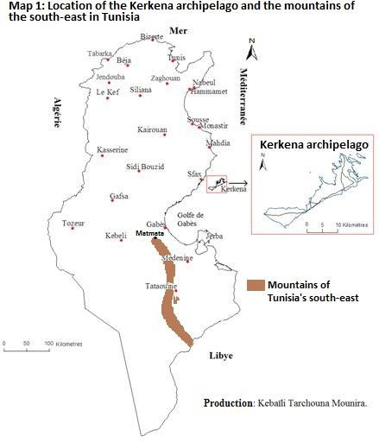

I chose Kerkena and these mountains because of the particularity of their cultural offer which could be of importance on an international scale. The particularity in Kerkena is linked to the fishing activity, while the particularity in the mountains of south-eastern Tunisia is related to the original architecture of the troglodyte houses and the "Ksour". These traditional constructions have an exceptional historical and cultural value. One finds the troglodyte houses especially in the village of Matmata located at forty kilometers in the southwest of the city of Gabès (governorate of Gabès) and occupying the mount of Matmata in the north of the mountains of Dahar. The ksour characterize the mountain range of Dahar in the governorates of Medenine and Tataouine.
This work is a study of the relationship between heritage richness and cultural tourism in Kerkena and in the mountains of south-eastern Tunisia. We will present the cultural offer of the two cases, then we will analyze the impacts of heritage richness on tourism development for the two examples, finally we will present proposals for the development of cultural tourism in favor of the local population in Kerkena, in the mountains of the southeast and in general in Tunisia.

Specificity of the cultural offering in Kerkena and in the mountains of Tunisian Southeast
  - Kerkena the archipelago of fixed fisheries and the diversity of civilizations
Kerkena is an archipelago of 150 km², consisting of two main islands (Charguia and Gharbia) inhabited since ancient times, and a few uninhabited islets. It is an archipelago of low altitude and surrounded by shallows. It is characterized by the importance of fishing, the main activity of its inhabitants, and especially by the fixed fisheries.
The fixed fishery called charfia, is a traditional fishing technique which allows the fisherman to have his own portion at sea where he practices his activity and catches the fish in a fixed space limited for him since he installed his fishery in this space. The installation of a fixed fishery consists in limiting at low tide a stretch of sea on the shallows by artificial partitions made of palms, for catching fish in the traps. Launching a fishery is hard work that requires mutual assistance between fishermen and above all a skill of the fisherman who must choose the exact location of the fishery where he will implant the fins within the limits of the portion of sea he owns or that he rented. The sea portion is generally limited by underwater grasses or by an underwater channel (wad). The master fisherman chooses the location according to the direction of the current. The fishermen bring the palms free of their thorny and pointed leaflets by boat. At low tide, they plant in the mud the palms of the axial path of the fishery which is the way to go (photo 1). The insertion of the fins in the mud must be done quickly. This is why it requires collaboration between fishermen. The height of the palms, which measures almost 1.5 meters, should never be exceeded by water at high tide. The fisherman must carefully calculate this height and the space between each palm planted and the other, which is estimated at 15 or 20 cm.
At the end of the axial path, the fisherman forms a door made up of two racks and opening onto the capture chamber. Several fisheries have a double catching chamber: a first one of polygonal shape which gives access to a second smaller one and of triangular shape where the traps are installed at the end. After completing the capture chambers, the fisherman plants his second line of fins at an angle of 60 to 80 ° with the axial path and forming with it a large V. This line of fins extends to the front door of the capture chamber is the way back (photo 1). The angle is well calculated between the axial path and that of the return. The two paths narrow, meet and lead to the front door of the capture chamber to direct the fish towards it and precisely trap it in the traps. The capture chamber is surrounded by nets supported vertically by wooden stakes. The two stakes without a net are those where the basket is tied.

Photo 1: Fixed fishery at Kerkena, axial path and return path opening onto the capture chamber.

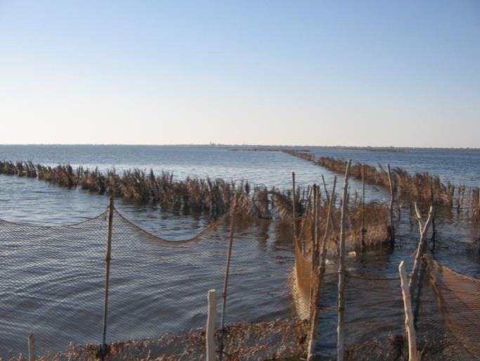
Source: Kebaïli M, August 2008.
This fishing facility seems to us like an architect's job. Calculations, enclosures and rooms, it looks like the fisherman is building a palm house in the sea, with well-defined dimensions, well-studied shapes to trap the fish in this house. This technique reflects the knowledge of the Kerkenian fisherman, his experience inherited for centuries, his intelligence and his creativity. "Fisherman by necessity and by tradition" (Louis, 1961), he knew how to take advantage of these fixed fisheries to take advantage of the special conditions of the Kerkena Sea, its banks, the tide and resources of the archipelago such as palm trees which provide materials for the fishery.
In fact, the Kerkena Islands barely emerge from an extensive and very shallow platform north of the Gulf of Gabès, and despite the shallow depths, the underwater topography is quite uneven. It is characterized by the existence of wad (channels), b’hira (depressions) and shoals that surround the depressions. The shallow depths allow you to walk on foot in the sea and discover the lithology and underwater flora. The existence of fixed fisheries in the shallows is a potential for ecotourism and cultural tourism, it allows for boat trips. On the one hand the tourist observes the rugged underwater topography, on the other hand he discovers the adaptation of fishing techniques to the environment since the Kerkenians knew how to take advantage of this topography and the movement of the tide by installing fixed fisheries on the deep sea.
Today the fixed fisheries have almost disappeared from the Tunisian coast and are only of great importance in Kerkena. The materials used in a fixed fishery come from the palm trees of Kerkena. But today there is a gradual abandonment of materials of local and plant origin in favor of synthetic materials that are easier to use. These modifications affected several elements of the charfia and especially the traps which constitute the traps where between the fish and which are today made of plastic and wire.

But these modifications do not affect the originality of the fisheries, and we believe that this technique constitutes a heritage specific to Kerkena. It is a sustainable fishing method which preserves marine life and the sea and which could be used for the development of ecological and cultural sustainable tourism. Sea trips can be organized for tourists to discover fixed fisheries and to be in direct contact with fishermen during their work. There are also techniques for trapping octopus using vans or fish traps. We think it is very interesting for tourists to attend a fishing scene and observe and understand the hard work of the fisherman, his patience, his struggle for his livelihood in the sea and his experience inherited since centuries.
Traditional fishing techniques are assets for cultural tourism and constitute part of a rich and varied cultural and historical heritage in Kerkena which we will study in the following.

Cultural tourism offer in Kerkena:
The richness of culture in Kerkena comes back to the age of human occupation of the archipelago, its passage through several civilizations and the will of its inhabitants to adapt to their specific island environment. Different civilizations have left several archaeological traces.
      - Archeology: (map 2)
Borj El H'sar is the most important archaeological site of Kerkena where the Turkish fort stands on the Roman city of Cercina, that is to say, in this site meet two Mediterranean civilizations of different era: ancient and modern, but the antique is more important since we discovered a whole Roman city which continues under the sea. The important excavations started in 1993 thanks to several Tunisian researchers like the archaeologist Chelbi Fathi who established a report on the great importance of archeology in Kerkena at the national level saying that "the concentration of vestiges and archaeological evidence is one of the strongest in Tunisia" (National Institute of Heritage, 1996). He also says that the excavations of the old port of Cercina have yielded "examples unique in the world" (Salting and maceration tanks, ovens, tanks). This site is therefore of importance on a Mediterranean and global scale since it includes examples unique in the world. However, there is not an archaeological museum in the archipelago to put the pieces found in the excavations and indicate their origin.

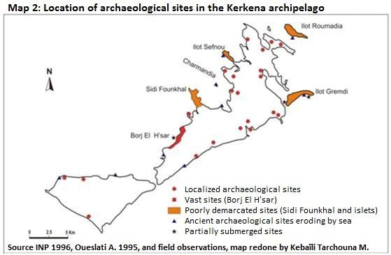

Traditional activities and practices:
In addition to traditional fishing techniques, Kerkena has an important heritage in agriculture, crafts and traditions.

Organic farming:
The Kerkena archipelago has been known for dry crops depending on the amount of rain since the Punic era. The production of its vineyards and olive trees is organic. But the fall in production in recent decades has prompted players to create irrigated areas.

The craft activity:
It is disappearing for several reasons, including the evolution of fishing techniques. The abandonment of local products from the archipelago and specifically palm elements for the production of fish traps, led to the abandonment of this tree. This is why today local associations insist on the maintenance of this tree which is the main element of the landscape in Kerkena. It would be interesting to encourage the use of palm materials for making pots, baskets, bags and parasols.
Likewise, Kerkena has an important heritage in traditional clothes. The enhancement of this heritage would be interesting for the conservation of heritage and the supply of local products to tourists. We quote for women: the "jebba" which is a kind of straight but very wide dress, in one color or cut in two parts to the length, half green and the other half red or dark pink, the long shirt white that the woman wears under the "jebba" and which has a collar and sleeves in white and visible embroidery, the short wide white pants at the top and decorated at
the bottom by an embroidered band under the knees and visible under the "jebba" . We also cite the "tarf" which is a large woolen scarf, often red and embroidered and which has almost disappeared, and the "coufia" worn by the bride on her head and which is a round and rigid cap embroidered in silver. 'in a meticulous way. The bride also wears traditional silver accessories.
The elderly woman still covers her head with a traditional light cloth scarf, or she wears two scarves one on top of the other. The first with a black background with white and red designs falls on the shoulders, and the second, red with yellow flowers and tied behind the head, falls on the back. Thus, the face remains clear and the two braids of hair that the traditional woman is used to making, remain visible. (Kebaïli Tarchouna, 2014).
Concerning the man, we find the "jebba", the short pants in light textile, and the "kadroun" and the "barnouss" in wool. Today there are only a few elderly fishermen who wear these clothes, women only wear traditional clothes during wedding parties, and a minority of women who can sew or embroider traditional clothes. It would be interesting to motivate the inhabitants to this craft activity to conserve the heritage, allow the archipelago to market its crafts and attract tourists who seek local products and traditions of the local population.

Traditions of the archipelago:
There are wedding parties where the bride wears traditional clothes and where we can attend the folklore of Kerkena which is original. It is presented by four male artists, each wearing a traditional uniform consisting of a long white pleated skirt that helps you move, a white blouse with long sleeves, a sleeveless open red vest, a wide belt red, with a head covering formed by a white band above the forehead and a red “cabbous” or “chachia” (traditional cap) at the back of the head, finally light white sneakers and white socks. The artists are musicians- dancers, two drummers and two flutists. They sing and dance at the same time. Sometimes the night parties last until the morning and this is a characteristic of the summer evenings in Kerkena highly esteemed by locals and visitors. This folklore represents a very important aspect of the richness of the Kerkenian heritage. It is present in all the events of the archipelago such as the mermaid festival in summer, that of the octopus in spring and that of the "charfia" at the end of summer. The festival exposes in addition to folklore several aspects of island life in Kerkena like habits and local production, it enlivens the archipelago, attracts visitors and it is a potential for cultural tourism.
To enhance the craft activities and traditions there is a private museum of heritage and traditions in the village of Abbassia. The marabouts also are an expression of the heritage of Kerkena by their historical value and their architecture. There are also local dishes based on fish, octopus, cuttlefish and seafood. These dishes are very popular with Kerkenians and visitors.
Kerkena therefore has a very rich and varied heritage and has great potential for the development of cultural tourism. This heritage is very different from that found in the mountains of south-eastern Tunisia, but each territory has its originality. And if the originality of Kerkena is not invested in the development of cultural tourism, that of the mountains of south-eastern Tunisia is valued for the development of this type of alternative tourism.

The cave houses and the ksour of sites important for cultural and Saharan tourism

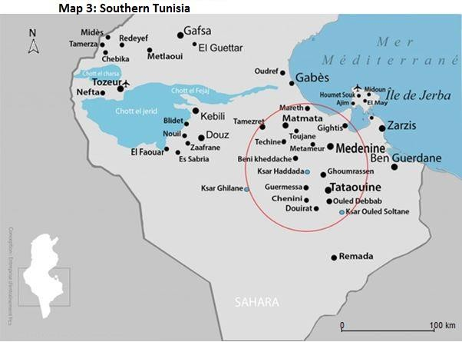

    - The cave houses in Matmata:

Matmata is a mountainous village which is part of the governorate of Gabès located in the south-east of Tunisia. Although New Matmata has become the main town in the region, the center of the Matmata tribe remains the ancient village (Matmata El Kdima) located in the heart of the mountain at an altitude of almost 600 m. Urban development and the rural exodus of populations have emptied and deserted it in favor of the new modern city. Matmata El Kdima had 1,847 inhabitants in 2014 according to the National Institute of Statistics. Matmata is the name of a Berber tribe which founded near a thermal spring, the city of Hamma Matmata (current El Hamma de Gabès). But she was forced to flee it during the invasions of the Bedouin Arab Kabylians the Hilalians in 1051-1052 and founded the current Matmata in the neighboring mountains which bear the same name.
The Matmata mountains are located about forty kilometers southwest of the city of Gabès and north of Djebel Dahar which is a low mountain range (about 700 m) oriented north-south and which cuts the south of Tunisia. The Matmata mountains dominate the coastal plain of the Djeffara and constitute a cuesta clear in the limestone rocks and marls of the Upper and Middle Cretaceous by various wadis.

The troglodyte houses are dwellings dug in the sides of the mountain around a vast well usually circular. Around this well constituting the courtyard of the house are dug longitudinally and in floors the parts which will be used for the lower floor of bedrooms, kitchen, sheepfold for goats and stables, the upper floor being reserved for the storage of cereals, dates, olives and dried figs.
This particular arrangement of the habitat makes it possible to bring the light into the underground rooms while maintaining freshness in summer, because the Tunisian south is subjected to very strong heats several months per year. In these houses, the thermal amplitudes between winter and summer are quite small: about fifteen degrees in January and 23 to 25 degrees in July. From the natural level of the exterior ground, one generally descends into the courtyard directly by means of a narrow staircase arranged in the rock. You can also enter the courtyard through a horizontal underground corridor.
These houses are basically built to cope with the strong heatwaves in the region. In fact, Dahar is located in an arid zone characterized by a hot and dry summer with temperatures that can exceed 40 °. Annual precipitation does not exceed 200 mm and is located mainly in Matmata. Further south towards Tataouine, the average annual rainfall is almost 50 mm.
The village of Matmata was created by digging caves in the soft clay rock, thus providing residents with climatic comfort. This village created out of necessity and as a refuge illustrates the adaptation of the Berbers to their environment and the way of life of a sedentary population which practices agriculture and stores its agricultural products for dry periods. The inhabitants were able to adapt to the climate with this particular arrangement of the cave dwelling allowing the light to penetrate into the underground rooms while maintaining freshness. They also knew how to adapt their agricultural economy by organizing crops according to height: olive and fig trees in the mountains, date palms on lower terraces, and cereal crops under the trees and in the silty basins of the foothills, where the floods of the wadis spread out.
Today Matmata and its cave dwellings constitute an original rich heritage and one of the peculiarities of southern Tunisia, thus attracting tourists from several countries of the world.

Photo 3: Troglodyte house transformed into a Sidi Driss hotel

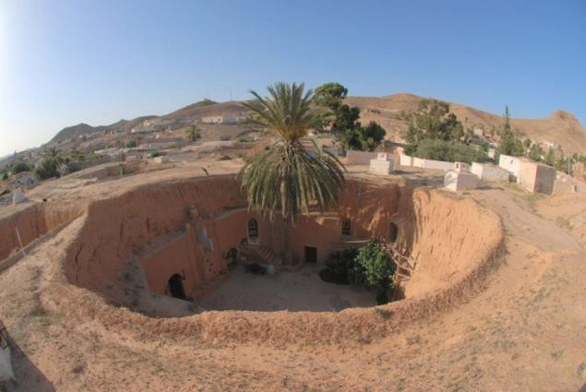

    - The Ksour in the governorates of Medenine and Tataouine:

The ksour (plural of ksar in Arabic, the ksar means castle) are built by local materials such as stones. They are more widespread in space than cave dwellings. They characterize the mountain range of Dahar, which begins south of Gabès and stretches south, towards Medenine and Tataouine and whose highest point is located at 713 meters above sea level. There are nearly 150 ksour in south-eastern Tunisia in the governorates of Medenine and Tataouine. The ksar includes ghorfas (rooms) generally spread over three or four levels, up to fifteen meters high and accessible by external stairs. This particular architectural form appeared for centuries on the ridges and characterizes a sedentary Berber population who practices agriculture in the heights, and who went to take refuge in the mountains, of the Bedouin nomad tribes of the desert plains and of the Hililian Arab invasion in the 11th and 12th centuries. The products of this population: cereals, wheat, dates, olives, olive oil and livestock products, were stored under cover in granaries made up of ghorfas (chambers) in these mountain ksour . Oil and dates are kept in large jars.

Photo 4: Ksar Ouled Soltan kept his ghorfas having three or four levels
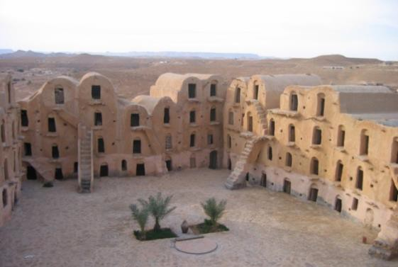

Ksar-ouled-Soltane, located about 20 km southeast of Tataouine is one of the most important ksour in Tunisia. It’s an attic mountain ksar. It has two courtyards, the first dates from the 15th century and the second dates from the 19th century, and it includes a record number of ghorfas (400) for the storage of food reserves. These ghorfas are spread over three or four levels. The ksar was fully restored in the late 1990s.
Ksar Hallouf located in Béni Khdèche in Medenine is also restored. It dates back to the period of the nomadic Arab-Hilalian invasions in the 11th century. It is built of stone on the side of a hill overlooking a small oasis that stretches along a wadi. The roof of the ghorfas is also made of stone. The ghorfas are arranged on two levels and are organized around a small square. One of them houses a traditional oil mill. From the top of the hill overlooking a small degraded mosque, you can see the palm grove of the oasis.
The ksour constitute an original Berber architecture, real fortifications combining granaries and dwellings. The number of ghorfa per ksar has an average of between 150 and 200. Ghorfa in general is four to five meters deep and two meters wide and high. Its upper part is
ventilated by two small holes in the walls. The different ghorfas are adjoining but do not communicate unless they belong to the same owner. They are built around a central courtyard where residents can meet, welcome visitors and do business transactions.
There are three types of ksour (Ben Ouezdou, 2001):
- Ksour citadels or kalâa (fortresses): These are inhabited ksour appeared from the 11th century to the period of the Hilalian invasions, such as Douiret, Chenini or Guermassa. They are defense ksour compared to nomadic tribes. It is difficult to access them because they are high perched on reliefs. Their main function is military (protection of the village and place of refuge against enemies) in addition to the economic function (collective granary which makes it possible to preserve or store in the ghorfas the different crops (wheat, dates, olive oil, etc. ) for years of drought.
- Mountain ksour: They are more accessible than the first group, they have kept the defensive character, but in the first place they have a vocation of agricultural storage like ksar Ouled Soltan. They dominate depressions and fertile plains and they are not associated with villages.
- Plain Ksour: From a later period, dating from the end of the 19th century, the Berber peaks, in a period of peace, descended to the plains of Jeffara. Their ksour are larger, for example in Medenine and Tataouine.
Currently, the function of ksour as family granaries or fortress, is replaced by new functions related to culture and tourism. These ksour represent a potential for tourist circuits in southern Tunisia and are valued for the development of cultural and Saharan tourism like the cave dwellings of Matmata which have also changed function and are invested in cultural and Saharan tourism.

Impacts of heritage wealth on tourism development in the Dahar mountains and in Kerkena
  - Investment of cave houses and ksour in cultural and Saharan tourism:
The cave dwellings and the ksour are valued to offer a Saharan tourist product particular to the Tunisian south-east based on this Berber architectural heritage. Similarly, an international Saharan ksour festival is organized each year in Tataouine to attract foreign and Tunisian tourists.

Cave houses transformed into hotels:
There are cave houses in Matmata that have been converted into hotels, such as the Sidi Driss Hotel (photo 3) which served as the setting for George Lucas’s famous movie "Star Wars". In this original hotel, the rooms are small caves carved into the ground and the bathrooms are shared. It is a form of accommodation that does not offer luxury but particularity.

The Marhala Matmata hotel, too, was an old cave house. It is a 3 star hotel, with a capacity of 70 rooms. The accommodation is totally cave-dwelling. However, the 4-star Diar El Barbar hotel is a new construction inspired by the troglodyte heritage.
These hotels offer local products and local dishes like couscous in the manner of southern Tunisia to enhance the culinary art. We can also cite an original example of accommodation in the village of Tamezret located on the national road which links Matmata to Douz. This is the Tamezret inn which has three rooms, the most original of which is "the Grotto" carved into the rock of the mountain. There is also in Tamazret the rural cottage Dar Ayed with a capacity of 20 beds, a museum presenting the history and the way of life of the Berbers of this region and craft shops offering local products such as carpets wool. The development of small accommodation units in Tamazret and Matmata has made it possible to offer some jobs to the local population.

Restoration of Ksour:
The ksour present a great historical and cultural potential for tourist circuits in the south of Tunisia. For this there were interventions to redevelop and restore them for decades. The ksour have been ceded by their owners to the public authorities to rehabilitate them. The National Heritage Institute intervened in the restoration of some ksour, with a scientific and professional approach. But restoration operations have only affected a limited number. 38 ksour were restored between 1994 and 2008 by the National Heritage Institute, the Heritage Development and Cultural Promotion Agency which is under the supervision of the Ministry of Culture, and the Regional Worksite Program for the Development of Tataouine and Medenine led by the governorate. The costs of these restoration actions are almost 1000 thousand dinars (Abichou, 2009).
However, dozens of ksour are in an alarming state of degradation and are not being restored. Private initiatives and local actors seeking economic and tourist development and an immediate benefit have sometimes disfigured the architectural heritage of the ksour, for example by using new materials, such as hollow red brick and reinforced concrete. We cite the case of Ksar Hallouf where we used different colors (blue from Sidi Bou Said) and concrete slabs. We also cite the refurbishment of the ghorfas of Ksar Hadada in rooms and the use of different colors, as well as the restoration of some caves at the ksar Douirète by an individual to have tourist accommodation in this ksar.

Photo 5: Ksar Hadada

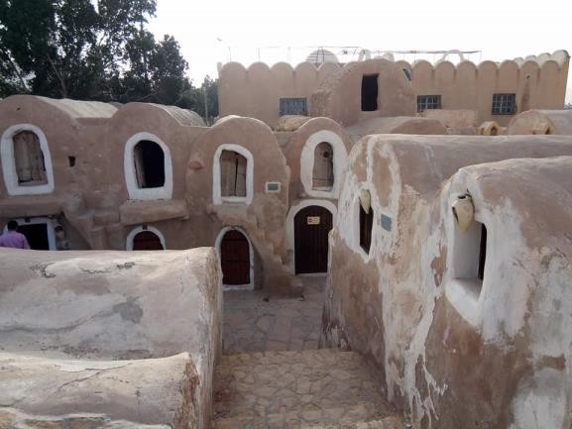

Source: Kebaïli M, April 2018.

Cave houses and ksour in Chenini and Duirète (Tataouine)
-Chenini is a Berber troglodyte village located 18 kilometers from Tataouine. It is overlooked by a citadel ksar, or kalâa, on a hill about 500 meters above sea level. It is a place of storage of food reserves and valuables which also served as a refuge in the event of an attack. When the risk of invasion or pillage became low and with the sedentarization of the Berbers, the village began to develop on the flanks of the hill and down until the creation of the new village of Chenini around 1960. Some inhabitants still live in their troglodyte habitat. Underground oil mills are still in operation. The minaret of the white mosque located at the foot of the citadel once served as a landmark for caravanners. Tourists are accommodated in the Kenza lodging made up of cave rooms.

Photo 6: Chenini and its citadel ksar.

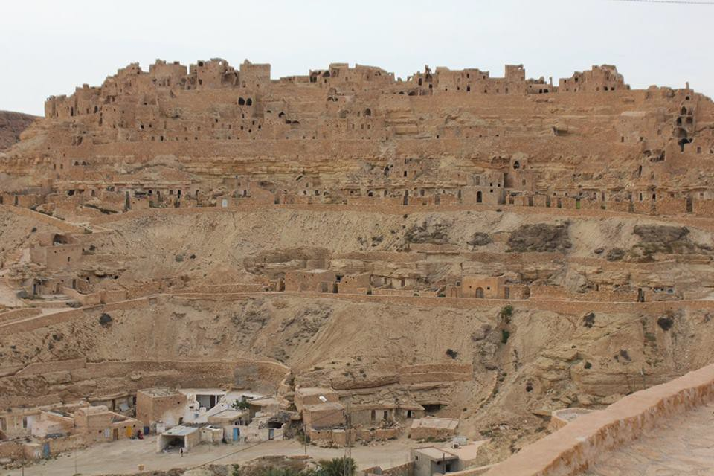
Source: Kebaïli M, April 2018.
The Kenza cottage is 500 meters from the Mosque of the Seven Sleepers. It offers accommodation in several caves and a sun terrace. It is located 1 kilometer from the Oasis El Ogla and is an important anchor for excursions in Dahar. It can accommodate around thirty tourists and offers local dishes. This gîte has been built for years thanks to a private initiative which aims to set up an integrated cultural and tourist project through catering, accommodation, training as a tourist guide and the sale of wool and wool products. weaving of the local population. This project enables young people and rural women to benefit from a source of income and is based on the preservation of natural and cultural wealth and the promotion of local products. This is an example of a sustainable development and cultural, social and solidarity-based tourism project.

Photo 7: The Kenza gîte in Chenini

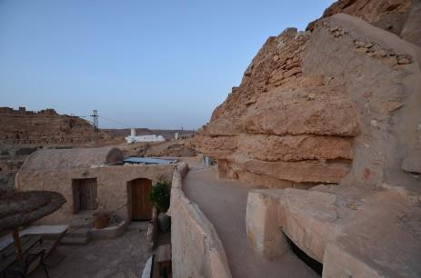

Source: Kebaïli M, April 2018.

Chenini is today a tourist site of great importance including the ksar citadel, the troglodyte houses, the troglodyte oil mills and the mosque of the seven dormants. The introduction of tourist activity has made it possible to enhance traditional activities such as weaving wool into traditional carpets. Several local associations in Chenini work for the promotion of tourism such as the Association of Economic Development and Tourist Promotion South Tunisia.
Duirète is also a village-ksar-citadel, perched on a hill 22 km from the city Tataouine. The foundation of this village dates back to the 12th century. It stretches over 3 km of slopes and the extent of its remains is a measure of its power. At the top of the hill, the ruins of the "kalâa" give a defensive aspect, witnessing long periods of insecurity. Below and all around, lie along several contour lines of the cave houses. Stairs lead to the top of the hill to discover an exceptional landscape. The village of Douiret was prosperous when it was a caravan crossroads, it sheltered a rural society of mountain, where lived in 1850 approximately 3500 inhabitants.
Today the old village has been deserted for fifty years. There are no more fields, the channels draining rainwater are no longer maintained. The site has become practically vestiges, overlooking the new village at the foot of the mountain. It is included in the Saharan tourist circuits. The visit of Douiret allows you to see dwellings aligned on the mountainside on successive levels and dominated by the ksar, to walk in the alleys and to discover the underground oil mills. For accommodation there are a few lodgings such as the Douiret lodge managed by a local association and which employs young people from the village.
Guermessa: Perched further north, Guermessa was also for centuries a large Berber city with a citadel ksar. Today, it is completely deserted by its inhabitants and there are few travelers who go there. Because the path to reach the top of the village is difficult and steep. Accessibility to a ksar remains a constraint for its tourist exploitation and this is the case for several ksour, in addition to other constraints and limits.

Photo 8: Duirète site and gîte. April 2018.

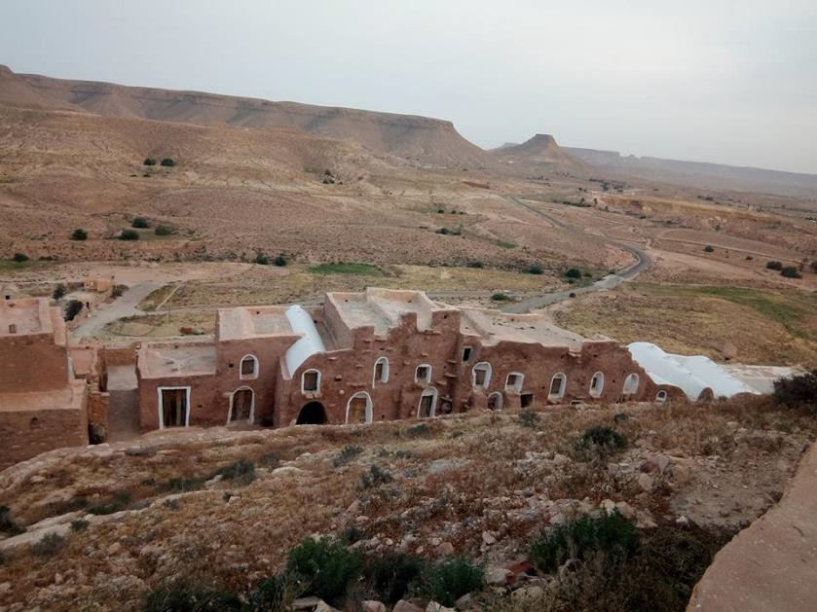
Photo 9: Ksar de Duirète next to the gîte. April 2018.
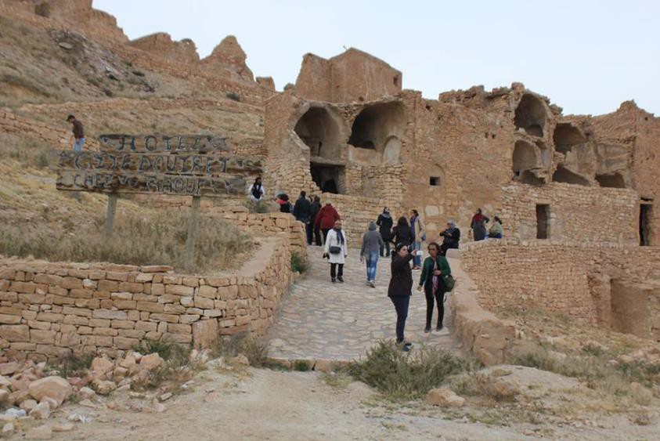

Photo 10 : Guermassa. April 2018.

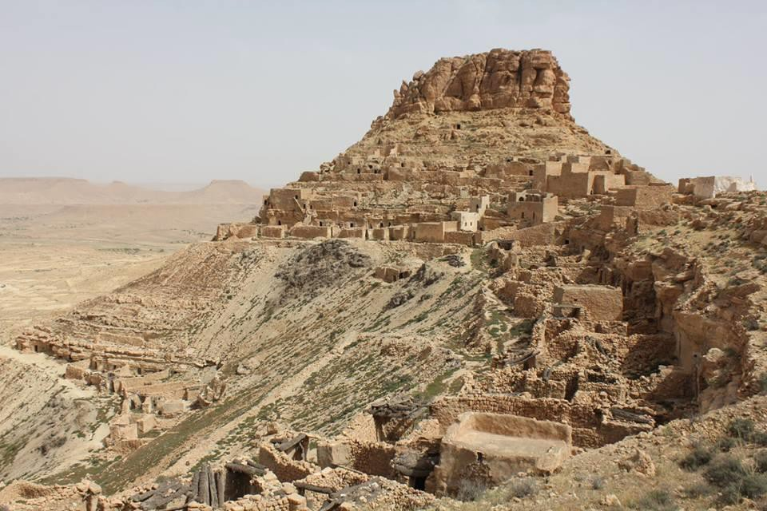

    - Case study of alternative tourism in Zammour:
Zammour is a Berber village, located about 40 kilometers from the city of Medenine, at an altitude of 600 meters in the mountains of Matmata and administratively attached to the delegation of Beni Khedache (governorate of Medenine). It has a population of nearly 1,000 inhabitants and is an important example of the development of alternative tourism in which the inhabitants are the main players, in particular the Association of Youth of Zammour (AJZ). This association has an important role in the development of tourism in Zammour. It is a local non-governmental organization, created in 1991 by a group of volunteer Zammurians. Its objectives are essentially the safeguarding of heritage and development. She works for cultural and solidarity tourism and for the solidarity and social economy in general for example the realized project of "Dar Elmouna" which consists in valuing and buying the products of the inhabitants of Zammour, like honey and dates and all local products, to improve the income of the inhabitants and fight against the rural exodus.
With the support of AJZ, the inhabitants of Zammour are struggling to revitalize their village through economic development projects, heritage preservation and cultural events. AJZ members and some villagers work as guides and accompany tourists to show their cultural, architectural and natural heritage, as well as their farming and craft techniques.
We can therefore say that the rich heritage has positive impacts on tourism development in the Dahar mountains and that we can still develop cultural tourism in these mountains. What about cultural tourism in Kerkena?

A wealth of heritage not valued in Kerkena for the development of cultural tourism:
The islands are major and preferred tourist destinations for tourists around the world. But the tourist frequentation of these islands is characterized by a great disparity. Kerkena is among the Mediterranean islands least visited by tourists. Seaside tourism is limited in this archipelago, unlike the majority of Mediterranean islands including the island of Jerba in the south-east of Tunisia. The only tourist area in Kerkena is that of Sidi Fraj Cercina, which was developed in 1963. This area covers 112 hectares and has a capacity of 1099 beds. It is located southwest of Charguia Island and extends into the northern part of Sidi Fraj Bay. The advantages of this area are the existence of a relatively large beach and its location near the archaeological site of Borj El H’sar. The downside is that seaside tourism is limited to the summer season. However cultural tourism can cover the whole year and what is remarkable in Kerkena is almost the nonexistence of cultural tourism, with the exception of a few visitors to the archaeological site of Borj El H'sar or the museum of heritage and traditions of Abbassia, as well as the exhibition of folklore of song and music of Kerkena in hotels.
The richness, originality and diversity of the heritage in Kerkena is not invested in the development of cultural tourism. While the peculiarity of the architectural heritage of ksour and cave houses is valued for the development of cultural tourism in south-eastern Tunisia with success and also with limits and constraints.

Limits and constraints of Saharan and cultural tourism in south-eastern Tunisia
    - Circuit tourism:
Decision-makers in Tunisia began to take an interest in Saharan tourism from the 1980s as part of the diversification of the tourism product. According to the Tunisian national tourism office, there are two tourist areas in southern Tunisia: Jerba-Zarzis seaside tourist area in the southeast and Gafsa-Tozeur Saharan area in the southwest. The Gafsa-Tozeur area includes four governorates: Gafsa, Tozeur, Kébelli and Tataouine. In the southeast region that we studied, from Matmata to Tataouine, there is no extensive tourist area, but small traditional accommodation units. According to my readings tourism in Matmata and in the ksour is part of Saharan tourism and generally constitutes circuit tourism. The tourist accommodation capacity in Tunisia is concentrated on the eastern coast, in particular on the island of Jerba, in Nabeul- Hammamet, Sousse and Monastir. In the south of Tunisia the Jerba-Zarzis tourist area is the most important area for accommodation capacity, the number of foreign tourists and residents in Tunisia and the number of overnight stays. There is a great disparity between the Jerba-Zarzis tourist area and the rest of southern Tunisia (Table 1).

Table 1: Tourism in southern Tunisia in 2016

Region | Jerba-  Zarzis | Gafsa-  Tozeur | Gabès | Kebili | Tataouine | Total  Tunisie

Number of beds | 53 729 | 7 333 | 1 734 | 3 999 | 503 | 235 018
Number foreign tourists | 443  778 | 34 410 | 11 068 | 43 386 | 2 712 | 2 283  640
Number resident tourists | 194  178 | 101 080 | 44 088 | 28 735 | 9 103 | 2 304  810
Number of nights | 4 138  002 | 203 184 | 97 172 | 79 657 | 17 807 | 17 880  034
Source: National Office of Tunisian Tourism, 2016.

In fact there is a big difference in the length of stay between the two tourist areas of southern Tunisia since the duration in the Jerba-Zarzis area is 7 days, while it does not exceed
1.3 days in the Saharan region Gafsa-Tozeur (Suissi, 2007). This disparity shows that there are two forms of tourist practices in southern Tunisia: seaside tourist tourism and Saharan circuit tourism focused on an excursion product. Tourism in the mountainous villages of south-eastern Tunisia is a circuit and excursion tourism. The movements of international tourists to the Saharan tourist sites are generally from the tourist areas of the eastern coast and especially the island of Jerba which has had an international airport since 1970. These are guided excursions to see the oases, the desert and the Berber villages. But it should be noted that the island of Jerba is close to the Berber villages of the south-east and this is an asset, because in a limited space you can see the sea, the Berber heritage and the desert.

Organized circuits:
Organized tours represent the most popular form of tourism in southern Tunisia for international tourists. Tour operators and travel agencies organize excursions from the coastal regions to the Saharan regions. These excursions take place most often in all-terrain vehicles (4x4) and sometimes in buses. Their duration is often three nights and four days. The majority of circuits cover the desert, Matmata, Douze and Tozeur. Map 4 includes an example of a tourist circuit. The circuit starts from the island of Jerba, passes through the ksour of the south-east and Matmata then continues west until the arrival at Douz in the middle of the Sahara. The circuit can also be longer, after the arrival in Douz the route can continue towards the north west passing by chott-el-Jerid then the city of Tozeur until the arrival in the governorate of Gafsa in chébika Tamerza and Midès.

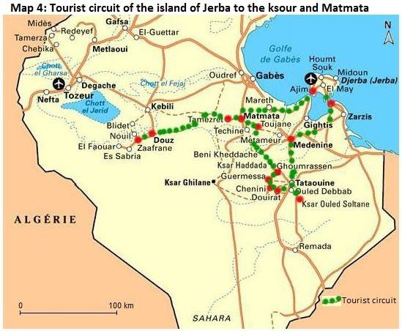
There are also travel agencies in Tunisia that offer Tunisians excursions to the south of Tunisia by bus for a weekend or three days of vacation, especially during the winter and spring school holidays and during cultural events. like the Saharan Ksour festival in Tataouine. This type of excursion for domestic tourism has been booming for years.

- How to develop cultural tourism in Kerkena and and Tunisian southeast.

  - Tourism development strategy in mountain villages in the south-east:
    - Development of Saharan and cultural tourism:
The development of tourism in the mountainous villages of south-eastern Tunisia requires the implementation of a new tourism strategy aimed at promoting the Saharan and cultural tourism product and the marketing of specific stay formulas. These formulas relate to all of southern Tunisia, characterized by the richness and diversity of the tourist offer. Cultural tourism in Berber villages is only one component of Saharan tourism. These formulas should have the objective of transforming Saharan and cultural tourism into stay tourism and spreading out the tourist season. This could be achieved by cooperation between the different actors, the change in the way of selling the Saharan product, advertising for heritage and cultural sites, and
taking into account the experiences of Mediterranean countries like Morocco in alternative tourism. in general and cultural tourism in particular.

Various marketing options for the “Ksourian” tourism product:
The tourism product "ksourien" can be marketed in a narrow framework as a specific product based on a particular heritage and on the local population and far from the pollution of cities. The tourist in this case chooses this destination in its capacity and takes part in the improvement of the incomes of the local population within the framework of an alternative cultural, ecological and united tourism. The example of the village of Zammour illustrates the possibility of success for this type of tourism.
The tourist product "ksourien" can also be marketed as a component of tourism in southern Tunisia as part of the diversification of the tourist product (seaside, Saharan and cultural), as well as the tourist who visits southern Tunisia, abroad. opportunity to discover several landscapes and a particular heritage.
The tourism product "ksourien" can also be marketed in a broader framework, cultural tourism in Tunisia. In this case, it is necessary to better develop cultural tourism by promoting cultural sites in Tunisia and the itineraries of tourist circuits that can be offered to tourists, and also by maintaining archaeological sites throughout the Tunisian territory and the promotion of all the components of the country's tangible and intangible heritage.
In all these cases, it is necessary to advertise carefully, to better develop cultural and Saharan tourism on the web by promoting cultural sites and highlighting geographic and cultural particularities in Tunisia. In the marketing strategy, advertising is used to promote the notoriety of a tourist site, to arouse enough interest in a destination, to announce a price reduction on a destination during a slack period or to promote a event, for example a festival. Online commerce is effective in creating quality content (articles, videos, photos, etc.) that will meet travelers' expectations. Social networks represent a strong lever to improve the image of a site. The fact of making known a tourist site to Tunisians and foreign tourists and presenting them a beautiful image, is a main condition for their attraction.

Simple and original accommodation in Kerkena and promotion of the cultural offer:
    - Simple and original accommodation:
Accommodation could be in small hotels built or decorated with local products, for example the creation of a residence which could take the form of an old village in the archipelago with traditional style houses. An original accommodation could also be by the restoration of some abandoned old houses and their reconstruction while preserving their original style like the ksour and cave houses. Thus we enhance the architectural heritage of the archipelago and include cultural tourism in the heart of the villages. This requires initiative on the part of local actors such as associations and the inhabitants of Kerkena. We also offer
solidarity tourism, because it supports small projects for the local population. The objective is to discover the culture of the local population. It is therefore necessary to enhance the cultural offer and the heritage of the archipelago.

The development of the cultural tourist offer in Kerkena:
We offer a map with hiking trails that pass through all the islands to enhance the tourist
offer of this archipelago (Map 5). The layout of the paths presented on this map takes care to
highlight the ecosystems of the archipelago, its landscapes, its heritage and its archaeological
sites. The enhancement of the marine ecosystem appears in trips to the sea for islets of the
archipelago rich in avifauna or fixed fisheries to see this heritage, observe the Posidonia
meadows and the underwater topography. That of continental ecosystems is manifested by the
diversity of landscapes: palm trees, vineyards, sebkhas and coasts. Cultural tourism is also
associated with ecotourism, the objective of which is the discovery of natural environments.
(Kebaïli Tarchouna, 2014) The archaeological site of Borj El'Hsar is of particular interest,
because it shows the age of civilizations in Kerkena and the importance of Roman civilization
on the one hand and it is a proof of the subsidence of the land in the archipelago on the other
hand. Thus the visit of this monument will be an opportunity for tourists to learn about the
history and geography of the archipelago and understand the causes of its vulnerability and the
evolution of its coastline through an indication proving that the sea is gaining ground at the
expense of the archipelago's lands (photo 11). Similarly, the organization of outings to Gharbia
Island would be interesting. These outings can follow the sea route with the help of sailing boats
or the continental route in a mini bus or in carts drawn by horses or donkeys. The most important thing to see on this island for tourists is the site of El Jorf (Jorf means cliff). Arriving at this island from Charguia Island following the path we have proposed, we find a sebkha very frequented by birds, then Ras El Bargouth, then El Jorf which includes the highest altitude of the archipelago equal to 13 m. This site is little distorted, which is an asset for ecological and cultural tourism. It is made up of a rocky cliff where sea erosion has shaped beautiful geological sections that can be observed. Then, the exit could be followed by a walk in the vineyards of Mellita where we see the ancient ruins, then a visit to the irrigated perimeters of Mellita where we see the ruins of the Ottoman Turkish era, and in particular the Borj which has a height of almost 12 m. This allows comparison with the Borj El H’sar site on Charguia Island and shows the continuity of civilizations in the archipelago.

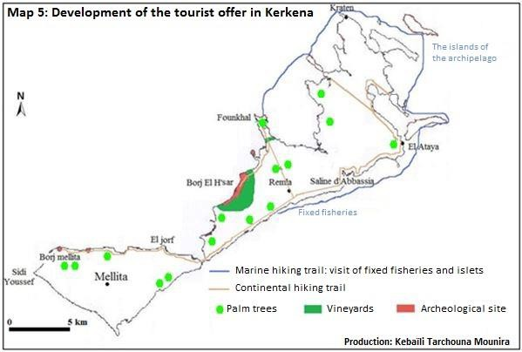

Photo 11: Remnant of a Roman construction, emerges at low tide about 200 m from the shore of Borj El H’sar

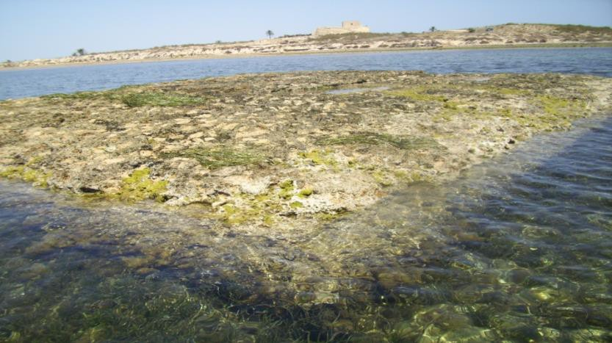

Source: Kebaïli M, August 2009.

The development of ecological and cultural tourism will contribute to the development of crafts and to the increase in demand for local products. It would be interesting to encourage the use of palm materials for making pots, baskets, bags and parasols. Similarly, the enhancement of the heritage in traditional clothes would be interesting for the conservation of heritage and the supply of local products to tourists.

Change in methods of marketing the tourism product:
-The classic image of the destination Tunisia to avoid: The classic image of the destination Tunisia in advertising brochures or even in international tourism fairs is the sea, the sun and the camel in the desert. This image is no longer used to develop tourism. It would be effective to show the image of a rich and authentic Tunisia from a natural and cultural point of view. This country enjoys different environments and landscapes despite the small size of its area compared to other Maghreb countries. It is characterized by the richness and diversity of its heritage inherited from different civilizations for three thousand years. The fixed fisheries at Kerkena and its cultural richness, as well as the cave houses and the Berber ksour constitute an original part of this rich and diversified heritage. For Kerkena it is an island heritage in a calm archipelago and beautiful landscapes composed mainly of the sea and palm trees. For cave houses and Berber ksour, this particular heritage is located in an arid mountain environment near the oases, not far from the south-eastern coast of Tunisia and the city of Jerba and close to the Sahara. It is this image that attracts a clientele interested in culture and discovery.
-The search for a diversified clientele: This clientele can be young and dynamic, for example pupils and students from Tunisia or abroad during the winter or spring holidays or during the weekend for families in Tunisia. The clientele may also be European for the elderly in the context of winter tourism. This spreads out the tourist season. This diverse clientele should not seek luxury, but the originality and the particularity of the heritage in Kerkena and in the south of Tunisia.
-Taking into account the experiences of the Mediterranean countries in alternative tourism and the example of the village of Zammour: Several Mediterranean countries have turned towards alternative tourism, while having successful seaside tourism. We can content ourselves with citing two cases: Greece and Morocco. In Greece, we find cultural, rural tourism and ecotourism. These forms of tourism are based on small family businesses which can be small hotels or traditional accommodation. The excursions are organized by local agencies and not by large tour operators (Tsartas, 1998). In Morocco also alternative tourism is booming. Local associations have an important role in the development of ecological, cultural and rural tourism, for example in the Middle Atlas in mountain villages (Gourija, 2007). Several non- governmental organizations in the world are fighting for alternative and sustainable tourism and contest the major tour operators and international travel agencies which are the big beneficiaries of mass seaside tourism. However for alternative tourism, travel agencies are local, regional or national, and the local population is a main actor, as is the case in the village of Zammour.

The local population a main player:
-A cultural tourism in favor of the local population: Tourism in Matmata and ksour is located geographically between Saharan oasis tourism in the Djérid and Douz regions on one side, and mass seaside tourism in Jerba and Zarzis from the 'other. It is a passing and crossing tourism where the visitor spends at most a few hours during a 4x4 stop or a bus as part of a
guided tour. The number of tourists staying in Matmata or in the ksour villages and the number of overnight stays are very limited. This type of tourism offers modest accommodation capacities, but it has the advantage of offering the tourist a particular cultural product and original accommodation managed by the local population.
The beneficiaries of this tourism will not be large hoteliers and large tour operators, as is the case for mass tourism, but the local population, with the offer of original accommodation, the enhancement of crafts , training local tourist guides and offering local products from nearby oases and local gastronomy. Youth hostels and homestay accommodation can also be solutions for welcoming foreign and Tunisian tourists and visitors.
-The organization of tourist circuits by local guides: The pedestrian circuits allow tourists to discover the architectural particularity of these Berber villages, to breathe clean air in the mountains, to know the traditions of the local population and to consume local products. The development of walking or cycling tours in nearby oases and palm groves is also effective in discovering the various agricultural techniques, in particular the traditional hydraulic installations in Tataouine. Regional public authorities such as the governorate and local authorities such as the municipality will have to develop the trails to facilitate access to the ksour located at the top of the villages. AJZ’s efforts in Zammour are considerable in organizing tourist circuits.
However, efforts in Kerkena are lacking for the development of cultural tourism, although this archipelago has great potential to develop cultural tourism alongside seaside tourism existing in summer.
- Support from local alternative tourism agencies and associations: There are a few local agencies in Chenini, Douiret and Guermessa that offer tours by personal car or rental. Half-day or full-day hikes are offered by local residents on foot or by donkey on mountain trails. This work by local travel agencies is important, but not enough. There are also several local associations which have contributed to the development of traditional forms of accommodation and to the promotion of local products from Berber villages such as AJZ in Zammour. These associations need support and training to contribute to the development of alternative tourism, the proper management of traditional residences and the safeguarding of ksour.
It is also important to enhance the craft heritage (traditional rugs and sheets, jars, etc.) for the interior decor of hotels and to offer local products such as traditional dishes and handicrafts. This will provide jobs for the local population, especially young unemployed graduates. The possibility for these young people to have loans, their supervision and their encouragement by the public authorities, could help them to make their own projects of tourist accommodation, travel agency or original restaurant.

Conclusion
The troglodyte dwellings and the ksour constitute the basis of an alternative cultural and Saharan tourism in south-eastern Tunisia. This tourism offers modest accommodation capacities compared to seaside tourist areas, but accommodation is simple and original and could evolve in this direction. Similarly, the situation of Matmata and the ksour between the seaside tourist area of Jerba-Zarzis and the Saharan area of Gafsa-Tozeur is a great asset for diversifying tourism in southern Tunisia. The fact that currently Ksourian tourism is limited to excursion tourism, especially from the island of Jerba, does not mean that it is difficult to develop it towards a tourism of stay, while also welcoming trippers. This could be achieved by changing the methods of marketing the tourism product based on the image of Tunisia rich and authentic from a cultural and landscape point of view, and by moving towards a clientele that seeks the discovery of the culture of the other. The proposed tourism product is an alternative Saharan tourism, cultural and united. The beneficiaries of this tourism will not be the large hoteliers and large tour operators, but the local population. This homestay tourism project has started to be carried out in Zammour by the local population. It is interesting to encourage this experience and to see other projects in favor of the region and the local population.
Cultural homestay tourism would also be effective in Kerkena and it would be interesting to benefit from Zammour’s experience. The richness and diversity of the cultural offer, the originality of the marine environment of the archipelago and the preservation of the purity of the natural environment are assets for ecological and cultural tourism. For this, tourism must take care to target a clientele oriented towards an island cultural tourism. It would also be effective to see the experiences of the Mediterranean islands and other countries in the world, and to take ideas and forms of planning which insist on the preservation of the natural environment and the participation of the local population, and which can be practiced in Kerkena. We should think of a real alternative and sustainable tourism in Kerkena.
The success of alternative tourism, in particular cultural tourism in Kerkena and in the mountains of south-eastern Tunisia is possible. There is some success in the sites of ksour and cave houses, but insufficient. The development of alternative tourism in Tunisia requires considerable efforts on the part of all stakeholders. The crisis of mass seaside tourism in Tunisia after January 14, 2011, is proof of the fragility of this type of tourism. This should sensitize new decision-makers to change Tunisia's tourist orientations towards alternative forms within the framework of sustainable development, in particular in fragile environments like Kerkena and in interior regions rich in natural potential and heritage in the north, between and in the south of Tunisia, but where the population is poor and development projects are rare.

References
Abichou H. (2009). The enhancement of heritage as a vector of sustainable local development: what economic benefits and what institutional arrangement? Case of the Tunisian south-east. Doctoral thesis in economics under the supervision of Professor Elène Rey Valette, University of Montpellier I, Faculty of Economics, 273 p.
Ben Ouezdou H. (2001). Discover southern Tunisia. From Matmata to Tataouine: ksour, jessour and troglodytes. Faculty of Human and Social Sciences of Tunis, 78 p.
Gourija S. (2007). Tourism and sustainable development: what combination? Case of Morocco. doctoral thesis in economics, under the supervision of professor Zaoual Hassan, University of the Littoral Côte d'Opale, 303 p.
Hammami Z. (2014). Tourism, heritage and development in the Matmata-Demmer chain (south-eastern Tunisia). Doctoral thesis in geography under the supervision of Professor Abdelfatteh Kaseh, University of Sfax, Faculty of Letters and Human Sciences of Sfax.
Kebaïli Tarchouna M. (2014). The Kerkena archipelago: Organization of space and planning. Doctoral thesis in geography under the supervision of Professor Abdelkarim Daoud, University of Tunis, Faculty of Human and Social Sciences of Tunis 2013, published in 2014 by the University Publication Center, 432 p.
Louis A. (1961). The Kerkena Islands, Study of Tunisian ethnography and human geography. Publication of the Institute of Beautiful Arab Letters, Tunis, 3 volumes: The works 410 pages, The days 447 pages and Document of ethnography 315 pages.
National Heritage Institute, Tunis (1996). Archaeological map and park project in the Kerkennah Islands. Report prepared by Chelbi F, 2 p and a map at 1/25000.
Souissi M. (2007). International tourism in Tunisia: towards new forms and the reorganization of the tourist space. Doctoral thesis in geography under the supervision of Professor Guy CHEMLA, Sorbonne-Paris IV University, 524 p.
National Office of Tunisian Tourism (2016). Tunisian Tourism in figures. 95 p. Oueslati A. (1995). The islands of Tunisia. CERES publication, 368 p.
Tsartas P. (1998). Greece: from mass tourism to alternative tourism. L’Harmattan, Tourisme et Sociétés collection, Paris, 238 p.

Doctor en Geografía. Université de la Manouba. Faculté des Lettres, des Arts et des Humanités. Túnez. Email: ke.tarchouna_mounira@yahoo.fr
Doctor en Geografía. Université de Sfax. Faculté des Lettres et Sciences Humaines. Túnez. Email: samirkebaili8@gmail.com

