Kitsch landscapes as tourist destinations in South and Southeast Asia (China, Vietnam, Nepal)
El paisaje “kitsch” como destino turístico en el Sur y el Sudeste de Asia (China, Vietnam, Nepal)

Philippe Bachimon *
Evelyne Gauche
Anh Thư Lê

Abstract
Carried out within the framework of the AQAPA programme 2014-2019 of the French National Agency for Research (Agence Nationale de la Recherche, ANR), this study focuses on the stereotypical kitsch-based “staging” of tourist sites and resorts, taking as examples three Asian tourist regions characterized by the presence of ethnic minorities: Da Lat in Vietnam, Pokhara in Nepal and Sandu in China. This staging notably relies on the use of false décors (Baudrillard, 1981) – what Umberto Eco (1985) called an “artistic lie” – and aims to provide the tourist with “a reassuring but artificial vision of things” (Menon, 2006). This article thus looks at this kitschifying of landscapes developed for tourism at the rural/urban interface (scenography, experience provided for tourists, processes mobilized) and the objectives it serves, in order to start to understand and interpret the underlying message(s).
Keywords: landscape, kitsch, tourism development, governance, Vietnam, China, Nepal .

Resumen
Realizado en el marco del programa ANR AQAPA (2014-2019), este trabajo parte del análisis de tres regiones turísticas de Asia caracterizadas por la presencia de minorías étnicas –las regiones de Dalat en Vietnam, Pokhara en Nepal y Sandu en China- y centra su interés en la estereotipada puesta en escena de los lugares y centros turísticos que se basa en la utilización del kitsch. Esta construcción turística de decorados se apoya, principalmente, en la utilización de lo falso (Baudrillard, 1981), lo que Umberto Eco (1985) califica de «mentira artística», pretendiendo proveer al individuo de «una visión tranquilizante, aunque artificial, de las cosas» (Menon, 2006). El estudio aborda, así, esta utilización del kitsch en el paisaje que se pone a disposición del turista en la interrelación de lo rural y lo urbano (escenografía, experiencia que se proporciona a los turistas, procesos implementados), así como los objetivos que esta puesta en escena pretende alcanzar, de modo que podamos aproximarnos e interpretar el mensaje o los mensajes que subyacen en ella.
Palabras claves: paisaje, kitsch, puesta en valor turístico, gobernanza, Vietnam, China, Nepal.

1. Introducción
An important factor in the development of tourism in South and Southeast Asia is the creation of a world of artificial objects made of plastic, concrete and plaster, producing a stereotypical kitsch-based staging of tourist sites and resorts. The origin of the term “kitsch”1 can be traced back to around 1860 in Bavaria, to designate products of dubious quality (Menon, 2006). Initially referring to the “artistic and industrial production of cheap objects” (Legrand, 2005), this term in everyday language designates objects created in poor taste, adorned with superfluous decorations, and is linked to the idea of inauthenticity and extravagance, based on attributes considered as trivial. This inevitably raises the question of the definition of the beautiful and the trivial or bad taste, but referring to “the difficulty of explaining the aesthetic evidence” (Nahoum-Grappe and Vincent, 2004). We will not enter into this debate here. According to C. Menon (2006), “kitsch is a mode of the relationship of mankind with reality. It is based in particular on the use of what is fake (Baudrillard, 1981) or a sham. It is conveyed by an object or system that causes the subject to plunge into an emotional state of positive blindness, adopting a charming and reassuring, albeit artificial, view of things.” While kitsch is an attribute of mass civilization (Moles, 1971), inseparable from the consumer industry, it is particularly present in Asian tourist sites, which are thus often characterized by a process of “kitschification” (Moles, 1969).
Within the framework of the ANR AQAPA programme (AQAPA Project (2014-2019) this article therefore looks at the processes of this kitschification of landscapes developed for tourism in three regions of Asia particularly marked by the presence of ethnic minorities, at the urban-rural interface, and at the objectives this kitschification serves. It takes as examples the cases of Da Lat (Vietnam), Pokhara (Nepal) and Sandu (China), and their surrounding countrysides.3 These cities have a strong relationship with the rural space in the context of tourism development, being the centres from which the tourist clientele spreads out. In Vietnam and China, minority villages are the object of ethnic tourism (more developed in the latter case than in the former), while Pokhara constitutes the starting point for trekkers in the Annapurna Mountains in Nepal.
From this perspective, the landscape, in line with the European Convention of Florence (2000) which defines it as “part of the land, as perceived by local people (...)” is considered as a material object on which various social representations are projected. Here the landscape plays the role of a setting charged with meaning via the representations of the actors involved in its kitschification (mainly States and tourism actors) and those of its spectators (tourists).
In order to address the complexity of this question of the kitschification of landscapes undertaken for their tourism development, we will begin by describing the staging of such landscapes through their scenography, showing on what criteria they can effectively be qualified as kitsch. We will then outline a deconstruction of the experience intended for tourists – mainly domestic tourists in China (Taunay, 2011) and Vietnam (Peyvel, 2009), and international tourists in Nepal (Sacareau, 1999) – to focus on the processes mobilized in order, finally, to start to understand and interpret the message(s) underlying the posture studied.

2. The kitsch tourism system
In Asian destinations, the tourism system, in the sense of all of the visited places that make up the destination, is often based on a process of kitschification of the landscapes, of which the three regions studied present comparable situations.

2.1. The notion of kitsch in three Asian tourist destinations
South Asia, and in particular India4 and Nepal (“Kollywood” for Bollywood in Kathmandu), is fond of a kitschification of landscapes that matches the profusion of deities in Hindu temples, extending and updating it. But seemingly more “low-key” and secularized countries such as China and Vietnam are also very fond of all things kitsch. The marker of the appearance of kitsch in China and some Southeast Asian countries was the introduction of Western culture during the colonial era (Francization for Indochina, Briticism for Hong Kong, Dutchism for Indonesia, etc.). The colonists thus built replicas of their countries for recreation purposes (Jennings, 2015; Peyvel, 2009), bringing to Asia a reversed “exoticism”, in particular in their holiday resorts through villas and other buildings such as railway stations, post offices, churches and so on. Currently, this exotization, already kitsch in the sense that it mixed stylistic references to make sense (Davallon, 2006), has become heritage in certain countries such as Vietnam (example of the colonial villas of Da Lat). Outside of colonial kitsch, the tourism system of these Asian countries operates on the basis of a universe of particularly visible objects made of plastic, plaster and concrete giving an atmosphere reminiscent of the world of yesteryear – very often that of the colonial era but not only, as the referencing is intended to be as broad as possible. This redundant kitsch system is a response to the demand of domestic tourists, a clientele that has been growing in the most developed countries of Asia for the last fifteen years (Cabasset-Semedo et al., 2010).
The regions around Da Lat (Vietnam), Pokhara (Nepal) and Sandu (China) as illustrations of the kitsch tourism system in Asia
The cities of Da Lat, Pokhara and Sandu, as well as the countrysides they focus attention on, present comparable tourism systems from the point of view of the kitsch mechanism mobilized, with nevertheless certain variations in the modalities of its use.
Da Lat and Pokhara are first and foremost high-altitude resorts (1,000 to 1,500 m) in tropical environments, thus constituting appreciated “havens of coolness”. They present rural mountain landscapes (with plantations of tea around Pokhara and coffee around Da Lat) comprising waterfalls and lakes, where the forest layering oscillates between the primary vegetation of the heights and arboriculture around the resorts. These peripheral regions (in the imperialism sense of the term) are marked by a strong ethnicity due to the presence of ethnic “minorities” who symbolize a form of authenticity, and who have done so since the origin of tourism – which for Pokhara and Da Lat was a contemporary phenomenon of colonization (indirectly English for Nepal and French for Vietnam). All of these “primordial” ingredients, in the current surge in the reputation and attractiveness of these destinations, are now taking a back seat to developments specific to the growth of mass tourism. Here, the artefact of the desired atmosphere (the effect, so to speak) takes precedence over the aforementioned reference framework (in other words, the artefact is neither entirely cultural nor commercial, but a combination of the two).
Contrary to Da Lat and Pokhara, Sandu is not a former high-altitude resort. Since the early 2000s, it has been a tourist resort in the south of Guizhou Province, chief town of the xian (district) of Sandu within the Qiannan Autonomous Prefecture. It is part of the central government’s desire to develop domestic tourism in the poor rural areas of the country, such as Guizhou. Within the framework of the Province’s tourism policy, which is based on both nature and ethnic tourism, Sandu represents a regional relay to the city of Guiyang and is positioning itself as a tourist destination based on its image as the “capital” of the Sui ethnic group. A landlocked region due to its terrain, the Qiannan Prefecture has benefited since 2015 from the development of its transport infrastructures, notably road (motorways) and rail (high-speed line), which has resulted in the tourism development of Sui villages, formerly only little visited by tourists. While tourist numbers in the xian of Sandu increased from 80,000 in 2005 to 450,000 in 2016 (Taunay, 2017), they are still much lower than in Da Lat and Pokhara, which each attract several million tourists every year. The xian of Sandu, like the two other areas discussed in this study, is multiplying efforts to strengthen its tourist attraction and extend the length of stays (still too limited today to excursions). This is notably being accomplished through the construction of so-called “ethnic” districts (specific architecture and street furniture, craft shops, museums, restaurants), various forms of accommodation in local homes, and remarkable new sites (jingdian in China).
The tourism development strategies of these resorts and their surrounding villages are based on major transformations leading to a kitschification of the landscape through the addition of numerous artifices according to a standard model. It is the principles of this kitsch scenography, today asserting itself in these three Asian regions, that we will now address.

2.2. A kitsch landscape scenography
The staging of tourist sites results in the production of a kitsch landscape, which presents a number of common features that we have identified in our different regions based on studies by Moles (1969), Baudrillard (1981) and Génin (2010).
Extravagance: the accumulation and blending of styles. One of the characteristics of kitsch is to mobilize a maximum number of artefacts in the form of an accumulation of disparate objects presented in an ostentatious manner (Moles, 1971).
An example illustrating this characteristic is that of the kitsch posters created in the 1960s in Egypt, and since then widely distributed throughout South and Southeast Asia, resembling photographs but being in reality “unusual and baroque objects copied and pasted from ecological environments and/or architectures juxtaposed in an unlikely way” (Battesti, 2017).
Today, retouched using Photoshop, “they then make what they see as the best of different continental, ecological and architectural worlds coexist”: (...) snow-covered Swiss forests and mountains, waterfalls in equatorial forests, Versailles-style châteaux and pools of Moorish inspiration, lush floral compositions, eternal snows (Battesti, 2017).
In China, in the famous Miao tourist village of Xijiang5 in eastern Guizhou, in picturesque nongjiale recently built in the “local style”, the exoticism of the rooms can be quite unexpected, combining, for example, the marine “styles” of temperate and Scandinavian Europe (Figure 1).

Figure 1: Décor of the rooms at the Miao Family Guesthouse in Xijiang.
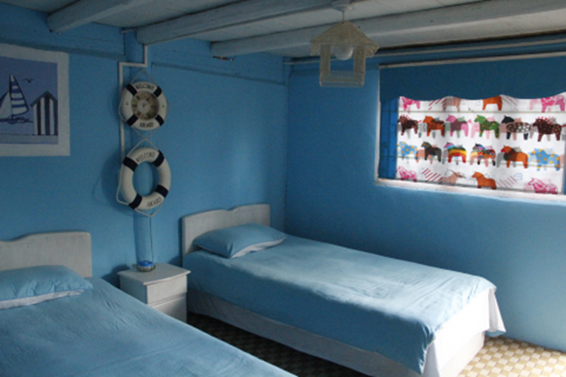
Source: E.G., 2014.

The resort of Da Lat, created by the French in 1893 during the Indochina period, was intended from the outset to be a compendium of different styles taken from the architectural stereotypes of the French provinces, with a specific affinity for Alsace, Lorraine and Normandy. These were brought together in a resort where the climate (cool and humid) and the alpine landscape, in particular the pine endemic to the region (pinus dalatensis), reminded holidaying colonists of Metropolitan France. To build the resort of Da Lat, and with the exception of the pre-existing climate and landscape, it was necessary to augment the so-called “reality” by resorting to developments: lakes (all the lakes in Da Lat are artificial), parks, estates of holiday villas, and so on. All these developments were superimposed on, and sometimes associated with, the indigenous nature of the places, within a process of landscape mutation that served as a framework for the kitsch tourism system. It was from the 1960s to 1970s onwards that Da Lat, still in its original colonial state, became the favourite destination for Vietnamese artists, who stayed there in a peaceful setting conducive to forgetting the context of the Vietnam War. The romantic and melancholic atmosphere of this city acted as a catalyst, a “blank cheque” for them to draw inspiration from the style of the “true” famous Western artists (Nguyên, 2016). The recent tourism development in the city has only reinforced this trend to the point of consumer hypertrophy.

As A. Moles (1971) explained, in the kitsch style, the surface of things, the appearance, is a continuum. Kitsch is therefore about filling in the gaps. It is this filling in principle that leads to the ornamental extravagance. Today’s Da Lat is a perfect illustration of this. The colours are “stark” and the passage from one to the other abrupt (without transition of shades and hues). One thus passes directly from red (a noble colour and sign of prosperity in Vietnam) to candy pink (plastic strawberries or flowers, statues of flamingos in the garden of the Valley of Love, etc.). Moreover, kitsch colourism excessively reproduces the colours of the rainbow in the many amusement parks surrounding the city (Valley of Love, Datanla Waterfall, Crazy House, Historical Village, Clay Tunnel, etc.). The materials used are rarely presented for what they are. The wood is painted to imitate marble, the veined concrete balustrades replicate tree bark, the metal columns simulate stucco that is rarely in plaster... But plastics are central as they are cheap and easily “mouldable”. These uses are found in Chinese ethnic villages, except that wood is often used as a marker to reinforce the picturesque aspects of minority villages originally built in wood, but nowadays mainly in concrete.

At Lakeside (Pokhara), the abundance appears first as religious and reified by the Hindu and Buddhist temples (Pinney, 1995), and is part of the specific atmosphere of pilgrimages. But the reference to the hippie period (Davis Falls, Begnas Lake) and the “Peace & Love” years forms a background noise (a relaxed atmosphere) on which, with the exception of a few living witnesses (and testimonies), the current merchandizing of the destination is built. This is done through a speculative investment of the lakefront which has become, following the Fish Tail Lodge (ranked in the bestseller 1000 Places to See Before You Die by P. Schultz, 2003), the trendy place in the resort. The lakefront is lined by a series of heterogeneous bars such as the Olive Café, the Busy Bee, the Maya Pub, the Pokhara Java, the Hungry Eye and more, attracting a clientele of trekkers relaxing in a “trendy” setting where psychedelic rococo with post-hippy references dominates.

2.3. The disappearance of proportions

Another aspect of kitsch, after that of distancing itself from local attractiveness, consists in erasing the proportions of the objects represented (Battesti, 2017), generating a disproportionate and totalitarian landscape. Although the kitsch décor provides unlikely coexistences, it is essentially anamorphic in nature, the implements making reference to real objects not being used according to a stable scale ratio.

Thus, in Da Lat, a strawberry can be huge while the Eiffel Tower, a Nepalese Himalayan summit or the Vietnamese Mount Langbiang appear as scale models (Figure 2 to 5). The “right scale” becomes that which consists in using a dimension of maximum visibility with regard to a specific objective: in general, to succeed in obtaining on a single photo a collection of significant objects (a mountain, a strawberry, a swan, etc.) featuring the visitor in situ. Ultimately, it is the effect of anamorphosis that participates in the photogenic wondrous nature of such sites.

Figure 2: Giant strawberries, but a reduced-scale Eiffel Tower

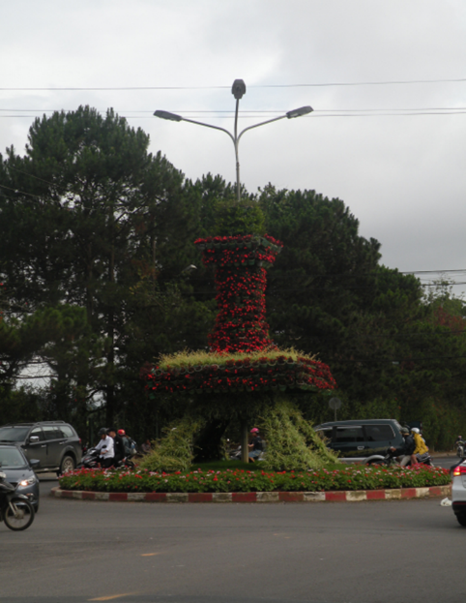

Source: A. T. Lê, 2017.
Figure 3. Giant strawberries, but a reduced-scale Eiffel Tower

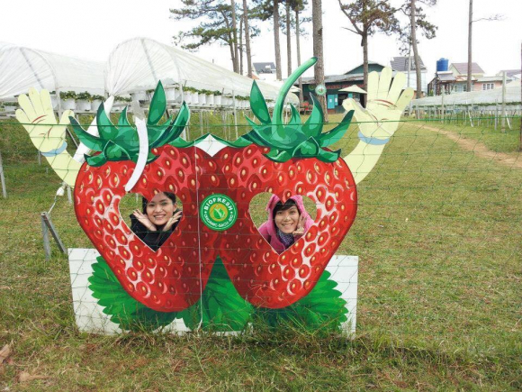
Source: A. T. Lê, 2017.
Figure 4: Nepalese visitors climbing the reduced-scale model of Manaslu (8,163 m in reality), garden of the International Mountain Museum, Pokhara
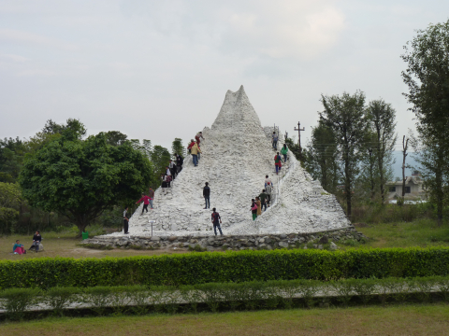
Source: P. Dérioz, 2014

Figure 5: Visit to a miniature Mount Langbiang within the Clay Tunnel, Da Lat
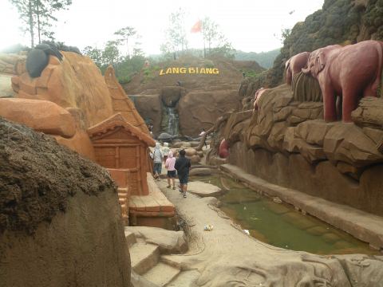
Source: P. Bachimon, 2017.

This multi-scale game has its replica in the souvenirs brought back by tourists (an Eiffel Tower in a snow globe, a big cuddly panda, etc.), the size (and the material) being conditioned by the standard for carry-on luggage, especially when these are the final purchases made in the airport duty free shop.

These effects of exoticism, extravagance and modifications of scale are also and inevitably obtained by another recurrent characteristic of kitsch: the use of fakes (Baudrillard, 1981). More often than not, the kitsch object is inanimate, as a decorative element and as an in situ contextualization of a narrative. Sometimes it can be disproportionately portrayed, as in Guilin and Tianmen (Xiang et al., 2017), when it comes to producing a grandiloquent sound and light show. We can deduce from this that “kitsch is always based on a lie” (Menon, 2006), which Umberto Eco (1985) called an “artistic lie”.

The Chinese villages, which are echoed in the “ethnic” neighbourhoods that are developing in Sandu, have been transformed by numerous artefacts designed to idealize the atmosphere of the places so that they resemble as much as possible the picture-perfect Chinese landscape – the shan shui, a landscape of mountains and water – and reinforce its ethnic character (Gauché, 2017). In Gulu, for example, false façades of wooden houses have been built, while large pebbles visible in a rock face, called “stone eggs”, have been staged by creating an artificial waterfall flowing over fake rocks, bearing a false inscription of a “real” Chinese poet in order to reinforce the spirituality of the place. Access to the site is via a steep path, built from scratch and adorned with statues of Sui gods with a phantasmagorical appearance, which the “official” account of the site claims to be the true image of the Sui gods although these do not actually have a proven form in the culture of this minority.

Moreover, next to Da Lat, some so-called ethnic minority villages (such as Lang Cu Lan) have also been created from scratch for tourists who can stay there in concrete huts in a pleasant setting where they are told mythological stories and cosmogonic legends that are totally made up.

This use of the fake corresponds to the cumulative bias of soliciting a maximum number of signs in a place in order to create the most exceptional tourist experience possible, with minimum financial investment (low cost of the materials used, replicas without copyright, etc.) for a maximum number of visitors (standardized mass tourism itineraries). This bias tends to modify the place of the rural landscape in the kitsch scenographic mechanism.

2.4. From the productive to the decorative rural landscape.

The rural landscape enters the tourism system as “naturation” (an aesthetic naturalism). The latter produces replicas of it (plastic strawberries, reconstituted ethnic huts, fake alpine chalets, and so on). But it is beyond the rural environment that the referents of most amusement parks are sought. The “wild” space is the undisputed star in this case. For example, in the Valley of Love (Da Lat) a jungle is reconstituted rather succinctly, in which almost life-size fake animals in resin (tigers, rhinos, elephants, etc.) are frozen in place. The aim here is not the quest for reality, but rather a conjuring up of reality around an attraction (a form of concentration in an enclosed place) giving an impression: that of visiting one or more types of forests that look real, at least in the photo or the streaming video when visiting the place in a vehicle (jeep, toboggan, pedal boat, etc. – (Figures 6, 7 and 8). Kitsch also presents the paradox of wanting to make the artefact visible by making invisible everything that is more or less closely related to what can be considered to be the authentic object.

Figure 6: Cement mushrooms in the Maple Leaf tourist area (Da Lat)

Source: A.T. Lê, 2017

Figure 7: The toboggan – an exotic attraction at Datanla (Da Lat)

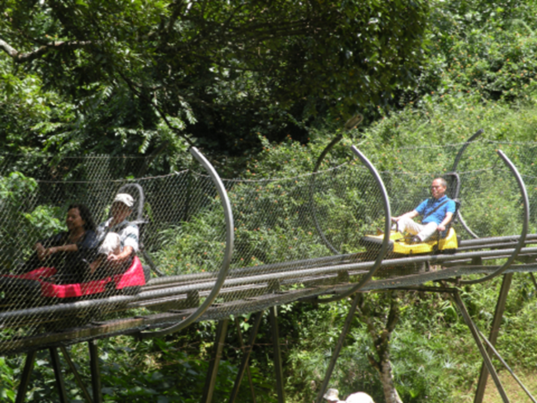

Source: A. T. Lê, 2017

Figure 8: Bubbles on Lake Pokhara

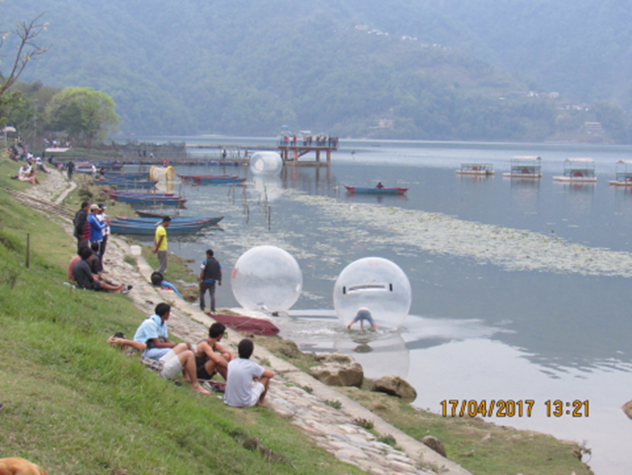
Source: P. Bachimon, 2017

Subsequent to the landscape artefact, “rurality” is declined in the consumable “product of the land”. Around Da Lat, this goes from the greenhouse where tourists can “pick & carry” their own strawberries, to rose gardens and even fields of lavender or thyme offering purplish colours, where the landscape dimension is enhanced by that of exotic fragrances. A new form of tourism is developing around these acclimatization gardens, namely rural tourism, of an exotic rurality, here with a very European influence. During the flower and fruit seasons in Da Lat, the farmers add the visit of their fields to complement their agricultural activities. Thus, in the flower farms (which invariably grow lilies, roses, sunflowers and hydrangeas – Figure 9 and 10), the entrance fee of VND 10,000 to VND 30,000 per person (i.e. between EUR 0.4 and EUR 1.2) includes the possibility of picking the flowers and taking photographs in the fields. Since colonial times, Da Lat has been famous for its temperate climate fruits and vegetables (including its famous artichokes) intended for residents on holiday (“fresh garden produce diet”). More recently, the region has started producing wine with direct sales at the “wine cellar” (since 2008). Here, too, an artifice is involved. This consists of mixing blackberries with grapes to obtain a red wine bottled under the name of “Château Dalat”, for example, with tastings proposed in the cellar of a largely fake winery, in reality no more than a bottling plant.

Figure 9: When the fabricated landscape (fields of lavender and sunflowers) becomes a setting dedicated to photography
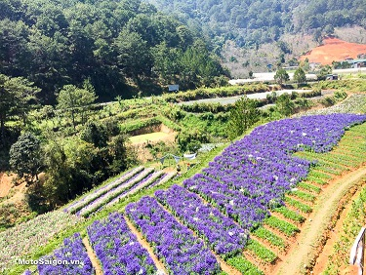

Source: https://motosaigon.vn/​cafe-f-canh-dong-hoa-tren-deo-mimosa-da-lat-dep-nhu-chau-au.html

Figure 10: When the fabricated landscape (fields of lavender and sunflowers) becomes a setting dedicated to photography
Source: https://motosaigon.vn/cafe-f-canh-dong-hoa-tren-deo-mimosa-da-lat-dep-nhu-chau-au.html

In the tourist resorts of South and Southeast Asia studied, the staging of this kitsch imagery and its reification thus create a product. The resulting kitsch landscape has to be related to the specific experience that these destinations want to offer tourists.

3. The kitsch landscape at the service of a total tourism experience.
We speak of a “total tourism experience” (Bachimon, Decroly and Knafou, 2016) in the sense of an experience that satisfies all the supposed expectations of visitors, and even exceeds them, because to this is added the “wow factor” generated by the exceptional nature of the system (spectacular attractions, dizzying rides, etc.). In the sense, also, that it is completed by souvenirs that will become anchored in the positive memory, that of the holiday and the regeneration expected of it. This is indeed the purpose of tourism kitsch, which, to quote C. Menon (2006), aims at “pleasure (and therefore money), [and for whom] everything must be transformed into a show, a source of entertainment, a picture postcard”. Inevitably, kitsch leads to consumerism. The kitsch experience is but an illusion of a change of scenery, shared by its consumer and its promoter. The feeling of well-being it leads to stems from its sweetening effect, combined with the social valorization expected in return and for which the selfie (immediate proof) has replaced the photo (deferred proof).

3.1. The surreality of the fake becoming more real than real
In kitsch scenography, all artefacts are mobilized to obtain a surrealistic effect, in the sense of being more realistic than the original or “more real than real” (Eco, 1985). Or even more tangible than reality (Eco, 1996), in the sense of being easier to see, touch and feel. In fact, the result is a kind of enchantment (Menon, 2006).
In a kitsch tourism system, stereotypical representation6 prevails over the represented object to the point of erasing it as a referent. To invert the statement by René Magritte (1929) who, when looking at a representation of a pipe, considered that “this is not a pipe” but its image, the representation is self-sufficient in itself, and leaves as a question only the truthfulness, or rather the likelihood of the “transitional object” (Winnicott, 2010).
Up to a certain point, kitsch will confer a value of near authenticity on replicas of original objects (both architectural and cultural), with the complicity and consent of tourists. Da Lat is one of the most “typical” places of this amalgam in which the kitsch object, through its distancing from the pretext object, acquires total autonomy. In Lang Cu Lan near Da Lat, as in the Chinese minority villages, tourists do not have the means to verify the veracity of the stories and legends recounted for them. In the village of Gulu, in order to amplify the exceptional nature of the experience, the statues of Sui gods that have been added to the site are associated with the completely invented story, transmitted by the guides, that Gulu is the village of 1,000 Sui gods. Similarly, because of the importance of song in Sui culture, primarily based on an oral tradition, the guides romanticize the story by saying that, even today, children still communicate with each other by singing.
However, no young people in the villages actually know traditional Sui songs, these being mastered by only a few elders or partially relearned by some individuals for the benefit of tourists. In Vietnam, these landscape additions aimed at satisfying tourists are even integrated into the music: in the Koho Lat gong shows for Vietnamese tourists, much of the music is inspired more by Vietnamese pop hits than by traditional koho music (Clavairolle et al., 2019). As Pal Nyiri noted for China, most tourists do not have an attitude of questioning the veracity of the stories and the “authenticity” of the landscapes they visit (Nyiri, 2006).
Chinese tourists are satisfied with the experience offered to them in ethnic villages: an aesthetic, spiritual, ethnic and modern experience. They appreciate the transformations of villages promoted to the rank of official tourist sites, which correspond to their expectations. They admire this “false” heritage and prefer “a modern experience rather than an authentic one” (Taunay, 2011), a position that is also found in Vietnam among the national clientele.
Today, Da Lat is extending the process of kitschification to its gastronomy. Thus, this city, which for the Vietnamese is considered (and touristified) as the “Little Paris”, has to accumulate demonstrative attributes – wine tasting being one of them, even if no connoisseur would agree to give this red alcoholic liquid the qualifier of wine (Figure 11). Visitors appreciate it, however, and this “wine”, which bears the names of “Châteaux”, was chosen by the President of Vietnam as the beverage representing the country during the APEC summit in 2006. This confirms that, in the final analysis, kitsch becomes a self-fulfilling prophecy of the kind “what I market as wine, or as an Eiffel Tower... becomes wine, an Eiffel Tower...”

Figure 11: The “wine” of Da Lat, pride of the Vietnamese people
Source: A. T. Lê, 2012.

3.2. Encouraging consumerism
Incitement to consumerism is strong when it is practised as a means of proving its presence in the place visited (Bachimon, Decroly and Knafou, 2017). It is expressed in the plethora of in situ experiences (such as the multiplication of “not-to-be-missed” amusement parks) and the overwhelming multitude of souvenirs to bring back home. These objects are presented in kiosks and shops on the “must-see” sites, which are visited according to the unambiguous sequence of a signposted and guided tour. It is also on these sites that photos of oneself (and more and more selfies) are taken in situ. Photographs that, combined with the souvenirs purchased, certify the visitor’s narrative, the latter therefore being particularly encouraged to consume in order to prolong his or her experience. In La société de consommation (1970), Baudrillard described this logic of consumption that stems from the kitsch contextualization: “The solicitude of advertising and services, the smile, the ideology of happiness, the repression of anguish and ambivalence, the flattening out of any object by tolerance, the ‘combinatorial game’ of the system, the magic aspect that creates the atmosphere, all this cries out for kitsch.” When the sign merges with the object (when a pale imitation of wine takes on the status of wine, or when a pedal boat shaped like a swan becomes the only “swan” on the lake and photographed as such), a “soft” atmosphere is created, a sentiment of well-being conducive to the consumption of “addictive” products (drinks, sweets, snacks) intended to enhance the tourist experience, which must be as total and complete as possible. This consumerist space turns out to correspond to a nebula (a gaseous state according to S. Dawans and C. Houbart, 2011) as soon as the objects/signs present inconsistencies with each other and with their system of reference. The kitsch resort derives its attractiveness from this kind of inconsistency that produces a surprise effect, for want of the real astonishment of aesthetic emotion (Stendhal, 1826), which leads to consumption.
The question is therefore posed: why is this kind of “natural” site developing more and more significantly in Da Lat in particular and in Vietnam in general (or even in other countries of South and Southeast Asia such as China, Cambodia, Thailand, etc.)? The following table (Table 12) gives an answer in terms of costs (figures are given in euros).
Figure 12: Comparison of the relative price paid by a visitor to a kitschified and non-kitschified nature site in France and in Vietnam
 | Vietnam | France
Kitschified nature (1) | Datanla Waterfall  Products: Entrance fee + Toboggan + Cable car + Lift  = EUR 7/person | Disneyland amusement park  Product: entrance fee EUR 75/person (1 day/1 park)
Naturality (2) | Bidoup National Park  Product: Trekking EUR 35/day/person | Arêches-Beaufort ski resort  Products: chairlift EUR 30 + ski rental EUR 38  = EUR 68/day/person
Standard of living of the inhabitants | EUR 175/month | EUR 2,100/month
Proportion (1)/(2) | Kitschified nature is five times cheaper than non-kitschified nature | Kitschified nature is more expensive than non-kitschified nature
Source: A. T. Lê, 2019.
If we compare the price of kitschified nature to that of non-kitschified nature in France and in Vietnam, we can see that for the latter country, the packaging of products from kitschified nature is five times cheaper than a trek in the Bidoup Nuiba National Park. In France, conversely, a day of entertainment at Disneyland costs more than a day’s skiing. The cost largely explains the fact that Vietnamese tourists, with the intermediate purchasing power that characterizes emerging countries, seem to prefer kitschified products. This difference in the tourism development of kitschified and non-kitschified nature can be expressed through the following tourism landscape gradient (Table 13).
Figure 13: Tourism landscape gradient
 | Kitschified nature | Non-kitschified nature
Signs | Profusion  (Maximizing) | Economy  (Minimizing)
Objects | Substitutes | Authentic (label)
Message | Immediacy | Interpreted intermediation
Products | Cheap | More expensive
Spatial position | Central resort | Peripheral area, reserve, national park
Otherness | Reduced (groups) | Strong (change of scenery)
Source: P. Bachimon, 2018.
Kitschified nature accumulates a maximum of signs, and uses substitutes and fake objects to produce immediate effects. Its products are sold cheaply to serve a mass tourist clientele. While they provide customers with a reduced otherness, not too out of step with their daily life, this is also what makes them accessible. On the contrary, a “naturality” product offers a minimum of signs, authentic objects, and the message is then more a matter of interpretation than intermediation. The price to be paid is then higher because, to experience it, it is necessary to travel to peripheral areas, reserves or national parks.

3.3. Well-being and the false semblance of a change of scenery.
The kitsch tourism system claims, in its communication in particular, to provide its customers with an unusual and exceptional experience by producing the illusion of thrills and adventure. An experience that will then – or even immediately via selfie and social media – provide social value. In the Clay Tunnel, a kind of Da Lat version of Minimundus made of clay covered with concrete (and therefore 100% fake), as well as in the village of Gulu, the paths leading respectively to the “monuments” (the cathedral, Mount Bidoup, the statue of Yersin, etc.) and to the site of the stone eggs are punctuated with notices warning about the “slippery” and “risky” nature of the walk (“Caution”, “Dangerous”, “Hold on to the railing”). This sensationalism is promoted to tourists as an experience cut off from the rest of the world. Thus the fake ethnic village of Lang Cu Lan has been designed in a kind of deep, closed crater, which produces a “bubble” effect (Moles, 1971), an isolate that reinforces this impression. It is moreover the paying aspect of the sites (the ticket) that automatically makes them separate and paradoxically protected spaces. Da Lat is promoted in millions of copies as a “honeymoon” destination. There are therefore references to Verona (with the cult of Romeo and Juliet), Paris (with its Pont des Arts and its hundreds of thousands of love locks), Venice (with its gondolas under the Bridge of Sighs), but also to cruises on a kind of “swan lake”. Not forgetting wine (and the distinguished intoxication it brings), roses, tulips and strawberries, and more recently lavender. All of these factors contribute to make the site a Vietnamese Las Vegas through a kind of “Disneyfication” effect (Brunel, 2012).
While it aims to be exceptional, the kitsch experience is also meant to be reassuring and must provide the tourist with an illusion of well-being. This is the case with the stereotype of paradise that can be experienced during a honeymoon, which, to be successful, will “obviously” take place on the shores of a lake (“narcissistic” surface as a mirror in front of which selfies can be taken and where pedal boats can be hired), on which fake swans, symbolizing fidelity, swim (Figure 14), and that is bordered by open-air cafés. Another example is the reproduction of an old steam train, symbolizing longevity (Document no. 15), a dream setting for taking photos (the “official” photograph taken by a professional come to immortalize the experience).

Figure 14: Swans materialized in the form of pedal boats on the artificial lake of Xuan Huong, Da Lat
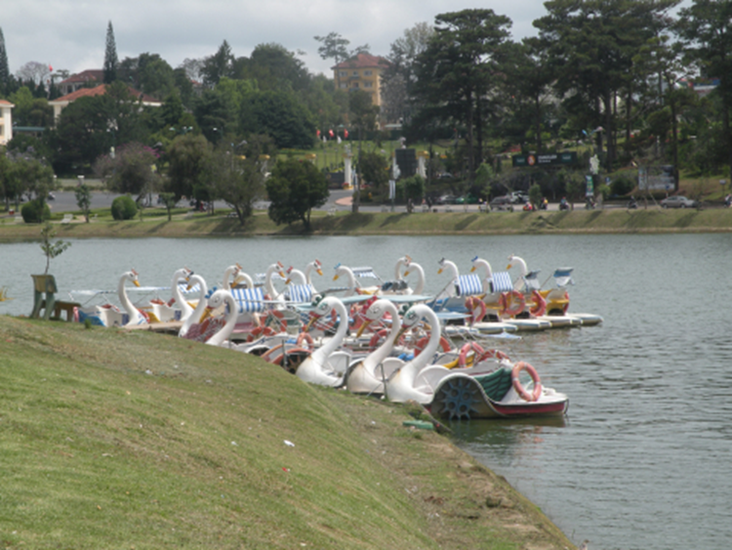
Source: P. Bachimon, 2016.

Figure 15: Newlyweds standing in front of a train carriage in Da Lat station
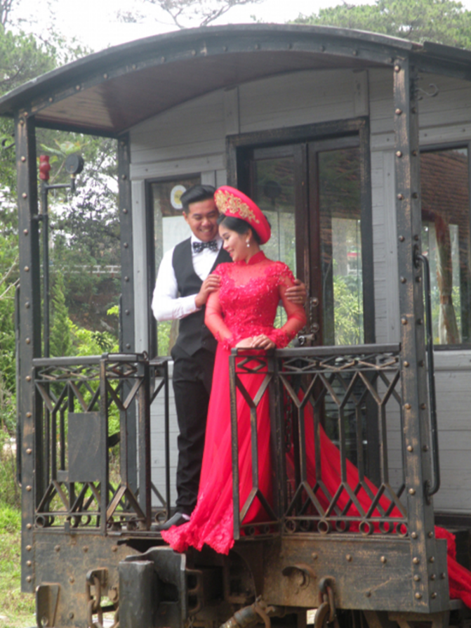
Source: A. T. Lê, 2016.

4. The subliminal message of kitsch
What is the purpose of kitschifying tourist areas, or for whom is this kitschification performed? The direct experience offered to tourists appears to be coupled with a subliminal message that we are going to decipher; a message that, beyond appearances, gives a certain depth to what has none... at least on the surface.

4.1. A figure of cheap western modernity
From an economical perspective, kitsch is a “figure” of modernity that is therefore not expensive. In the first place, the artifice (stucco, plastic) costs less than the original, whether it is a matter of reproducing it or making a short trip to see it (instead of multiple long trips to visit scattered originals). Da Lat thus brings together a maximum of objects reminiscent of Paris. This “cheap” nature of the stand-in is indeed a form of democratization that makes it possible to satisfy a Vietnamese clientele whose standard of living does not facilitate travelling to faraway destinations.
The question raised by the kitsch impregnation of the East is that of the relationship it cultivates with its Western equivalent. In the East, kitsch has a tangible and living religious filiation (Pinney, 1995; Olalquiaga, 2013) that the Baroque, now considered heritage, formerly had in the West. But in the East, kitsch is also a mode of westernization based on custom. One could say that it plays the role of the icon serving to show (and therefore to be satisfied with) what is visible in modernity (in the case of the icon it is the finery and pomp of a deity) without going beyond that.
If in a way kitsch allows a kind of democratization of access to modernity and mass tourism, as well as a figure of westernization, it actually conceals a political strategy.

4.2. Soft power or an anaesthetic aesthetic...
This process of kitschification, which is complex and which currently prevails in the construction of many of Asia’s tourist landscapes, is not without corresponding to various but no less composite strategies.
Indeed, it is by virtue of this use of kitsch by political power that C. Menon (2006) employed the expression “demagogic kitsch”. This refers to a process that aims to obliterate “the critical consciousness of individuals” (according to the same principle as circus entertainment under imperial Rome) and to legitimize power through the implementation of a certain number of aesthetic scenic mechanisms that “take hold of public opinion and build loyalty”, by anaesthetizing it in its relationship to reality. Kitsch is thus part of a process of the exploitation of landscapes, which become “soft” constructions (Baudrillard, 1981, 1990) with consensual appearances (false semblances), because they are frozen in time, far from the hazards and contradictions of ordinary everyday life experienced outside these protected places. Quite simply put, kitsch corresponds to what C. Menon (2006) referred to as an “anaesthetic aesthetic”.
Kitsch is similar to soft approaches (slow, soft... or even smart) in the sense that it only takes from the world (and presents) the sweetness of sugary treats, the relaxation of background music, the soothing scent of fragrances and the enchantment of objects, through which the positive part of existence is played out (that of childlike joy, the happiness of newlyweds, etc.). This pleasant universe (a golden age revisited and revised by the fountain of youth effect of kitsch) is that of the smiling photos and videos now taken in selfie mode. Also kitsch, which only shows the good side of things, does so at the cost of superficiality, interference, or even blurring with the surrounding reality, eliminating “from its field of vision all that is essentially unacceptable in human existence” (Kundera, 1985). “Like a sedative, by repressing worries and depression, it allows life to flow like a long, tranquil river, crossed only by aesthetic emotions” (Menon, 2006).
It should be noted, moreover, that the figures of reappropriation (and in particular diversion) are few in such a kitschy environment. In some Da Lat sites (a good example being the Clay Tunnel – Document no. 5), there are a few inscriptions (graffiti), but on the whole they are absent (or erased) from a system that does not envisage its self-criticism, and even less so its mise en abyme. To this end, it has recourse to meticulous maintenance aimed at erasing any asperity, any opening towards a reverse side of the “accredited” discourse. Indeed, “kitsch is totalitarian. Consensus must be absolute, without ulterior motives, without doubts: above all, the critical awareness of the subject must not be awakened, nor must the object or its raison d’être be questioned. (...) Behind the light appearance of the kitsch object hides a gentle violence” (Menon, 2006). As the author explains (Ibidem), “for these illusions to be effective, it is absolutely not important for them to be plausible; they must be beautiful and exciting”. Such is the case with the legend of Romeo and Juliet highlighted by a large statue on top of Mount Langbiang near Da Lat.

The kitschification of tourist sites is ultimately presented as a process of idealization of landscapes that is part of the ideology of the ruling power.

4.3. In the service of the legitimization of power
Kitsch conveys only positive messages, reinforcing a simplifying political ideology, that of a perfect world based on the dialectic of the material and the ideal. In Vietnam, the site of Lang Cu Lan is a staging of this dialectic. The itinerary, above all ethnic, inserts in its middle, juxtaposed with huts exhibited as the traditional habitat of the minorities, a military system presenting the objects of a war scene (Figure 16 and 17). These include a jeep, a tent, tin trunks, rockets, and so on, where the atmosphere is that of a “military” camp, that of the Viet Minh and the Viet Cong army fighting for the liberation of the country. And the only supplement to the walking tour is a jeep tour in the jungle around the “village”.
The subliminal message is quite broad: the Vietnamese army protects minorities, even if we know that in the unofficial discourse of the Kinh majority, it is distrust that prevails with regard to the “suspicious” behaviour attributed to minorities, believed to have acted as back-up troops in the war against the French and the Americans. The kitsch mechanism thus erases the politically incorrect interpretation of a Vietnamese army oppressing minorities, or of a government continuing to monitor them closely through regroupings in bungalow villages that have no ethnic character... and that are not visited.

Figure 16: Military tent and jeep next to a K’ho hut. Lang Cu Lan, Da Lat
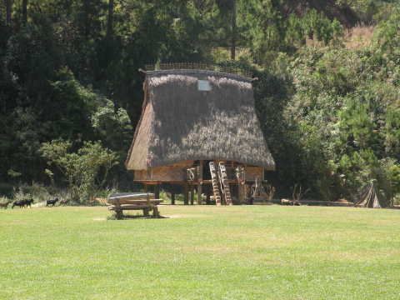
Source: A. T. Lê, 2017

Figure 17: Military tent and jeep next to a K’ho hut. Lang Cu Lan, Da Lat
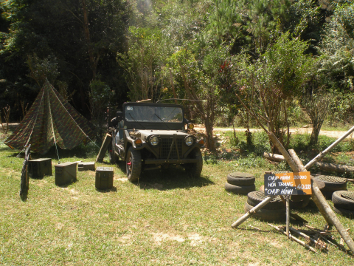

Source: A. T. Lê, 2017
In China, the political message is that of building a national identity (nationalist ideology), which is that of the Han majority. Thus the kitschification of tourist sites is carried out by artifice, aiming to show the diversity and richness of the cultures of ethnic minorities within the framework of a valorization of the shan shui landscapes, a prestigious symbol of Chinese culture. Through the promotional image aimed at tourists, which presents their happiness at living in harmony with nature, where we find the contributions of modernity within the touristifed villages (public lighting, car parks, fire-fighting equipment, etc.), this tourism development is also a way of enhancing the socialist ideal (Véron, 2013). Thus, in China, in ethnic minority villages open to visitors, a national narrative is constructed with an underlying patriotic dimension (Oakes, 1998). In Vietnam, the same ideology can be found (around the Kinh majority), but it is less in the grandeur of the State and more in that of the superiority of a people who have defeated all imperialisms, whether Western (the French and the Americans) or regional (the Japanese and the Chinese). This syncretic staging then appears to be only the nationalist counterpart of a social peace.
Thus in Vietnam, but also in China, “tourism serves as a national showcase, which the State mobilizes in the service of a sovereign, united and unanimously socialist nation (...) Ethnology museums, for their part, convey the image of a nation united beyond the different ethnic groups” (Cabasset-Semedo et al., 2010).
In the Nepalese mountains, finally, authenticity is not necessarily sought after but seems to impose itself around the concept of uniqueness. Is there an awareness that the economic interest is not in the denaturing that the kitschification of the mountain landscape engenders? A kind of restraint, of minimalism undermined by the advent of motorized trails that encourage the “rise” of products (décors, uses, etc.) of a superficial modernity? While the valleys of Nepal, like the Vietnamese mountains, were high places of communism, Nepal does not escape this exploitation since it is finally a question of imposing the majority view through the Hindu aesthetic, which is not that of the minorities, often Buddhist, found in the trekking valleys. In Vietnam and China, certainly more so than in Nepal, the situation is closer to a historical compromise between two materialisms: Marxism, the official ideology and that, in its fight against idealisms (which are supposed to hide reality) proposes equal access for all to everything, and liberalism, versus consumerist materialism, with happiness deriving from the consumption of tangible products. We could thus re-situate the phenomenon of kitschification in the political transition that marks the emerging societies of the Far East, from one model (Marxist) to another (liberal). A seemingly “soft” transition since it can be presented as a symbiosis of the two.

5. Conclusion
Kitsch confers upon replicas of objects (be they architectural, natural or cultural) a specific value, that of subsidiarity. This effect can in turn form part of the authenticity of the destination (the example of colonial villas) – an authenticity that is also reproduced, stereotyped and multiplied (Davallon, 2006).
The fact remains that kitsch is above all a subliminal object message. Subliminal inasmuch as it is not portrayed as a message, but rather as the absence of a message in the sense that pale imitations become sufficient in and of themselves. Obviously, as we have seen, the message is strong: that of a “soft” world, the watered-down character of which rests on a transmutation of the reality in a reductive and naïve staging mechanism (or at least claiming to be so), but also “totalitarian” since it involves all the senses and offers no alternative.
Thus, contrary to the thesis developed by C. Génin (2006) defending the idea that, in Western societies, kitsch takes on a rather subversive dimension, kitsch in Asia appears to constitute a strategy for legitimizing the power in place since it is, unlike in the West, the very product of the actors in power.
Kitsch has attained unofficial cultural status in Asia. Its strong presence acts as a means of moving away from dogmatic austerity, and its proliferation as a kind of cheap antechamber from one world to the other. But it is above all a political message, which makes it possible to rewrite a happy material end to current history (there is no post socialism in China, for example, just as there would be no celestial royalty in Thailand or Nepal). A kind of “presentism” (Hartog, 2003) of the best of worlds characterized by material signs of self-sufficient abundance. Kitsch could be a sublimation of the tensions and contradictions that mark society, by the profusion that simulates abundance, as in the self-fulfilling prophecy of the cargo cult in Melanesia (Worsley, 1970). It is true that cyclically recurring events such as Christmas, Spring, the flower festival and so on constitute the secularized ritual of festivals and other celebrations, and also give an impression of eternity (in the sense of an eternal return), a dream setting for the immutability of a time that no longer elapses. The cardboard or plastic swan is perennial, like the reconstructed concrete ethnic hut or the revolutionaries’ jeep – compared with nature, more uncertain and recently affected by an acceleration of its variability due to climate change. The invariant of kitsch is reassuring in the sense that it combines nostalgia with modernity, in an assortment that is typical of postmodernity. The question could be whether the artificialization of the landscape in the kitsch tourism system is an effective tool in the planning of tourist spaces. It has been seen that it is particularly cheap, which thus makes it possible to open places up to mass tourism – at the risk, obviously, of an acculturation and denaturing that, moreover, appear to be assumed. But finally, if the economic counterpart seems simple to understand, at least in the short term, the inanity of the kitsch tourist experience, as well as its durability resulting from its lack of originality (and therefore its infinite reproducibility) or even its conformism, nevertheless raise certain questions. Is kitsch only the initial phase of tourism development, to be followed by phases of cultural sophistication – and perhaps going as far as its heritagization, or even a period of renaturalization?

6. References

Bachimon, Ph., Decroly, J.-M. and Knafou, R. (2016). Expériences touristiques et trajectoires de vie. Rapports à la nostalgie”, “Tourist experiences and life trajectories”, Via [En ligne], 10/2016, http://journals.openedition.org/viatourism/1336.

Battesti, V. (2017). La nature version kitsch / In Egypt, nature in its kitsch version, The Conversation, 23 March 2017.

Baudrillard, J. (1970). La société de consommation. Paris: Folio.

Baudrillard, J. (1981). Simulacres et simulation. Paris: Galilée.

Baudrillard, J. (1990). Enrico Baj – Transparence du kitsch. Paris: Editions de la différence.

Brunel, S. (2012). La planète disneylandisée: Pour un tourisme responsable. Paris: Sciences Humaines Editions. DOI : 10.3917/sh.brune.2012.01

Cabasset-Semedo, C., Peyvel, E., Sacareau, I. and Taunay, B. (2010). De la visibilité à la lisibilité : le tourisme domestique en Asie. Espace populations sociétés, 2010/2-33. DOI : 10.4000/eps.4118

Davallon, J. (2006). Le Don du patrimoine: Une approche communicationnelle de la patrimonialisation. Paris: Hermes Science-Lavoisier.

Dawans, S., and Houbart, C. (2011). Le patrimoine à l’état gazeux : comment le tourisme détourne notre conception de l’authenticité?. Paris: ICOMOS, pp. 592-598.

Clavairolle, F., Dérioz, P., Déry, S., Ducourtieux O., Garambois N., Gauché, E., Landy F. and Laques, A. E. L. (2019). Programme AQAPA, A Qui Appartiennent les Paysages en Asie ?, Final Report to the ANR, Scientific paper.

Eco, U. (1985). La guerre du faux. Paris: Grasset et Fasquelle.

Gauché, E. (2017). Mise en tourisme d’un village shui dans la province montagneuse du Guizhou (sud de la Chine) : imaginaires et instrumentalisation politique du paysage. Journal of Alpine Research | Revue de géographie alpine [online], 105-3, http://journals.openedition.org/rga/3830. DOI: 10.4000/rga.3830

Ged, F. (2010). Protection du patrimoine et développement du tourisme en Chine : quels enjeux pour quels territoires ?. Tourisme et patrimoine, un mariage difficile, Mondes chinois, 22, 6-19.

Génin, Ch. (2006). Le kitsch : une histoire de parvenus, Actes sémiotiques. Proceedings of the conference “Kitsch et avant-garde. Limoges: University of Limoges, 29-30 September 2006, https://www.unilim.fr/actes-semiotiques/3268

Génin, Ch. (2010). Kitsch dans l'âme. Paris: Vrin, Collection Matière étrangère.

Goulet, A. (1994). Le stéréotype : crise et transformation. Caen: PUC. DOI : 10.4000/books.puc.9695

Jennings, E. (2013). La ville de l’éternel printemps. Comment Dalat a permis l’Indochine française. Paris: Payot.

Hartog, F. (2003). Régimes d’historicité. Présentisme et expérience du temps. Paris: Le Seuil.

Kohler, F. (2017). Stéréotypes culturels et constructions identitaires. Tours: Presses universitaires François-Rabelais. DOI : 10.4000/books.pufr.6244

Kundera, M. (1985). Discours de la remise du Prix Jérusalem, texte publié dans L'Art du roman (Gallimard, 1986).

Legrand, E. (2005). Séductions du Kitsch. Roman, art et culture. Montréal: Editions XYZ.

Menon, C. (2006). Le kitsch : un manuel, Travail de Fin d’Etudes. Bruxelles: ISACF La Cambre.

Moles, A. (1971). Qu’est-ce que le kitch ?, Communication et langage, 9, 74-87.

Moles, W. and Whal, E. (1969). Kitsch et objet. Communications, “Les objets”, 13 (1), 105-129.

Nahoum-Grappe, V. and Vincent O. (dir.) (2004). Le goût des belles choses. Paris: Editions de la Maison des Sciences de l’Homme, Ministère de la Culture, Collection Ethnologie de la France.

Nguyên, V N. (2016). Dalat – Đà Lạt một thời hương xa. NXB Tre.

Nyiri, P. (2006). Scenic spots: Chinese Tourism, the State, and Cultural Authority. China: Program Books.

Oakes, T. (1998). Tourism and modernity in China. London: Routledge. DOI: 10.4324/9780203978344

Olalquiaga, C. (2013). Royaume de l’artifice : l’émergence du kistch au XIXe siècle. Fage Editions.

Peyvel, E. (2009). L'émergence du tourisme domestique au Vietnam: lieux, pratiques et imaginaires. Doctoral thesis in geography, University of Nice-Sophia Antipolis.

Pinney, Ch. (1995). An Authentic Indian Kitsch : the Aesthetics, Discriminations and Hybridity of Popular Hindu Art, in Social Analysis: The International Journal of Anthropology, 38, ‘Too Many Meanings’: a Critique of the Anthropology of Aesthetics, pp. 88-105.

Sacareau, I. (1999). Les transformations d'une haute montagne par le tourisme : le massif des Annapurna dans l'Himalaya du Népal, Annales de Géographie, 108 (605), 21-45.

Schultz, P. (2003). 1000 Places to See Before You Die. Workman.

Stendhal, (H. Beyle dit) (1826). Rome, Naples et Florence. Paris: Delaunay.

Taunay, B. (2011). Le tourisme intérieur chinois. PUR, coll. “Espace et Territoires”.

Taunay, B. (2017). Les enjeux politiques du développement touristique à Sandu. Présentation en atelier AQAPA, 24 avril 2017, AgroParisTech.

Véron, E. (2013). Les espaces ruraux touristiques dans le delta du Yangzi, entre intégration ville-campagne et développement rural. EchoGéo, 26. https://echogeo.revues.org/13607. DOI : 10.4000/echogeo.13607

Worsley, P. (1970). The Trumpet Shall Sound: a study of “cargo” cults in Melanesia. London: Paladin.

Winnicott, D. W. (2010). Les objets transitionnels, coll. “Petite Bibliothèque Payot”, Paris: Payot.

Xiang, W., Bachimon, Ph. and Dérioz, P. (2017). Le spectacle de plein air dans les sites paysagers remarquables des montagnes chinoises : entre réinvention d’une tradition et mise en tourisme. Exemple du spectacle “Renard du Mont Tianmen” à Zhangjiajie, Chine”. RGA-JAR, 105-2. http://journals.openedition.org/rga/3707. DOI : 10.4000/rga.3707.

Professor of Geography, University of Avignon, UMR Espace-Dev 228 IRD philippe. Email: bachimon@neuf.fr Id.Orcid: https://orcid.org/0000-0002-5655-257. * Autor para la correspondencia
Associate Professor in Geography, University of Tours, UMR CNRS 7324 CITERES. Email: evelyne.gauche2@gmail.com Id. Orcid.: https://orcid.org/0000-0001-6710-1971
. PhD in Geography, University of Avignon, UMR Espace-Dev 228 IRD anhthu2012@gmail.com. Id. Orcid: https://orcid.org/0009-0001-4160-4746

