The pursuit of difference as a reason for travelling decisions
La búsqueda de lo diferente como motivación del viaje

Tobias Reeh *
Werner Kreisel

Abstract
The pursuit of difference is regarded as an important stimulus for travelling decisions within the German-speaking tourism geography (Hopfinger 2007; Reeh 2011). In order to lay the ground for adopting this concept in future empirical studies, this article suggests a few thoughts on both perspectives for a theoretical foundation and an operational model to use the concept of the pursuit of difference in tourism research.
Keywords: Tourist motivations; Trips; Tourism Geography; Germany; Theoretical reflections.
Resumen
En los estudios de geografía del turismo en alemán (Hopfinger 2007 ; Reeh 2011), la búsqueda de lo diferente se presenta como una fuerte motivación para el viaje. Si se quiere usar este paradigma para futuras investigaciones empíricas, este artículo propone unas reflexiones teóricas y también un modelo operativo para utilizar y comprender el concepto de “búsqueda de lo diferente” en la investigación turística.
Palabras claves: Motivaciones turísticas; Viajes; Geografía del Turismo; Alemania; Reflexiones teóricas.

The pursuit of difference is regarded as an important stimulus for travelling decisions within the German-speaking tourism geography (Hopfinger 2007; Reeh 2011). In order to lay the ground for adopting this concept in future empirical studies, this article suggests a few thoughts on both perspectives for a theoretical foundation and an operational model to use the concept of the pursuit of difference in tourism research.
Within the broader framework of needs’ theories, the pursuit of difference can be deduced from the quest for sensorial stimulation, which is of central importance when explaining the behaviour of human decision-making. In a psychological sense, the pursuit of difference can therefore be seen as a ‘quasi-need’. The creation of a stress state and the resulting actions depend on the development of so-called motivation factors. On the one hand they can be attributed to the situational area (environment), and on the other hand to the personal area (personality). This approach is ascribed to Lewin (1951) who defined human behaviour as the function of person and environment – the later being defined as the psychological (perceived) environment which together with the person forms the life space (Behaviour as the Function of Personality and Environment (B = F (P.E)). Accordingly, behaviour has to be understood as the product of interactions between the characteristics of persons (‘self-perception’) and the characteristics of the situational context (‘worldview’).
When needs are not gratified, tensions arise which the individual considers as displeasing and which s/he wants to alleviate (Steinbach 2003). This results in the desire to amend the unsatisfactory situation with appropriate actions (e.g. decision to makea holiday trip). The motivation to act thus becomes a concrete holiday motivation. However, the real-life everyday situation is not necessarily deficient but rather the need to experience something ‘new’ and ‘different’ that might be stimulated extrinsically by the tourist industry, and thus it may contain a ‘proactive’ component. Overall, travel behaviour can be classified as belonging to the explorative human behaviour. Typically the differences in the pursued holiday experiences do not generally coincide but differ individually. The reason for this is that the ‘homo touristicus’ does not perceive the spatial environment (Spatial experience), the personal anchor in the stream of time (Temporal experience), and oneself (Self experience) in the same way (STS model) (Figure 1).

Figure 1. STS model on Holiday Motivation
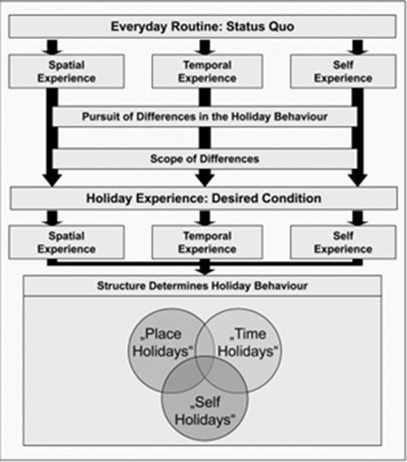

When studying ‘Spatial experience’, tourism research can refer to landscape aesthetics as well as environmental psychological approaches. In the field of ‘Temporal experience’, it is possible to carry out not only a detailed analysis with the help of time estimation tests but also to increasingly integrate experiments as a method of empirical research into tourism studies. Interesting opportunities of cooperation also exist with related sciences in the area of ‘Self-experience’.
Here, for example, standardized psychological test methods can be used to cover the following aspects: life satisfaction, stress management and self-attention. It is evident that the perspectives that are outlined above result in a considerable demand for future research. In this case, the pursuit of difference must be connected much closer to explanations of human behaviour, whereby it is especially important to reveal the respective significance of the conative, affective and cognitive components (Gnoth 1997; Young 1999). To do so, we need detailed empirical analyses considering the individual dimensions of the tourist and, also, we have to investigate possible interdependencies between these dimensions. Furthermore the nature of the pursued experience of difference has to be taken into account with regard to the stimulus intensity. Finally, it is necessary to link the STS model to the holiday behaviour observed in real-life in order to better understand, for example, the impact of basic conditions such as the available travel and time budgets or the role of the travelling companion, which leads to identical searches of differences resulting in various ways to make a holiday.
The pursuit of differences as a holiday motivation originates from the ‘needs theory’ and can alternatively be operationalized over the dimensions of Spatial experience, Time experience and Self experience. The sketch of the STS model helps define the assumptions of the pursuit of difference comprehensively as it allows to better understand individual differences in the pursued holiday experiences. The research of travelling decisions is not limited to the description of motivations as, with the STS model, it can develop from a marketing research with ‘data knowledge’ to a basic and applied research with ‘explanation knowledge’ (Kreisel 2011). In this case the presented thoughts could by all means prove to be an integrative conceptual framework for an interdisciplinary approach to study the phenomenon of the tourists’ search for experiences.

References
Gnoth J. (1997). Tourism Motivation and Expectation Formation. Annals of Tourism Research, 24(2). DOI : 10.1016/S0160-7383(97)80002-3
Hopfinger H. (2007). Geographie der Freizeit und des Tourismus, in Gebhardt H., Glaser R., Radtke U. & Reuber P. (Eds.), Geographie: Physische Geographie und Humangeographie, München, Elsevier, pp. 710-733.
Kreisel W. (2011). Some thoughts on the future research on leisure and tourism geography. Current Issues in Tourism, iFirst article, 1-7. doi:10.1080/13683500.2011.615914. DOI : 10.1080/13683500.2011.615914
Lewin K. (1951). Psychological ecology, in Cartwright, D. (Ed.), Field theory and social sciences: Selected theoretical papers by Kurt Lewin, New York, Harper & Brothers, pp. 17-187.
Reeh T. (2011). Das RZS-Modell als Axiom erlebnisorientierter Tourismusgeographie – eine Forschungsskizze, in Kagermeier A. & Reeh T. (Eds.), Trends, Herausforderungen und Perspektiven für die tourismusgeographische Forschung, Mannheim, MetaGIS-Systems, pp. 21-35.
Steinbach J. (2003). Tourismus – Einführung in das räumlich-zeitliche System, München, Wien, Oldenbourg.
Young M. (1999). The Social Construction of Tourist Places, Australian Geographer, 30(3), 373-389. DOI : 10.1080/00049189993648

Georg-August-University of Goettingen, Germany. Institute of Geography. Email : treeh@gwdg.de * Autor para la correspondencia.
Georg-August-University of Goettingen, Germany. Institute of Geography. Email : wkreise@gwdg.de

