The rhetoric in tourism websites: Influential voices of digital space
La retórica en sitios web de turismo: Voces influyentes del espacio digital

Ganna Zakharova García

Abstract
The persuasive influence of tourism promotional materials is increasingly evident today. To capture viewers' attention, marketers employ various techniques in their digital content, utilizing diverse voices for transmitting information. These strategies aid web designers in conveying brand messages and boosting conversions. In tourism marketing, different techniques are used to engage and persuade potential tourists to purchase tourism products through authoritative and external voices. Incorporating diverse opinions into a website provides valuable information, evokes different emotions in viewers and assists them in making final decisions. This article examines the voices used by health tourism websites to attract potential tourists and reviews the messages delivered by these voices, analysing their persuasive viewpoints. The article highlights how specific perspectives in tourism promotional materials can influence the decisions of users on health tourism websites. The results section provides real examples of voice deployment on the websites of the “Karpaty” and “Solva” resorts in Ukraine, demonstrating how they convince their audience. Different points of view are significant as they play a crucial role in promoting tourism services. The data collected in this study will offer updated insights into the rhetoric of tourism.
Keywords: tourism discourse; tourism promotion; persuasive discourse; persuasive voices; marketing influential voices.

Resumen
La influencia persuasiva de los materiales promocionales de turismo es cada vez más evidente hoy en día. Para captar la atención de los espectadores, los mercadólogos emplean diversas técnicas en su contenido digital, utilizando voces variadas para transmitir información. Estas estrategias ayudan a los diseñadores web a comunicar los mensajes de la marca y a aumentar las conversiones. En el marketing turístico, se utilizan diferentes técnicas para atraer y persuadir a los turistas potenciales a comprar productos turísticos a través de voces autorizadas y externas. Incorporar diversas opiniones en un sitio web proporciona información valiosa, evoca diferentes emociones en los espectadores y les ayuda a tomar decisiones finales. Este artículo examina las voces utilizadas por los sitios web de turismo de salud para atraer a los turistas potenciales y revisa los mensajes transmitidos por estas voces, analizando sus puntos de vista persuasivos. El artículo destaca cómo las perspectivas específicas en los materiales promocionales de turismo pueden influir en las decisiones de los usuarios en los sitios web de turismo de salud. La sección de resultados proporciona ejemplos reales de la implementación de voces en los sitios web de los resorts "Karpaty" y "Solva" en Ucrania, demostrando cómo convencen a su audiencia. Diferentes puntos de vista son significativos, ya que juegan un papel crucial en la promoción de los servicios turísticos. Los datos recopilados en este estudio ofrecerán perspectivas actualizadas sobre la retórica del turismo.
Palabras clave: discurso turístico; promoción del turismo; discurso persuasivo; voces persuasivas; voces influyentes en marketing.

1. Introduction
Since tourism is one of the biggest industries in the world, it has received great focus in research. As a multidisciplinary field, tourism is also one of the most engaging research areas, especially its discourse. Unlike other industries, tourism is an information-intensive business; therefore, the discourse of tourism mediates the relationship between tourists and destinations by manipulating various kinds of linguistic, visual, audio, and audiovisual resources to persuade potential consumers and convert them into actual clients (Jack & Phipps 2005).
Tourism marketing materials are an important source of information for potential tourists. The main objective of tourism promotion is to portray the beauty, charm, and uniqueness of a particular place. Tourism promotion engages people in decision-making concerning the destination they would like to travel to (Salim, Ibrahim & Hassan 2012). Tourism advertisements try to sell emotions, sensations, and experiences that travelers are eager to find. Moreover, promotion helps a destination differentiate itself from others and construct its own identity. Its purpose is to turn potential clients into real tourists.
Tourists cannot try a destination before booking. In other words, a holiday is not an object that prospective tourists can check beforehand, and thus, promotion plays an essential role in tourism. The consumer buys a holiday purely on the basis of symbolic expectations established promotionally through words, pictures, sounds, or promises (Morgan & Pritchard 2000).
Preliminary results indicate that the search for the ideal tourist destination and the desire to go and experience new places are supported both by strategic, persuasive language and by technological choices used in tourism promotion (Kim & Fesenmaier 2008). The promotional materials must be properly selected to beautifully present a place and persuade potential tourists to buy the advertised product or service.
Promoters have to showcase their products using effective discourse techniques due to the competition in the tourism field. Therefore, the discourse of tourism is rhetoric, implying the power of the producer over the addressee. Nowadays, tourism discourse relies heavily on various points of view or voices, the application of which can lead to the desired outcomes. Websites that use convincing opinions about a product or service become more powerful and effective. Consequently, many tourism websites have started to embed not only the subjective point of view of authors but also the voices of external parties, such as customer testimonials. These voices can be expressed verbally and non-verbally, primarily through linguistic messages, pictures, videos, 3D tours, webcams, different maps, etc. Some of these solutions are able to virtually transport prospective clients to a travel destination. Such data effectively portray reality, providing an overview of a place and simplifying communication. Due to the implication of various techniques, tourism websites become a multi-layered environment involving verbal and non-verbal elements.
The process of planning a journey is dominated by digital tools as well as by travelers’/users’ posts or opinions (Narangajavana et al., 2017). Marketers carefully choose discourses to make tourism websites engaging. Accordingly, influential strategies for websites are of paramount importance in the tourism industry. They help describe a reality, giving tourists the illusion of truly experiencing an “off-the-beaten-track” holiday (Maci 2013, p. 21). Tourist consumers purchase the expectations and benefits that satisfy their needs. To achieve the desired advertising reaction, advertisements should be designed to match these needs (Crişan, Bolyai & Cantemir 2013). Moreover, a destination should be differentiated from other destinations to be included in potential tourists’ “shopping list” (Jorgensen 2004). Using different voices on promotional web spaces is now extremely important for tourism marketers to create a positive image of a destination.
This article will review the implementation of voices in tourism website design employed by the Carpathian health resorts. The purpose of this study is to evaluate the effectiveness of these points of view in capturing and maintaining the attention of users. What makes a health resort website promotion attractive and influential will be explored, focusing this investigation on the persuasiveness of tourism discourse.

2. Methodology
To understand tourism information from a persuasive point of view, it is interesting to consider the voices that tourism texts involve in creating persuasive units. Paying attention to the different points of view will provide an opportunity to examine the nature of tourism promotion and understand how these opinions contribute to persuasive force.
The purpose of this investigation is to examine the content of health tourism websites and offer a general view of some elements of this type of discourse to better understand their main persuasive features. The techniques employed to attract potential clients will be investigated, with particular attention to the voices applying them. We will undertake a study to see real examples of the use of these techniques in health tourism promotional materials with the intention of persuasion. Specifically, we will consider the voices used by the websites of the "Karpaty" hotel and resort and the "Solva Resort & SPA" recreation-therapeutic complex (accessed from https://san-karpaty.com/ and http://solvahotel.com/en/) to encourage visitors to choose these places as their travel destinations. The selection of these websites is purposeful, as they officially represent health tourism and describe their tourism locations, healthcare services, natural attractions, and culture in very attractive language using different verbal and non-verbal strategies. The data compiled was taken during 2019-2020.
For conducting the analysis, Kress and van Leeuwen’s (2006) work Visual Grammar on visual representation was helpful in determining the specific points of visual influence. Visual Grammar allows the realization of meaning-making through the analysis of visual images, making it possible to read the images without linguistic assistance. As Kress and van Leeuwen (2006) state, images lead to various relations with viewers.
The influential techniques will be discussed in relation to their contribution to persuasive effects. Different tools that can shape tourists’ attitudes towards the services and influence their purchase decisions will be observed. In particular, we will identify voices through which different techniques are used to attract tourists during the search phase. We will provide a comprehensive view of these strategies employed to persuade.
Thus, examining the persuasive strategies will help elucidate how the discourse of health tourism works in promotional materials through various voices. We will investigate how these techniques, applied in health tourism marketing materials, construct persuasive tourism discourses. Hence, this article will demonstrate how tourism promotion now depends on particular components to offer a healthy break away from everyday life.

3. Results and discussion
3.1. Author’s Voice
The websites are communicating in a first-person point of view. The authors of these websites are not textually hidden, they are verbally personalised through the “we” pronoun (Mocini 2009). The websites’ authors and owners are “Karpaty” sanatorium and “Solva” resort respectively. Moreover, the sites offer different forms of contact (i.e., telephone numbers, e-mail address, live chat, profiles on social media) to communicate with the guests. The first-person producers try to convince the audience by providing the information from their points of view. The first person plural pronoun “we” extends the sender identity to the resorts’ staff. The use of the pronoun “we” together with “you” plays an important role in shaping messages. Owing to the first person narration combined with the personal pronoun “you”, the readers feel as if they are a part of the stories. The verbal texts ably position the addressees in a dialogic, friendly and warm relationship with the authors.
Through different verbal techniques, the authors favourably assess the locations, amenities, and surroundings, demonstrating their ideological positions. They deliberately present their resorts as the best ones evoking in readers a positive attitude toward them. Moreover, the verbal strategies create a conversational mood that reduces anxiety (Dann 1996). These resources are used as persuasive elements to influence potential tourists.
The authors depict reality in positive terms by making use of pleasant vocabulary with the aim of transmitting pleasure and wellbeing. The verbal descriptions contain many strategies whose purpose is to present the beauty, attractiveness, uniqueness, and authenticity of the resorts. The verbal items of both websites have been thoroughly selected to present appealing and convincing texts. The consistent implication of content words, nouns and adjectives in particular, arouses positive feelings in the readers towards both destinations and their services.
“Karpaty” and “Solva” are the establishments that cater to tourists seeking to improve or maintain good health. The word “treatment” becomes a keyword throughout their websites. This key-noun, which is constantly repeated in the texts, brings a positive feeling to patients. This word collocates with various phrases that make an impression that people can find the remediation of health problems in these establishments.
The authors’ verbal messages are influential. Through imperatives and conditional sentences, they direct the readers to taking actions, that is, to book the services described. They encourage the would-be tourist to act by offering to take part in the exciting experience. Examples are the following:
“Book a ticket to the Karpaty sanatorium to evaluate all our advantages personally.”
“If you want to book a sanatorium and come with children to Truskavets, you can be sure of the right choice.”
The verbal texts are supported by various visuals to present the precise perspective on the stay at these resorts. The images and videos convey the information on the places and serve to persuade the reader that the given information about the resorts is based on truth. The websites also invite the viewers to participate in these content.
As for the logos, they are introduced on the websites to function as identifications to the destinations. They introduce the resorts and portray the brand images of these places. The viewers spent some seconds focused on these elements before moving on. The logos provide positive impression of the brands and create awareness about the destinations.
Figure 1 illustrates the logo of “Karpaty” resort in Ukrainian and in English. The logo of destination is simple and clear incorporating a symbol that is an indicator of nature and resembles the forested mountains of the Carpathian region. It signifies that the destination is situated in a natural area. Hence, the main emphasis of the logo is on a nature aspect of the place. The resort name is introduced as a simple graphic treatment to create a clear, visually memorable identity.

Figure 1. Destination brand logos of “Karpaty” resort (Ukrainian and English versions)
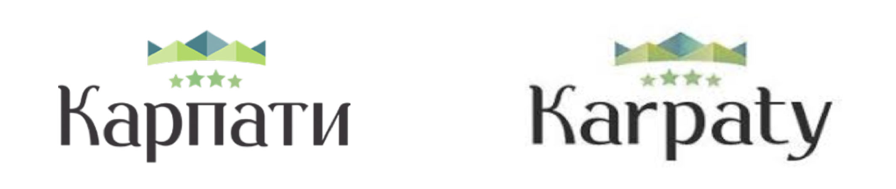
Source: Screenshots from the website of “Karpaty” resort

The logo creates the curiosity and invites the viewers to explore natural areas within the region. Two shades of green create an impression that the beauty of the place lies in nature. The green colour is usually associated with grass and tress, and it creates feelings of calmness. Through this logo, the destination is perceived as an authentic and unspoiled place where time has stopped and the technological changes have not reached the area.
For the visual representation of the brand “Solva”, three versions of logo are introduced on the website (Figure 2). The first logo occupies a top-middle position and pops up in a form of a small flag on each website’s page. It grabs users’ attention each time a new page is opened. The logo incorporates the symbol of crown that is a distinct indicator of royalty and resembles the luxury facilities and exclusive services of this place. The verbal message of the logo is the resort name, the village name the resort is located in, and its field of services. There is a sign of acorn in the middle position that is used as a symbol of prosperity. The black background provides a feeling of formality and power and serves as a good contrast to the white and red letters.

Figure 2. Destination brand logos in the corpus of “Solva” resort website
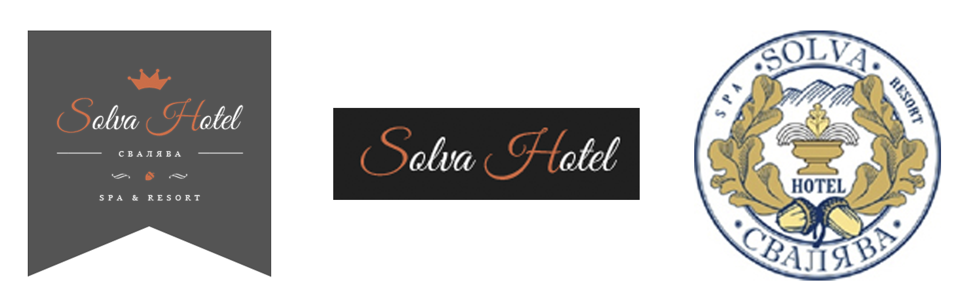
Source: Screenshots from the website of “Solva” resort

The second logo is an extract from the main logo and incorporates the wordmark only. The third version of logo is totally distinct from the previous ones. It has a form of a round seal and is located on the final page with the contact information of the resort. It creates an impression that the website is a document and it is sealed to be authenticated and formalized. The emphasis of this logo is on a nature aspect of the place. In the middle position, we find the symbol of mountains, spring water fountain together with acorn and oak leaves. Throughout the major cultures of Europe, the oak tree has been held in high esteem and is known as a king of forest for its strength and longevity. By incorporating these elements, the brand practitioners try to bring the feeling of honour, power, wealth, and pride. It creates the image of comfort and enjoyment in the reader and, consequently, serves as a technique to engage the consumers.
Visual elements used in both websites have positive effect on the formation of both discourses. Pictures are strong elements for the promotion of the resorts’ facilities, and they are found on every page of each website. The pictures used are professionally done. The websites use the relevant and meaningful pictures to communicate their messages. The destinations are visually represented as welcoming, vibrant places, the ideal destinations for wellbeing-seekers, sport-lovers, those who enjoy nature, and foodies.
From the analysis, one can see that nature is a common theme in the visual representation of both websites. The websites give a lot of attention to the role of each resort’s location. Hence, the resorts promote themselves through nature. Nature plays an important role; it is an essential selling point for tourists. Due to salience and modality, the naturalness is ably constructed. The sceneries are portrayed as empty and timeless, they are appealing for those who seek calmness and vacation contributing to their health.
Figure 3 is a photo taken from a long distance showing “Karpaty” resort and its surroundings “from a lookout position, a place not itself in the landscape but affording an overview of it” (Kress & van Leeuwen 2006, p. 108). Such a panoramic view “invites a reassuring act of contemplation” (Giannitraphani, 2010, as cited in Francesconi 2014, p. 94). As a result, the wide-angle shot of the picture suggests impersonal relationships, with elements that invite observation from a distance (Kress & van Leeuwen, 2006)

Figure 3. Image of “Karpaty” hotel and resort complex
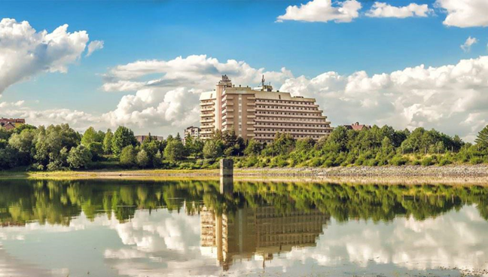
Source: Screenshot from the website of “Karpaty” resort

The building stands out in the picture due to its foreground position, large size, and contrasting colours. As a result, the building of the resort is the primary focus. The image features the sanatorium against the skyline and includes iconic signs of nature, creating a visual cliché that highlights the main quality of the resort. The producers chose tree images to represent the natural aspect of the Karpaty resort. These trees symbolize the forests and greenery of the Karpathians landscape, emphasizing the resort as an ecological place. Nature surrounds the entire building, showcasing the relationship between the resort and its natural surroundings. By incorporating this image into the website, the author aims to appeal to city dwellers who may find greenery uncommon.
No people appear in the image as if to invite the viewer to enter the depicted space (Dann, 1996). The place is presented in order to be imaginarily visited by people who are viewing the picture. The place seems to be very beautiful and attractive. This picture helps the website build an image of relaxing and peaceful place in the viewers’ mind.
The visual analysis reveals that the authors regard the traditions of the country the resorts are located as important and potential to attract tourists. Figure 4 is the representation of ethnic restaurant “Kolyba”. The restaurant is made in traditional style with the original design. The plastic visual signs, such as colours and forms, together with linguistic message “Kolyba” imply and represent Hutsul ethnic culture. The old Ukrainian word “Kolyba”, which was mainly used by the Hutsuls, means wooden small house. The interior of the restaurant presents vivid natural colours that are an inherent characteristic of this ethnographic group. The traditional decoration, such as hand-woven textiles and embroidery, has dominant black and dark red colours. Moreover, the Hutsuls are renowned for their artistic wood carving and inlaying of wooden objects with contrasting wood that is also observed in the picture.

Figure 4. Photos of “Kolyba” restaurant in the corpus of “Solva” resort website
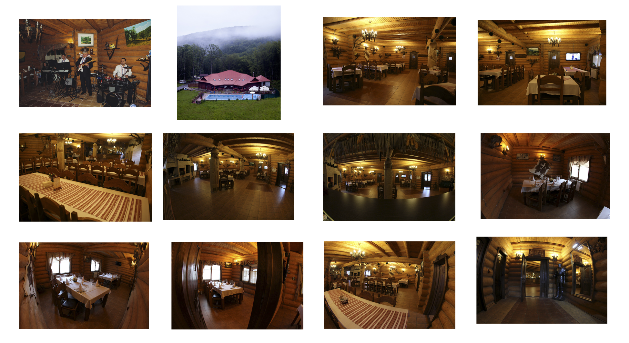
Source: Screenshots from the website of “Solva” resort
The restaurant is not described linguistically; the images are the main source of information. Certain information is best delivered by means of image then words, and this is true with this traditional place. The decoration of the restaurant signifies that the recipes and preparation of food are very traditional as well. Therefore, the images express local culture and cuisine to convince the potential visitor to explore it.
In the website, Hutsul culture is employed as a tourism commodity in realizing “Solva” destination image. The promoters draw the tourists’ attention on the authentic and unique aspects of the local culture. This technique is used as a tool to provide potential tourists with feeling that they can expect to experience a meaningful trip. It may create a positive appeal for the viewers.
The picture of musicians enhances the cosy atmosphere of the restaurant and can activate the affective responses of pleasure and interest. The rooms are depicted as empty and waiting for tourists’ presence. The frontality and medium shots engage and invite the viewers to enter these spaces. In addition, the long shot invites to view “Kolyba”, which means wooden small house, from a distance.
A lot of images presented on the websites display strong social engagement with the viewers. Utilizing Kress and van Leeuwen’s framework for conducting a visual analysis, findings reveal that the images presented on the websites demonstrate strong interpersonal relationship among all the participants involved in the production and viewing. Through visual texts, the websites look for establishing a dialogic relationship between the depicted participants and viewer through various techniques like contact, angle and, social distance.
The photos featuring the medical staff of the "Karpaty" resort (Figure 5) establish demands. An imaginary relationship is created with the viewers, as the represented participants appear to address them directly. These images generate a strong sense of involvement because the viewer looks directly at the participants from a close distance, giving the impression that they can converse with the doctors.
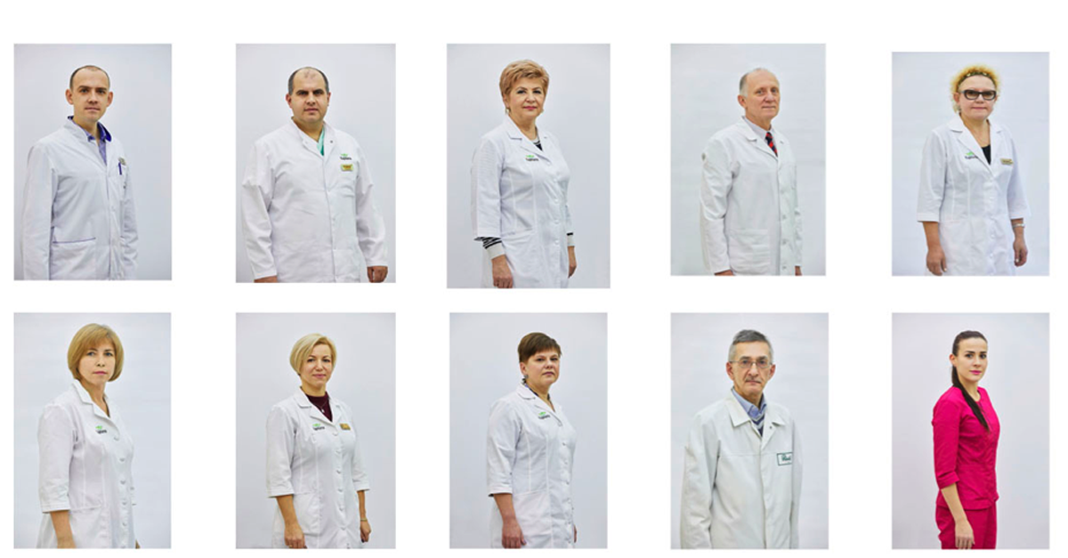
Figure 5. Pictures of the section “Doctors of Karpaty sanatorium”

Source: Screenshot from the website of “Karpaty” resort

The facial expressions of the represented participants in the photos show that the doctors appear friendly, warm, and professional. Additionally, the photographs are taken at eye level, signifying engagement and equal power relations between the doctors and the viewer. This positioning helps the viewer feel comfortable and trust the medical staff, as it creates a professional and approachable image. Consequently, the photos convey positive themes such as support and help. By providing real photos of the resort’s employees, the author enhances the credibility of the resort complex.
The "Karpaty" resort offers travelers the opportunity to view scans of certificates and diplomas (Figure 6). These images primarily provide linguistic messages in Ukrainian and Russian, with no English translation. Therefore, readers who do not understand these Slavic languages can only view the images without grasping the content. However, the heading of the section, along with the visual elements in the scans, such as the documents' texture, helps English-speaking readers understand that these documents are a form of certification.

Figure 6. Images of “Rewards” in the corpus of “Karpaty” resort website
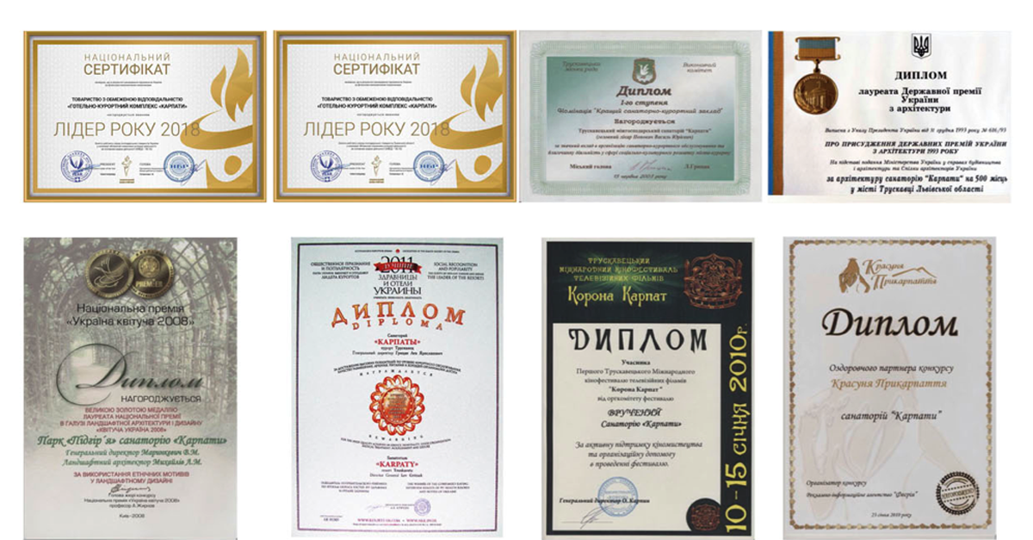
Source: Screenshot from the website of “Karpaty” resort

By including this section, the author aims to confirm specific characteristics of the resort and establish a connection with external parties. This confirmation is presented through reviews and assessments, which serve as trust indicators. Such professional accreditation builds confidence by certifying the resort's qualifications. Therefore, incorporating this section into the website can enhance its credibility and trustworthiness.
The author of the "Karpaty" resort website includes several videos, with the introductory video being the first experience guests may encounter. This video is a key part of their marketing materials, effectively capturing visitors' interest as it is prominently displayed right after the site's banner. It showcases the resort at its finest, providing a wealth of information by quickly transitioning between various scenes. The fast pace and stunning visuals immediately grab the viewer's attention within the first few seconds. The introduction is visually captivating and evokes emotion in the viewer. The video starts with a significant selling point: the breathtaking views of the landscapes surrounding the resort complex. This approach engages the target audience, encouraging them to watch the entire video.
Figure 7 identifies key segments and frames extracted from the video, creating a visual table of contents. The combination of visual and audio elements highlights the resort’s unique features and activities. The video begins with an excellent use of aerial shots before transitioning to the resort’s interior. Viewers are treated to effective drone footage showcasing the resort and its lush surroundings. The long shots convey a sense of impersonal relations, inviting viewers to observe from a distance. This approach helps the website establish the resort as a relaxing and peaceful place in the viewer’s mind. The video also features pleasant weather conditions, supported by the linguistic message: “It is good for any weather.” This reassures viewers who may be concerned about the weather in that region.
Figure 7. Key frames of homepage introductory video
in the corpus of “Karpaty” resort website
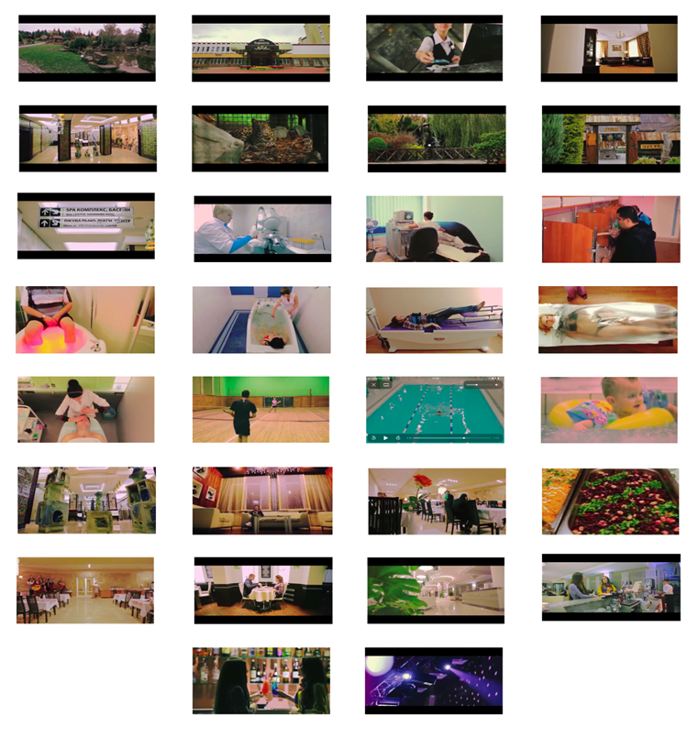
Source: Screenshot from the video on the website of “Karpaty” resort
The third frame features a demand segment of the video. The represented participant of this brick of information is a resort receptionist addressing the viewer with a direct gaze and treating the viewer as a newly arrived guest. This segment generates strong engagement between the receiver of the message and represented participant. The viewer is invited to interact, as imaginary relation is established with him/her. The viewer imaginarily receives a resort key card that grants the holder access to facilities beyond a hotel room, such as the resort’s surrounding green territory, diagnostic centre, rooms of medical and SPA procedures, sport centre, lobby, and restaurants. The following shots provide the feeling that the viewer is actually in the resort him/herself and can see all these facilities including the amazing resort’ ethnic restaurant, pool, lobby, medical and SPA equipment and services. The visual message of invitation is supported with the linguistic one: “Welcome to the hotel and resort “Karpaty”.
Most of the shots in the video are displayed at close and medium distances, creating a sense of physical presence for the viewers. This approach makes it feel as though viewers could actually enjoy the facilities and services. By showcasing the amenities within easy reach, the producer encourages viewers to envision what they can experience and participate in while staying at the resort. Overall, the video allows viewers to see the entire resort complex in natural lighting.
The incorporated audio and speech components enhance the visual information. The linguistic message functions as an anchor, guiding viewers through the meaning of the shots and generating an additional accompanying message.
Nouns are the main linguistic resource of the video, conveying objective and practical information about the resort. They describe the interior and exterior of the sanatorium. Moreover, the linguistic message features a high number of nouns referring to healthcare, creating the register of health tourism. The author uses these terminologies to describe medical and wellness procedures, such as rehabilitation, therapies, hydrotherapies, etc. In order to successfully present the treatment, the author makes use of the terms for illnesses, such as “gastro-intestinal illnesses”, “gastro-intestinal illnesses”, “chronic gastritis”, “spasms”, “prostatitis”, “hepatitis”, “colitis”, “cholecystitis”, “cystitis”, etc. By using these items, the authors advertise their health facilities to tourists. The use of this terminology is employed in order to gain prestige. The technique aims to make this type of discourse more attractive, evoking a feeling in readers that the services are reliable in this institution.
A great number of verbs are used, too. They are functional to the wellness experience and refer to actions that the guests are very likely to perform at this resort. The most commonly used tense is the present tense, conveying the idea that these experiences are true.
Other resource used in the linguistic message is positive descriptive adjectives. They highlight the qualities and values of the place giving beauty to the message, for example, “comfortable”, “breath-taking”, “modern”, etc. These positive adjectives are used to trigger positive emotions in the viewers.
Numerals are used to present the benefits of the resort and to show how big the resort is, prompting the viewers to visit the place (Zakharova, 2021). Here are some examples:
“50% of organic products”
“248 rooms”
“more than 23 therapeutic-diagnostic procedures”
The background music of the video enhances its impact by attracting tourists' attention and invoking an emotional response. Additionally, the background music aids memory retention and creates a sense of reality for viewers.
The video positions the resort as unique, highlighting its location, luxurious facilities, modern medical and diagnostic center, excellent cuisine, and helpful staff. It offers engaging material that allows viewers to visualize the resort before making a booking. Furthermore, it serves as a useful tool to instill a sense of assurance, stability, and security in the minds of potential tourists.
To keep customers engaged, “Solva” resort offers a virtual reality tour on its website. Using this virtual reality technology, the guests can experience the place remotely. It means that through the virtual tour, they are able to visit the place virtually and experience the surrounding even without being there. The detailed virtual reality environment showcases key features of the resort and its services. It delivers information allowing the viewers to experience the exterior and what the inside of the resort actually looks like and how it is organized. The tour takes the viewer to all the attractions and highlights, focusing on the spacious and luxurious qualities of the place and the main activities that guests can expect to enjoy. Through this latest technological advancement, the website is presented in a more attractive and explorable way. It enables the guests to get all the information they need in one single experience.
This 3D computer-generated environment looks like the real world. It allows users to explore the resort independently. The tour gives them the power to interact with images to get a better understanding of the resort and its services. By highlighting the attractive features of the resort, the author entices the audience to make a booking. With eye-catching features in the tour, the resort becomes more memorable to the would-be guests. It increases the viewer’s willingness to experience the place for real. In addition, this virtual experience helps convey the message that the resort is transparent and authentic, making the place trustworthy and giving the users confidence that they are dealing with the honest website.
Moreover, this engaging tool builds a sense of value, creating a positive first impression. Having the interactive tour on the website lets the users know that the resort cares enough to invest money and time in the way to promote its services, thus generating an additional value for this place.
The analysis of the authors’ points of view uncovers positive themes and traits, which are reflective of the overall attractive representation of the websites. The authors achieve this effect by presenting the highly selective contents that emphasize only the positive aspects. Indeed, such promising promotional materials play an important role in convincing tourists to visit a certain place.
3.2. Customer’s Voice
The authors’ subjective opinions are not limited points of view, as the reader will also know the appraisals made by the resorts’ clients. The websites involve their clients as the co-producers of the content. It must be considered that the guests are both consumers and the producers of the content, making it highly influential.
The participants featured in the photos on the "Famous Guests" page of the "Karpaty" resort website are well-known singers, celebrities, and public figures (Figure 8). They are primarily recognized by individuals from countries of the former Soviet Union. As indicated by the page title, these celebrities have been guests at the Karpaty resort. Each image is accompanied by linguistic messages that serve as anchors, providing the names of these individuals along with quotes that highlight their successful experiences and testimonials.
Figure 8. Images of famous guests in the corpus of “Karpaty” resort website
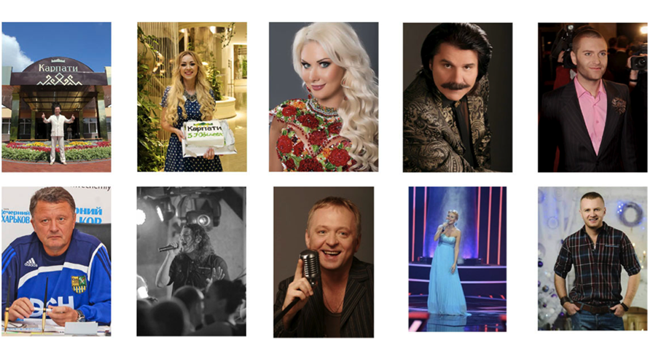
Source: Screenshot from the website of “Karpaty” resort
The first two pictures on the "Famous Guests" page are taken within the Karpaty resort grounds and feature the sanatorium's logo, indicating that the guests are on the resort premises. The smiles on their faces convey happiness, symbolizing their satisfaction as guests. This positive portrayal of well-known individuals can be appealing to potential tourists. The first photo, a long shot, also invites viewers to appreciate the resort’s beautiful entrance.
The photos featuring celebrities work as trust indicators and, thus, function as an impactful marketing tool. They can grab attention immediately building credibility, as famous people usually cause a lot of attention. Their fans commonly trust them. Hence, the celebrities in the photos can greatly influence conversion rates. Such photos are able to reassure the reader of the quality of the services. Viewing the pictures of celebrities as the customers of this resort, the tourists realize that the services are worth using. Moreover, the celebrities make the resort stand out. Using the photos of these people in the website to represent the services helps differentiate the resort from its competitors.
The photographs illustrating therapeutic procedures seem very professional, and their settings are ably staged (Figure 9). It seems that the shots were taken secretly and the represented participants did not know about it. Therefore, no contact is established to make any interaction with them. The represented participants are depicted as the patients and medical staff in order to be observed. The pictures suggest that the viewer can only be a passive observant and is not offered to enter the therapeutic rooms and participate in the procedures.
Due to the clients depicted in these images, the viewers perceive the relaxation and the peaceful atmosphere of Karpaty resort. The clients having a spa treatment and therapeutic massage clearly express joy and happiness. It gives would-be guests a fair idea of what they can experience in this establishment. From the perspective of narrative process, these images adopt invisible vectors formed by the depicted medical staff. The viewer can perceive the action processes realized by them. The depicted clients feature their pleasant experiences during the rehabilitation services performed by the resort’s medical staff. Therefore, the pictures can help the viewers contextualize and understand what this establishment can help them accomplish.
Figure 9. Photos of medical facilities of the hotel resort “Karpaty”
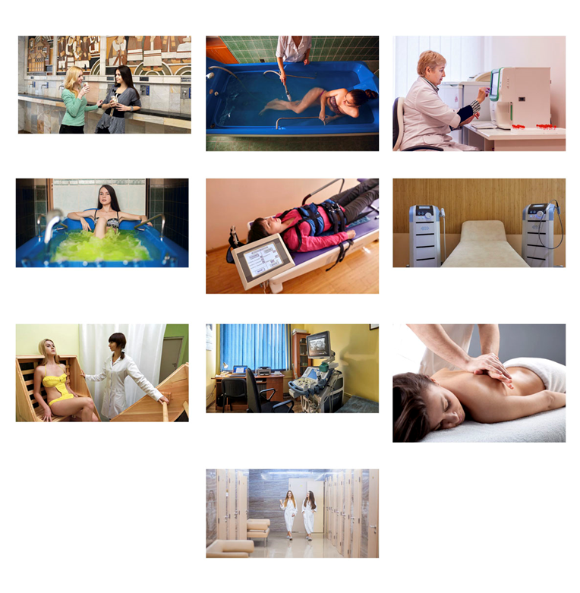
Source: Screenshot from the website of “Karpaty” resort
The last image captures two women, and as it is the final image, viewers can infer that they have already experienced the treatment procedures. The photo highlights their content facial expressions, which are positively perceived by viewers and enhance engagement. The happy and shiny appearance of the clients boosts the trustworthiness of the medical procedures shown in previous photos. Overall, the depicted customers evoke affective responses of pleasure in viewers, conveying that visitors can enjoy a combination of treatment and recreation, ensuring a pleasant experience at this health resort.
The section “Reviews” on the website of “Karpaty” resort enables the users to add a feedback text thus allowing them to provide an additional content basing on the clients’ opinions regarding this place. The user-generated content has the benefit of coming from the real customers, rather than from the owner of the resort, increasing the tourists’ trust.
Figure 10 identifies the meaningful segments of the video that features the feedback delivered from the clients of “Karpaty” resort. The main represented participants are the guests of the resort. The focus of this video is interviews with them. They share their positive experiences during their stay at the resort. Some participants smile, uncovering the themes of pleasure and happiness that is an important point in the persuasion of the viewer. Therefore, the satisfied customers affirming the services have a very strong influence on the potential tourists. By using this video, the website has a positive impact on the first impression of the viewer.

Figure 10. Video interviews in the corpus of “Karpaty” resort website
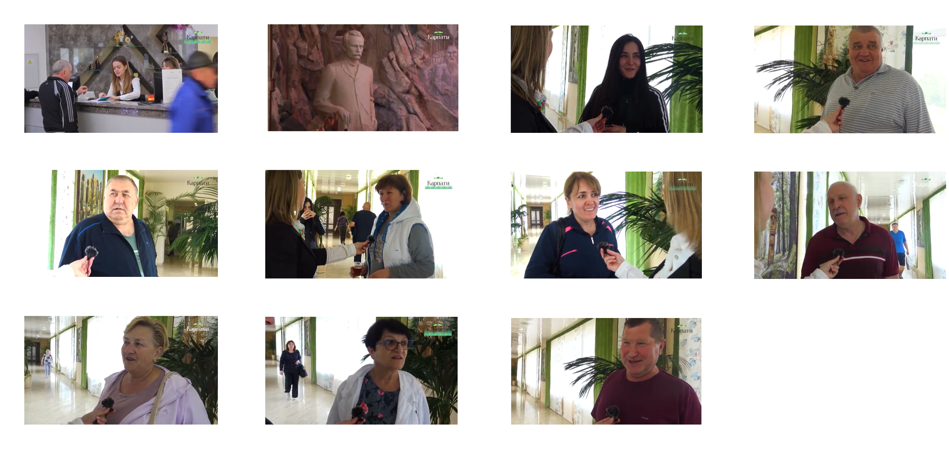
Source: Screenshots from the video on the website of “Karpaty” resort
The guests’ feedback assists the viewer with product selection, subsequently increasing a conversion rate at the same time. They reassure the viewer of the quality of the services by transmitting the messages that the services are worth booking. Hence, this kind of video is a very powerful technique to convince the travellers to become customers.
By providing the voices of the clients, the authors want to positively confirm the characteristics of the resorts and associate them with external parties. This confirmation is provided in the form of assessments delivered by verbal and pictorial messages. The clients’ points of view can be considered as trust indicators, due to the fact that testimonials are great for building confidence. People buy from other people they trust. From a marketing point of view, people trust peers more than professional descriptions or author voice. The clients’ voices act as some sort of proof to the users of the websites. So, embedding these external viewpoints into the websites can boost the credibility and trustworthiness of them.
3.3. New Technologies’ Voices
Both websites are built using various technologies to be more powerful and more effective. The technologies used provide useful information and create additional experiences in the users. Resourses, such as live webcams and Google Maps, have become popular marketing tools in tourism industry. Moreover, they are used in order to gain prestige.
The website of “Karpaty” resort incorporates the Truskavets online webcams, dedicating an entire page for these visual imageries. Truskavets is the city where the resort complex “Karpaty” is located. The viewers can visit this place online and enjoy Independence Square and the Buvet area. These two street-level webcams are video cameras that stream video in real time. The cams give the users the live views of current happenings and events taking place in those spots. They provide aerial views of these important places of Truskavets to the world 24 hours a day. High resolution allows capturing the surroundings in good quality.
The first webcam overlooks the main square of Truskavets – Independence Square (Figure 11). This HD (high definition) webcam is situated at one end of Central Park Adamivka the part of which is presented in the background. It is one of the busiest spots of the city, which can be seen in real time. Here are held public events, festivals and concerts, meetings and marches. Through this camera, the viewers can see all these cultural events live and understand what the place looks like. As the most interesting events take place here, the viewers realises that this central part of Truskavets is worth coming here.
Figure 11. Two shots of the video streaming by webcam on Independence Square in Truskavets in the corpus of “Karpaty” resort website
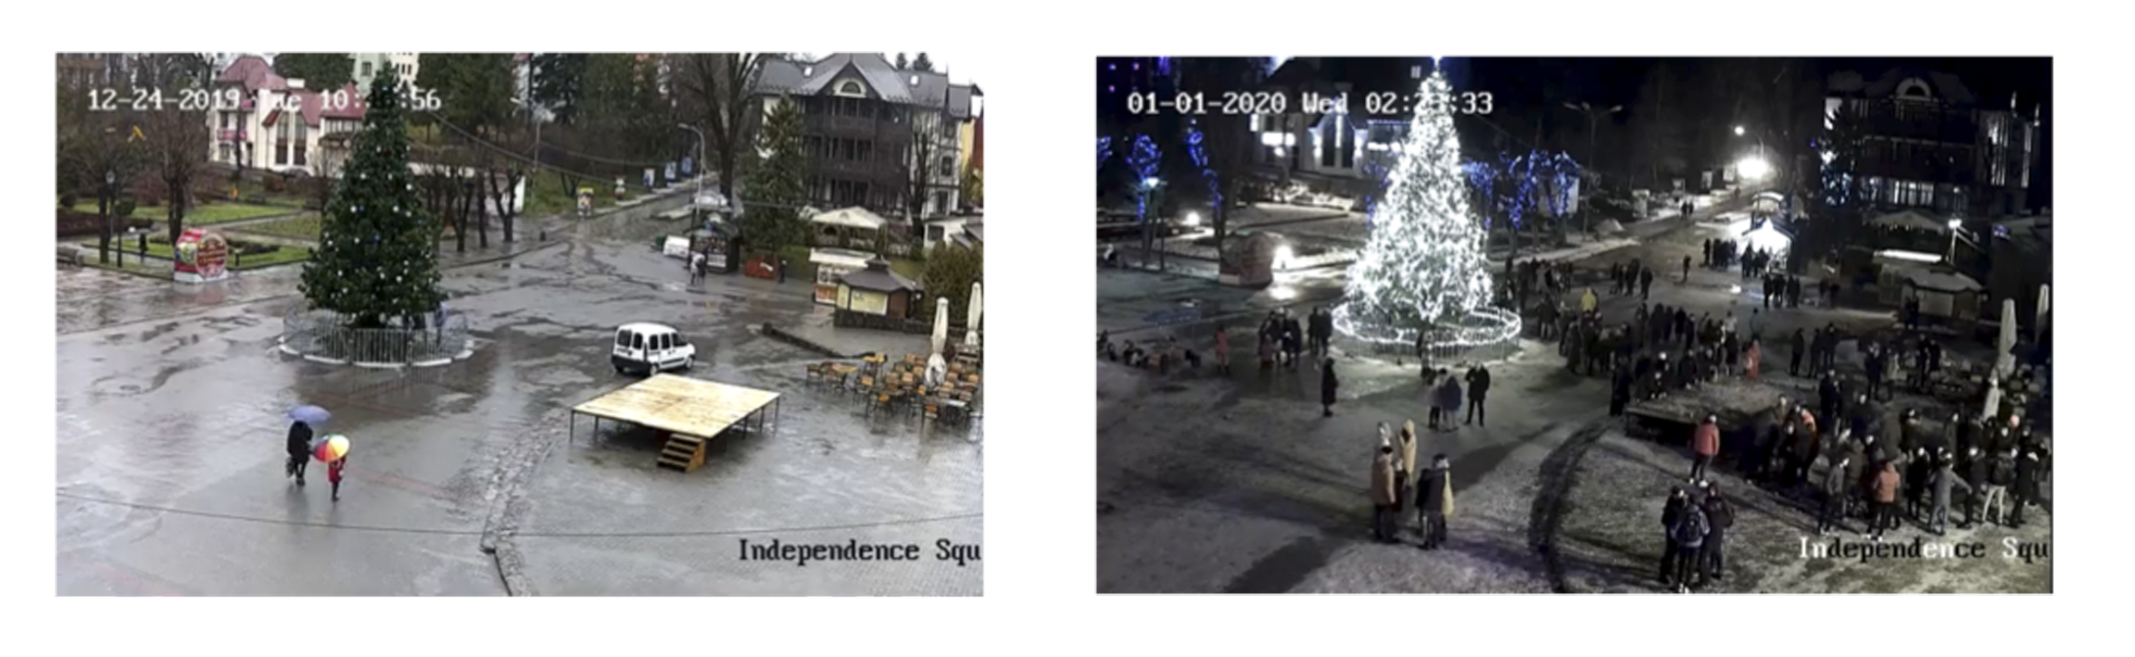
Source: Screenshots from the video by the webcam on the website of “Solva” resort
The second webcam takes the viewer on a virtual tour of the most visited spot in Truskavets, the Lower Buvette where the tourists are provided with the pump facilities (Figure 12). The essence of the treatment in Truskavets is taking the mineral waters, and this spot is considered to be the main one for these services. It is located in the centre of the city on Torosevicha Street. It must be interesting to observe what the heart of Truskavets looks like for whose who are interested in this kind of treatment. The building in which the Lower Buvette is located is included in the list of sights of the city. The webcam completely covers the object, showing not only the building area, but a small part of the surrounding area. The Lower Buvette is visited not only for drinking mineral water, it is also a wonderful place for just walking, listening to birds, observing the park fauna located next to it. Thus, the website visitors can watch live the activity in the beautiful city centre of Truskavets.
Figure 12. Two shots of the video streaming by webcam on the Buvet
in Truskavets in the corpus of “Karpaty” resort website
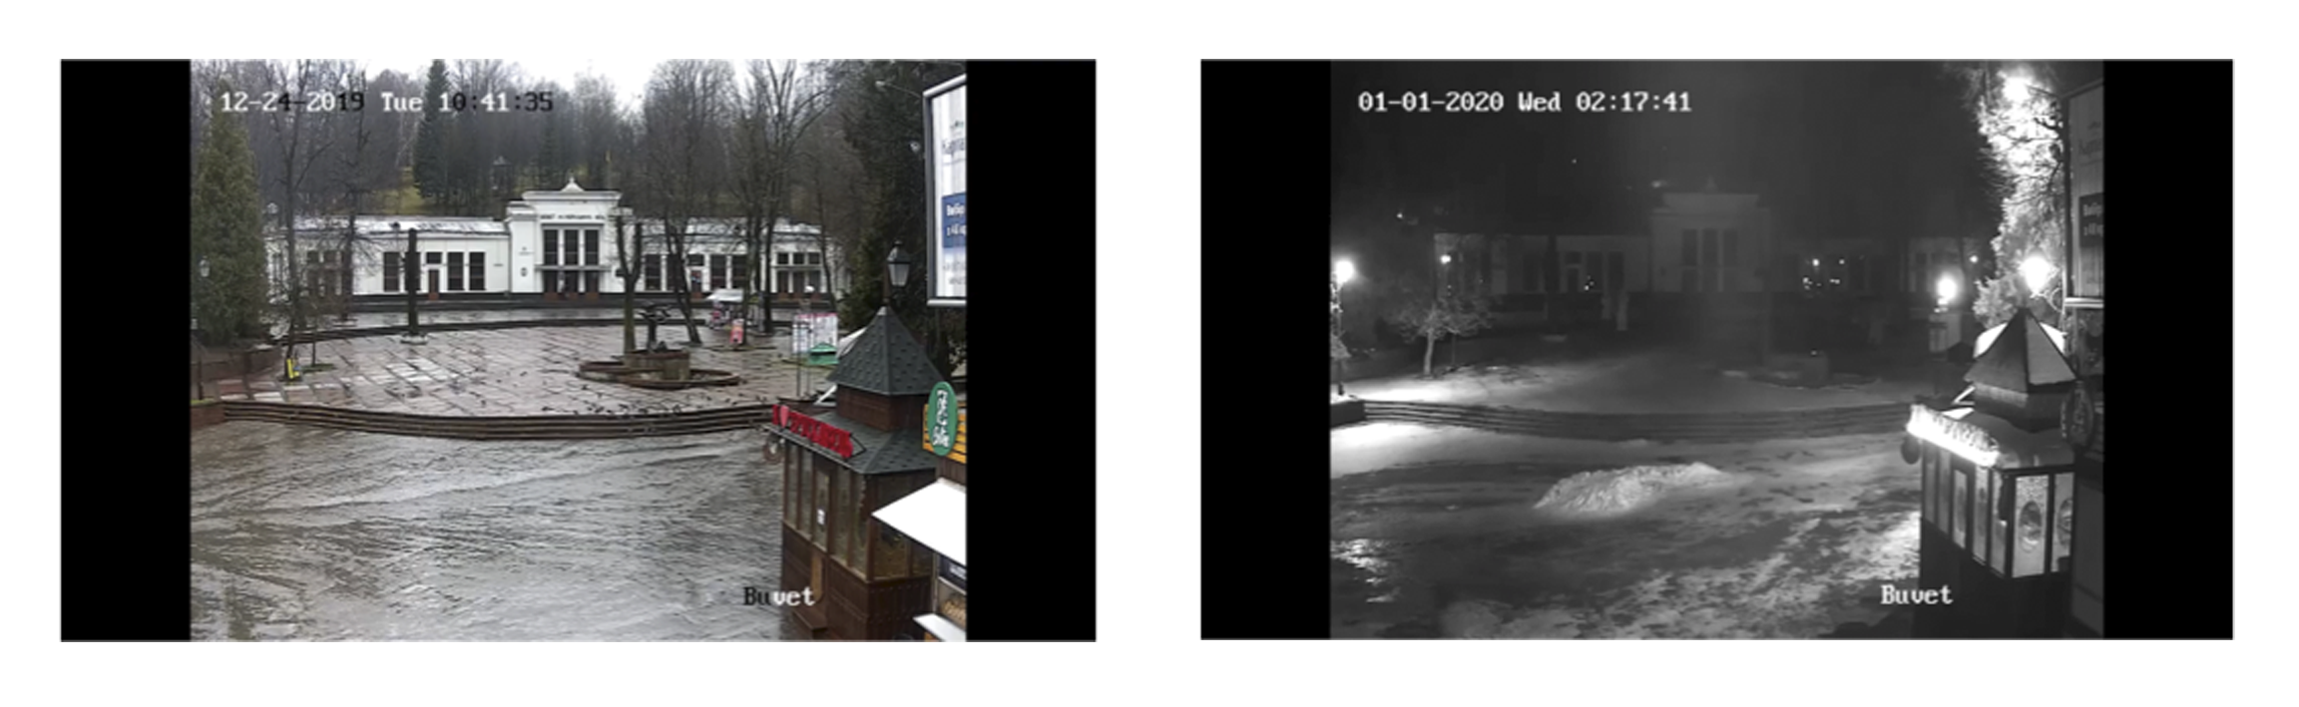
Source: Screenshots from the video by the webcam on the website of “Karpaty” resort

By clicking on the webcams, the target audience can go from any place in the world to Truskavets. The viewer is given the opportunity to travel online and discover the important and appealing places next to the sanatorium “Karpaty”. Both webcams keep the viewers interested creating an authentic and meaningful content. The webcams real-time views provide the users an opportunity to dream of their future visit. With the webcams, the would-be clients are always up to date with the latest weather information out of that region. Therefore, these virtual travels to Truakavets tourist attractions are used to persuade the audience, they can be considered as a good technique in the promotion of the destination.
The website of “Solva” resort provides the web mapping service developed by Google (Figure 13). Nowadays, Google Maps is one of the most widely used services with interactive zooming and panning, location details, satellite views, and 360 degree street level panoramas. It is an effective informative tool that is easy to handle and that is regularly updated.

Figure 13. Images of Goggle Maps in “Solva” resort website
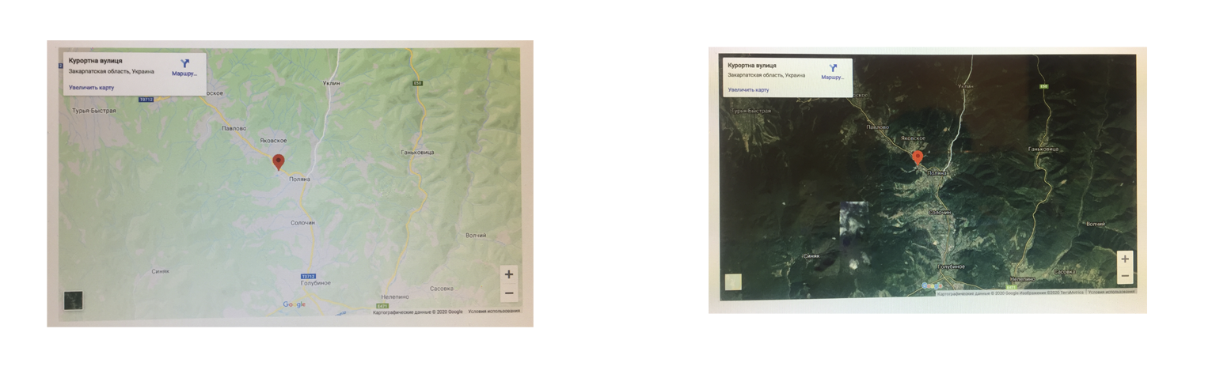
Source: Screenshots from the website of “Karpaty” resort
Embedded Google Map into the website offers the visitors many benefits. It is a simple way to help them quickly find the direction to the resort and build a route to the place right on the page, since the map includes a pin dropped at the address of the location. The users can also navigate the area for general overviews of the neighbourhood. Thus, the map is useful to highlight the nearby points of interest, like parks, lakes, rivers, restaurants, etc., featuring on the map. Actually, it allows the viewers to see where each point is, making it easier to plan their trip. Moreover, this can be helpful for orientation when visiting the resort in real life.
The virtual map can be displayed as a map view image or a street view image (terrain or earth view). The street view picture of the location helps people see the beauty of this place. They get a spectacular first impression of it, as the resort is featured as a location surrounded by captivating nature, alluring the viewers to come and discover the place.
Whatever the tourists want to know about the location, they can find it in the map while remaining on the website instead of leaving for the Google site. The virtual map increases confidence by displaying details about the resort’s physical presence. The map service can assure the viewers that this place is reliable. Moreover, the map adds a tech savviness and professionalism to the website. Therefore, the resort presents itself in the best way by using Google Maps that can be considered as an influential tool for online tourism marketing.
Finally, the websites display their social media outlets, such as Facebook, Instagram, YouTube, and TripAdvisor. The viewer is offered to link these outlets that are managed by the resort. These social media platforms operate together with the websites to enhance the online exposure. The integrated social media feeds can easily boost a stronger online following.
The functionalities of technological tools embody particular voices that are not visible at the first sight. These tools are integrated to deliver intended positive effects on the websites, as they possess an ability to express opinions from their technological points of view. The authors make use of them due to the fact that they bring the beneficial viewpoints of the places that can encourage the users to book the offered services. They promote the health tourism products in a dynamic and clever manner that gains the impressions.

4. Conclusion
The analysis reveals that the selected digital promotional content employs a broad range of persuasion techniques, expressed through various voices. The language used on the websites is highly persuasive, reflecting their promotional function. These resort websites serve as effective communication tools, where marketing experts utilize diverse linguistic and non-linguistic strategies to attract potential tourists. The combined opinions of the authors, customers, and technological messages on both websites assist users in making decisions and influencing their behaviour. Incorporating persuasive opinions into the website design positively impacts viewer engagement and attention.
The websites present a complex compositional structure that features the resorts’ amenities and services. Through different voices, the marketers project the images of the resorts to the intended audience. The authoritative voices of the websites are expressed through the usage of first person plural voice in the texts and the adaptation of subjective camera positions in the images and videos. The voices of the external parties are also manifest in the textual and visuals elements, easily adding up to one unified point of view. Both resorts are represented as the locations where the tourists can improve their health; they are different from the places they live in in terms of naturalness. Moreover, the discussed voices add an extra meaning to the contents, such as the authenticity and uniqueness of the places, openness and friendliness. These indicators are important points in convincing tourists to visit destination.
Due to the implication of technologies and clients as co-producers of the contents, the websites become multi-authored environments. The marketers carefully construct messages derived from different voices in order for the reader to comprehend them and develop a positive attitude towards the destinations. The offerings delivered by authoritative voices, customers’ feedback areas together with technological points of view are used to convert the target audience and, consequently, guide them to buying services that is the main goal of both websites.
This study contributes to the field of tourism studies by focusing on how persuasion operates in tourism communication through different voices. The results of this study could be helpful for those who design tourism websites and create tourism promotional materials.

References
Crişan, R. E., Bolyai, B., Cantemir, D. (2013). Tourism destination slogans - persuasive or manipulative? Editura Universităţii “Petru Maior”. Retrieved September 10, 2020, from https://docplayer.net/20853214-Tourism-destination-slogans-persuasive-or-manipulative-keywords-metaphors-slogans-linguistics-the-language-of-tourism.html
Dann, G. M. (1996). The Language of Tourism – A Sociolinguistic Perspective. Oxford: CAB International.
Francesconi, S. (2014). Reading tourism text: a multimodal analysis. Bristol: Channel View Publications.
Jack, G., Phipps, A. (2005). Tourism and Intercultural Exchange: Why Tourism Matters. Channel View Publications.
Jorgensen, L. G. (2004). An analysis of a destination’s image and the language of tourism. The Aarhus School of Business.
Kim, H., Fesenmaier, D. R. (2008). Persuasive design of destination web sites: An analysis of first impression. Journal of Travel Research, 47(1), 3-13.
Kress, R. G., Van Leeuwen T. (2006). Reading images: The grammar of visual design. London: Routledge.
Maci, S. (2013). Tourism discourse: Professional, promotional and digital voices. ECIG, Genova.
Mocini, R. (2009). The verbal discourse of tourist brochures. Annals of the Faculty of Foreign Languages and Literatures of the University of Sassari, 5, 153-164.
Morgan, N., Pitchard, A. (1998), Tourism Promotion and Power – Creating Images, Creating Identities. West Sussex: John Eiley & Sons Ltd.
Narangajavana, Y., Fiol, L.J.C., Tena, M., Ángel, M., Artola, R.M.R., García, J.S. (2017). The influence of social media in creating expectations. An empirical study for a tourist destination. Ann. Tour, 65, 60-70.
Salim, M. A. B., Ibrahim, N. A., Hassan, H. (2012). Language for tourism: A review of literature. Procedia-Social and Behavioral Sciences, 62, 136-143.
Zakharova, G. G. (2021). Video materials as a persuasive strategy in tourism discourse. Servis v Rossii i za rubezhom [Services in Russia and Abroad], 15(2), 30–44. doi: 10.24412/1995-042X-2021-2-30-44.

Professor (PhD) of the University of Cadiz (UCA). Department of English and French Philology, Spain. Email: ganna.zakharova@uca.es. Id. Orcid: https://orcid.org/0000-0002-4219-411X

