Ceremonies of Ship Launching in Egypt in the Context of Valorisation of Maritime Heritage and Tourism

Las ceremonias de botadura de barcos en Egipto en el contexto de la valorización del patrimonio marítimo y el turismo

Sara el Sayed Kitat *

Abstract:

In the Roman world, the sailors launched the “vessel of Isis”, into the sea to symbolize their opening of the shipping season. During the festival, the priests of Isis carried vessels of the Nile water to represent the resurrection of her husband Osiris. The festival was witnessed by a great crowd of people. During the festival, which was accompanied with carnival procession, people sang songs for Isis and carried lanterns in the form of a golden boat. After the spread of Christianity, ship christenings or baptisms continued to include liturgical elements, but in Europe, they appear to have been discontinued after the reformation. In the Ottoman period, the Sultan had to attend ship launching ceremonies. In the 18th century, celebrations were held to launch many ships in Egypt, particularly the royal and military one. After reciting prayers and verse 41 of Surah Houd in Quran, the ship was launched through slipways. This paper aims to threw the light on the various ceremonies of ship launching in Egypt and approaches such ceremonies form a cultural perspective rather than a technical one and as a possible intangible heritage resource of tourist interest.

Keywords: ships, launching, ceremonies, marine, heritage, cultural tourism, Egypt

Resumen:

En el mundo romano los marineros lanzaban al mar el “barco de Isis” para simbolizar la apertura de la temporada de navegación. Durante el festival, los sacerdotes de Isis llevaban vasijas de agua del Nilo para representar la resurrección de su esposo Osiris. El festival era presenciado por una gran multitud. Durante el festival, que estaba acompañado de una procesión de carnaval, la gente cantaba canciones para Isis y llevaba linternas en forma de un barco dorado. Después de la expansión del cristianismo, los bautizos de barcos continuaron incluyendo elementos litúrgicos, pero en Europa parece que se interrumpieron después de la Reforma. En el período otomano, el sultán tenía que asistir a las ceremonias de botadura de barcos. En el siglo XVIII, se celebraban celebraciones para botar muchos barcos en Egipto, especialmente los reales y militares. Después de recitar oraciones y el versículo 41 de la Surah Houd del Corán, el barco se botaba a través de gradas. Este artículo pretende arrojar luz sobre las distintas ceremonias de botadura de barcos en Egipto y abordar dichas ceremonias desde una perspectiva cultural más que técnica y como un posible recurso patrimonial inmaterial de interés turístico.

Palabras clave: barcos, botadura, ceremonias, marina, patrimonio, turismo cultural, Egipto.

- Introduction:

Garofalo (2018) defined launching as “the birth of a new ship for seafarers”. This birth is accompanied with remarkable ceremonial context and is dated by the competition of its hull rather than the end of construction. After launching the ship, the interior parts of the superstructures might be added. Following the launch, the floating hull is moved to the quay for the subsequent achievement of the ship. As early as the early 20th century, the launch took place after the construction of the ship was completed. There are two different types of launch. In the first and oldest, using a slipway to slide the hull on it. The side launch for medium to small boats built on sites with little opening in front of the sea. Thus, the research objectives are to trace the ceremonies of launching the ships in ancient Egypt since the dynastic period till its modern times. Moreover, the current study will analyse the authenticity of such ceremonies and their development and diversity from the ancient world till the modern times. The analysis will be studied in accordance of the religious, social and political contexts of these launching ceremonies. Finally, the research aims to frame the current launching the ships as a crucial aspect of marine cultural heritage.

- Literature Review:

A significant number of sources and researches throw the light on the rituals practiced in Egypt while launching ships and boats particularly during the Roman times (Metamorphoses, Book XI; Apollonius Rhodius (I: 375); the Orphic Argonautica (270). However, sources dealing with launching ships in Islamic and modern Egypt are obviously limited. Certain Arab historians, namely el-Maqrizi, Ebn-Eyas, and Ali Mubarak gave a brief account about certain practices during ship launching in Egypt. Prior research on the religious, political and social context of such ceremonies are also pertinent to this research. George Hodgkinson (2024) recently published his book which deals mainly with ship launching ceremonies in the ancient world part of which were attested in Egypt.

- Materials and Methods:

This research combines both the descriptive research and analytical research. Based on the descriptive research, the study will throw the light on the various launching ceremonies in Egypt and their development through the historical phases of Egypt. Furthermore, the analytical research will assist the researcher to study the diversity and the importance of such ceremonies in the marine heritage of Egypt. A quantitative approach was also used to examine the validation of the study hypotheses. Surveys, including interviews with ship makers, will frame the current status of these ceremonies in modern times.

Based on the objectives of the study, as previously mentioned in the introduction, the research questions are:
RQ1: How did launching ceremonies develop in Egypt as early as the dynastic period till its modern times?
RQ2: What are the differences between the various rituals of launching the ships in Egypt in every period according to the religious, political and social context of the Egyptian society?
RQ3: To what depth did the ceremonies form a crucial aspect of the Egyptian marine heritage?
RQ4: How could ship launching ceremonies be involved as tourist promotion for maritime heritage sites in Egypt?

- Ceremonies of Launching Ships in Ancient Egypt:

Launching is perceived as the birth of a new ship for seafarers, and many propitiatory rituals have been handed down over the centuries. The most widely known is probably the breaking of a bottle on the bow but the traditions are copious – i.e. a hull blessing by a priest, the sacred images affix to the hull, or an olive branch fix on the bow. The launch date is dated by the competition of its hull rather than the end of construction. After launching the ship, the interior parts of the superstructures might be added. Following the launch, the floating hull is moved to the quay for the subsequent achievement of the ship. As early as the early 20th century, the launch took place after the construction of the ship was completed. There are two different types of launch. In the first and oldest, the hull, having been built on a slipway, is slipped into the sea. In its most common form, the vessel slips with its stern at sea. There is also the side launch but such cases are usually reserved for medium to small boats built on sites with little opening in front of the sea (Garofalo 2018, 236-237).

Since the earliest period of the ancient Egyptian history, heads of the votive animals and even their horns were used to be placed on the prow of the ship before launching. The practice was applied to overwhelm the launched ship with divine blessing and protection during her voyage from any dangers and evil spirits (Landström 1970, 82-246, 249; Stockholm. 1970, fig. 15; Hornell 1939, 35-44, pls. I-IV 283). By the late period, the stern of the Egyptian ships was made to take the shape of the heads of various sacred animals for the same purpose. For instance, in a chamber of Mut Temple in Ashr, wall scenes represent number of the ships are represented. On of them is pointed out by Landström (1970, 140) and was described by the text to be the great ship form Sais. Heads of falcons adorns the two prows of the ship fore and aft. On the right of this scene the “great ship of Amun” is represented. It is apparently a late version of the divine ship Amun Useret. The prow of the ship takes the shape of the divine ram of God Amun (Blackman 1995, 153; Benson and Gourlay 1899: 257-258). The same processional boat of Amun has been attested in the temple of Madinet Hapu. The stern and stem of the boat take the shape of the sacred ram of Amun, namely wsr HAt of Amun and is carried by a row of priests (Doyle 2017: 2, fig.1) (fig.1).

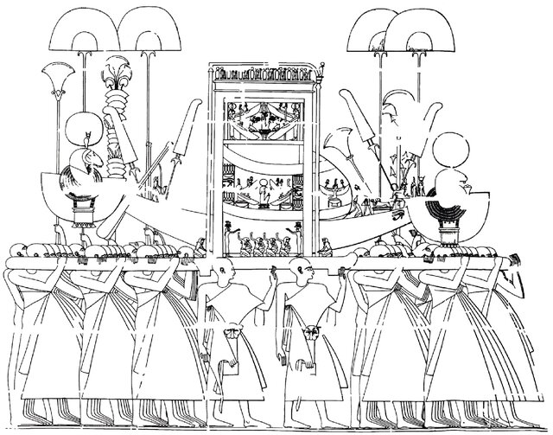

Fig.1. Detail from a relief of priests carrying the processional barque of Amun. Twentieth Dynasty, Medinet Habu. After Epigraphic Survey 1940, pl. 231
After: Doyle 2017: 2, fig.1

In addition, there is bronze head of an ibex and dates back to the 25th dynasty. This piece is now preserved in Berlin Museum. Despite of not being dedicated to any deity in ancient Egypt, the ibex was involved in the rituals of sacrificed animals (Landström1970, 140, fig. 409) (fig.2).

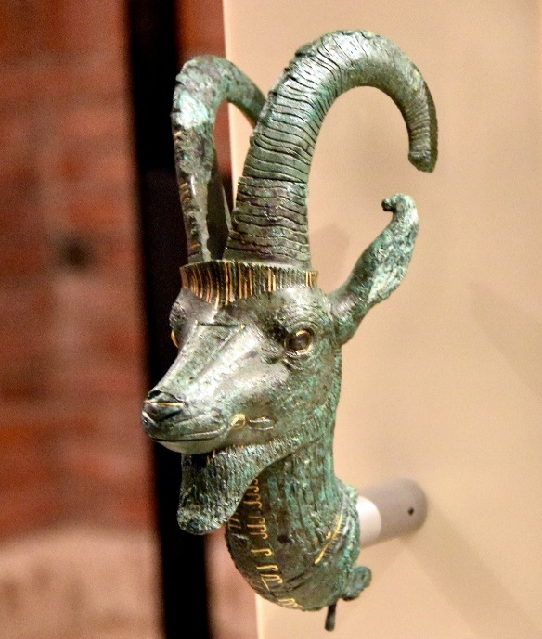

Fig.2. bronze head of an ibex and dates back to the 25th dynasty, Neues Berlin Museum, Berlin
After: https://www.worldhistory.org/uploads/images/11139.jpg?v=1710561129-0

Stern-posts were found also in the tomb of Tutankhamun and another similar craft is figures in the mortuary temple of Quenn Hatshepsut. Furthermore, there is terracotta model discovered in Luxor, it shows a high stem and stern-post taking the shape bull (Landström, 1970, 116-127, 141, fig. 410) (fig.3).

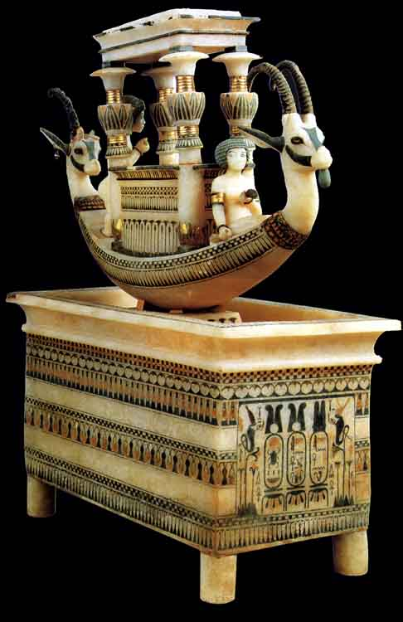

Fig.3. Alabaster Boat of Tutankhamun with the prow taking the shape of an ibex, Egyptian Museum, Cairo, JE 62120
https://www.ancient-egypt.co.uk/cairo%20museum/cm,%20tutankhamun,%20artifacts/pages/alabaster%20boat,%20syrian%20ibex%205.htm

There is another remarkable piece form the Late Period and preserved now in Louvre Museum. It is a pendant which is said to have belonged to a King Necho of the 26th dynasty. The piece takes the shape of a small boat with similar holes in the bulwark, and with a ram as a prow in the Graeco-Phoenician style (Landström, 1970, 141, fig. 411; Paris L 5856; La Rotrie, 381). According to Herodotus, after sacrificing a sheep during Amun's feast, its fleece was placed upon the statue of the god so that it could be identified with him. Similar to this ritual, the skin of a sacrificed goat was placed to cover the head of the ship's stem head (Blackman 1995, 153). According to Hornell (1939, 282, 283) sacrificing a goat whose head was placed on the prow the ships before launching was a practice for blessing which continued to be attested in many Arabian ports.

- Ceremonies of Launching the Ships in Græco-Roman Egypt:

The tradition of adorning the prow of the boats, particularly the ceremonial divine barques, with the shape of sacred animals or heads of deities continued in Græco- Roman Egypt. For instance, On the eastern wall of the sanctuary of Denerah temple, lower register, the king is depicted burning incense to both the sacred barque of Hathour and the sacred barque of Horus Behdety ( Kitat 2023: 73; Chassinat: 2009: 33-34, pls. L, LV). Furthermore, the Open Court of Edfu Temple represent scenes of the Festival of the Divine Union. The scenes depict the Nile voyage of Hathour from Dendera temple to meet her husband Horus Behdety in Edfu temple. The divine procession of Hathour is preceded by five sail boats in which the prows take the shape of Hathour; a woman wearing the Hathouric crown (Coppens 2009: 6, fig.7; Kitat 2023: 169). The same traditional scene was attested on the inner wall of the first pylon of Isis temple of Philae (Hölbl, G. 2000, 64; Abdel el-Rahman 2021: 112-116; Kitat 2023: 295-296) (fig.4)).

Fig.4. Selection of scenes from the Beautiful Feast of Behdet, depicted on the walls of the open court, temple of Edfu. After: Coppens 2009: 6, fig.7

In the same temple, mainly on the northern wall of on the hall of Appearance, the sacred barks of Horus (left side western part) and Hathour (right side eastern part) are depicted. The prows of Hathour barks take the shape of the goddess, while the barks of Horus are adorned with the sacred flacon on both side of the barks (Chassinat, 2009, IX, pl. XLf, XLg; Lotfy 2003, 71-91; Abdel el-Rahman 2021: 195-196; Kitat 2023; 187-188) (fig.5).

Figs.5 a, b. The sacred barks of Horus (left side western part) and Hathour (right side eastern part) are depicted, the northern wall of on the hall of Appearance, Edfu temple
Chassinat, 2009 IX, pl. XLf, XLg reproduced by Kitat 2024: 188.

In the sanctuary of Edfu temple, a black granite naos which is four meters in height is found. The naos dates back to the reign of Nectanebo I of the 30th dynasty is preceded by an altar and the sacred bark of Horus which is adorned by the aegis taking the shape of the sacred falcon of Horus (Watterson 1998: 48; Snape 1999: 57; Kitat 2023, 202) (Fig. 6).

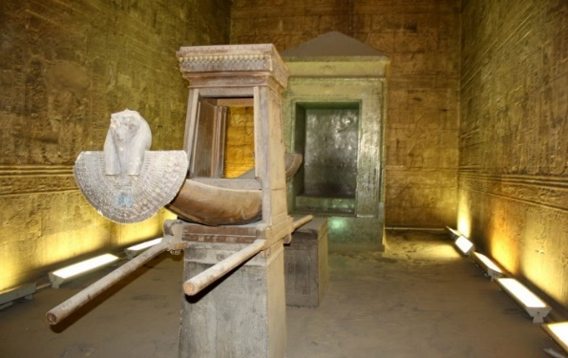

Fig. 6. The processional boat of Horus, sanctuary of Edfu Temple
After: Kitat 2023, 2023

During the Greek Period, timbers were used in sliding the ships to be launched to the sea. The ancient Greek words ϕάλαγγες or ϕαλάγγια which usually mean a trunk or round piece of wood. Launching the Argo was mentioned by the name the word ϕάλαγξ. This launching was attested in two literary sources, namely Apollonius Rhodius (I: 375) and in the Orphic Argonautica (270). Based on these sources, the so-called Argonauts dug a launching a slide made of smooth timbers down the beach. The name of the ship was named on to the first timbers (Blackman 1995, 74).

Ceremonies of launching the ships was attested in the Greek and Roman world particularly in Egypt. Lucius threw the light on the ceremonies of the three initiation rites in the cult of Isis and Osiris. With much more emotional atmosphere, Apuleius in his Metamorphoses (XI, 5-7) give a full detail about the Isiac cult including launching her ship (Witt 1997, 158). The opening of the shipping season was celebrated on the fifth of March every year. In March, a small boat symbolically dedicated to Isis opened the season of navigation on the high seas under her protection. The ceremony was called Navigium Isidis (Giunio, 2013, 423; Bommas 2005, 271; Tomorad 2005, 250 -253; Griffiths 1975, 31-32; Tibiletti 1997, 653-661; Wild 1981, 101-113). Among the ceremonies of the launching the ships of Isis, the high priest purified the ship with a torch, an egg and sulphur, consecrated to the goddess. Then, the ship was loaded with various types of offerings (Giunio, 2013, 434; Apuleius, Metamorphoses, XI, 5-7).

This ceremonial launching was followed by ceremonies in the temple of Isis. Among the ceremonies of the navigium Isidis, the Isiac priestesses were described to be dressed in white dresses and crowned with headdresses and floral wreathes. As for the Isiac priests, they appeared with clean shaven heads. The Isiac procession was led by the priestesses while the priests were in charge of carrying cultic symbols such as; the sistra, the situla and the caduceus (Apelius Metamorphoses, XI, 16; Sarolta 2008, 73-87, pp. 84-85; Giunio, 2013, 434-435, fig. 5,6; Tibiletti 1997, 665). Other Isiac priestesses hold mirrors and combs, while others poured perfumes and ointments. The priestesses were followed by men and women carrying lanterns, torches and candles to lighten the way of the goddess. Musicians, singers participated in this great marine festival. After that, initiates came to the scene, dressed in white linen and either with veiled heads veiled if they were females and with shaven heads if they were men. Each one of them was involved in certain ritual; shaking her rattles (sistra), carrying a cultic object, or a lamp (Giunio, 2013, 434-435, fig. 5,6). Moreover, several lamps were produced in the form of boats on which Isis was depicted. These lamps were used in the ceremonies of this festival (Bommas 2005, 271; Tomorad 2005, 250 -253; Griffiths 1975, 31-32; Tibiletti 1997, 653-661; Wild 1981, 101-113) (fig.7).
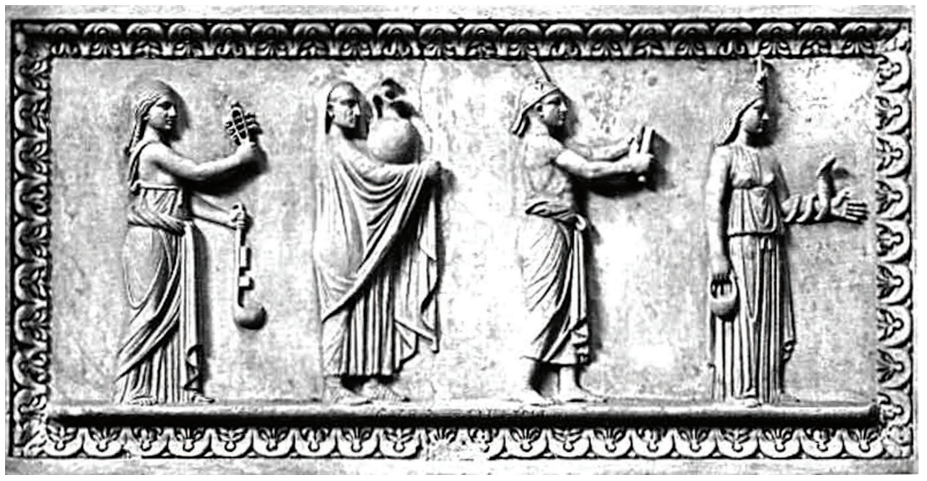

Fig.7. Relief from Rome showing four oicials of the Isiac cult carrying various sacred objects in procession. Museo Gregoriano Egizio, Roma
Kornelija A. G., 2013: 435, fig. 6.

The Isiac procession continued in the sea, where the launch of the sacred vessel took occurred. The white sails were described to be decorated with prayers to Isis hoping for her divine protection of the sea voyages of the vessel. Milk was poured as a kind of sacred libation upon the waves (Giunio, 2013, 435-436, fig. 5,6). The ship's ropes were cut, and it fell into the ocean, gliding out to sea without a crew to steer it as it vanished into the distance. After state prayers, the phrase “the ship has been let go” was recited as an announcement of her sacred launching. (Hofmann, 1993, 42-227; Giunio, 2013, 435-436, fig. 7; A. Alföldy, 1937, 46-56) After the launching of the Isiac ship, the chief priests entered the sanctuary of the temple and set up the “living statues.” A scribe stood at the entrance of the sanctuary and was responsible for summoning the pastophori and then reciting special prayers for the well-being of the emperor, the state, and seafarers. Then the priest scribe announced in Greek, and later in Latin, the launching of the ships. The crowd celebrated the ceremonial launching by carrying flowers, wreaths and branches and by kissing the feet of a silver statue of Isis attached to the temple-steps (Apuleius, Metamorphoses XI, 11.17; Sarolta 2008, 73-87, pp. 84-85; Bommas 2005, 271; Tomorad 2005, 250 -253; Griffiths 1975, 31-32; Tibiletti 1997, 653-661; Wild 1981, 101-113).

Isiac processions are depicted in the paintings of Herculaneum and the sacrarium of the Isis temple at Pompeii. The sacrarium functioned as a sort of temple sacristy and as a gathering place for initiates. (Hofmann, 1993, 42-227; Giunio, 2013, 435-436, fig. 7; A. Alföldy, 1937, 46-56; Bommas 2005, 271; Tomorad 2005, 250 -253; Griffiths 1975, 31-32; Tibiletti 1997, 653-661;). This festival was depicted on a bronze coin dating back to Antoninus Pius (138-161 AD.). It depicts the harbour of Cenchreae as a semi-circle place fronted by three ships. In the central part, Isis Pharia is depicted. It seems that this form of Isis had her own sanctuary in this place According to Berreth, he believes that the festival of “navigium Isidis” was merely celebrated in Corinth and not in Cenchreae. He depended in his opinion on the existence of two sanctuaries for Isis in this city. The first was dedicated to Isis Pelagia and the other one to the Egyptian Isis. Moreover, two sanctuaries are dedicated to Serapis in this city (Griffiths 1975, 14-20) (fig.8).

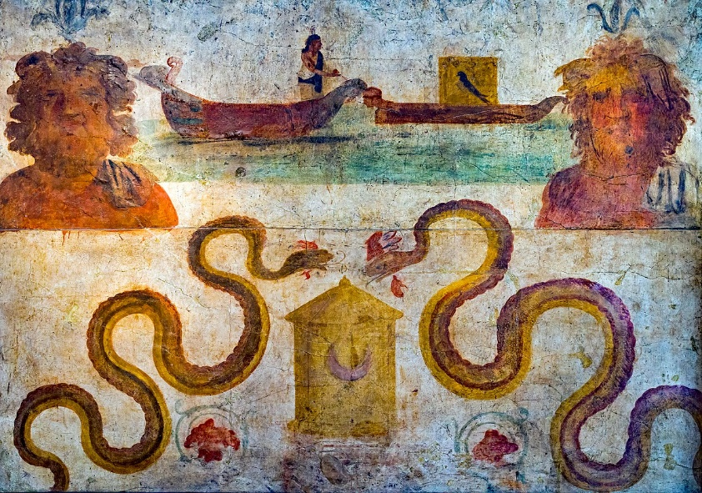

Fig.8. Fresco painting from the Temple of Isis in Pompeii showing the boat of Isis, fourth style of Pompeian wall painting , Napoli, Museo Archeologico Nazionale inv. 8929

The launching ceremony had definitely an ancient Egyptian origin as the procession comprised masked men and exotic animals revealing some apotropaic functions. Even judges, gladiators and philosophers shared in this marine carnival and were at the beginning of this procession (Giunio, 2013, 434-435, fig. 5,6). During the festival, the priests of goddess Isis carried vessels of the Nile water to represent the resurrection of her husband Osiris. Isis Pelagia was honoured during this festival (Tibiletti 1997, 653-661). This festival was celebrated on the honor of Isis Pelagia, mistress of the sea and the guardian of sailors. The festival seems to have had a broader meaning; it was not only the celebration of the reopening of navigation and the renewal of all nature, as mentioned by Apuleius (Apuleius, Metamorphoses, XI, 5-7; Giunio, 2013, 434).

- Ceremonies of Launching the Ships in Egypt after Christianity:

By the time, the festival of “navigium Isidis” experienced some modifications. Its rituals were celebrated on January 3rd instead of March 5th. Thus, the festival seemed to gain new significance and had nothing to do with the start of the navigation season. In this vein, Alföldy (1937, 46–56) refers to specific coins from the fourth century AD that bear scenes for Isis on her sacred boat raising the sail with her hands or the Nile reclining and holding the sacred boat. The scenes, which refer to navigium Isidis and rather here relevant to the vota publica legend, which reflects the emperor's wishes for prosperity. In other words, it could be assumed that Navigium Isidis was modified to coincide with the emperor's vota publica celebration on the first day of the New Year. Through this modification in the date of this marine festival, the celebration's original intent-wishing successful pagan cults was lost ( Giunio, 2013, 435-437).

With each new issuance of festival coinage declaring open warfare against the church of Christ, the boat of Isis launched repeatedly. An intriguing theory links the festival of the Navigium Isidis, or carrus navalis, which is associated with the vota publica celebration, to the beginnings of the festival (Giunio, 2013, 436-437; Arslan, 1997, 139; Witt, 1997, 179-180; Bricault, 2006, 152-176). After the spread of Christianity in Egypt, the cult of Isis continued to have a strong influence on the Egyptians and their new religious believes. One of the titles of Virgin Mary was “Stela Marris” meaning “the star of the sea”; a title that was strongly related to Virgin Mary in the 9th century AD. This title was also attested under the name Ursae Minoris or Polaris, meaning the “guiding star”, which was used during the celestial marine navigation in antiquity. All these titles reflect the Christians belief in the role of Virgin Mary as a protector of the sailors and their voyages. By the 9th century AD, prayers were recited to conduct successful navigation in the way to the Christ (Giunio, 2013, 437). Additionally, there are traces of the rite being carried out during Christian celebrations like the Feast of St. Agatha in Sicily and the Blessing of the Feet. The Festival of Lights and the Epiphany of the Christian and Coptic people are two more closely related celebrations. Recalling the Navigium Isidis, Muslims set out in small boats on the second day of the Eid el-Adha feast and take to the waters (Giunio, 2013, 437; Hodgkinson 2024).

During the Byzantine Period, there was much interest in showing the glorious appearance of the emperor aboard his ships. This obvious care resulted in affirming the imperial ceremonies particularly those connected with the marine port. By the time, the imperial dromon referring to the vessel of the emperor was repetitively attested according to the historiographical sources in addition to smaller boats (Simeonov 2018, 222; Hodgkinson 2024). Among the significant Byzantine court ceremonies were the ceremonies of launching a new ship. The new vessel was launched through the “baptism with red wine”, a practice that was associated with prayers, blessings conducted by the priest or even by a Mass. The new boat was decorated with many elements such as; flowers (rivers Minho and Douro, Aveiro), olive branches (Povoa de Varzim, river Douro) and of spurge-laurel or holly (Viana do Castelo), with pennants and flags (Aveiro) (Blackman 1995, 150; Filgueiras 1978,29,30; Hodgkinson 2024).

A bottle of wine was broken against the stern of the ship. This tradition was attested and studied by Amades who threw the light on launching the ships in Catalonia. The “Godmother”, usually the mestra, was responsible for conducting this ritual, and the craft was launched. The wine bottle was broken on the stern of the Catalonian fishing boats were given a feminine name. After that, the sailors got in the ship to check the stability of her building. During this initial navigation of the ship, they sacrificed a cock and its blood was spilt over the deck. The first voyage of the launched ship ended ashore with a supper (Blackman 1995, 150).

- Ceremonies of Launching Ships in Egypt during the Islamic times:

Despite of having two major centres for manufacturing ships in Egypt, namely Alexandria and Damietta, there is an obvious lack of the historical sources of launching ships in Egypt during the Islamic period. El-Maqirizi described the flourishment of the Egyptian navy during the Fatimid period. A third factory for manufacturing ships was established during the reign of Mu’iz in Max in addition to those located in el-Ruda and Fustat. The Egyptian historian Ezz el-Malik el Masbahi mentioned that about six hundred ships were established in these two factories in order to control over Jerusalem. According to el-Maqirizi, there was a commander of the navy forces in Egypt during the Fatimid period and was named in Arabic “the prince of armies” (Amir el-Geyoush). He described that the departure and arrival of the Egyptian naval ships was highly celebrated in Egypt. These ceremonies were even attended by the Fatimid Caliph and his dignitaries. During these ceremonies, prayers were recited wishing victory for the naval forces in their battles. After that, the ships sailed to Damietta then to the open sea (Maher 1967: 97-98; el Magqrizi part 2: 368).

The available sources describe reciting Quranic verses before launching the ships during that the Mamluk period. The Mamluks apparently tried to regain the naval power of Egypt especially after the decline of manufacturing ships during the Ayyub Period. Thus, the Mamluk Caliphs attended in person the launching of the ships. El-Maqrizi described that Ashraf ibn Qalawuun in 692 Hijri ordered his vizier Shams el-Din Ibn Sal’usi to prepare manufacturing great naval ships called in Arabic “Shona”, until its equipment was completed with about sixty ships of the Shouni model. He equipped them with weapons and Mamluk navy soldiers. Common people were keen in witnessing the great fleet and crowded on the banks of the Nile three days before the arrival of the Sultan. After that, the Sultan Qaitebey went for Qal’et el-Jabal to Bustan el Khassab in Bulaq (now Garden City in Cairo) her the Sultan stood with his delegate Baydar and the other Mamluk princes to attend the launching of the great shawani ships. Then, Ibn Moussa el Ra’i appeared on a Nile boat to open the ceremonies by reciting verse 41 of Surah Houd in Quran; “bismillahi mojraha wa moursaha” meaning “embark therein; in the name of Allah will be its (moving) course and its (resting) anchorage” and Surah “El-Mulk”. The Sultan attended the ceremonies till Duhr prayer then he went back to Qal’et el Jabal. Being impressed by the grandeur of shouna ships, the common people celebrated the launching of such ships for the rest of the day (Maher 1967: 117-118; el- Magqrizi part 2: 195).

- Ceremonies of Launching Ships in Ottoman Egypt:

Similar to the Byzantine Empire, many ceremonies and protocols were conducted by the Ottoman court particularly those relevant to the marine activity. For instance, there were special ceremonies for the reception of foreign envoys and ambassadors, the sailing off and returning of the royal navy, the start of a military campaign, sending gifts by ships to the holy city of Mecca, and launching of a new ship (Zorlu 2008, 55)

The accurate day of launching a new ship was usually determined by a chief-astronomer (müneccimbaşı) who was in charge for all Ottoman court ceremonies. On the Ottoman documents mention that Kapudân Pasha asked the Sultan Mahmud II for permission to start of furnishing, decorating and sailing off a frigate. The Sultan ordered him to bring a horoscope from the chief astronomer in order to launch the ships on a happy day. Determining a certain day by the chief astronomer was also applied for marking of a ship's sternpost during the construction and launching of the ship. The same document says: “In a petition, I inquired as to which day—tomorrow, Monday, or the seventh Thursday of the holy month of Sha’ban—the Sultan the Majesty preferred for the placement of the sternpost, and he ruled that the honorable/auspicious one should be chosen. This date was selected because it was the auspicious/honorable time—the seventh Thursday of the Arabic month of Sha’bân” (Zorlu 2008, 55-56).

Despite of this Ottoman protocol for launching the ships, determining the day of launching by an astronomer was not followed by certain Sultans such as; Sultan Abdulhamid I and Selim III. For example, when the Sultan Selim III was asked to choose between two days for a naval campaign, he refused this matter as he did not belief in astrology. One of the Ottoman Prime Ministerial Archives recorded the rites of launching one of the Imperial Naval Arsenal called Tersâne-i Âmire in 26 Rebî`el-awel 1209/21 Hijri-October 1794 AD. It was recorded that prayers were recited by a sheikh named Mardînî Şeyh (Sheikh from the south-eastern city of Mardin). Presents and clothes were given as gifts to the workers and engineers who were responsible for constructing the ship. Among the workers were the French engineer, the deputy of chief architect (Nikoli Kalfa), two carpenters were all given presents and clothes. The cost of the presented were estimated 522.5 kuruş (BOA; Cevdet-Bahriye, no. 7210. Zorlu 2008, 55-56).

Ceremonies of launching a new Ottoman ship was witnessed by the Sultan in addition to other dignitaries. There was a law which stated that the attendance of the Ottoman Sultan during the ceremonies of ship launching became obligatory. This law was issued during the reign of Süleyman the Lawgiver and continued in use during the reign of by Selim II and Murad III. Preparing for the arrival of the Sultan, his throne was elaborated with precious cloths. For example, red broadcloth, cotton for cushions as well as pink fabric for furnishing the throne of the Sultan were bought to celebrate launching ceremony of a three-decked galleon. The cost of such clothes was estimated to 380.5 kuruş in 1217 Hijri/1802-03 AD (Zorlu 2008, 57).

The Grand Vizier (Sadrazam) sent invitations to the dignitaries to attend this significant marine occasion. For instance, The Ottoman Sheikh el-Islam known as “Şeyhülislam”, the Grand admiral “Kapudân Pasha” attended the ceremonies of launching ships. Every Arsenal settled in his special tent and the clothes presented as gifts were displayed on the hull of the ships. They were divided according to the receiver of the gift including all the crew of manufacturing the ships; architects, foreman as well as workers. During this grandeur occasion, Sheikh el-Islam recited prayers before the launch hoping for divine blessings and protection. Launching an Ottoman galleon “the Bed’-i Nusret” was attended by the Sultan Abdulhamid I, the Grand Vizier, the Sheikh el-Islam and the Grand Admiral Gazi Hasan Pasha on Thursday, the 2nd of July 1785 Ad, the 24th of Rajab 1199/2 Hijri. verse 41 of Surah Houd in Quran was recited; “bismillahi mojraha wa moursaha” meaning “... embark therein; in the name of Allah will be its (moving) course and its (resting) anchorage”. This verse which was recited ten times, refers to the Prophet Noah and his ship during Flood. After reciting the prayers and the Quran verse, the ship was launched through slipways. After launching the ship to the sea, animals were sacrificed and a great banquet was held in which all participants were invited (Zorlu 2008, 57-58).

Regardless the strict launching ceremonies in Constantinople, the capital of the Ottoman empire, such elaborate ceremonies were not celebrated in Egypt during that time. According to el-Maqrizi, Selim I controlled over Egypt after defeating the Mamluks in the battle of Marj Dabeq in Allepo in 1516 AD. After that, he forced the Egyptian craftsmen including the sailors and shipbuilders to leave Egypt and to go to Constantinople. This forced displacement resulted in the decline of many crafts and manufacture centers in Egypt. The major shipbuilding centers in Egypt were consequently closed. However, Khaier Beik, who was appointed by Selim I to be the Ottoman provincial governor of Egypt, restored the Nilotic ships in Egypt after the decline of the Egyptian navy during that time. After that, his interest in retaining the naval power of Egypt obviously increased in order to face any dangers. Thus, Khayer Beik ordered to build a new arsenal in Bulaq. Ibn Eyas mentioned that the new ships were launched in 1520 AD/ 962 H by the presence by Khair Beik who was described to be delighted with such achievement (Maher 1976: 135-137; el-Maqrizi part 2: 69; Ebn Eyas part 3: 214).

The new Arsenal in Bulaq was described to be a major center which was equipped a mill house, ovens, cisterns and horse stables. It seems that Khayer Beik attended launching of the ships on Bulaq. For instance, Ali Mubarak mentioned that Khayer Beik ordered Nazer el-Dashisha (one of his dignitaries) to build a big ship which reached 120 arm scale in length (ca. 74.2 m). The manufacture of the ship was in Bulaq and her launching was inaugurated by Khayer Beik by himself (Maher 1976: 135-137; Mubarak, part 12: 70: Ebn Eyas part 3: 274).

Additionally, during the reign of Abdel Hamid Khan I, Serhank mentioned that after the naval battle between both Murad Bek and Ibrahim Bek against the Ottoman naval power led by Qaputan Ibrahim el-Gazayerly, the latter built a new arsenal (Tersana) in Giza to manufacture new ships. Furthermore, the Ottoman Sultan Selim III paid a special interested in ship manufacture in Egypt. He ordered to build different types of naval ships in Egypt such as; Fergata ships, Shaydeya ships and Galea (galley ships (. Part of such ships were used to pacify the northern sea borders of Egypt against the dangers of the French naval powers during that time (Maher 1976: 142-143; Serharnk, part 3: 43).

- Ceremonies of Launching Ships in the Context of Egyptian Heritage:

Ancient Egypt's rich cultural and spiritual legacy was closely entwined with the ship-launching festivities. An important part of Egyptian culture was shipbuilding, which represented social order, divine favour, and mechanical prowess. These intricate maritime customs frequently included religious rites in order to guarantee the safety and prosperity of the ship. Apart from its spiritual component, these rituals also exhibited the ship as a representation of opulence and distinction. The opulence of the occasion, which featured public feasting, music, and chants, gave the ruling class and elite a chance to show the general population how strong and giving they were. These rituals not only signaled the start of a ship's voyage but also strengthened ties between society members and a shared sense of hope.

The maritime legacy of these societies was reflected in the rich cultural and theological significance of ship launching ceremonies in Coptic and Islamic Egypt. Ship launchings in Coptic Egypt frequently included a Christian element, entwined with church blessings. On the other hand, Islamic customs and ceremonies were included into the ship-launching celebrations in Islamic Egypt. The procedure started with prayers and passages from the Quran, asking Allah to grant the ships and boats safety and blessings on their voyage. Historical accounts emphasise the social significance of these occasions by mentioning the attendance of nobles and local leaders. In remembrance of the occasion, gifts like clothing and cash were occasionally given to the shipbuilders and sailors.

Maritime launching ceremonies are definitely a remarkable part of the intangible cultural heritage in Egypt. This importance is because of involving many aspects of intangible cultural heritage; performing arts including traditional music and dance, oral traditions and linguistic expressions, social practices, rituals and festivals, and traditional craftsmen (Ballard 2008: 75). The Egyptian huge ship launching ceremonies preserve a feeling of heritage and cultural pride, despite the current emphasis on technological innovations and financial successes. The maritime culture's lasting influence is emphasized by the ceremonial ships that are used in parades and national holidays. In contemporary festivities, official musical performances, speeches by dignitaries, and other updated customs are frequently included to honor Egypt's rich maritime history. This fusion of the ancient and the modern keeps Egypt's rich maritime legacy intact while also allowing it to change and grow, reflecting the country's dynamic culture and unwavering ties to its nautical past.

In modern times, ceremonies of launching ships in Egypt are obviously diverse according to the size of the ship. Many interviews were conducted with shipbuilders in Alexandria, Port Said and Suez. They stated that launching the small ships and boats are celebrated in a more folkloric ceremonies which are inherited by the descendants of seaman and forms a remarkable aspect of the intangible marine heritage in Egypt. During launching the boats in Egyptian ports, verses of holy Quran are recited for blessing and protection. Furthermore, Islamic religious words and verses were painted on the hull of boats for the same purpose, namely to guarantee blessing to the newly launched boats. Despite the detailed ceremonies of the past, launching the ship ceremonies are now more limited in time and are basically attended by the seamen and shipbuilders who inherited this manufacture form their parents. In addition, the name of the owner is painted on the hull of the ship. The shape of the eye is sometimes painted to ward off any evil eye; a practice that might be inspired for the ancient Egyptian wedjat eye of God Horus (fig. 9).

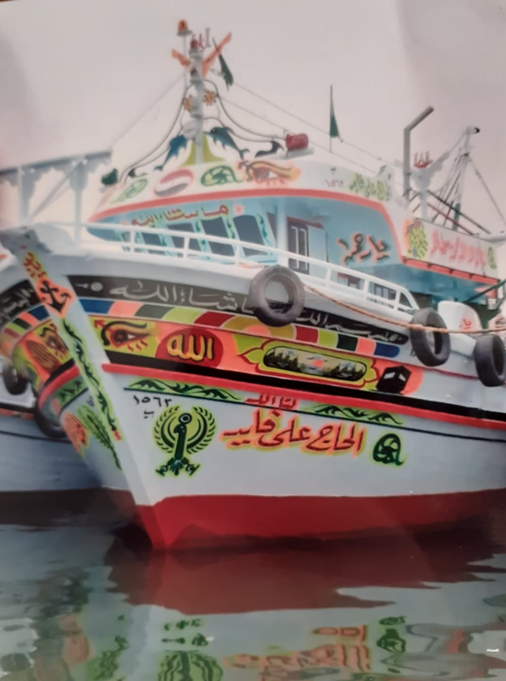

Fig.9. The shape of modern ships in Alexandria
Taken by author

Such ceremonies for launching ships were fortunately documented in Egyptian Cinematic heritage in the context of a famous Egyptian movie called Ibn Hamido. The movie, which was directed by Fateen Abdel el-Wahab in 1957, talks about two undercover police officers on secret mission they have to play as fishermen in Suez port to catch the drug dealers. Among the scenes of this comic movie, folkloric ceremonies were shown during launching one of the ships including dancing, Islamic prayers and breaking a vessel among the bow of the ship named “Normandy 2” (figs 10, a, b). Breaking a bottle on the hull of the ship became a major ritual during launching ships in Europe by the 18th century AD (Blackman 1995, 150; Hodgkinson 2024). On the contrary, yachts and military and commercial vessels, ceremonies were practiced but in more official context due to the development of air transportation.

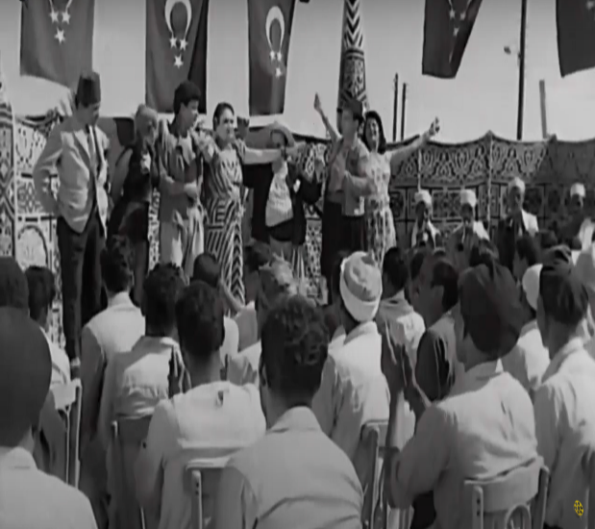 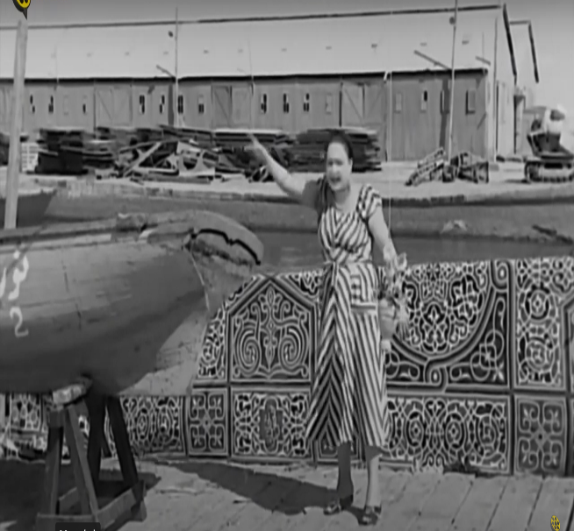 A b
Figs. 10 a,b. Scene of Egyptian movie showing ceremonies of launching the ship, “Ibn Hamido movie,” directed by Fatin Abdel el-Wahab in 1957
https://www.youtube.com/watch?v=YBJfAzHzhkQ

- Egyptian Ship launching ceremonies as an effective promoting tool for the Egyptian Marine heritage:

Admittedly, launching practices in maritime communities could be utilized as means of promoting tourism in ports of Alexandria. By reenacting ship-launching rituals, Egypt combines cultural heritage with immersive experiences to give visitors a firsthand peek into its rich past through the reenactment of ship-launching traditions. A dramatic backdrop that heightens the realism of the event can be created by using sound and light shows in conjunction with storytelling performances to portray these reenactments in a variety of ways. Visitors are given a rare opportunity to experience a tradition that has been performed for thousands of years through the use of period-appropriate clothing, music, and vessels that assist to transport them back in time.

From a tourism promotion perspective, these ceremonial reenactments complement Egypt's larger marketing campaign to showcase its rich cultural maritime past. They are an effective means of drawing in tourists who are interested in history, culture, and in-depth, hands-on tours, particularly in the port areas of Egypt. To give tourists a genuine experience, marine communities' involvement in these places should be given careful thought. To spark potential tourists' interest, the events can be promoted via a variety of platforms, such as; social media, museums and galleries, and travel agencies. By drawing attention to these marine customs, Egypt ensures that respect for its long-standing customs endures and not only protects its cultural legacy but also uses it as a powerful tool to grow its tourism sector.

According to the previous study, ship launching ceremonies could indisputably play a crucial role in promoting for the intangible marine heritage in Egyptian ports. Approaching a better understating of ceremonies of ship launching in the context of cultural heritage and tourism, a SWOT analysis is conducted to make a better a framework to identify and analyse the ship launching ceremonies in Egypt (table 1).

Strength | Weakness
- Ship launching ceremonies are diverse due to the richness of the ancient Egyptian History and civilization.  - Ship launching ceremonies reflect the cultural and ideological identity of the Egyptian society along its long history.  - Ship launching practices are a crucial part of the folkloric ceremonies of seamen and shipbuilders in Egyptian ports. | - Ship launching ceremonies are not documented through non-profit organizations.  - The lack of historical resources did not give a full account about ship launching ceremonies in Egypt particularly during Islamic and modern times.
Opportunities | Threats
- Many non-organizations may have the motivation to document ship launching ceremonies. For instance, The Raquda Foundation for Art and Heritage in Alexandria leads now a promising project for rescuing the area of el-Max in Alexandria which is a prominent fishing and maritime community in the city https://raqudafoundation.org/projects/el-max/. The project could involve the traditional practices which accompanied launching fishing boats in such area.  - Ship launching ceremonies could be part in promoting for Egyptian marine heritage.  - Ship launching ceremonies could be involved in the context of Egyptian museums through storytelling, workshops and children’s activities.  - Promoting for ships launching ceremonies will offer a good opportunity for engaging the local maritime communities in preserving their traditions and for promoting for it in the field of tourism. | - Traditional launching ceremonies could face distinction since they are inherited form one generation to one generation and they are not systematically documented.  - The rapid devolvement of technology as well as the dominance of air transportation threaten such traditional ceremonies.

Table.1. SWOT Analysis revealing the role of launching ceremonies in the Egyptian Marine Heritage

- Conclusion:

The ceremonies of launching the ship are diverse and represent the inherited marine heritage of any country. Having a rich history and long history and civilization, Egyptian ceremonies of launching the ships passed through various stages all of which were mainly based on religious concept. Regardless the obvious change of the religious beliefs and transformation that occurred in Egypt, the Egyptians mainly aimed to guarantee a divine protection for their marine voyage through such ceremonies. Documenting folkloric ceremonies in Egypt will be worthful particularly for the fishing ships and will preserve a crucial aspect of the intangible marine heritage of Egypt. Displaying such scenes in museums should be one of the potentials for conserving these ceremonies. These ceremonial reenactments complement Egypt's larger marketing campaign to showcase its rich cultural past from the standpoint of tourism promotion. They are an effective means of drawing in tourists who are interested in culture, history, and in-depth, hands-on excursions. To spark interest in the events among prospective tourists, a variety of media platforms, such as; social media, as well as museum, exhibitions, and tourism offices, can be used for advertising.

References:

- Abdle el-Rahman, A. 2021, المعابد المصرية في العصرين اليوناني و الروماني [Egyptian Temples in the Græco-Roman Period], Cairo, Dar El Zahraa el-Sharq.

- Alföldy, A.1937: “A Festival of Isis in Rome under the Christian Emperors of the IVth century,” Dissertationes Pannonicae ex Instituto Numismatico et Archeologico Universitatis de Petro Pazmany nominatae Budapestinensis provenientes, s. III, fasc. 7, Budapest.

- Arslan, E. A.1997: “La moneta”, in M. A. Brida, and A. Magni, eds., La Festa Iside il mito, il mistero, la magia, in: di Ermanno A. Arslan , Francesco Tiradritti, Electa, Milano, 134-141.

- Andrews, C.1994: Amulets of Ancient Egypt, British Museum Press, London.

- Ballard, L. M. 2008: “Curating Intangible Cultural Heritage,” Anthropological Journal of European Cultures, 17(1), 74-95. http://www.jstor.org/stable/43235374

- Blackman, D. 1995, “Some Problems of Ship Operation Harbour,” Proceedings of the 3rd International Symposium on Ship Construction in Antiquity, Athens 24-27 August 1989, Harry Tzalas (ed.), Greek Ministry of Culture, 73-82.

- BOA, Cevdet-Bahriye, no. 7210.

- Bommas, M. 2005: Situlae and the Offering of Water in the Divine Funerary Cult; A New Approach to the Ritual of Djeme, L' Acqua Nell' Antico Egitto, Proceedings of the First International Conference for Young Egyptologists, Italy, October 15-18,2003, in: A. Alessia (ed.), L' Erma di Breatschneider, Roma, 257-272.

- Bricault, L. 2006: Isis, Dame des Flots, Isis dame d’flots, Ægyptiaca Leodiensia 7, in Malaise, M., (ed), Presses Universitaires de Liège, 155.

- Benson Margeret & Gourlay, J.1899: The Temple of Mut in Asher; An Account of the Excavations of the Temple and of the Religious Representations and Objects found therein, as illustrating the History of Egypt and the Main Religious Ideas of the Egyptians. London

- Chassinat, É. 2009: Le Temple d’ Edfou IX, MMAF 26, Le Caire: IFAO, (2nd edition).

- Coppens F. 2009, “Temple Festivals of the Ptolemaic and Roman Periods,” In W. Wendrich, J. Dieleman, E. Frood, & J. Baines (eds.). UCLA Encyclopaedia of Egyptology, (http://escholarship.org/uc/item/4cd7q9mn) [Accessed on December 2016], 1-11.

- Doyle N. 2017, “Processional Barques from the tomb of Tutankhamun (kV62),” Journal of Ancient Egyptian Interconnections 16: 1-8.

- Ebn Eyas, بدائع الزهور في وقائع الدهور [Flowers in the Events of the ages], part3.

- Garofalo A. 2018, “Ship Launches in Medal”, Rivista Italiana Di Nvmismatica E Scienze Affini, vol. CXIX, Milano, Estrato: 231-254.

- Hornell J. 1939, “Origins of Plank-built Boats”, Antiquity 13(49): 35-44.

- Giunio, K. 2013. “Isis - the sea star and the ceremony of navigium Isidis / Izida - zvijezda mora i obred navigium Isidis,” Isis - the sea star and the ceremony of navigium Isidis // Diadora : glasilo Arheološkog muzeja u Zadru, 26-27, 421-440

- Griffiths, J. G. 1960, The Conflict of Horus and Seth, Liverpool: Liverpool University Press.

- Griffiths, J. G. 1975, The Isis-book: (Metamorphoses, Book XI) Edited with an Introduction, Etudes préliminaires aux religions orientales dans l'Empire romain volume 39, Leiden: Brill.

- Dominik H., Simeonov, G., 2018, “Ceremonies by the Sea. Ships and Ports in Byzantine Imperial Display (4th–12th Centuries)”, in: C. von Carnap-Bornheim et al. (eds.), Harbours as Objects of Interdisciplinary Research – Archaeology + History + Geosciences. International Conference “Harbours as Objects of Interdisciplinary Research – Archaeology + History + Geosciences” at the Christian-Albrechts-University in Kiel, 30.09.-3.10.2015, within the Framework of the Special Research Programme (DFG-SPP 1630) “Harbours from the Roman Period to the Middle Ages” (RGZM-Tagungen 34 = Interdisziplinäre Forschungen zu den Häfen von der Römischen Kaiserzeit bis zum Mittelalter in Europa 5), Mainz 2018, 221–248.

- Hölbl, G. 2000, Altägypten im Römischen Reich der römische Pharao und seine Tempel Volume 2, Darmstadt: Philipp von Zabern.

- Hodgkinson G. 2024, A History of Ship Launches and Their Ceremonies, Barnsley: Pen and Sword Transport.

- Hofmann, P. 1993, Der Isis-Tempel in Pompeji, Münster-Hamburg.

- Faulkner, Raymond O. 1962: A Concise Dictionary of Middle Egyptian, Oxford.

- Filgueiras 1978, OCTÁVIO LIXA, A proposito da protecqio magica dos barcos, Centro de Estudos da Marinha, Lisboa.

- Kitat, S. 2006, Gods of Medicine in Ancient Egypt: A Civilization & Tourist Study, unpublished Master Thesis, Faculty of Tourism and Hotels, Alexandria University.

- Kitat, S. 2010, Water divinities in Egypt during the Græco-Roman Period, A religious, archaeological and tourist study, Faculty of Tourism and Hotels, Alexandria University.

- Kitat, S. 2023, Egyptian Temples of Upper Egypt during the Ptolemaic and Roman Times; An Academic Guide to the Tour Guide, Cairo: Ranna Publishing.

- Landström, B. 1970, Ships of the Pharaohs, New York, Doubleday: Garden City.
- Lotfy M. 2003, translated by Saleh M., أساطير معبد أدفو [Myths of Edfu Temple], Cairo: Egyptian General Book Authority, Cairo.

- Maher S. 1967, البحرية في مصر الإسلامية وآثارها الباقية [ The Navy and its Remaining Monuments in Islamic Egypt], Caro: Dar el-Kutub.

- Mubarak A. الخطط التوفيقية [Al. El Khetat el Tawfiqeya] , part 12, Cairo: Ameereya Press. produced by Princeton University.

- Plans of Tawfiq Müller-Winkler, C. 1986, “Udjatauge,” LÄ VI, Otto Harrassowitz, Wiesbaden: 824-826.

- Nunn, J. F. 2002: Ancient Egyptian Medicine, 2nd ed., Norman: University of Oklahoma Press,.

- Sarolta, A. T. 2008, “Initiations and Mysteries in Apuleius’ Metamorphoses,” Electronic Antiquity 12.1: 84-85.

- Serhank, حقائق الأخبار في دول البحار [Real News in offshore countries], part 3.

- Tibiletti, T. 1997: Navigium Isidis’, in M. A. Brida, and A. Magni, eds., La Festa Iside il mito, il mistero, la magia, in: di Ermanno A. Arslan , Francesco Tiradritti, Electa, Milano, 653-661.
- Tomorad, M. 2005: Egyptian Cults of Isis and Serapis in Roman Fleets, L' Acqua Nell' Antico Egitto, Proceedings of the First International Conference for Young Egyptologists, Italy October 15-18, 2003, in: Amenta Alessia, ed., L' Erma di Breatschneider, Roma, 241-253.
- Watterson B. 1998, The House of Horus at Edfu: Ritual in an Ancient Egyptian Temple, Stroud: Tempus.
- Wild, R. A. 1981: Water in the Cultic Worship of Isis and Serpais, E. J. Brill, Leiden.

- Witt, R. E. 1997: Isis in the Ancient World, The Johns Hopkins University Press, Baltimore and London.

- Zorlu, T. 2008: “Ottoman Ship Launching Ceremonies: A Practice between Symbols and Rites,ˮ International Review of Turkology (IRT), vol. I, no. 1: 55-63.

University of Alexandria, Egypt. Email: sarakitat@alexu.edu.eg . Id. Orcid: https://orcid.org/0000-0002-1750-8770 * Autora para la correspondencia

