Tourism and Folk Music: City Branding, Musical Imaginaries, and the creation of tourist destinations in Yulin, Chengdu (China)
Turismo y música folclórica: marca urbana, imaginarios musicales y creación de lugares turísticos en Yulin, Chengdu (China)

Shuyue Chen *

Abstract
As intercity competition increases, cities search for distinctive meanings and create identifiable symbols for places to increase their attractiveness. These symbols change the urban landscape and shift the characteristics of ordinary neighborhoods. This paper is a case study of a neighborhood called Yulin in Chengdu in southwest China. Developed in the 1980s, Yulin was an ordinary neighborhood representing Chengdu’s work unit housing in the 1980s and 90s. Although its name is well known by locals, Yulin was suddenly exposed to the wider public of the country due to a folk song. In 2017, a folk musician, Zhao Lei, performed his song, Chengdu, on Hunan TV. Using guitar, piano, and children’s voices, the song depicts a romantic story on the street of Yulin and reinforces the imaginaries of Chengdu as a leisure city. Names and addresses in the lyrics became well-known overnight. From then on, tourism-induced investments have driven significant changes in Yulin. This study focuses on the built environment of Yulin and shows the power of folk music to shift people, buildings, and money. It discusses how a contemporary folk song resonates with the imaginaries of Chengdu as “the city of leisure” and how Yulin has been changed due to musical imaginaries. In addition, it aims to enrich the discourse of city branding and placemaking to raise awareness of tourism-induced changes in ordinary neighborhoods, in China and beyond.

Keywords: Community-based tourism, Land dispute, Neoliberalism, 2030 Agenda, Northeastern Brazil

Resumen

En el contexto del modelo neoliberal, se ha promovido la expansión del turismo dando prioridad a las estructuras de mercado, apoyando a las grandes empresas y, a menudo, dejando de lado las iniciativas centradas en la justicia social y la distribución equitativa de los ingresos. El turismo comunitario (turismo basado en la comunidad, turismo con base comunitaria o TBC), por el contrario, se considera una práctica contrahegemónica que persigue una mayor equidad socioeconómica, a diferencia de su homólogo convencional. Este estudio pretende analizar los factores motivadores y las estrategias de acción que subyacen en el desarrollo del TBC en Chã de Jardim, Doces Tambaba y Porto do Capim, en el estado de Paraíba (nordeste de Brasil). La metodología consistió en el análisis de documentos sobre políticas públicas de turismo, la recopilación de datos de organizaciones no gubernamentales y plataformas digitales, y la realización de entrevistas. Aunque las condiciones son desfavorables, se concluyó que la TDC está ganando visibilidad en Brasil. En los contextos examinados, representa acciones contrahegemónicas, sirviendo como estrategia para garantizar la propiedad de la tierra.
Palabras clave: Turismo comunitario, Disputa por la tierra, Neoliberalismo, Agenda 2030, Nordeste de Brasil

1. Introducción
As intercity competition increases, cities search for distinctive meanings and create identifiable symbols for places to increase their attractiveness. Imaginaries are socially transmitted representational assemblages that interact with people’s imaginings (Salazar, 2012). Materializing musical imaginaries in urban spaces becomes an essential meaning-making and placemaking device to add meanings to the built environment and change the urban landscape.
This is a case study of a changing neighborhood Yulin (玉林) in Chengdu (成都), the capital city of Sichuan Province in southwest China. In 2017, a Beijing folk musician, Zhao Lei (赵雷), performed his song, Chengdu (成都), on Hunan TV (湖南卫视). Produced as a contemporary genre, this minyao (民谣, folk song) depicts a romantic story on the street of Yulin and reinforces the imaginaries of Chengdu as a leisure city. Its lyrics mention Chengdu (the city), Yulin (the neighborhood), and Little Bar (小酒馆, a bar in the neighborhood). The song became popular overnight and attracted domestic tourists to visit Yulin. From then on, tourism-induced investments and placemaking have driven significant changes in Yulin.
In the Chinese context, the concept of minyao (民谣, folk song) is vague and can be interpreted as folk ballads, traditional and ethnic songs, and contemporary folk music. In this study, minyao refers to a contemporary genre using guitar, which is deeply influenced by American folk musicians such as Woody Guthrie and Bob Dylan. In recent years, researchers have tried to map the genealogy and development of contemporary folk music in Mainland China³. For example, Dong summarizes that new folk songs (新民谣) in the 21st century are different from campus folk songs that represent elite culture in the 1990s. New folk songs, sometimes called urban folk songs, emphasize authenticity and simplicity and adopt a critical lens to rethink urbanization and modernization.
The seed of placemaking was planted in the 1960s when Kevin Lynch (1960) and Jane Jacobs (1961) introduced groundbreaking ideas about city images, urban social life, and good designs for people. The term placemaking appeared in academic writings in the 1980s and the early 1990s5 (Burgess, 1979; Coates and Seamon, 1984; Hayden, 1988; Motloch, 1990; Day, 1992). Various definitions of placemaking have appeared throughout research and practices since the mid-1990s, and to a degree, fixed definitions are avoided (Courage, 2020). Growing out of William Whyte’s research on the relationship between the built environments and human behaviors in New York City (1980), The Project for Public Spaces (PPS) defines placemaking as a collaborative process to shape the public realm to maximize shared value6. Recently, creative placemaking is a more popular term. The American Planning Association (APA) defines it as the process where stakeholders use arts and cultural strategies to implement community-led change. Placemaking (场所营造) in China is associated with the concept of urban renovation (城市更新). Friedmann’s research (2010) analyzes the case of Beijing hutong (胡同, alleyways) where new developments replaced old buildings and forms. A decade later, although most urban practices remain top-down citywide planning, placemaking in Chinese cities is gradually shifting its approaches from mass demolition and construction to micro renewal inside neighborhoods, as Friedmann advocated.
This study focuses on the built environment of Yulin and shows the power of minyao to shift people, buildings, and money. It discusses how a contemporary folk song resonates with the imaginaries of Chengdu as “the city of leisure” and how Yulin has been changed due to musical imaginaries, investments, and tourism-induced placemaking .
I applied four methods to gather information - literature review, semiotic analysis, observations, and interviews. I reviewed literature, news, official documents, reports, online articles, and blogs to achieve a comprehensive understanding of the historical and cultural background of Chengdu and Yulin. I used semiotic analysis to identify key imaginaries produced in the song and connected them to Chengdu’s city branding. My observations of Yulin before 2020 were casual participatory observations tied to my personal background⁸. Formal observations took place from February 2021 to February 2022. Then, in October 2021 and February 2022, I invited an 18-year-old resident to observe the street where Little Bar is located because I could not visit Yulin in person non-stop. After getting a deep understanding of the neighborhood, I conducted semi-structured interviews with 16 people - 5 Yulin long-term residents, 6 Chengdu long-term residents, and 5 residents of other cities who mainly learned about Chengdu from the Internet. Interviewees were asked to share their thoughts of the folk song, city characteristics, and changes in Yulin.

2. The development of Chengdu and Yulin

2.1. An overview of Chengdu’s urban development
Chengdu is the capital city of Sichuan Province in southwest China. It is about 1,240 km to Lhasa, 1,510 km to Beijing, and 1,660 km to Shanghai. Because of its inland location, Chengdu has grown more slowly than coastal Chinese cities despite the economic reform starting in 1979 (Qin, 2015). The city was less influenced by the western world and has retained more of its distinctive culture and local customs than coastal cities in China (Ng, 2018). Poetry, teahouses, spicy food, and mahjong represent the distinct Chengdu style formed in an affluent agricultural region.

Chengdu has adopted five general plans since 1954 and inherited a concentric spatial arrangement. Historical satellite imagery (Figure 1) shows the accelerating urbanization of Chengdu. From the 1980s to the 1990s, the city’s early-stage development happened on previous farmland between the first ring road and the third ring road. In 2001, the city set specific goals to comprehensively transform the planned economy into a market-oriented economy¹¹ (Qin, 2015), which accelerated the growth of the city. Figure 2 shows the increase in the registered population and the GDP growth of Chengdu in the primary industry, the secondary industry, and the service industry.

Figure 1: Satellite Imagery of Chengdu
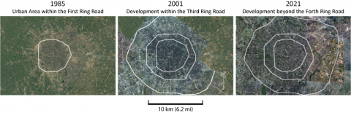
Source: Created by Shuyue Chen, based on Google Earth

Figure 2: GDP and Population Growth of Chengdu (1980 - 2020)
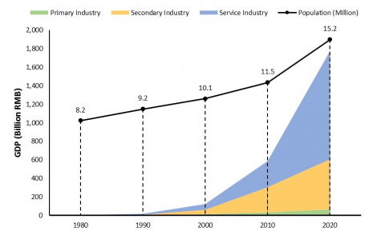
Note: Population is the registered population without all types of temporary migrants.
Source: Created by Shuyue Chen, based on Chengdu Statistical Yearbook (2021)

While Chengdu planned to catch up with the rapid growth of the east and south coasts, coastal metropolises had already established urban areas far larger than Chengdu. Figure 3 compares the built-up area of Chengdu and major cities in coastal regions. In 1985, the urban area of Chengdu was 87 km² (33.6 mi²) including the urban peripheries, while Beijing was 366 km² (141.3 mi²) which was four times bigger than Chengdu. Chengdu’s built-up area expanded by 1,123 percent from 1985 to 2021. In other words, a large portion of the urban area was newly built after the 1980s and a large number of populations were migrants from other regions (including other parts of Sichuan Province) and new urban residents who previously lived in the rural area.
Figure 3: The Built-up Area of Chengdu and Major Cities in Coastal Regions

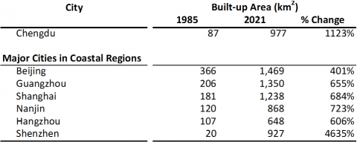
Source: Created by Shuyue Chen, based on Chengdu Statistical Yearbooks and China City Statistical Yearbooks

2.2. Yulin and its spatial characteristics

The perceived Yulin is located between the first ring road and the second ring road (Figure 4). According to The Chronicle of Yulin and The Chronicle of Wuhou District, when the First Ring Road was built in 1984, Yulin was still suburban farmland. With fast urbanization, the construction of northern Yulin was completed in 1988 and the southern part was developed from 1988 to the 1990s. The city also added infrastructure and located Sichuan Gymnasium, the Department of Construction, and a Computer Mall in Yulin.

Yulin was considered a representative work unit residential neighborhood by many Chengdu residents. Yulin and several other work unit neighborhoods built in the 1980s and 90s followed the same spatial pattern and shared similar neighborhood characteristics. It reflects the general land-use pattern in most large cities before the housing reform (Wang and Murie, 2000) - work units and public institutions were developed between the historical urban core and rural settlements (see Figure 4).

Figure 4: The Location of the Perceived Yulin

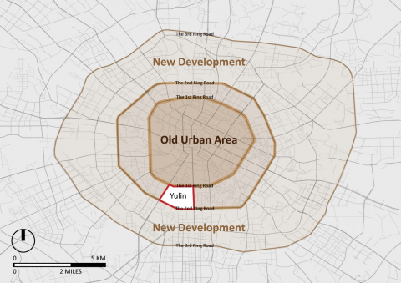
Source: Created by Shuyue Chen
n 1991, several work units were relocated to Yulin after the establishment of Wuhou District (武侯区), which determined the spatial characteristics and the demography of this neighborhood. Work units (单位, danwei) were designed to provide workers with almost all facilities and services including housing, health care, education, and factories. Although work units were no longer able to provide free services and facilities to their workers and retirees (Friedmann, 2010) after the economic transition, other legacies remained. For example, Yulin has a functional urban form where many buildings are gated communities of different work units. Gated communities are arranged in strict road hierarchies and spatial order. Buildings along the main streets have ground-floor stores serving the entire neighborhood. These six-floor or seven-floor buildings enclose a backyard that is collectively owned by the gated community where daily activities take place (Figure 5). The entrances of gated communities are always on narrow and quiet back streets (Figure 6). People from the same work unit greet each other every day when hanging clothes, drying peppers, or passing by. The affinity between residents coming from the same work unit remains today, although younger generations have left Yulin and lived in other parts of Chengdu.

Figure 5: Front Stores and Backyards of Gated Communities
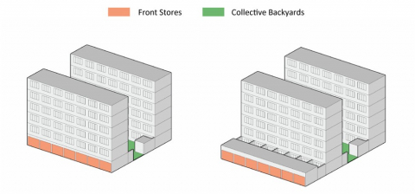

Source: Created by Shuyue Chen

Figure 6: Backstreets and Entrances of Gated Communities
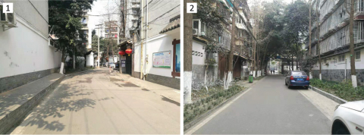

Image 1: A quiet backstreet with entrances of gated communities on both sides.
Image 2: A quiet backstreet with informal parking on one side.
Source: Shuyue Chen, 2021
Yulin was a name synonymous with cutting-edge and prosperous in the 1990s. Although these buildings are not luxurious by current standards, at that time, everything was new and could be seen as the embodiment of productivity and modernity. Meanwhile, market-oriented real estate development started to occupy the edge of the neighborhood, providing high-end housing to attract wealthy families. Artists and musicians also came to the new and dynamic neighborhood. They bought or rented condos and turned them into studios. Because of the mixed demography of work unit employees, wealthy families, and artists, Yulin had a large number of dynamic consumers, contributing to after-work leisure activities such as eating at hotpot restaurants, meeting friends in bars and teahouses, and playing Mahjong. The first registered restaurant of Chuan Chuan Xiang (串串香) was located in this neighborhood.

Yulin’s growth slowed down after 2000 because all land has been developed, like several nearby neighborhoods developed during the same period. First, the neighborhood lost some residents and investments. Due to fast urbanization, Yulin became a neighborhood between the old city center and the new technology center in the south. Opportunities and the housing market in the south were more attractive to people. Second, after work units decayed, the connection between work units and younger generations has broken up. Children who grew up in work units left their parents, found jobs in other companies, and lived elsewhere. Third, although Yulin has convenient public transportation, outdated work unit buildings without elevators and adequate parking space are less attractive to potential renters and buyers. Old residents stayed in the neighborhood. According to data from the Seventh National Census in 2020, the aging population (people over 65 years old) of Yulin Street is 15.8% while the aging population of Chengdu is only 13.6%.

3. Musical imaginary in Yulin
3.1. The city of leisure
In Chinese, xiuxian (休闲) means rest and leisure. It originally connoted the rest betwee agricultural seasons, such as the winter fallow. With economic development and increasing incomes, xiuxian gained the meaning of leisure and recreation. In the 1990s, scholars started to discuss tourism as a recreational activity, urban recreational spaces, and the city leisure industry (城市休闲产业).
The term xiuxian chengshi (休闲城市, the city of leisure or leisure cities) was put forward and developed in the 2000s. The implementation of two-day weekends and longer holidays since 1999 made tourism and other leisure activities accepted by Chinese society; changes in consumption patterns encouraged development in the leisure industry. Xiuxian became an adjective to describe not only urban spaces and tourist attractions but also city characteristics. In 2001, both Chengdu (成都) and Hangzhou (杭州) municipals proposed to build “the city of leisure” and manage city images. In 2006, People’s Party Animals (Lee, 2006) was an article talking about Chengdu in the Los Angeles Times. This article used “a leisure city” to describe Chengdu and emphasized that Chengdu’s leisure is different from other famous Chinese cities. Several Chinese newspapers reported on Chengdu’s sense of leisure during the same period, including People’s Daily (人民日报), Global Times (环球时报), and Beijing Daily (北京日报). In addition, City Leisure Index was widely discussed in the academy and later became a rating reference for leisure cities.
In 2007, after a series of expert reviews, netizens’ participation, and professional consultation, Chengdu was selected as one of the ten leisure cities in China at the China Leisure Industry Economic Forum20. Leisure cities became a formal and institutionalized label that many cities desire to achieve. Until 2017, Chengdu had been selected as a leisure city five times. Chengdu’s leisure city images are gradually constructed and improved, including the images of hotpots, teahouses, nightlife, bar and disco culture, and a relaxing lifestyle.
3.3. Little Bar, musical imaginaries, and city characteristics

On February 4, 2017, when everyone was enjoying the Spring Festival at home, Zhao Lei (赵雷), a Beijing folk musician, performed his song Chengdu (成都) on Hunan TV. The folk song was composed in 2014 and released in 2016. It is a contemporary folk song using instruments such as guitar and piano. Its genre is different from the traditional music in this region. Its lyrics mention Chengdu (the city), Yulin (the neighborhood), and Little Bar (a bar inside the neighborhood).
Little Bar (Figure 7) is one of the ground-floor businesses on Yulin Xi Lu (玉林西路, Yulin West Street). The owner of Little Bar is Tang Lei (唐蕾) who is known as the mother of Chengdu Rock and Roll. In 1997, a group of artists and musicians contributed to the birth of the bar including Shen Xiaotong (沈小彤), Liu Jiakun (刘家琨), and Qiu Anxiong (邱岸雄). Created by pioneering artists and musicians, Little Bar soon became a well-known gathering place for avant-garde artists, musicians, and writers to communicate and perform. Later, Little Bar opened branches in other parts of Chengdu and offered more opportunities for musicians to play on the stage. Around 2007, Zhao Lei was a wandering busker who traveled across the country. Little Bar was the place where he met musicians and where he performed. His experience in Chengdu in 2007 inspired him to create the song in 2014.

Figure 7: Little Bar and Yulin West Road
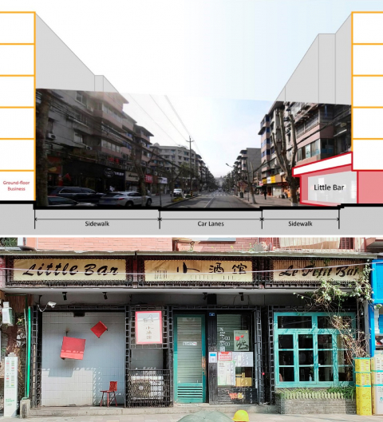
Source: Shuyue Chen and Xinwen Liang, 2022
The folk song Chengdu reinforces romantic imaginaries of Chengdu as a leisure city. The most famous lyrics are as follows:
Leaving in September; memory is missing you with sorrow
From the tender willow in late fall, a kiss on my forehead
In the rainy small town, I never forget you
Chengdu, I take everything away except you
Walk with me along the street of Chengdu
Don't stop even though all lights are off
You hold my arm; I put my hands in pockets
We walk to the end of Yulin Road
Sit in front of Little Bar at its door

The rhythm of this song is soothing and gentle. The poetry of lyrics is a core feature of new urban folk songs. This song uses “September” and “fall” to anchor the time. It conveys a sense of departure (nostalgia) in the fall. The relaxing summer ends and people have to leave Chengdu, go back to work and daily routine, and face the pressure of life. Environmental features render a sense of sorrow, such as the rainy town and a kiss from the willow. Depicting environment features in the fall is a common rhetorical technique in traditional Chinese poems to attach a strong emotion to the scenery. A well-known poem Autumn Thoughts by Ma Zhiyuan (马致远, 1250-1321) portrays sadness in quiet autumn by listing objects in sight. The chorus of the song tells a romantic story of walking along the street at night, enjoying the night of Chengdu, and visiting Little Bar. However, when “I” have to leave, “I” can “take everything away except you” from Chengdu. This song talks about leaving an intimate friend and leisure. A newly published local chronicle, Streets in Wuhou (2021), analyzes the lyrics and concludes, “Couples holding hands, a relaxing lifestyle, this song arouses people’s yearning for Yulin Road and Little Bar.” What’s more, “Chengdu, I take everything away except you” became a famous sentence and was repeated by netizens, advertisements, and official promotions. One interviewee (Chengdu resident, in her 50s) shared that the song made her recall her past, “At my age, I see things with a stronger emotion. This song reminds me of my life in Yulin when I was in my 30s...”
Additionally, the city branding strategy of Chengdu deepens people’s similar imaginings of a leisure city and a relaxing lifestyle. Leisure is a key to Chengdu’s city branding although not everyone agrees that life in Chengdu is relaxing. When I searched “Chengdu Life” on the internet, photos of outdoor teahouses immediately came out. There are luxuriant trees, wooden corridors, and square tables. People are playing mahjong, chatting, and drinking tea. Although leisure may be a purified romantic imagination, audiences of the folk song will immediately link the imagining of a relaxing lifestyle in Chengdu to the song due to previous city branding. Indeed, many young workers have decided to live and work in Chengdu after traveling to the city as tourists.

3.4. Tourism growth

In 2017, the song of Zhao Lei was widely circulated on the Internet along with the names in the song. According to Baidu Index (百度指数), online searches of Zhao Lei and Chengdu exploded in early 2017. Zhao Lei and Chengdu became popular words during the first season in 2017 (Figure 8). The green line in the chart shows the trend of Chengdu. It did not drop down immediately, which means people continued to search Chengdu on the internet.

Figure 8: Searches of Zhao Lei and Chengdu on Baidu
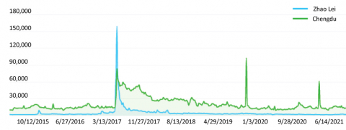

Source: Generated by Baidu Index. This image shows the trend on both PC and mobile from 2015 to 2022.

The long-lasting influence of the song boosted domestic tourism in Chengdu. Figure 9 shows the numbers of domestic tourists and their growth rate by year. The number of domestic tourists to Chengdu increased every year. In 2018, the number of tourists was 207 million, and the annual growth rate reached its highest point, at 16%. In 2019, the growth rate is still as high as 15%. In comparison, the national growth rates were 11% and 8% in 2018 and 2019. Not all tourists would plan to visit Yulin and Little Bar. Tourists to Yulin are mostly small groups of young adults or people connected with the music circle. They organize tours themselves and are attracted by the song and the bar. Sometimes, tourists are not necessarily folk music lovers or fans of Zhao Lei. They are more like hipsters who want to catch the newest trend online and who hold the view of “joining in the fun” and “coming along for the ride”. In addition, local people may not consider Yulin an ideal tourist attraction. One Chengdu interviewee said, “If my friends ask me to take them around Chengdu, I won’t take them to Yulin unless they strongly request.”

Figure 9: Annual Domestic Tourists and Growth Rate
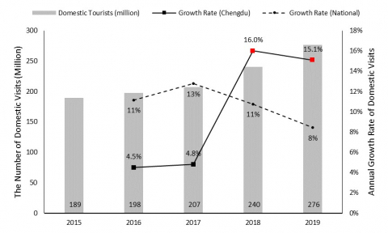
Source: Created by Shuyue Chen.
Source: EPS Data collects the tourism data from the Sichuan Provincial Bureau of Statistics, the National Bureau of Statistics of China, and China Statistical Yearbook.

4. Changing an ordinary neighborhood

4.1. Musical imaginary from external audiences
While the public widely agrees that Chengdu is a leisure city, the specific music imaginaries of leisure created by the folk song are constructed from the external gaze.
First of all, the folk song Chengdu was written from the perspective of an outsider because Zhao Lei was a Beijing visitor to Chengdu. In the interview, only about 25% of the interviewees (4 out of 16) thought the song could represent Chengdu. They imagined and depicted Yulin as Zhao Lei did. They described activities such as rambling along the street in Yulin after dinner, chatting with people, and enjoying leisure time on weekends. Other interviewees (11 out of 16) felt the connection between the song and the city was weak. They compare their experiences in Chengdu with their travel or living experiences in other places, and find that leisure in Chengdu is not surprising, or even not “true”. Some explained, “I have visited and lived in several cities. I don’t think Chengdu is relaxing. Chengdu is just like other big cities.” “This song can be used for any city that has the same climate, for example, my hometown Hangzhou.” “It’s only the personal feeling of Zhao Lei when he visited Chengdu.”
Interviewees’ words reveal that the song conveys a personalized yet mainstream feeling of leisure. This feeling can be applied to more than one Chinese city, to nowhere and everywhere. To explain, scholars and professionals use “urban folk songs” to describe folk songs created in the past twenty years. Folk musicians observe a city, write a song that describes a particular characteristic they notice, and connect the city to the song. Musicians have used the similar method to portray personal feelings such as leisure and loneliness. Zhao Chang (赵唱) wrote an online article for National Humanity History with an innovative title³², “There are fewer and fewer first-tier and second-tier cities left for folk music: what is the root of folk music in mainland China?” Zhao Chang pointed out that many recent folk songs depict a unique lifestyle in a certain place. To list a few, I’m Eating Fried Chicken at People’s Square (2013) about Shanghai, Lonely Beijing (2013) about Beijing, and Qu Da Li (2014) about Dali in Yunnan Province. Musical imaginaries produced by these songs reflect people’s questions about meanings, modernization, and urbanization in the industrial society and people’s desire to escape from daily routines in their busy cities to search for meanings.
In addition, new migrants and visitors perceive more elements of leisure than long-term Chengdu residents who are less conscious of leisure culture. New migrants came to Chengdu and Yulin because they were attracted by the certain kind of relaxing lifestyle produced by the media. New migrants and tourists who visit Yulin after 2017 value authenticity and neighborhood history to demonstrate their understanding of Yulin. They absorb the knowledge of Yulin from the media, musicians, artists, and community workers. An architect (interviewee, a new migrant to Chengdu) who worked in Yulin after 2017 said, “The street is more vivid and active than before.” He is satisfied that artists are coming back and that there are more restaurants for people to have lunch on work days. One well-educated interviewee who lives in a nearby neighborhood will regularly participate in community activities such as cafe fairs in Yulin to stay in touch with other young adults. For these people from the dynamic creative class, Yulin is a fascinating place for working, networking, and enjoying weekends. Only one new migrant who ran a store in Yulin felt dissatisfied because the original atmosphere of Yulin was disturbed by streetscape improvements.
Conversely, local people’s understanding of leisure varies. Although 64% (7 out of 11) of Chengdu interviewees do believe leisure is key to the city, long-term residents interpret leisure in different ways. For example, rather than enjoying bars, cafes, and music, some interviewees consider leisure as walking after dinner, playing mahjong with tea, having fewer working hours, and holding positive attitudes towards life.
Interviewees also raise concerns about “fabricated” information. Some of them think Yulin, especially its physical form and daily routines, is similar to other nearby neighborhoods that were built in the same period. All those neighborhoods have walking-friendly streets, large tree canopies, and mahjong houses. People said, “There is nothing special.” “I don’t care about building renovation along the street as long as it doesn’t impact my condo.” A Yulin resident repeated existing criticism on social media that Yulin Road is a fabricated address. “We only have Yulin West Road and Yulin East Road…Little Bar is not at the end of the street but in the middle.” In the past, little Bar did arrange activities but the space was too small. Now, the bar is holding concerts and performances on another site, but that Little Bar (a branch of the bar) is located on Yongfeng Road (永丰路) located on the edge of Yulin rather than Yulin Road mentioned in the song.

4.2. Tourism-induced investments and placemaking
Zhao Lei’s song became popular overnight and attracted tourists to Yulin. From then on, tourism-induced investments and placemaking have been changing the built environment in Yulin. The old environment of Yulin was “dull” (Figure 10). Buildings in the neighborhood were quickly built in the 1980s and 1990s without elaborate designs and decorations. Investments and placemaking projects after 2017 shifted the built environment by repainting walls in bright colors, highlighting building articulations, upgrading businesses, and redesigning sidewalks (Figure 11).
Figure 10: The Old Built Environment of Yulin
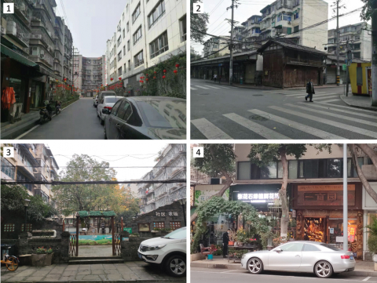
Image 1. A backstreet is located between a residential slab (left) and an elementary school (right).
Image 2. A street with one-floor stores.
Image 3. A quiet community farm that residents seldom visit.
Image 4. Small businesses along the main street of the neighborhood.
Source:Shuyue Chen, 2021

Figure 11: Changes of the Built Environment after 2017
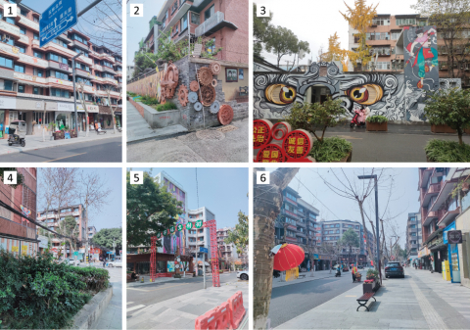
Image 1 and 4. New building facades along Yulin West Street.
Image 2. Decoration of the wall of a gated community.
Image 3. The mural of a public restroom.
Image 5. New signage (slogan) across the street.
Image 6. The overall streetscape of Yulin West Street.
Xinwen Liang, 2022.
At first, small private investments reacted to the market. Limited scales and monetary inputs enabled small businesses to invest quickly by renting and running ground-floor businesses such as restaurants, bars, cafes, and bookstores. Opening a music bar is a good option because tourists come to Yulin for the folk song and similar experiences. In the beginning, Yulin did not offer many vacant stores for opportunistic investments because the neighborhood had mature local services and a solid consumption base that had developed in the past thirty years. Available stores for private investors were sporadic in the neighborhood but not concentrated on Yulin West Street where Little Bar is located. Comparing the street views of 2016 and 2017 on Yulin West Street (Figure 12), there were no major differences in ground-floor businesses, even though visitors started to gather around Little Bar. Business turnover did happen, but new businesses still served local people, for example, from one clothing store to another clothing store.

Figure 12: Yulin West Street (June 2016 and July 2017)

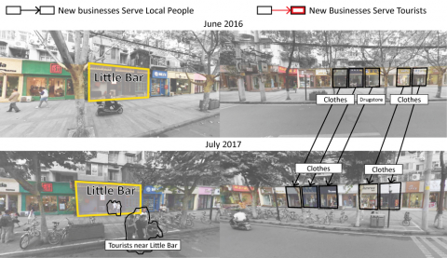
Source: Created by Shuyue Chen, based on Baidu Street Map View.

The economic sectors of Yulin are gradually changing to meet the needs of tourists and employees in the creative industry. Accumulative physical changes along the streets became obvious in 2018. With the increasing rental fees and housing prices, tourism-induced businesses started to push local businesses out of the market. More ground floor spaces were converted to bars, restaurants, and cafes with fashionable designs targeting young adults. Three years after the overnight fame, in February 2020, more than half of the stores on Yulin West Street had been converted to restaurants, bars, and other tourism-related businesses (Figure 13).

Figure 13: Yulin West Street (June 2016 and February 2020)

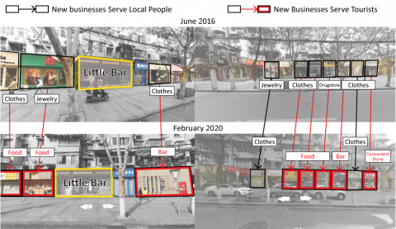
Source: Created by Shuyue Chen, based on Baidu Street Map View

In February 2022, I invited an 18-year-old Yulin resident to document a segment of Yulin West Street. She mapped every store that she perceived as new³⁷. As shown in Figure 14, red points are perceived as new restaurants, blue points are bars, and yellow points are all other businesses. Opening more than eight bars³⁸ along a short street segment is not common, especially in a residential neighborhood that has a large aging population. Some bars cost about 70 yuan (a drink is about 10 US dollars) per person, while a cup of coffee in Starbucks only costs about half the price.

Figure 14: Perceived New Businesses on Yulin West Street
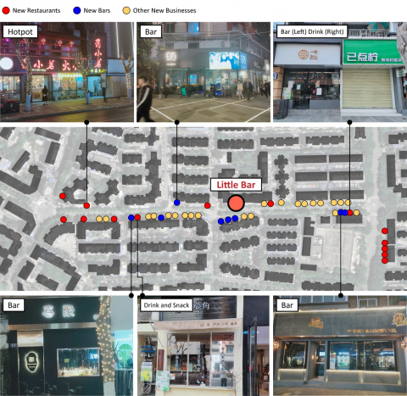
Source: Created by Shuyue Chen, based on photos and notes of Xinwen Liang, 2022

While Chengdu’s music culture is well-known, Yulin was never officially branded as a musical district (音乐街区) before 2017. The 13th Five-Year Plan of Chengdu39, published in 2016 and revised in 2018, puts forward the goal to develop an international music city (p. 123). The plan proposes four music parks (音乐园区), five music towns (音乐小镇), and several other sites, but Yulin is not on the list. Yulin was an ordinary residential neighborhood outside the official planning of musical streets.
It was the folk song that made Yulin famous, placed Yulin in the sight of planners and policymakers, and provided Yulin chances to join important development plans. For example, the 14th Five-Year Tourism Plan (2022) proposes to develop Yulin North Road Community (玉林北路社区) as a place for experiencing Chengdu urban life. The new City of Music Plan (2022) also propose to select 20 blocks, 50 communities, and 200 cultural yards to strengthen Chengdu’s music atmosphere (p. 84).
The experimental success of small businesses in 2017 attracted more stakeholders including the district government and the street office42. In Yulin, government-led projects mainly focused on streetscape improvements, for example, streetscape renovation projects on Yulin West Street (玉林西路) and Fangcao Street (芳草街). These projects involve professional planners and urban designers, but project details were not fully open to the public. They usually target to improve sidewalks and building quality, create a vivid street atmosphere, wake up the nighttime economy, and upgrade businesses. In addition, there are several public-private projects that serve residents as well as office workers and visitors. For example, the Yard Cultural & Creative Park (院子文化创意园) is a project providing spaces for community activities, workplaces for design studios, start-ups, and Yulin Street Office.

4.3. Gentrification in Yulin due to the folk song
Huang and Yang (2010) summarizes factors contributing to gentrification in Chengdu, such as government policies, the decay of work units, industrial restructuring, economic stimulus by developers, and individual wishes. However, Huang and Yang confuse gentrification and displacement, although these two processes always happen together. There is little evidence of negative resident displacement in Yulin. Many housing units in Yulin are owned by retired work unit workers who were first-generation urban residents of Yulin. The elderly themselves enjoy convenience Yulin provides and do not have urgent needs to leave. In the long term, displacement may happen since Yulin is an aging neighborhood. When families need money or old residents pass away, people may sell condos and go to other places.

Gentrification in Yulin is still in its early stage and is shown in two aspects. First, private investments and small businesses convert stores serving residents to businesses serving tourists. Second, government-led streetscape improvements renovate the built environment using different colors and styles. Yulin was one of the ordinary neighborhoods in Chengdu. It rose due to land development in the 1980s and 90s. Yulin declined because the influence of work units decreased. Yulin experienced a rise and a fall like other residential neighborhoods, but the place was no longer ordinary after 2017. Yulin was pushed into the tourism market by the folk song and became a so-called revitalized neighborhood that can catch up with the trend of Chengdu and even become a representative neighborhood of the city. I use a conceptual timeline (Figure 15) to describe drastic changes in Yulin. The development from 1980 to 2017 shows the original pace of Yulin. People came and left in harmony with the larger urban context. Buildings faded and were repainted with similar colors. After 2017, things happened so fast that businesses, colors, and even walls have become completely different, only in five years.

Figure 15: The Development of Chengdu, Yulin, and an Ordinary Neighborhood.
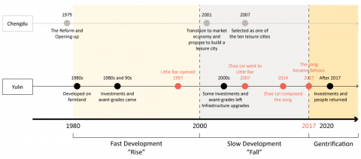
Source: Created by Shuyue Chen
Gentrification in Yulin is driven by multiple stakeholders. First, the folk song attracts people and money. Its popularity made Yulin able to gain more resources and attention for reinvestment. Second, changes in Yulin are supported by the government. After 2017, projects in Yulin are considered projects of urban renewal and the creative industry, gaining multiple support from the national level to the local level. Third, small businesses accelerate gentrification in Yulin. Small businesses use different graphic designs and decoration than before, which gradually changes the streetscape. As Yulin has become an experimental field for cafes and bars, competition among small businesses intensifies. Distinct and eye-catching designs proliferate, and ordinary streetscapes disappear. To some extent, new storefronts work better than older ones because they were designed by professionals. From 2017 to the present, physical changes are so ubiquitous that almost all major streets in Yulin have been transformed.
41Gentrification in Yulin is not considered a bad thing. No strong public backlash happened. Residents’ attitudes towards the changes tend to be neutral or positive. Although Chengdu’s government website received a few public complaints from Yulin residents, most messages were complaints about the noise of tourists or construction. Residents did not oppose changes in the built environment. Only one interviewee felt strongly dissatisfied with the new streetscape. Other Yulin interviewees never strongly opposed the ongoing placemaking or worried about gentrification in Yulin. After all, streets are more beautiful and colorful. People may feel frustrated because too much has changed over time and their control and understanding of their own neighborhood has been weakened. Yet people’s attitudes toward change are vague. Someone explained that Yulin has become cleaner and more beautiful, “Everything is changing (in Chengdu)...Besides, changes in Yulin are not that bad...”.

4.4. Placemaking for whom?

Yulin is a typical case reflecting a consistent and widespread mode of placemaking that transforms and homogenizes ordinary neighborhoods.

First, some groups have more influence on Yulin than others. Designers, writers, poets, musicians, and businesspersons have been the most engaged stakeholders in Yulin since the 1990s. The local government and the local media always pay attention to them and consider them valuable community assets. In addition, many avant-garde artists and residents have the social networks, resources, and financial strength necessary to run businesses and organize activities in Yulin. When the folk song Chengdu and Yulin became famous, the stories and social status of those people became a brand. The culture and identity of these small groups are continuously strengthened, constructing a dominant image and a simplified imaginary of Yulin.
44Second, designers who bring physical changes to Yulin intentionally select easily identifiable representations to create attractions, which may homogenize the identity of the neighborhood. This placemaking mode portrays representative symbols but emphasizes dominant images and reinforces mainstream interpretation.

It is obvious that new developments are different from old projects serving local residents. As shown in Figure 16, the renovation projects of Cuiyuan Community Park (翠园) and Huoshaoyan Corridor (火烧堰巷) led by the local government before 2017 have a different style. Old projects added traditional symbols, planted trees, designed gardens, and arranged seats. They placed residents at the core of design while new projects tried to satisfy the public including tourists and the creative class. How can a tourist know the neighborhood is inviting and promising? Let’s have a cafe! Let’s open a bar, just like Little Bar! Let’s create a place for photography! Designers refer to existing projects in world-class cities to replace the vernacular spaces with identifiable symbols and popular Instagram sites. Whether culturally or materially, these rapidly transforming spaces are ones of seduction and exclusion, and the result, some critics argue, is a neighborhood ironically lacking in identity and originality, a new form of placelessness (Lindner and Sandoval, 2021). In other words, unintentionally or intentionally, city branding and placemaking are ignoring everyday life to create “diversity” to attract visitors and investments.

Figure 16: The Improvement of Public Space before 2017 for Residents
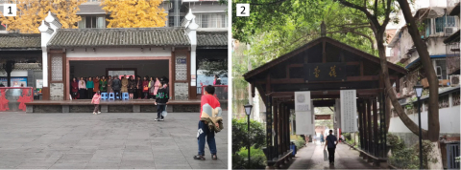

Image 1. Cuiyuan Community Park (翠园). This photo shows a stage for community activities.
Image 2. A segment of the Huoshaoyan Corridor (火烧堰巷).
Source: Shuyue Chen, 2021

5. Conclusion

Yulin provides a chance for long-term research. The neighborhood is still in the early stage of urban renovation and gentrification. As I am writing this paper, changes are taking place. In addition, Yulin is only one case, but the same process is happening in other neighborhoods in Chengdu and everywhere. For example, Chengdu applies a similar development mode to neighborhoods such as Mengzhuiwan (猛追湾). In the future, more cases across geographic boundaries should be included to examine whether the same placemaking pattern reappears and to explore alternative possibilities.

Yulin raises concerns about ordinary work unit neighborhoods established in the 1980s and 90s. Yulin was unexpectedly exposed to the wider public because of a folk song, which initiated changes. Following investments and projects try to reproduce musical imaginaries created by the song, such as emphasizing leisure atmosphere and leisure consumption (music, cafes, and bars). Yulin was only forty years old. Its spatial form is different from the new urban development, and its specific urban environment reflects a certain period of Chengdu. Yulin’s patterned mode of placemaking that transforms the built environment and causes homogeneity reflects a paradox of branding activities. Cities are searching for meanings and creating “unique” places, but they are using the same development mode, representations, and design languages. Diverse contents finally create a unified aesthetics for the creative (leisure) industry. When cities want to make neighborhoods “extraordinary”, these neighborhoods are homogenized due to the same development method and business mode, ending up with a new “ordinary”. For this neighborhood, the folk song is a fuse. For another neighborhood, the fuse could be a film, a dance, or a book. It is a process of creating a homogenous genre in an ordinary yet complex neighborhood. If this process could take place in one neighborhood, it could happen everywhere.

Referencias
Burgess, J. A. (1979), “Place-Making: The Contribution of Environmental Perception Studies in Planning”, Geography, Vol. 64 No. 4, pp. 317-26.
Coates, G. J. and Seamon, D. (1984). “Toward a Phenomenology of Place and Place-Making: Interpreting Landscape, Lifeworld and Aesthetics”, Oz, Vol. 6.
Courage, C. (2020), “Introduction: What really matters: moving placemaking into a new epoch”, in Courage, C. et al. (Ed), The Routledge Handbook of Placemaking, Taylor & Francis Group, United Kingdom, pp. 62-9.
Day, L. L. (1992), “Placemaking by Design: Fitting a Large New Building Into a Historic District”, Environment and Behavior, Vol. 24 No. 3, pp. 326-46.
Friedmann, J. (2010), “Place and Place-Making in Cities: A Global Perspective”, Planning Theory & Practice, Vol. 11 No. 2, pp. 149-65.
Hayden, D. (1988), “Placemaking, Preservation and Urban History”, Journal of Architectural Education, Vol. 41 No. 3, pp. 45-51.
Jacobs, J. (1961), The death and life of great American cities, Vintage Books, New York, NY.
Lindner, C. and Sandoval, G. F. (2021), “Introduction: Aesthetics of Gentrification” in Lindner, C. and Sandoval, G. F. (Eds.), Aesthetics of Gentrification: Seductive Spaces and Exclusive Communities in the Neoliberal City, Amsterdam University Press, pp. 9-24.
Lee, D. (2006), “People’s Party Animals”, in Los Angeles Times, available at: www.latimes.com/archives/la-xpm-2006-feb-08-fi-chinaparty8-story.html (assessed 29 June 2023).
Lynch, K. (1960), The Image of the City, MIT Press.
Motloch, J. (1990), “Placemaking: Urban landscape system management”, Systems Research, Vol. 7 No. 4, pp. 273-85.
Ng, K. (2018), “A World Garden City in the New Millennium: Chengdu at the Crossroads of Verbal Representation and Global Vision”, in Bekkering, H., Esposito, A. and Goldblum, C. (Eds.), Ideas of the City in Asian Settings, Amsterdam University Press, pp. 209-44.
Qin, B. (2015), “City profile: Chengdu”, Cities, Vol. 43, pp. 18-27.
Salazar, N. B. (2012), “Tourism Imaginaries: A Conceptual Approach”, Annals of Tourism Research, Vol. 39 No. 2, pp. 863-82.
Wang, Y. P. and Murie, A. (2000), “Social and Spatial Implications of Housing Reform in China”, International Journal of Urban and Regional Research, Vol. 24 No. 2, pp. 397-417.
Whyte, W. H. (1980), The social life of small urban spaces, Conservation Foundation, Washington.
Chinese
Cao, X., Miao, C., Chen, Y. and Wang, W. [曹新向, 苗长虹, 陈玉英等] (2010), “Study on the index system to evaluate leisure city and its application” [休闲城市评价指标体系及其实证研究], Geographical Research [地理研究], Vol. 29 No. 09, pp. 1695-705.
Dong, D. [董德] (2020), “The Cultural Study of Folk Music in Contemporary Mainland of China (PhD dissertation)” [中国大陆当代新民谣音乐文化研究（博士）], Northeast Normal University [东北师范大学].
Huang, X. and Yang, Y. [黄幸,杨永春] (2010), “The Characteristics and Forming Mechanisms of Gentrification in Cities of Western China: The Case Study in Chengdu City” [中国西部城市绅士化现象及其形成机制——以成都市为例], Progress in Geography [地理科学进展], Vol. 29, pp. 1532-40.
Lv, N. [吕宁] (2009), Research on Leisure City Development in China Based on City Leisure Index (PhD dissertation) [基于城市休闲指数的中国休闲城市发展研究（博士）], Minzu University of China [中央民族大学].
Zhang, G. [张广瑞] (2002), Chinese tourism development: analysis and forecast: Chinese Academy of Social Sciences tourism research center report (2001-2003) [2001-2003年中国旅游发展: 分析与预测: 中国社会科学院旅游研究中心研究报告], Social Sciences Academic Press (China) [社会科学文献出版社].
成都市发展和改革委员会 (2018), 成都市国民经济和社会发展第十三个五年计划, available at:
http://cddrc.chengdu.gov.cn/cdfgw/c120589/jksj_nry.shtml?id=1644217068112863232 (assessed 29 June 2023).
成都市文化广电旅游局 (2022a), 成都市“十四五”文化广电旅游发展规划, available at: www.chengdu.gov.cn/chengdu/c147315/2022-08/23/content_b4dbb074170942789e6f528d72383802.shtml (assessed 29 June 2023).
成都市文化广电旅游局 (2022b), 成都市“十四五”旅游名城和音乐之都建设规划, available at:
https://www.chengdu.gov.cn/chengdu/c147315/2022-05/20/content_426cc26c96f34cf5ad70c69517385b5e.shtml (assessed 29 June 2023).
成都市武侯区地方志编纂委员会 (2011), 成都市武侯区志（1990~2005).
成都市武侯区地方志编纂委员会 (2021), 武侯街巷, 成都时代出版社.
成都市武侯区玉林街道志编纂委员会 (2005), 玉林街道志（1988年-2005年）.
刘鲁 (2007), “成都荣膺‘中国十大休闲城市’”, in Chengdu Daily [成都日报], available at: https://oversea.cnki.net/KCMS/detail/detail.aspx?dbcode=CCND&dbname=CCND2007&filename=CDRB20071209A012&uniplatform=OVERSEA&v=i87SPFv1xFOmfC7Hld_VO1I8UOValmluobrbH8lCLx1YzW-63oJxD8oKrkPifKzQ_AGZk5nGH7U%3d (assessed 29 June 2023).
闪媛媛 (2006), 休闲城市指标体系研究 （硕士）, Zhejiang University [浙江大学].

Architecture PhD in History, Theory, and Society. University of California, Berkeley (USA). Email: shuyue_chen@berkeley.edu Id. Orcid: https://orcid.org/0009-0003-3073-462X * Autor para la correspondencia

