REVISTA INTERNACIONAL DE TURISMO, EMPRESA Y TERRITORIO
Nº 18, julio-diciembre de 2025, pp. 1-19.
ISSN: 2660-9320
DOI:10.21071/riturem.v9i2.18619


Cita bibliográfica: Khoza, N.G.; Hoeyi, P. & Olaposi, T.O. (2025). Exploring the Impact of Digital Skills on Innovation in Hospitality SMMEs in the Free State Province of South Africa: A Systematic Review. Revista Internacional de Turismo, Empresa y Territorio, 10 (2), pp. 1-19. https://doi.org/10.21071/riturem.v9i2.18619
Exploring the Impact of Digital Skills on Innovation in Hospitality SMMEs in the Free State Province of South Africa: A Systematic Review

Explorando el impacto de las habilidades digitales en la innovación de las PYMES de hostelería del Estado Libre de Sudáfrica: una revision sistemática

Nomfundo Gladys Khoza *
Prosper Hoeyi
Titilayo Olubunmi Olaposi

Abstract

Digital transformation is increasingly recognised as a driver of innovation and competitiveness in Small, Medium, and Micro Enterprises (SMMEs). In South Africa’s Free State Province, hospitality SMMEs face significant disparities in digital skills adoption, especially between metropolitan and non-metropolitan areas. This systematic review explores how digital skills influence innovation within hospitality SMMEs in this context. The review followed the PRISMA framework, with searches conducted across Web of Science and JSTOR. Inclusion criteria were peer-reviewed English-language articles published between 2019 and 2025, focusing on digital skills, innovation, and digital transformation in hospitality or SMME contexts in developing regions. Exclusion criteria ruled out grey literature, non-English texts, and studies unrelated to the hospitality sector. Of 300 initial records, 50 articles met the inclusion criteria and were analysed. Findings reveal that digital skills are key enablers of product, process, and business model innovation. However, challenges such as financial constraints, limited infrastructure, and digital literacy gaps hinder widespread adoption. Hospitality SMMEs with access to digital ecosystems and structured support (e.g., training, mentorship) demonstrate greater innovation capacity and entrepreneurial resilience. The review also finds that while basic digital tools (e.g., social media, booking platforms) are adopted in urban areas, non-metropolitan businesses lag significantly. The study concludes that bridging the digital divide through targeted policy interventions and inclusive digital ecosystems is essential for enhancing innovation in hospitality SMMEs. The findings offer practical insights for policymakers, educators, and support agencies aiming to foster sustainable digital transformation in under-resourced regions.

Keywords: Digital skills, Hospitality SMMEs, SMMEs innovation, Digital transformation, Digital ecosystems and Entrepreneurial resilience.

Resumen

La transformación digital se reconoce cada vez más como un motor de innovación y competitividad en las pequeñas, medianas y microempresas turísticas. En la provincia del Estado Libre de Sudáfrica, las pymes del sector de la hostelería se enfrentan a importantes disparidades en la adopción de competencias digitales, especialmente entre las zonas metropolitanas y no metropolitanas. Esta revisión sistemática explora cómo influyen las competencias digitales en la innovación dentro de las pymes del sector de la hostelería en este contexto. La revisión siguió el marco PRISMA, con búsquedas realizadas en Web of Science y JSTOR. Los criterios de inclusión fueron artículos revisados ​​por pares, en inglés y publicados entre 2019 y 2025, centrados en las competencias digitales, la innovación y la transformación digital en el sector de la hostelería o en el contexto de las pymes en regiones en desarrollo. Los criterios de exclusión descartaron la literatura gris, los textos en otros idiomas y los estudios no relacionados con el sector de la hostelería. De 300 registros iniciales, 50 artículos cumplieron los criterios de inclusión y fueron analizados. Los resultados revelan que las competencias digitales son facilitadoras clave de la innovación de productos, procesos y modelos de negocio. Sin embargo, desafíos como las limitaciones financieras, la infraestructura limitada y las deficiencias en alfabetización digital dificultan su adopción generalizada. Las pymes del sector de la hostelería con acceso a ecosistemas digitales y apoyo estructurado (p. ej., formación, mentoría) demuestran una mayor capacidad de innovación y resiliencia empresarial. El análisis también revela que, si bien las herramientas digitales básicas (p. ej., redes sociales, plataformas de reservas) se adoptan en zonas urbanas, las empresas de zonas no metropolitanas se encuentran rezagadas significativamente. El estudio concluye que superar la brecha digital mediante intervenciones políticas específicas y ecosistemas digitales inclusivos es fundamental para impulsar la innovación en las pymes del sector de la hostelería. Los resultados ofrecen información práctica para los responsables políticos, educadores y organismos de apoyo que buscan fomentar una transformación digital sostenible en regiones pobres o en vías de desarrollo.

Palabras clave: Competencias digitales, pymes del sector de la hostelería, innovación en las pymes, transformación digital, ecosistemas digitales y resiliencia empresarial.

- Introduction

The rapid advancement of digital technologies has transformed the operational landscape of Small, Medium, and Micro Enterprises (SMMEs), necessitating the development of digital skills to remain competitive and innovative (Bhuiyan, Faraji, Rashid, Bhuyan, Hossain & Ghose, 2024). In the hospitality sector, digitalisation has become a critical enabler of business efficiency, customer engagement, and service innovation. Digital competencies facilitate the adoption of emerging technologies such as artificial intelligence, big data analytics, and cloud computing, all of which enhance operational agility and customer experience (Ononiwu, Onwuzulike & Shitu, 2024). However, despite the potential benefits, the digital maturity of SMMEs remains inconsistent, particularly in developing economies, where access to digital resources, training, and infrastructure is often constrained. Within South Africa, and more specifically the Free State Province, hospitality SMMEs face distinct challenges that hinder their ability to harness digital skills effectively for innovation (Gallant, Amadi-Echendu, & Esterhuyzen, 2025). The province's hospitality industry is a vital economic contributor, yet its digital transformation trajectory is often limited by resource constraints, skills shortages, and infrastructural disparities.

Digital transformation in the hospitality sector has been widely recognised as a key driver of innovation, improving customer service, operational efficiency, and business sustainability (Bekele & Raj, 2025). Moreover, digital skills enable businesses to leverage digital marketing, online booking systems, and data-driven decision-making to enhance service delivery (Hassan, Hasan, Mirza, Paul, & Hasan, 2025). In South Africa, where the hospitality industry plays a pivotal role in economic growth and job creation, the integration of digital technologies into business models is crucial. However, many SMMEs, particularly those operating in non-metropolitan regions in the Free State such as Thabo Mofutsanyana and Lejweleputswa, struggle to adopt and utilise digital tools effectively. This challenge is exacerbated by financial constraints, limited digital literacy, and inadequate institutional support (Ndibalema, 2025). Consequently, there is an urgent need to assess the role of digital skills in fostering innovation within the hospitality sector and to identify the barriers that impede successful digital adoption.

The Free State Province provides a compelling context for examining the intersection of digital skills and innovation in hospitality SMMEs (Rambe & Hinson, 2024). Unlike major urban centres such as Johannesburg and Cape Town, where digital infrastructure is more developed, the Free State is characterised by a slower pace of digital adoption, largely due to economic and infrastructural disparities (Modjadji, 2025). Hospitality SMMEs in the region often face constraints in accessing cutting-edge digital tools, resulting in a reliance on traditional business practices that limit their competitive edge (Matikiti, 2024). Given the significance of the hospitality sector in driving regional tourism and economic development, understanding how digital skills influence innovation in this context is essential for informing policy interventions and support mechanisms tailored to the unique needs of SMMEs in the province.

Despite growing research on digital transformation in SMMEs, there remains a notable gap in literature examining the specific role of digital skills in enabling innovation within the hospitality sector, particularly in underdeveloped regions such as the Free State (Dube, 2024). Existing studies primarily focus on broader themes of digital transformation or technological adoption (Faruque, Chowdhury, Rabbani & Nure, 2024; Wang & Zhang, 2025), often neglecting the nuanced challenges faced by hospitality SMMEs in resource-constrained environments. This systematic literature review seeks to address this gap by synthesising existing knowledge on the impact of digital skills on innovation in hospitality SMMEs in the Free State Province. By systematically analysing empirical and theoretical contributions, this review aims to provide insights into the mechanisms through which digital competencies drive innovation, identify prevailing challenges, and propose strategies to enhance digital capabilities within the sector. This research is guided by the following key question: How do digital skills contribute to innovation in hospitality SMMEs in the Free State Province? By exploring this question, the study aims to provide a comprehensive understanding of the extent to which digital competencies influence business model transformation, service improvement, and competitive positioning in the region’s hospitality industry. Through a systematic analysis of existing literature, this review identifies best practices, barriers, and strategic interventions that can enhance digital skill adoption and innovation in hospitality SMMEs, thereby contributing to both academic discourse and practical policymaking in the sector.

Digital skills are fundamental to the competitiveness of hospitality SMMEs, enabling businesses to integrate technology-driven processes for efficiency and innovation (Madondo, Akindeji & Ogunsola, 2024). The literature highlights the distinction between basic digital literacy, which includes proficiency in using computers and the internet, and advanced digital competencies, such as data analytics, cybersecurity, and digital marketing (Morgan, Sibson, & Jackson, 2022; Elrayah & Jamil, 2023; Thelma, Sain, Shogbesan, Phiri & Akpan, 2024). Aman (2025) indicate that while many hospitality SMMEs in developing regions possess basic digital literacy, the lack of advanced skills limits their ability to leverage digital technologies for strategic innovation. Moreover, digital upskilling remains a challenge due to inadequate access to formal training programmes and industry-specific digital education (Pinto, Perez, Gonçalves, Lampón & Pérez-Moure, 2025).

Hospitality SMMEs serve as crucial contributors to local economies, particularly in tourism-driven regions such as the Free State Province. However, these enterprises often operate in resource-constrained environments, making digital adoption uneven across businesses (Weilbach, 2025). Lopes, Gomes, Ferreira & Ferreira (2025) suggests that size and financial capacity significantly influence the ability of SMMEs to invest in digital solutions, with larger hospitality businesses demonstrating higher adoption rates of advanced digital tools. Furthermore, the hospitality sector’s reliance on direct customer interaction necessitates a strong digital presence, yet many SMMEs lack the necessary digital marketing expertise to optimise customer engagement and retention effectively (Aman, 2025).

Innovation within hospitality SMMEs is closely linked to the adoption of digital skills and technologies (Aman, 2025). Studies highlight that digital skills contribute to three primary forms of innovation: product innovation (Zhang, Zia & Shehzad, 2025), process innovation (Appiah, Essuman, Forson, Boso & Annan, 2025), and business model innovation (Spieth, Breitenmoser & Röth, 2025). Product innovation involves leveraging technology to enhance service offerings, such as mobile-based hotel bookings and AI-driven customer service (Zhang et al., 2025). Process innovation focuses on streamlining operations through digital tools, such as cloud-based reservation systems and automated inventory management (Appiah et al., 2025). Business model innovation entails the reconfiguration of revenue streams through digital platforms, online partnerships, and dynamic pricing strategies (Spieth et al., 2025). Despite these opportunities, the literature identifies limited digital competencies as a barrier to sustained innovation in hospitality SMMEs (Williams, 2025).

Digital transformation is a strategic imperative for hospitality SMMEs, yet its implementation remains fragmented due to multiple challenges, including financial limitations, resistance to change, and inadequate infrastructure (Omowole, Olufemi-Philips, Ofadile, Eyo-Udo & Ewim, 2024). Gillani, Chatha, Jajja, Cao & Ma (2024) distinguishes between incremental digital adoption, where businesses integrate digital tools gradually, and radical digital transformation, which involves a complete restructuring of business models around digital technologies. In the Free State Province, digital transformation efforts remain largely underdeveloped, with many hospitality SMMEs, especially in non-metropolitan regions, struggling to adopt even basic digital tools (Dikana, 2023). The uptake of technologies such as social media marketing and e-commerce platforms is minimal, and there is limited awareness or access to more advanced digital solutions like artificial intelligence and blockchain applications (Morepje, Sithole, Msweli & Agholor, 2024). The lack of digital infrastructure, skills, and targeted support initiatives further exacerbates the digital divide, leaving many hospitality SMMEs unable to leverage technology for growth and competitiveness (Dikana, 2023).

Digital ecosystems and entrepreneurial resilience are closely interconnected in shaping the ability of hospitality SMMEs to adapt to digital transformation challenges (Hokmabadi, Rezvani & de Matos, 2024). A well-developed digital ecosystem provides essential infrastructure, resources, and support mechanisms-such as training programmes, funding opportunities, and mentorship-which directly contribute to enhancing entrepreneurial resilience (Jaber, 2025). When hospitality SMMEs have access to strong digital ecosystems, they are better equipped to develop digital competencies, adopt innovative business models, and respond effectively to market disruptions (Hokmabadi et al., 2024). Conversely, entrepreneurial resilience plays a crucial role in maximising the benefits of digital ecosystems (Zhang & Li, 2025). Even in regions where digital support structures are weak-such as in the Free State Province, particularly in non-metropolitan areas, entrepreneurs who actively seek digital training, embrace technological change, and engage in knowledge-sharing networks are more likely to overcome barriers to digital transformation. However, in the absence of a well-established digital ecosystem, even the most resilient entrepreneurs face significant limitations in accessing advanced digital tools and strategic collaborations (Srivastava & Pandita, 2025). A more robust digital ecosystem can bridge the gap between technological opportunities and entrepreneurial adaptability, ensuring that hospitality SMMEs in underdeveloped regions can sustain their businesses, enhance competitiveness, and drive long-term digital innovation.

2. Methodology

This study adopts a systematic literature review (SLR) methodology to synthesise existing scholarship on the impact of digital skills on innovation within hospitality SMMEs in the Free State Province. The review follows the structured and transparent approach advocated by Tranfield et al. (2003), ensuring replicability and rigour. The review process is delineated into three sequential phases: planning, conducting, and documenting, as illustrated in Figure 1.

The planning phase laid the foundation for the systematic literature review by establishing the research scope, defining the review protocol, and refining the key thematic areas. Central to this phase was the formulation of a clear research problem, which focused on understanding how digital skills contribute to innovation within hospitality Small, Medium, and Micro Enterprises (SMMEs) operating in geographically and economically constrained environments-specifically the Free State Province of South Africa. This problem was motivated by the observed digital divide between metropolitan and non-metropolitan hospitality sectors (Rule, Bekker & Dlamini, 2025) and the need for evidence-based strategies to enhance digital capacity and innovation in resource-limited contexts (Machucho & Ortiz, 2025). A scoping exercise was undertaken to map the existing body of literature and ensure that the review addressed a clearly delineated gap in current research. This involved conducting preliminary searches to explore the extent, range, and nature of studies related to digital skills, digital transformation, and innovation within hospitality SMMEs, particularly in African or developing regions. The insights gained during this exploratory phase informed the development of inclusion and exclusion criteria, as well as the overall structure of the review.

To ensure methodological transparency and reduce the risk of selection bias, a formal review protocol was developed. This protocol followed the Preferred Reporting Items for Systematic Reviews and Meta-Analyses (PRISMA) by Parums (2021) (see Figure 1) framework, which offers a standardised and replicable approach for identifying, screening, and synthesising relevant literature. The protocol outlined the review objectives, databases to be used, search string formulation, eligibility criteria, data extraction procedures, and quality appraisal methods. It also specified the strategy for documenting each phase of the review to support reproducibility and accountability. Search terms were systematically developed and tested to ensure comprehensive coverage of relevant literature. These terms were grounded in the conceptual focus of the study and reflected the intersection of digital skills and innovation within the hospitality SMME sector. The final list of core search terms included “digital skills,” “hospitality SMMEs,” “digital transformation,” “innovation,” and “digital ecosystems and entrepreneurial resilience.” These terms were further expanded using synonyms and Boolean operators (e.g., “AND,” “OR”) to increase sensitivity and specificity during the database searches. This structured approach ensured that the search strategy was aligned with the research question and capable of capturing both empirical and theoretical contributions across diverse disciplines, including business, entrepreneurship, digital technology, and regional development. The output of this planning phase was a clearly articulated and methodologically robust foundation for conducting the systematic literature review, ensuring that subsequent phases of data collection and analysis were guided by a coherent and replicable framework.

Figure 1: PRISMA diagram (Parums, 2021).

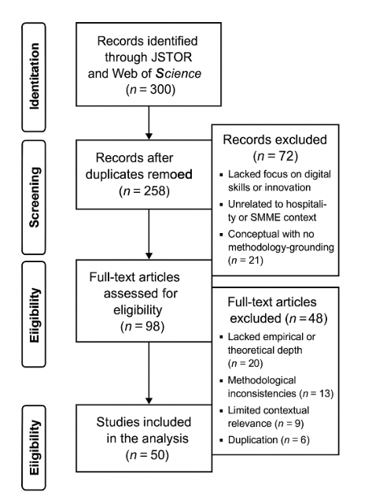

A comprehensive and structured search was conducted across two reputable academic databases-JSTOR and Web of Science-selected for their extensive indexing of high-quality peer-reviewed publications and their relevance to research on digital transformation, innovation, and small business development. The search strategy employed a combination of Boolean operators (AND, OR) (Carcassi & Sbardolini, 2023) and keyword variations, including terms such as “digital skills,” “hospitality SMMEs,” “digital transformation,” “innovation,” and “digital ecosystems and entrepreneurial resilience,” to enhance the breadth and precision of retrieval. The inclusion criteria were carefully defined to ensure the relevance and scholarly rigour of the selected studies. To be eligible for inclusion, articles had to be published between 2019 and 2025, written in English, peer-reviewed, and explicitly focused on themes related to digital skills, innovation, or digital transformation within the context of SMMEs or the hospitality sector in Africa. Conversely, exclusion criteria were applied to remove studies that fell outside the conceptual and methodological scope of the review. These included grey literature such as reports, dissertations, and conference proceedings; non-English publications; non-peer-reviewed articles; and studies unrelated to SMMEs, hospitality, or digital transformation-particularly those centred exclusively on large enterprises or sectors with no connection to the study’s objectives.

The initial search yielded a total of 300 records. Following the removal of 42 duplicates, 258 unique articles remained and were subjected to title and abstract screening. At this stage, 160 articles were excluded for failing to meet the core inclusion criteria. Specifically, a substantial number of articles either lacked a focus on digital skills or innovation, were unrelated to the hospitality or SMME context within Africa, presented purely conceptual discussions without methodological clarity, or constituted grey literature. As a result, 98 full-text articles were retrieved for detailed review. Upon further examination, 48 of these full-text articles were excluded. This decision was based on several grounds, including a lack of empirical or theoretical depth, methodological inconsistencies, limited contextual relevance to the Free State Province or similar developing regions, and significant overlap with other included studies. Ultimately, 50 articles satisfied all inclusion criteria and were retained for the final synthesis. These studies constitute the empirical and theoretical foundation of the bibliometric and thematic analyses presented in this systematic literature review.

The selected studies were subjected to a two-tiered analysis process. First, a bibliometric overview was undertaken to identify publication trends, authorship patterns, and dominant research themes. Second, a qualitative content analysis was applied to extract recurring concepts, challenges, and strategic insights related to digital skills and innovation. Thematic coding was used to identify relationships between digital competencies, technological adoption, and business innovation, particularly in resource-constrained environments. Quality assessment of the included studies was based on relevance to the research question, methodological soundness, and theoretical or practical contribution. Studies were appraised for clarity of research design, transparency in data reporting, and alignment with the broader discourse on digital transformation and SMMEs.

- Result and analyses

The bibliometric analysis of the final dataset, comprising 50 systematically selected review documents, yielded valuable insights into the scope, structure, and collaborative nature of the scholarly literature addressing digital skills, innovation, and digital transformation within hospitality SMMEs from 2019 to 2025. The review spanned a six-year period (2019–2025), during which literature growth exhibited a modest decline, with an annual growth rate of -10.91%, suggesting a potential saturation of publications in the specific domain or a recent narrowing of focus. The dataset included publications sourced from 40 different journals, books, and academic sources, indicating a broad yet thematically coherent academic interest in the topic. The average age of the documents was 2.32 years, which reflects the relative recency of the contributions and aligns with the fast-evolving nature of digitalisation and innovation in emerging economies. Furthermore, the literature exhibited a healthy citation rate, with an average of 8.52 citations per document, suggesting that the selected works are not only recent but also impactful within the scholarly community. A total of 3,277 references were cited across the 50 documents, reflecting the depth of engagement with existing literature and the multidisciplinary grounding of the research area. In terms of content composition, 154 Keywords Plus (ID) and 249 Author's Keywords (DE) were identified, underscoring the thematic diversity and conceptual richness of the review. This variety also highlights the evolving discourse and emerging sub-themes within the intersection of digital skills, innovation, and SMME resilience.

The authorship analysis revealed the contributions of 181 distinct authors, further supporting the notion of a collaborative and growing academic field. Of these, 7 authors contributed single-authored works, and the dataset contained 7 single-authored documents overall. The average number of co-authors per document was 3.64, illustrating a strong trend towards collaborative scholarship. Notably, 10% of the documents involved international co-authorship, indicating some degree of global academic exchange and cross-border collaboration, although most of the research was likely domestically anchored within Africa or comparable developing regions. All 50 documents included in the analysis were categorised as review-type articles, which aligns with the methodological framework of the study and ensures a consolidated synthesis of existing knowledge. The emphasis on review articles enhances the credibility and analytical rigour of the findings, as these works typically employ structured methodologies to synthesise empirical and theoretical literature. Overall, these bibliometric statistics offer a detailed snapshot of the current state of scholarship in the field and confirm the methodological robustness and academic relevance of the reviewed literature.

Table 1: Main Information
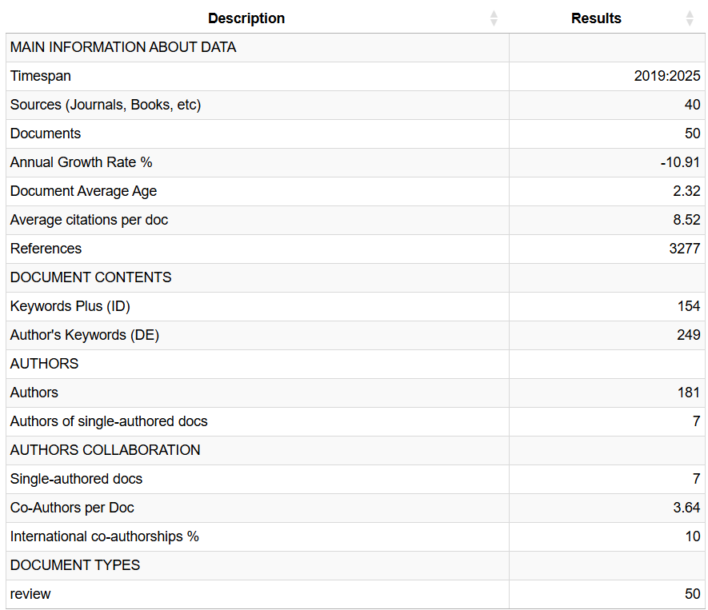

The Three-Field Plot diagram in figure 2 provides a Sankey-style visualisation that maps the interrelationships between three key bibliometric dimensions: Author Countries (AU_CO), Sources or Journals (SO), and Author Keywords (DE). On the left, the countries of contributing authors are displayed, revealing that nations such as South Africa, Malaysia, Indonesia, Pakistan, and Saudi Arabia have comparatively thicker flows, indicative of a higher volume of publications within the dataset. South Africa and Malaysia, emerge as significant contributors, suggesting a notable scholarly engagement with themes surrounding digital transformation and skill development, especially within educational and hospitality contexts. Conversely, countries like Zimbabwe, Colombia, and Rwanda show thinner flows, reflecting lower research output in this area. The middle section highlights the journals serving as publication outlets, with Sustainability standing out as the most prominent, suggesting its centrality in disseminating research on digital transformation, particularly in developing regions. Other notable sources include Global Knowledge Memory and Communication, Education Sciences, and Applied Sciences – Basel. On the right, the author keywords reveal recurring themes such as digital skills, digital transformation, education, development, digital literacy, computational thinking, and professional development. These highlight a strong thematic focus on education and skill enhancement in the context of digital innovation. Cross-field linkages show that South African researchers frequently publish in journals like Sustainability and Education Sciences, often focusing on professional development and digital skills. Similarly, Malaysia and Indonesia exhibit comparable thematic and publication patterns, indicating a regional convergence in research focus. Overall, the Three-Field Plot underscores a globally distributed research landscape with a significant presence from the Global South, a cluster of influential journals acting as dissemination hubs, and a set of core themes—particularly digital transformation and education—shared across geographical and institutional boundaries.

Figure 2: Three-Field Plot

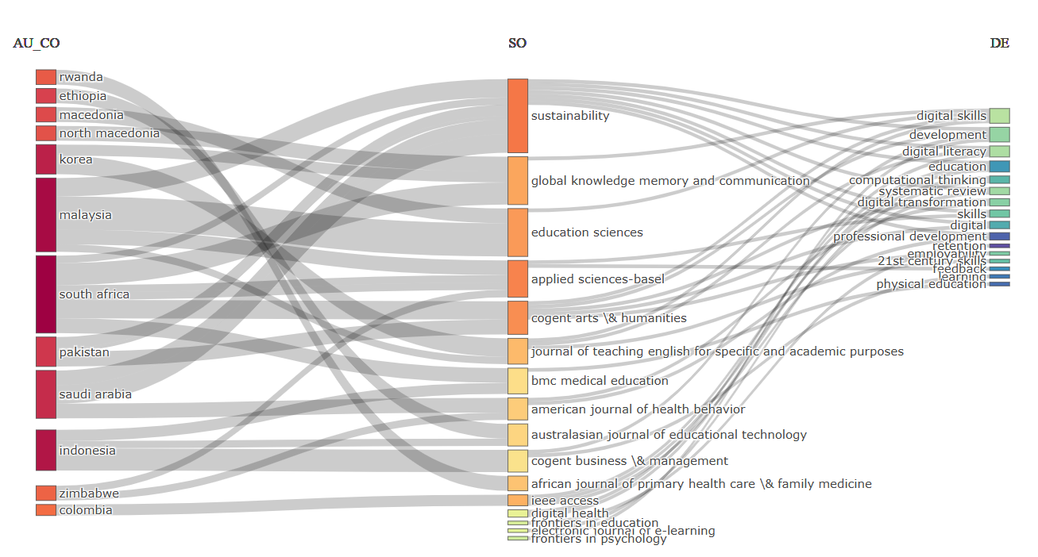

The visual representation of source relevance highlights the journals that have published the greatest number of documents within the dataset see Figure 3. Sustainability stands out prominently as the most prolific source, contributing five articles. This underscores its position as a key platform for disseminating research related to digital transformation, skills development, and education-particularly in the context of sustainable development and global equity. Following closely, a cluster of journals-Applied Sciences – Basel, Cogent Arts & Humanities, Education Sciences, Global Knowledge Memory and Communication, IEEE Access, and the Journal of Teaching English for Specific and Academic Purposes-each contributed two documents. These sources represent a diverse range of disciplinary orientations, from applied sciences and engineering to education, communication, and humanities, reflecting the interdisciplinary nature of the research landscape. Additionally, several other journals appear with single contributions, including the African Journal of Primary Health Care & Family Medicine, the American Journal of Health Behaviour, and the Australasian Journal of Educational Technology. Their inclusion, albeit with fewer documents, points to the breadth of contexts in which digital skills and transformation are being explored, spanning health, behavioural sciences, and educational technology. Collectively, this distribution illustrates the prominence of certain journals as central publication venues, while also revealing the broad thematic and disciplinary reach of the field.

Figure 3: Most relevant Sources

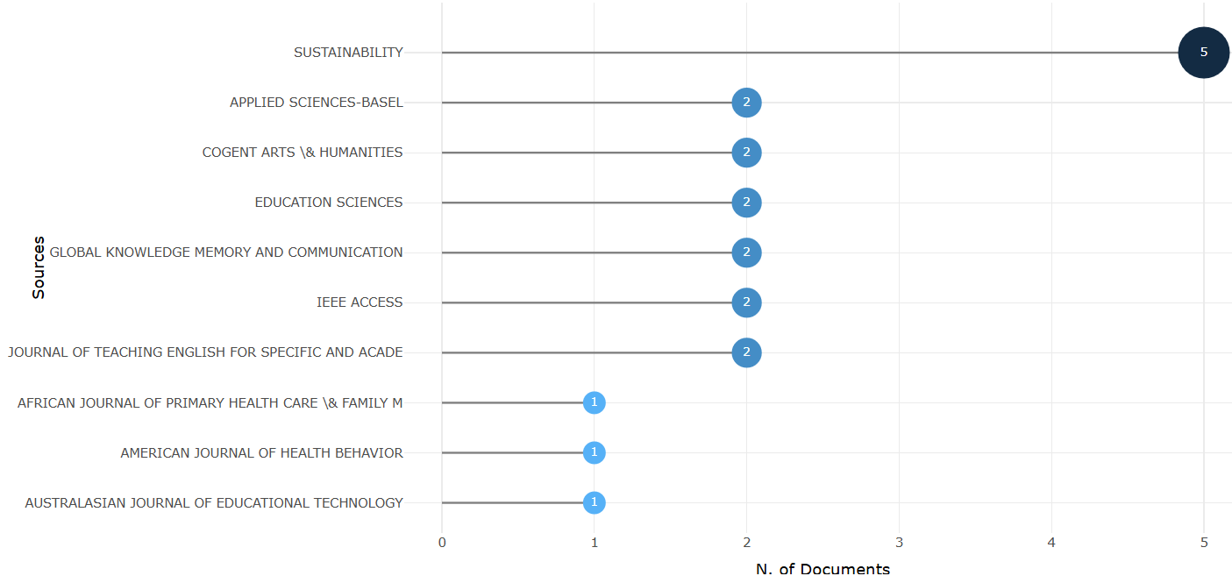

The analysis of author affiliations reveals the institutions most actively contributing to the body of research on digital transformation, skills development, and education. Universiti Malaya emerges as the most prolific institution, with a total of nine publications. This reflects its leading role in shaping discourse around digital innovation within education, particularly in a Southeast Asian context. Following closely is Seoul National University with eight articles, indicating strong research engagement from South Korea in this field. Three institutions-Durban University of Technology, Universiti Kebangsaan Malaysia, and University of the Western Cape-each contributed six publications, highlighting significant academic involvement from both Malaysian and South African higher education sectors. This reinforces the previously observed regional emphasis on digital transformation within developing country contexts. University of Lahore and University of South Africa also feature prominently, with five contributions each, underscoring the participation of institutions in Pakistan and South Africa in advancing research in this area. Additionally, institutions such as Prince Sultan University, South East European University, and Universitas Islam Negeri Salatiga each contributed four articles, signalling a wider geographical spread that includes the Middle East, Eastern Europe, and Indonesia. Overall, the distribution of affiliations suggests a strong academic footprint in the Global South, with multiple institutions emerging as key players in the dialogue around digital skills, professional development, and educational reform in the digital age.

Figure 4: Most relevant Affiliations

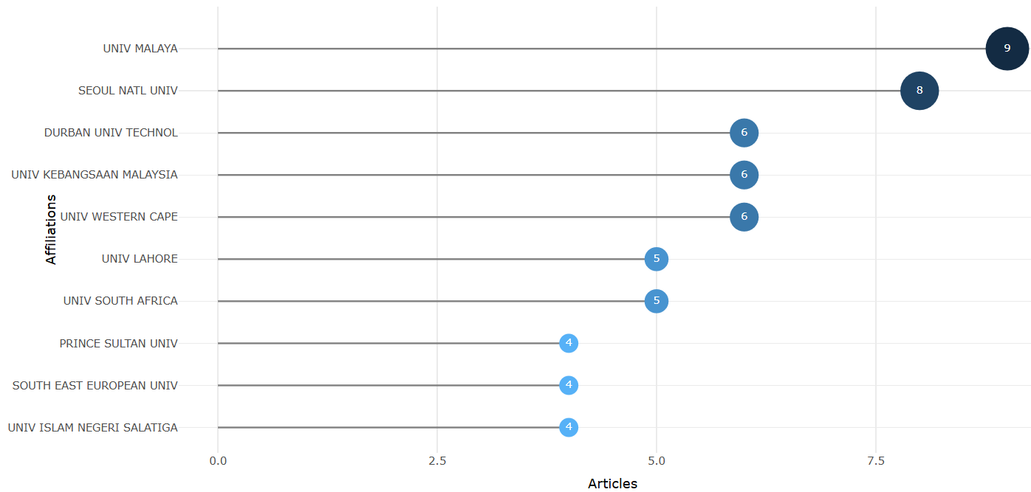

Figure 5 presents an overview of the most globally cited documents within the dataset, revealing the publications that have had the greatest scholarly impact based on citation count. Leading the chart is the article by Hussein MH (2019), published in IEEE Access, which received a remarkable 82 citations. This high level of engagement suggests that the paper addresses key themes in digital transformation or digital skills development that resonate strongly with the academic community. Following closely are contributions by Imran E (2021) in Applied Sciences – Basel and Behnamnia N (2020) in Thinking Skills and Creativity, which garnered 36 and 35 citations respectively, indicating their relevance and growing influence in discussions surrounding innovation and digital pedagogy. Other significant works include those by Nair V (2021) in Sustainability with 32 citations, Kubheka BZ (2020) in the African Journal of Primary Health Care & Family Medicine with 30 citations, and Gumbi N (2023), also in Sustainability, with 28 citations. These documents collectively reflect a research focus that converges on digital transformation, education, and sustainable development, particularly within developing and transitional contexts. Additional contributions, such as those by Quah CY (2022), Buitrago M (2019), Pyo SW (2020), and Almazroa H (2023), while receiving slightly fewer citations (ranging from 12 to 21), demonstrate continued interest in emerging digital practices and their implications for educational environments. The prominence of Sustainability as a recurring publication outlet further underscores its role as a key platform for disseminating impactful interdisciplinary research in the field. Overall, the citation landscape depicted in this figure highlights the growing body of literature concerned with equipping individuals and institutions with the digital competencies necessary for navigating contemporary educational and developmental challenges.

Figure 5: Most Global Cited Documents

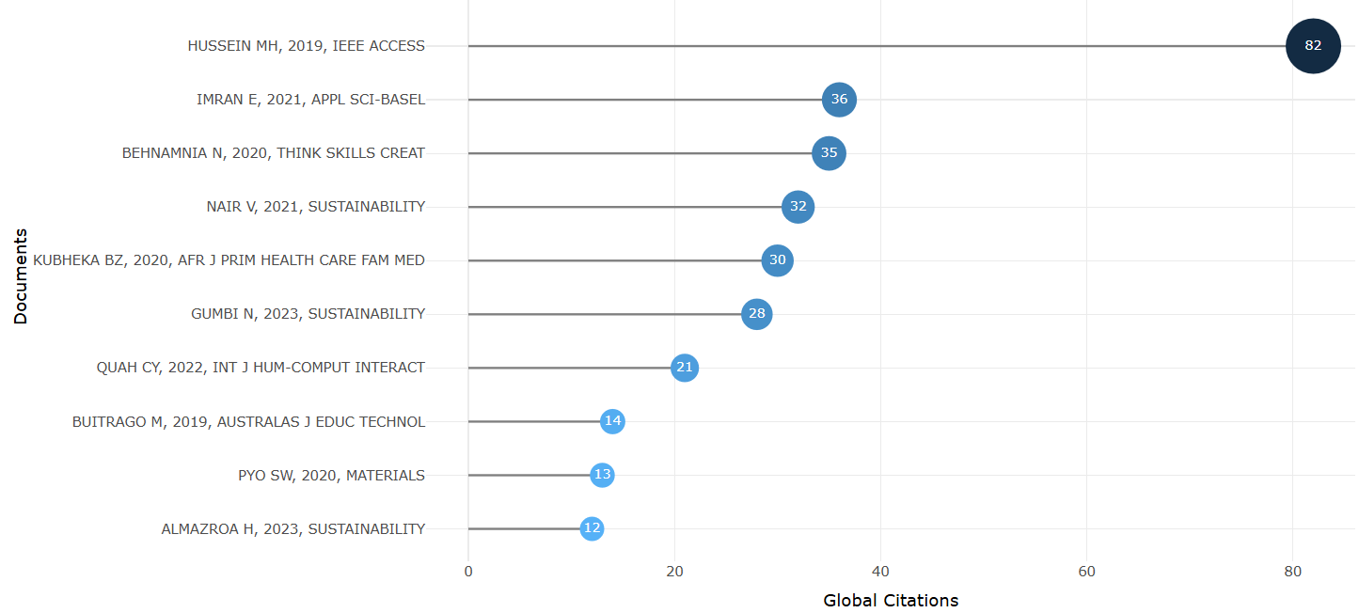

The co-occurrence network visualisation above reveals significant thematic relationships and interconnections between key terms across the reviewed literature. The most prominent nodes-such as “skills,” “education,” “technologies,” “digital literacy,” “technology,” and “digital skills” demonstrate strong linkages, suggesting that the discourse around digital capabilities is deeply embedded within broader conversations about educational transformation, technological advancement, and performance enhancement. Of relevance to this study is the clustering around “digital skills”, which is closely linked to “technology,” “digital transformation,” “perceptions,” and “digital literacy.” These relationships underscore the foundational role that digital skills play not only in individual competence development but also in shaping organisational readiness for innovation. This observation is particularly pertinent to Hospitality SMMEs in the Free State Province, where digital transformation may be contingent on both employee and managerial digital competencies. The node “technology” forms a central hub, connecting themes such as “science,” “higher education,” “digital revolution,” and “employability,” which reinforces the idea that technology is not an isolated variable, but a driver of systemic change in knowledge economies. In the context of Hospitality SMMEs, this implies that digital skills must be cultivated within a broader ecosystem that includes formal training, policy support, and continuous technological adaptation. Notably, “performance,” “motivation,” and “innovation” (the latter implicitly connected through surrounding nodes like “design,” “media,” and “collaborative learning”) also exhibit strong interconnections. These patterns align with the objective of this review to explore how digital competencies can enhance innovation performance among hospitality-focused enterprises. The interconnectedness between “skills,” “technologies,” and “feedback” further indicates a feedback loop in which digital adoption influences business processes and, reciprocally, performance outcomes inform future digital strategies. Furthermore, the presence of peripheral but related themes such as “systematic review,” “higher education,” and “21st century skills” provides methodological and contextual framing, validating the approach taken in this study and situating it within global academic discourse. This co-occurrence map reinforces the critical role of digital skills as both enablers of technological innovation and catalysts for business transformation-offering compelling implications for how Hospitality SMMEs in the Free State can strategically leverage these capacities to remain competitive in a digitally evolving marketplace.

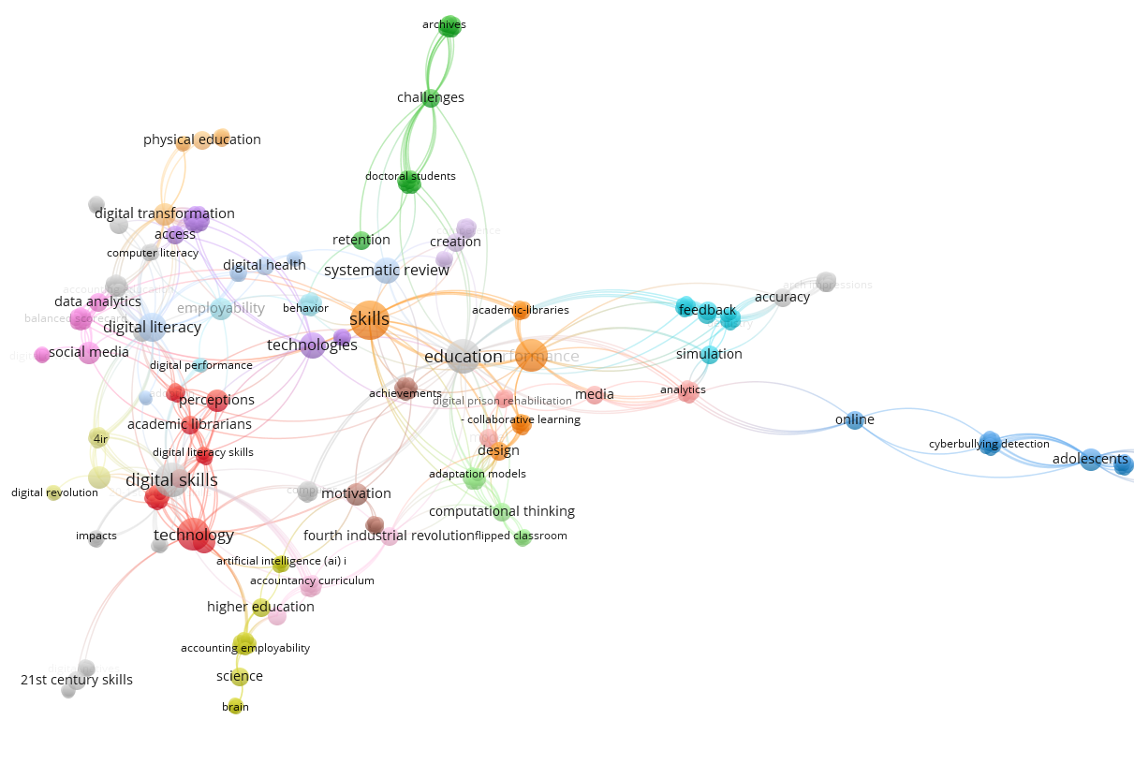

- Findings

The findings from the systematic literature review present key insights into digital skills adoption, innovation, challenges, and the role of digital ecosystems in hospitality SMMEs within the Free State Province. The results highlight disparities in digital transformation efforts, with notable variations between metropolitan and non-metropolitan regions.

The systematic literature review indicates that digital skills adoption among hospitality SMMEs in the Free State Province remains highly uneven, with a significant divide between metropolitan and non-metropolitan areas (Dikana, 2023). Larger businesses in urban centres have adopted basic digital tools such as social media marketing and online booking systems, while smaller enterprises in rural areas struggle with digital literacy and access to technological resources (Morepje, Sithole, Msweli & Agholor, 2024). Despite growing awareness of digital transformation, the integration of advanced digital solutions, such as data analytics and automation, remains limited due to financial and infrastructural constraints (Omowole, Olufemi-Philips, Ofadile, Eyo-Udo & Ewim, 2024).

Findings from the review demonstrate that hospitality SMMEs with higher digital proficiency experience increased innovation in service delivery and customer engagement (Zhang, Zia & Shehzad, 2025). Businesses that effectively utilise digital platforms for marketing, reservations, and customer communication report improved revenue streams and operational efficiency (Appiah, Essuman, Forson, Boso & Annan, 2025). However, the review also highlights that the lack of structured digital training and mentorship opportunities hampers the ability of many businesses to adopt new technologies effectively (Pinto, Perez, Gonçalves, Lampón & Pérez-Moure, 2025). While some entrepreneurs have embraced digital skills training, the overall participation rate remains low, particularly in remote areas where digital literacy initiatives are scarce (Elrayah & Jamil, 2023).

The systematic review identifies key barriers to digital transformation, including financial limitations, inadequate infrastructure, and skills deficiencies (Weilbach, 2025). Many hospitality SMMEs cite the high costs associated with digital adoption as a major deterrent, with limited access to external funding sources further exacerbating the issue (Aman, 2025). Resistance to change and a lack of digital confidence among business owners are also prevalent challenges that contribute to slow adoption rates (Lopes, Gomes, Ferreira & Ferreira, 2025). In non-metropolitan regions, unreliable internet connectivity and the absence of dedicated digital support programmes further restrict opportunities for technological advancement (Dikana, 2023).

The findings underscore the critical role of digital ecosystems in facilitating digital transformation among hospitality SMMEs (Hokmabadi, Rezvani & de Matos, 2024). However, the review highlights that in the Free State Province, particularly in rural areas, engagement with digital incubators and innovation hubs remains minimal (Jaber, 2025). Businesses with access to digital training, industry collaborations, and government-backed support initiatives demonstrate greater adaptability and resilience (Zhang & Li, 2025). Strengthening public-private partnerships and expanding digital training opportunities are essential to bridging the digital divide and enhancing the competitiveness of hospitality SMMEs (Srivastava & Pandita, 2025).

- Discussion

The findings of this systematic literature review contribute to the broader discourse on digital transformation by highlighting the persistent digital divide between metropolitan and non-metropolitan hospitality SMMEs in the Free State Province. Existing studies on digital transformation often focus on large enterprises or well-resourced urban businesses, yet this review underscores that smaller enterprises in rural and resource-constrained regions remain significantly disadvantaged (Dikana, 2023; Morepje, Sithole, Msweli & Agholor, 2024). While digital innovation is increasingly recognised as a driver of business sustainability, the review indicates that digital skills adoption is neither uniform nor easily attainable for all hospitality SMMEs. These findings align with research advocating for more inclusive digital policies, particularly in developing economies where limited infrastructure and financial constraints hinder business innovation (Aman, 2025; Weilbach, 2025). Addressing these disparities directly links to the United Nations Sustainable Development Goals (SDGs), particularly SDG 8 (Decent Work and Economic Growth) and SDG 9 (Industry, Innovation, and Infrastructure), which emphasise the need for inclusive economic participation and technological advancement in underdeveloped areas.

This study advances the conversation by positioning digital ecosystems as a crucial yet underdeveloped enabler of digital innovation. While prior research acknowledges the role of digital skills in business growth, there has been less emphasis on how institutional support, public-private partnerships, and targeted interventions can address existing disparities in digital transformation efforts (Hokmabadi, Rezvani & de Matos, 2024; Jaber, 2025). The findings indicate that hospitality SMMEs with access to structured digital support mechanisms, such as incubators and mentorship programmes, are more likely to engage with innovative digital solutions (Zhang & Li, 2025). However, in the Free State Province, such mechanisms remain limited, restricting the potential of hospitality entrepreneurs to capitalise on digital technologies for competitiveness and sustainability (Srivastava & Pandita, 2025). Strengthening digital ecosystems aligns with SDG 17 (Partnerships for the Goals), which emphasises collaboration between governments, private sector actors, and academic institutions to create sustainable development pathways through digital inclusion.

By identifying the financial, infrastructural, and skill-related barriers to digital adoption, this study emphasises the need for multi-stakeholder collaboration in fostering digital resilience among hospitality SMMEs. The findings suggest that without strategic interventions, the digital transformation trajectory in non-metropolitan regions will continue to lag behind urban centres, exacerbating existing economic inequalities. Future research should explore scalable models for digital capacity-building, focusing on locally relevant solutions that accommodate the unique challenges of SMMEs operating in resource-constrained environments. This study contributes to the broader debate on digital inclusion, urging policymakers, industry stakeholders, and academic institutions to rethink existing strategies for enabling digital transformation beyond major economic hubs. These discussions directly support SDG 4 (Quality Education), particularly in terms of fostering digital literacy, and SDG 10 (Reduced Inequalities), which calls for equitable access to digital infrastructure and opportunities for economic participation. Addressing these gaps is imperative for ensuring that digital transformation efforts contribute to long-term sustainability and resilience within the hospitality sector.

The findings of this systematic review reveal critical disparities in digital skills adoption and innovation among hospitality SMMEs in the Free State Province, particularly between metropolitan and non-metropolitan regions. These disparities reaffirm that digital transformation is not equally distributed across geographic or economic contexts. While businesses in urban centres adopt basic digital tools such as social media and online booking systems, their rural counterparts lag significantly due to infrastructural, financial, and literacy-related constraints. This uneven landscape reflects broader structural inequalities and highlights a pressing need for differentiated digital transformation strategies.

This study contributes to theory by extending the Technology-Organisation-Environment (TOE) framework and resource-based perspectives within a developing economy context. It offers a contextualised understanding of how digital capabilities, when supported by institutional resources and ecosystem infrastructure, enable innovation in small enterprises. In doing so, it responds to calls for more nuanced theorisation of digital innovation outside of high-income, digitally mature economies. The review also foregrounds the concept of digital ecosystems as critical enablers of entrepreneurial resilience, suggesting that these ecosystems should be integrated into future theoretical models addressing SMME digital transformation.

Furthermore, the analysis illustrates that digital transformation in underdeveloped regions is not merely a function of technological access but of ecosystemic support and strategic collaboration. Institutional voids in rural areas, such as limited access to training, mentorship, and finance, limit the full realisation of innovation potential. These findings align with literature that emphasises the significance of institutional enablers in the adoption and sustainability of digital innovations. As such, the review emphasises that addressing digital inequalities requires both technological investment and systemic capacity building through policy and institutional alignment.

- Implications and Future Research Directions

The review holds several theoretical and practical implications. Theoretically, it reinforces the need to contextualise innovation theories such as the resource orchestration theory within informal and resource-constrained environments. It also contributes to literature on entrepreneurial resilience, showing how digital skills, when embedded within supportive ecosystems, can bolster adaptability and long-term viability. These insights are particularly relevant for developing economies, where policy environments and digital infrastructure are often fragmented.

From a policy perspective, the findings highlight the urgent need to establish and expand regional digital innovation hubs and SMME-focused incubation centres in non-metropolitan areas. These interventions should prioritise advanced digital literacy programmes, access to affordable digital tools, and integration into national digital infrastructure plans. Tailored public-private partnerships can further facilitate the development of localised ecosystems that support hospitality entrepreneurs in leveraging digital tools for innovation.

Future research should build on these findings by conducting longitudinal empirical studies that examine the sustained impact of digital upskilling on innovation performance in rural hospitality SMMEs. Comparative research across provinces or countries could also uncover scalable strategies that work across varying degrees of infrastructure development. Moreover, there is a need to investigate the effectiveness of existing government-led digital training interventions, particularly their reach and relevance in non-urban areas. Finally, studies should explore how gender, age, and education level influence digital innovation uptake among hospitality entrepreneurs to provide more inclusive solutions.

Conclusion

This study provides a comprehensive synthesis of how digital skills shape innovation outcomes in hospitality SMMEs within the Free State Province. While metropolitan businesses demonstrate higher levels of digital engagement, rural SMMEs face persistent structural barriers that limit their ability to adopt even basic technologies. These disparities signal the importance of not only promoting digital literacy but also creating inclusive digital ecosystems that offer mentorship, funding, and infrastructural support. The review affirms that digital transformation is not a one-size-fits-all process. Instead, it is deeply shaped by context, resource availability, and institutional support. To advance digital innovation in hospitality SMMEs, especially in underserved areas, targeted policies and multi-stakeholder collaborations are essential. Higher education institutions, industry players, and government actors must work together to co-design localised digital training and support systems that respond to the unique needs of rural entrepreneurs. In conclusion, this study contributes new knowledge to the digital transformation literature by highlighting the interplay between digital skills, ecosystem support, and innovation capacity in a resource-constrained context. These insights not only inform policy and practice but also open new pathways for theory development around digital inclusion and innovation in emerging markets.

References

Aman, A. (2025). The Use of Technology in Small Hospitality Businesses in Pakistan: A Review and Comparison With India. Marketing Technology-Infused Hospitality: Upskilling Frontline Employees for Competitiveness, 365-394.
Appiah, L. O., Essuman, D., Forson, C. A., Boso, N., & Annan, J. (2025). Green process innovation and financial performance in small and medium-sized enterprises in a developing Country: Role of resource orchestration. Journal of Business Research, 189, 115210.
Bekele, H., & Raj, S. (2025). Digitalization and digital transformation in the tourism industry: a bibliometric review and research agenda. Tourism Review, 80(4), 894-913.
Bhuiyan, M. R. I., Faraji, M. R., Rashid, M., Bhuyan, M. K., Hossain, R., & Ghose, P. (2024). Digital transformation in SMEs emerging technological tools and technologies for enhancing the SME's strategies and outcomes. Journal of Ecohumanism, 3(4), 211-224.
Carcassi, F., & Sbardolini, G. (2023). Assertion, denial, and the evolution of boolean operators. Mind & Language, 38(5), 1187-1207.
Dikana, Z. (2023). SMEs digital divide: an analysis of factors influencing ICT adoption.
Dube, K. (2024). The State of Technology Deployment in South Africa’s Tourism and Hospitality Industry. In Tourism and Hospitality for Sustainable Development: Volume Two: Emerging Trends and Global Issues (pp. 149-161). Cham: Springer Nature Switzerland.
Elrayah, M., & Jamil, S. (2023). Impact of digital literacy and online privacy concerns on cybersecurity behaviour: The moderating role of cybersecurity awareness. International Journal of Cyber Criminology, 17(2), 166-187.
Faruque, M. O., Chowdhury, S., Rabbani, G., & Nure, A. (2024). Technology adoption and digital transformation in small businesses: Trends, challenges, and opportunities. International Journal For Multidisciplinary Research, 6(10.36948).
Gallant, N. D., Amadi-Echendu, A. P., & Esterhuyzen, E. (2025). Exploring SME owners’ motivation to learn and acquire new skills for the adoption of e-commerce. The Southern African Journal of Entrepreneurship and Small Business Management, 17(1), 12.
Gillani, F., Chatha, K. A., Jajja, S. S., Cao, D., & Ma, X. (2024). Unpacking Digital Transformation: Identifying key enablers, transition stages and digital archetypes. Technological Forecasting and Social Change, 203, 123335.
Hassan, A., Hasan, M. M., Mirza, J. B., Paul, R., & Hasan, M. R. (2025). Optimizing IT Service Delivery with AI-Powered Digital Marketing Analytics: Understanding Client Needs for Enhanced Support Solutions. AIJMR-Advanced International Journal of Multidisciplinary Research, 3(1).
Hokmabadi, H., Rezvani, S. M., & de Matos, C. A. (2024). Business resilience for small and medium enterprises and startups by digital transformation and the role of marketing capabilities—A systematic review. Systems, 12(6), 220.
Jaber, G. (2025). Strategies to Overcome Barriers to International Market Penetration for Entrepreneurs in Lebanon (Doctoral dissertation, Walden University).
Lopes, J. M., Gomes, S., Ferreira, J. J., & Ferreira, L. (2025). What Is the Impact of Digital Tools on Hospitality Business Performance? The Case of SME Accommodation Sector in Portugal. International Journal of Tourism Research, 27(1), e70004.
Machucho, R., & Ortiz, D. (2025). The Impacts of Artificial Intelligence on Business Innovation: A Comprehensive Review of Applications, Organizational Challenges, and Ethical Considerations. Systems, 13(4), 264.
Madondo, E., Akindeji, E. B., & Ogunsola, S. A. (2024). The role of innovative entrepreneurship and emerging technologies in South Africa's Small, Medium and Micro Enterprises. International Journal of Research in Business and Social Science, 13(7), 585-592.
Matikiti, E. (2024). Enhancing resilience in South African small and medium enterprises: a dynamic capabilities perspective.
Modjadji, M. M. (2025). Bridging divides: tackling technological change, inequality, and digital illiteracy in a fragmented South Africa.
Morepje, M. T., Sithole, M. Z., Msweli, N. S., & Agholor, A. I. (2024). The influence of E-commerce platforms on sustainable agriculture practices among smallholder farmers in Sub-Saharan Africa. Sustainability, 16(15), 6496.
Morgan, A., Sibson, R., & Jackson, D. (2022). Digital demand and digital deficit: conceptualising digital literacy and gauging proficiency among higher education students. Journal of Higher Education Policy and Management, 44(3), 258-275.
Ndibalema, P. (2025). Digital literacy gaps in promoting 21st century skills among students in higher education institutions in Sub-Saharan Africa: a systematic review. Cogent Education, 12(1), 2452085.
Omowole, B. M., Olufemi-Philips, A. Q., Ofadile, O. C., Eyo-Udo, N. L., & Ewim, S. E. (2024). Barriers and drivers of digital transformation in SMEs: A conceptual analysis. International Journal of Frontline Research in Multidisciplinary Studies, 5(2), 019-036.
Ononiwu, M. I., Onwuzulike, O. C., & Shitu, K. (2024). The role of digital business transformation in enhancing organizational agility. World Journal of Advanced Research and Reviews, 23(3), 285-308.
Parums, D. V. (2021). Review articles, systematic reviews, meta-analysis, and the updated preferred reporting items for systematic reviews and meta-analyses (PRISMA) 2020 guidelines. Medical science monitor: international medical journal of experimental and clinical research, 27, e934475-1.
Pinto, R., Perez, A. L., Gonçalves, G., Lampón, J. F., & Pérez-Moure, H. (2025). A Proposed Educational Framework for Professional Upskilling in Smart Manufacturing: On-Demand Microlearning Units. Procedia Computer Science, 253, 2039-2048.
Rambe, P., & Hinson, R. E. (Eds.). (2024). The Future of Entrepreneurship in Southern Africa: Technological and Managerial Perspectives. Springer Nature.
Rule, S., Bekker, M., & Dlamini, S. (2025). Making ends meet: spatial and socio-economic variations during the 2020-2021 COVID-19 lockdown in South Africa. South African Geographical Journal, 107(1), 112-131.
Spieth, P., Breitenmoser, P., & Röth, T. (2025). Business model innovation: Integrative review, framework, and agenda for future innovation management research. Journal of Product Innovation Management, 42(1), 166-193.
Srivastava, S., & Pandita, D. (2025). Unveiling the untapped potential: a comprehensive review of performance in women-owned firms. Journal of Innovation and Entrepreneurship, 14(1), 31.
Thelma, C. C., Sain, Z. H., Shogbesan, Y. O., Phiri, E. V., & Akpan, W. M. (2024). Digital Literacy in Education: Preparing Students for the Future Workforce. International Journal of Research (IJIR), 11(8), 327-344.
Tranfield, D., Denyer, D., & Smart, P. (2003). Towards a methodology for developing evidence‐informed management knowledge by means of systematic review. British journal of management, 14(3), 207-222.
Wang, S., & Zhang, H. (2025). Digital Transformation and Innovation Performance in Small-and Medium-Sized Enterprises: A Systems Perspective on the Interplay of Digital Adoption, Digital Drive, and Digital Culture. Systems, 13(1), 43.
Weilbach, N. (2025). Bridging the Digital Divide: AI Adoption for SMME Sustainability in Resource-Constrained Regions. Open Journal of Business and Management, 13(2), 1289-1306.
Williams, A. (2025). Strategies for Technology Adoption in Small-and Medium-Sized Enterprises to Improve Competitiveness (Doctoral dissertation, Walden University).
Zhang, J., Zia, U., & Shehzad, M. U. (2025). Tacit knowledge management process, product innovation and organizational performance: exploring the role of affective trust and task efficiency. Business Process Management Journal, 31(1), 267-297.
Zhang, M., & Li, X. (2025). Understanding the relationship between coopetition and startups’ resilience: the role of entrepreneurial ecosystem and dynamic exchange capability. Journal of Business & Industrial Marketing.

Lecturer at Central University of Technology, Bloemfontein, Free State, South Africa. Email: khozan@cut.ac.za Id. Orcid: https://orcid.org/0000-0003-3374-0489 *Autor para la correspondencia.
Lecturer Senior at Central University of Technology, Bloemfontein, Free State, South Africa. Email: phoeyi@cut.ac.za Id. Orcid: https://orcid.org/0000-0002-9874-7414
Associate Professor at the African Institute for Science Policy and Innovation of the Obafemi Awolowo University, Ile-Ife, Nigeria. Email: olaposititi@gmail.com Id.Orcid: https://orcid.org/0000-0002-8680-109X

