REVISTA INTERNACIONAL DE TURISMO, EMPRESA Y TERRITORIO
Nº 18, julio-diciembre de 2025, pp. 103-120.
ISSN: 2660-9320
DOI:10.21071/riturem.v9i2.18877
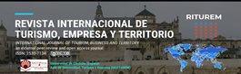

Cita bibliográfica: Thu Vu, N.; Long Pham, H.; Tietse, S. (2025). Bibliometry of slow tourism through the software lens of VOSviewer and MS Excel. Revista Internacional de Turismo, Empresa y Territorio, 10 (2), pp. 103-120. https://doi.org/10.21071/riturem.v9i2.18877
Bibliometry of slow tourism through the software lens of VOSviewer and MS Excel
Bibliometría del turismo lento a través de las herramientas informáticas VOSviewer y MS Excel

Ngoc Thu Vu *
Hong Long Pham
Samuel Tietse

Abstract

The concept of "slow tourism" has emerged from the active involvement of tourists, destination management organisations, and associated service providers, establishing itself today as an alternative to mass tourism. This study proposes a quantitative analysis of the scientific production on the subject, based on Scopus data and using a corpus of 120 documents (articles, conference proceedings, book chapters, books). Through the use of VOSviewer and MS Excel, combining several analytical methods (co-citations, keyword co-occurrences, bibliographic coupling), we obtained a detailed overview of the current state of research. The results confirm that the field of slow tourism remains emerging and fragmented, structured around distinct thematic poles. The bibliometric analysis provides an original perspective, despite limitations linked to algorithmic biases and the exclusive use of the Scopus database. Future research could cross-reference multiple sources and methods to refine these initial findings.
Keywords: slow tourism, bibliometric, co-citation, bibliographic coupling, VOSviewer.

Resumen

El concepto de «turismo lento» ha surgido de la implicación activa de turistas, organizaciones de gestión de destinos y proveedores de servicios asociados, y se está afirmando como una alternativa al turismo de masas. Este estudio propone un análisis cuantitativo de la producción científica sobre el tema, basado en datos de Scopus y utilizando un corpus de 120 documentos (artículos, actas de congresos, capítulos de libros y monografía). Utilizando los programas informáticos VOSviewer y MS Excel, y combinando varios métodos analíticos (co-citaciones, co-ocurrencias de palabras clave, correspondencia bibliográfica), obtuvimos una visión detallada del estado actual de la investigación. Los resultados confirman que el campo del turismo lento sigue siendo emergente y fragmentado, estructurado en torno a distintos grupos temáticos. El análisis bibliométrico aporta una perspectiva original, a pesar de las limitaciones asociadas a los sesgos algorítmicos y al uso exclusivo de la base de datos Scopus. Futuras investigaciones podrían combinar varias fuentes y métodos para afinar estos primeros resultados.
Palabras claves: turismo lento, bibliometría, co-citación, acoplamiento bibliográfico, VOSviewer

1. Introducción
The COVID-19 crisis has encouraged the tourism industry to embrace forms of sustainable tourism, such as local and ecological tourism, beneficial to communities and tourists alike (Everingham and Chassagne, 2020). In this context, slow tourism is seen as a promising alternative to remedy the harmful consequences of mass tourism (Meng and Choi, 2016). Although several research studies have been conducted on this topic, a definition of slow tourism has yet to find consensus, as each researcher has a different perspective when approaching this concept. Slow tourism is linked to deep thinking and an ethical approach, influencing the way tourists interact with places, people and tourism resources (Serdane et al., 2020). The adoption of the “slow” philosophy influences the image and reputation of tourism businesses, as well as the quality of the appearance and environment of destinations (Husemann and Eckhardt, 2019). Generally speaking, researchers believe that slow tourism is a solution to economic, social and environmental problems (Heitmann et al., 2011, Meng and Choi, 2016). Slow tourism is therefore considered a form of sustainable tourism (Le Busque et al., 2021).
Bibliometrics has become essential for evaluating and analysing the results of scientific research (Moral-muñoz et al., 2020). From the 2010s to the present day, bibliometric techniques have evolved significantly in the field of tourism (Sigala et al., 2021). Although many tourism researchers have carried out bibliometric studies, we noted that there are currently only two publications on slow tourism, namely (Krešić and Gjurašić, 2022, Mavric et al., 2021). The search by Mavric et al. (2021) used the keyword “slow tourism,” ignoring the keyword “slow travel” in the search for documents mentioned in the title on the Web of Science database. The search by Krešić and Gjurašić (2022) used the keyword “slow” combined with “tourism,” “travel” and “sustainable” mentioned in the title, abstract and keywords in the Scopus database. This leads to a large number of retrieved documents that are scattered and do not focus deeply on the research direction.
The aim of this research is to provide a review of the literature produced on slow tourism through a more systematic and integrated assessment of scientific research findings. This research also analyses the current trends and future potential of slow tourism, including the main authors, reputed journals and the authors' country of affiliation. The bibliometric analysis tool VOSviewer was used to analyse Scopus data from 2009 to 2024, identifying key research topics. The three main research questions of our query are:
RQ1: What is the current state of research on slow tourism?
RQ2: What scientific works have been published on topics related to slow tourism?
RQ3: What research prospects can be identified in this field?
2. Literature Review
The first attempts at formalisation sought to identify the fundamental dimensions of slow tourism: (Lumsdon and McGrath, 2011) put forward an analysis grid including rhythm, accessibility, experience and sustainability, while (Pécsek, 2014) emphasises territorial anchoring, local consumption and social coherence. These approaches are enriched by psychological perspectives, where slowness is seen as an inner disposition of the traveller (Oh et al., 2016, Serdane et al., 2020). Slow tourism is then no longer just a mode of travel or a logistical choice, but becomes a marker of values, aspirations and lifestyles, linked to the quest for meaning, well-being or authenticity.
The distinction between slow travel and slow tourism is also the subject of debate. Some authors make a clear separation between the two: the former focusing on modes of transport (walking, cycling, train) and the latter on the overall experience of a stay (Caffyn, 2012, Meng and Choi, 2016). Others, on the other hand, argue that these are largely intertwined concepts with blurred boundaries, often used interchangeably in academic literature (Klarin et al., 2023). This semantic ambivalence has methodological consequences, making empirical comparisons difficult and fragmenting the theoretical corpus.
The existing literature can nevertheless be grouped around three major analytical orientations, which often coexist but emphasise different dimensions. The first, centred on experience, sees slow tourism as a process of sensory, cultural and relational immersion (Manthiou et al., 2022, Agapito and Guerreiro, 2023, Hallem et al., 2020). This is a subjective time of reconnection with oneself, the environment and others, marked by voluntary deceleration and the quest for well-being. The second direction, ethical and critical, questions the excesses of globalised tourism - acceleration, cultural homogenisation, environmental pressures - and promotes slow tourism as a counter-model for frugality, ecological awareness and local commitment (Husemann and Eckhardt, 2019, Serdane et al., 2020, Tatin-Gourier, 2022). The third orientation, which is more institutional and territorial, analyses the issues linked to the practical implementation of slow tourism: public policies, local governance, conflicts between sustainability and market appeal (Walker et al., 2021, Pécsek, 2014, Rimaud and Piriou, 2020). These sensitivities structure the scientific debates and make it possible to place slow tourism within a complex moral economy, traversed by logics of differentiation, symbolic capture and sometimes discursive recycling.
Several studies have attempted to propose integrative conceptual models. (Klarin et al., 2023), using a systematic review of the literature, identify fifteen analytical perspectives that can be grouped into three families: an approach centred on the individual (values, behaviour, well-being), an approach centred on place (territory, community, heritage) and a systemic approach (responsible consumption, social justice). These categorisations provide a better understanding of the diversity of the field, but are not enough to give it a cumulative structure. Indeed, the literature is still characterised by a juxtaposition of qualitative studies, often localised, and by the absence of large-scale integrative syntheses (Kostilnikova et al., 2022).
In this context, academic databases such as Scopus offer an opportunity to map the scientific evolution of slow tourism using bibliometric approaches. These make it possible to identify cognitive poles, theoretical filiations, emerging clusters, as well as structuring authors and convergences or divergences between currents of thought. This method helps to distinguish lasting trends from passing fads, and to reposition existing contributions within a cumulative logic. Although a few attempts have been made (for example (Krešić and Gjurašić, 2022)), the field remains little explored from this angle. The present work is part of an exploratory systematisation perspective, mobilising an expanded corpus of scientific publications, cross-referenced bibliometric techniques, and an articulated reading of the conceptual and empirical dimensions of slow tourism.
3. Methodology
This article uses bibliometric techniques to provide a structured overview of research on slow tourism. This method makes it possible to analyse the scientific structure of the field by mapping the relationships between authors, countries, institutions and research themes. This part of the study is structured around five points which follow on from each other and range from : (1) research design, (2) data collection, (3) data analysis, (4) data visualisation to (5) explanation (Zupic and Čater, 2015).
The first step is to define the research objectives and questions. The second step is to select a data set for bibliometric analysis. We used the Scopus database, a major source of citations and abstracts in management sciences, to identify relevant articles. Three methods were used in this study, including the analysis of co-citations, co-keywords and bibliographic linkages using VOSviewer software.
We used the Scopus database search engine to collect the data, using keywords identified on the basis of the concepts described in the previous section. This choice is explained by the fact that Scopus is the largest database of peer-reviewed scientific publications, with a coverage around 60% wider than Web of Science (Norris and Oppenheim, 2007). The first thing the reader will notice is the title of the article (Jamali and Nikzad, 2011). Thus, the scientific publications selected contain the keywords ”slow travel”, ”slow tourism” mentioned in the title with the search query defined as follows: TITLE (“slow” AND (“travel” OR ”tourism” )).
Data extraction was carried out before 25 June 2024 in the research fields of social sciences, management sciences and economics. A total of 137 documents were found from 1997 onwards. From the documents found, we selected those that corresponded to the research objective. To begin with, we had to restrict the type of documents by choosing only articles, book chapters, books and conference papers, which provided a total of 133 documents. The second step involves selecting only documents in English and French, for a total of 127 documents meeting the criteria. Once the data were filtered, 120 documents were used and cross-referenced from 2009 to 2024 to carry out or refine the analysis.1
VOSviewer and Microsoft Excel were used to analyse, describe and explore research links on slow tourism, in particular co-citation networks, co-keyword networks and bibliographic linkage networks. The results of the analysis are presented visually in the form of tables and graphs.
The results are analysed by providing a detailed description of the main bibliographic parameters, such as type of document, annual scientific output, scientific sources, number of articles per author and output per country. This descriptive analysis was carried out using Microsoft Excel. Next, a co-citation analysis, a co-keyword analysis and a bibliographic linkage analysis, carried out using VOSviewer software, were used to identify the main research themes on slow tourism.
4. Presentation of Results
This evaluation was based on 120 scientific publications, including articles, book chapters, books and conference reports, which represent 87.59% (120/137) of the publications searched in the Scopus database related to the research topic. Of these, 60% (72 publications) were articles, 33.33% (40 publications) book chapters, 2.50% (3 publications) books and 4.17% (5 publications) conference reports (figure 1).
Figure 1: Breakdown of publication types
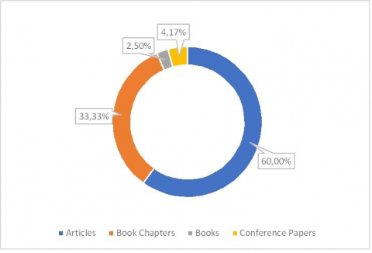
Source: Analysis by the authors based on Scopus data, June 2024
An analysis of the results of the Scopus scientific database reveals that publications on slow tourism began in 2009, which coincides perfectly with the emergence of the Slow Food movement, which embodies the philosophical principle of slow tourism. The evolution of scientific publications reveals that prior to 2011, the number of research studies on this subject was relatively low. In 2012, there was a marked increase in research. However, a sharp drop occurred in 2015, followed by another significant rise in publications in 2017. Despite a decline in 2018, they reached maximum growth in 2021 with 19 scientific publications (Figure 2). This figure reflects, in particular, researchers' concerns about the decline in tourism in the post-pandemic context of COVID-19.
As this research was conducted in June 2024, the relevant publications have not yet been fully compiled. From the data in the graph, it seems that this subject has not yet attracted the interest it deserves. However, the field of slow tourism research is still underdeveloped in terms of the number of scientific publications. The next phase of development could be rapid and intense, especially in the post-pandemic context of COVID-19. New tourism trends such as domestic tourism and slow tourism have led to major upheavals in the tourism industry (Da Silva Lopes et al., 2021). It is therefore highly likely that the number of publications on this research topic will increase considerably.
Figure 2: Annual growth in scientific publications on slow tourism
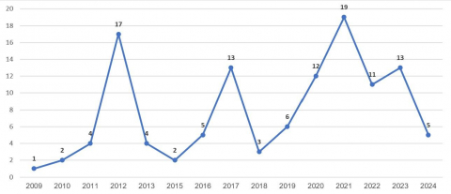
Source: Analysis by the authors based on Scopus data, June 2024
A descriptive analysis of the number of publications by journal shows that 120 articles were published in 78 scientific journals, covering a wide range of subjects such as business, management and accounting, social sciences, economics, econometrics and finance. The journal Sustainability (Switzerland) is the most represented in terms of publications related to the research topic, with 6.67% (with 8 publications). The following journals are “Journal Of Sustainable Tourism”, which has 6 publications (representing 5.00%), and “Geojournal Of Tourism And Geosites”, “Tourism Management”, “Tourism Recreation Research, Tourism Management”, which have 4 publications (representing 3.33%) (table 1).
Table 1: List of 8 journals with at least 2 publications
Review | Quantity | Ratio  (%) | SCImago 2023 ranking
Sustainability (Switzerland) | 8 | 6.67% | 0.67
Journal Of Sustainable Tourism | 6 | 5.00% | 2.82
Geojournal Of Tourism And Geosites | 4 | 3.33% | 0.32
Tourism Management | 4 | 3.33% | 3.35
Tourism Recreation Research | 4 | 3,33% | 0,92
Journal Of Destination Marketing And Management | 2 | 1,67% | 2,45
Journal Of Tourism And Cultural Change | 2 | 1,67% | 0,73
Research For Development | 2 | 1,67% | -
Source: Analysis by the authors based on Scopus data, June 2024
The results of the analysis of countries of registration by authors show that the number of research papers on this subject is relatively low, but diversified in terms of countries, demonstrating the practical interest recognised by many authors around the world (figure 3). The United Kingdom and the United States have the highest number of publications on this subject. In Vietnam and France, this area of research is still relatively new. More specifically, the figures for the number of publications by author's country of registration show that Vietnam and France have only one publication, which also includes collaborative writing by authors from France and Vietnam. This represents a new form of exploitation for Vietnamese and French researchers in the future.
Figure 3: Breakdown of publications by country of affiliation of authors
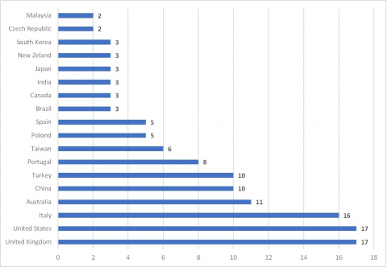
Source: Analysis by the authors based on Scopus data, June 2024

The statistical findings on the number of publications per author show that, with 120 publications and 157 participating authors, the most influential researchers in this field have an exceptional number of publications. With 6 publications/author, Conway D. and Timms B.F. are the most prolific authors, followed by Caffyn A., Fullagar S. and Moscarelli R. with 4 publications/author (figure 4).

Figure 4: Most prolific authors in the field of slow tourism
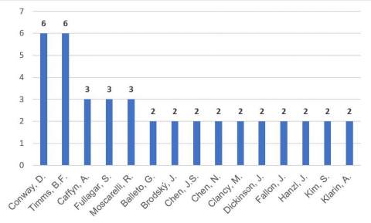
Source: Analysis by the authors based on Scopus data, June 2024
Co-citation analysis evaluates the relationship between objects when they appear together in the reference list of a given document. The degree of connection between articles is measured by the number of times an article is cited by others, as well as by the relationships between articles citing the same source (Benckendorff and Zehrer, 2014). There is no fixed threshold for co-citation analysis. With a limit of 20 citations, 41 authors divided into 3 clusters were identified (Figure 5). Authors in the same cluster often share similar approaches and perspectives on the topic. Figure 5 shows the network of co-citations, where the size of the circles representing the authors varies according to the number of citations. The same-coloured circles group together authors from the same cluster, and the space between them reflects the relevance and similarity of the citations. The density of the links shows the strength of the associations between the authors cited (Ertz and Leblanc-Proulx, 2019).
Figure 5: Map of the most cited authors in slow tourism (analysis of co-citations)
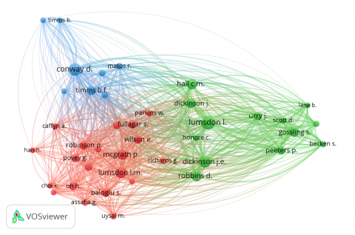
Source: Analysis by the authors based on Scopus data, June 2024
By analysing the citation network, we examined the summaries of the documents in each cluster to identify common ground for discussion and to name the clusters. The terms used in the co-citation analysis are defined subjectively, which can lead to inconsistencies between searches. These variations depend on the analytical method chosen, the criteria used to define the terms, and the researcher's perception (White and Mccain, 1998).
Cluster 1, in red, brings together researchers who discuss and define slow tourism as experiential tourism, aiming to reduce carbon emissions by favouring slow and ecological means of transport. This cluster includes 20 authors, led by Lumsdon, McGrath, Fullagar and Wilson. The central theoretical framework of this cluster is based on the slow tourism model developed where the elements “mode of transport” and “environmental awareness” are most frequently cited. According to the authors, slowness and choice of transport are essential to an enriching travel experience, highlighting tourists' environmental awareness as a key aspect of slow tourism (Lumsdon and McGrath, 2011).
Cluster 2, in green, brings together researchers exploring the link between the benefits of slow tourism and sustainable destination management, aimed at promoting sustainable tourism and adapting to climate change by reducing carbon emissions. The thirteen authors of this cluster are led by Lumsdon, Dickinson, Robbins and Gossling. Slow tourism is also defined as a leisure travel practice where air and car travel are replaced by more environmentally friendly means of transport, often requiring more time and fully integrating the holiday experience. Slow tourism has the potential to solve the environmental problems associated with climate change (Dickinson and Lumsdon, 2010). However, slow tourism destinations need to innovate in terms of management and operational policies to successfully apply the philosophy of slow tourism (Gössling, 2009).
Group 3, in blue, brings together researchers who interpret slow tourism as a global alternative model, integrating environmental sustainability concerns and highlighting the lasting cultural and social benefits of local community tourism (Matos, 2012, Timms and Conway, 2012). Eight authors belong to this group, the most mentioned being Conway, Timms, Gardner and Matos (Table 2).
Table 2: Most cited authors in each cluster
Cluster | Author | Cited | Connecting force
1 | Lumsdon L.M. | 71 | 1604
 | McGrath P. | 67 | 1513
 | Fullagar S. | 43 | 1011
 | Wilson E. | 42 | 961
2 | Lumsdon L.M. | 110 | 2415
 | Dickinson J.E. | 85 | 2352
 | Robbins D. | 68 | 1874
 | Gossling S. | 60 | 1826
3 | Conway D. | 96 | 2005
 | Timms B.F. | 56 | 1457
 | Gardner N. | 28 | 659
 | Matos R. | 27 | 554
Source: Analysis by the authors based on Scopus data, June 2024
Co-occurrence keyword analysis (keyword analysis or co-occurrence keyword analysis) is performed to visualise the relationship between keywords or topics (Van Eck and Waltman, 2014). This analysis assumes that keywords that frequently appear together in the same document under study are interconnected. The mapping of the scientific structure by research topics (Figure 6) and by research topics by stage (Figure 7) makes it possible to assess the evolution of research topics related to slow travel by analysing co-keywords.
Figure 6: Mapping of research themes on slow tourism (analysis of co-keywords)
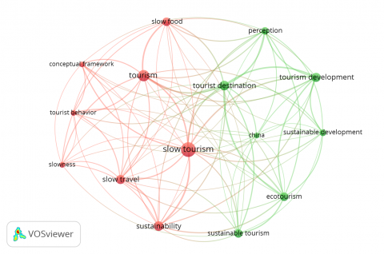
Source: Analysis by the authors based on Scopus data, June 2024
Figure 6 shows the results of the VOSviewer software after evaluating 120 documents containing 441 keywords that were included in the co-keyword analysis. The condition for a keyword to be considered is to appear at least 5 times (Van Eck and Waltman, 2014), and there are a total of 15 keywords that meet this criterion. The sparse network of keywords shows that the slow tourism theme has not yet received much attention in searches. In total, two themes were identified through the analysis of co-keywordThe main keywords for theme 1 are: conceptual framework, slow food, slow tourism, slow travel, slowness, sustainability, tourism, tourist behavior. It is therefore possible to designate this topic temporarily as "Elaboration of the concept of slow tourism." It is a research question preliminary to the pursuit of various research topics on slow tourism. A review of the literature shows that much research has shaped the concept of slow tourism, for example (Lumsdon and McGrath, 2011, Pécsek, 2014, Conway and Timms, 2012).
Theme 2, green cluster with the following key terms: china, ecotourism, perception, sustainable development, sustainable tourism, tourism development, tourist destination, which can be grouped under the heading "Sustainable development of slow destinations" appears to be the most recent research topic to emerge in this field during the period 2019-2020 (Figure 7). The research team with these keywords is focusing on analysing the benefits that slow tourism brings to slow destinations. At the same time, the researchers are examining the conditions imposed on destinations when they adopt the slow tourism philosophy in their management and operations. This work shows that slow tourism can help solve environmental problems, such as climate change, and promote the development of sustainable tourism (Dickinson et al., 2011).
Figure 7: Trends in slow tourism research themes by period
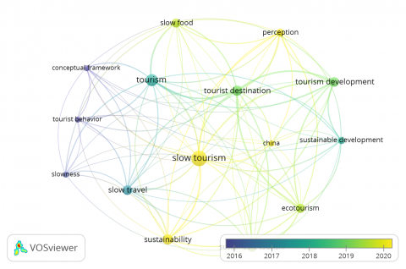
Source: Analysis by the authors based on Scopus data, June 2024

Bibliographic linkage is based on the idea that two documents sharing a large number of references are likely to be conceptually related. The higher the number of shared references, the stronger the thematic proximity between these documents (Zupic and Čater, 2015). From the 120 publications, we restricted the selection to publications with at least 20 citations. Thirty documents were thus retained for analysis (Figure 8), making it possible to map the intellectual structure of the field by grouping publications according to their citation similarities. This analysis revealed 4 main themes (table 3), illustrating the emerging dynamics of slow tourism.

Table 3: Bibliographic linkage themes
Themes | Representative Publications
Concept and motivation of slow tourism  (11 publications, cluster in red) | (Oh et al., 2016, Lin et al., 2020, Walker et al., 2021)
Slow tourism as a choice of "slow food," "slow movement" (10 publications, cluster in green) | (Heitmann et al., 2011, Molz, 2009, Lee et al., 2015)
Tourisme lent comme la solution au changement climatique  (6 publications, cluster bleu) | (Dickinson and Lumsdon, 2010, Dickinson et al., 2011)
Slow tourism and destination management  (3 publications, yellow cluster) | (Conway and Timms, 2010, Timms and Conway, 2012)

Source: Analysis by the authors based on Scopus data, June 2024

The first cluster, centred on the conceptualisation of slow tourism, brings together work exploring the motivations and experiential dimensions of slow travel, particularly around well-being and authenticity (Oh et al., 2016, Lin et al., 2020). This cluster also represents the largest number of publications (11 publications, 508 citations in total), which confirms the weight of this orientation in the structuring of the field. The second is part of a cultural and ethical perspective stemming from the slow movement in the broadest sense, highlighting alternative modes of consumption and lifestyles based on frugality (Heitmann et al., 2011, Molz, 2009). The third establishes a link between slow tourism and environmental sustainability, by linking soft mobility practices and the reduction of climate impacts (Dickinson and Lumsdon, 2010). Although fewer in number, the work in this cluster has the highest visibility, with an average of 124 citations per publication (743 citations for 6 papers), indicating significant academic recognition.
Finally, the fourth cluster focuses on the management of slow destinations in island or marginal contexts, in relation to local governance issues (Conway and Timms, 2010, Timms and Conway, 2012). This structuring reflects the diversity of the theoretical orientations of slow tourism and corroborates the typologies proposed in recent literature (Klarin et al., 2023).

Figure 8: Mapping of slow tourism thematic clusters (literature-matching analysis)
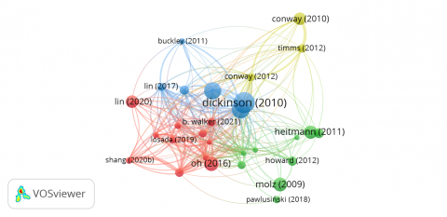
Source: Analysis by the authors based on Scopus data, June 2024

5. Discussion
The bibliometric analysis carried out on a corpus of 120 publications from the Scopus database reveals a recent but dynamic structuring of the field of slow tourism. The emergence of the first publications in 2009, and their increasing concentration in journals such as Sustainability or Journal of Sustainable Tourism, underlines the growing academic interest in this field. However, this quantitative growth remains concentrated in certain editorial and epistemological regions, which calls for a critical reading of the results.
An analysis of the co-key words shows a strong recurrence around the notions of sustainability, tourism development and destinations. This confirms that slow tourism is rooted in a perspective of alternative tourism serving the ecological transition. Nevertheless, this dominant orientation tends to under-represent other dimensions - such as the quest for subjective well-being, analysed by (Hallem et al., 2020), or slowness as a sensory and transformative experience. This bias suggests a methodological framing effect specific to the database and calls for interpretative vigilance.
The analysis of the co-citations identified three cognitive poles: experiential, institutional and community. These clusters reflect divergent but complementary analytical sensibilities. For example, the experiential cluster gives a central place to the choice of slow transport and environmental awareness (Lumsdon and McGrath, 2011). But these elements are extended in other works - not indexed in Scopus - which question slowness as a form of cultural resistance or philosophical heritage, notably in (Tatin-Gourier, 2022). This shows that the scientific literature on tourism is criss-crossed by an epistemic heterogeneity that needs to be accepted rather than standardised. Similarly, the institutional cluster identifies destination management as a key issue in the implementation of slow tourism. This observation echoes the studies by Rimaud and Piriou (2020) on the contradictions between the logics of sustainability and the imperatives of territorial attractiveness. Their qualitative analysis of the “Villages de pierres & d'eau” policy shows that the ethical discourse of slow tourism can be misused for institutional branding purposes, a dimension absent from the quantitative readings.
The groupings identified through the analyses confirm the presence of three major areas of research on slow tourism: the tourism experience and environmental awareness, sustainable destination management, and community dynamics. Although these orientations are robust, they also reveal certain gaps, particularly in the more subjective, institutional or critical dimensions highlighted by works not indexed in Scopus. Based on this cross-referencing, a number of avenues of research deserve to be explored in greater depth: the psychological motivations and behaviours of tourists, local communication strategies around slow tourism, and the values generated for local communities. This triangulation between a bibliometric approach and complementary theoretical perspectives opens the way to a more nuanced understanding of slow tourism and its scientific and practical implications.
6. Conclusion
The study has several implications for research on slow tourism. Firstly, it provides a structured, up-to-date and bibliometrically based overview of slow motion tourism research. The results enable researchers to identify the main trends, themes, authors, journals, institutions and countries in this field. Secondly, the analysis of the results highlights research gaps and opportunities in slow tourism. This allows researchers to explore new topics or perspectives that are less addressed, under-researched or unrecognised in the field. Thirdly, this study suggests future perspectives and directions for research in this key area of “slow tourism.”
Despite the considerable efforts made, this study has certain limitations inherent in the bibliometric methodology employed. In particular, the interpretation of the results is based on algorithmic groupings (co-citation, co-occurrence, bibliographic coupling) visualised using VOSviewer, which may introduce a degree of subjectivity into the labelling and reading of the clusters. Furthermore, the corpus analysed, drawn exclusively from the Scopus database, tends to favour international journals with a high impact factor, to the detriment of publications from regional, institutional or non-English-speaking databases. Finally, the extraction strategy based on a restricted set of explicit keywords linked to slow tourism may have excluded works that use similar concepts without naming them directly. To mitigate these biases, future research could adopt a hybrid approach combining bibliometrics and qualitative thematic analysis, diversify the documentary sources (Web of Science, Google Scholar, ProQuest, etc.), and broaden the inclusion criteria by incorporating related or multilingual terms, from a more inclusive and cumulative perspective.

Referencias
Agapito, D. and Guerreiro, M. (2023). Designing accessible tourism experiences: slow, sensory and smart framework, Enlightening Tourism. A Pathmaking Journal, Vol. 13, pp. 167-198.
Benckendorff, P. and Zehrer, A. (2014). A network analysis of tourism research, Annals of Tourism Research, Vol. 43, pp. 121-149.
Caffyn, A. (2012). Advocating and implementing slow tourism. Tourism Recreation Research, Vol. 37, pp. 77-80.
Conway, D. and Timms, B. F. (2010). Re-Branding Alternative Tourism in the Caribbean: The Case for ‘Slow Tourism’", Tourism and Hospitality Research, Vol. 10, pp. 329-344.
Conway, D. and Timms, B. F. (2012), Are slow travel and slow tourism misfits, compadres or different genres?, Tourism Recreation Research, Vol. 37, pp. 71-76.
Da Silva Lopes, H., Remoaldo, P. C., Ribeiro, V. and Martín-Vide, J. (2021), Effects of the COVID-19 pandemic on tourist risk perceptions-The case study of Porto, Sustainability, Vol. 13, pp. 6399.
Dickinson, J. E. and Lumsdon, L. M. (2010), Slow Travel and Tourism, Earthscan, London.
Dickinson, J. E., Lumsdon, L. M. and Robbins, D. (2011), Slow Travel: Issues for Tourism and Climate Change, Journal of Sustainable Tourism Vol. 19, pp. 281-300.
Ertz, M. and Leblanc-Proulx, S. (2019), Review of a proposed methodology for bibliometric and visualization analyses for organizations: application to the collaboration economy, Journal of Marketing Analytics, Vol. 7, pp. 84-93.
Everingham, P. and Chassagne, N. (2020), Post COVID-19 ecological and social reset: moving away from capitalist growth models towards tourism as Buen Vivir, Tourism Geographies, Vol. 22, pp. 555-566.
Gössling, S. (2009), Carbon neutral destinations: a conceptual analysis, Journal of Sustainable Tourism, Vol. 17, pp. 17-37.
Hallem, Y., Sahut, J. M. and Hikkerova, L. (2020), Le « Slow tourisme » comme voie pour améliorer le sentiment de bien-être, Gestion 2000, Vol. 37, pp. 129-147.
Heitmann, S., Robinson, P. and Povey, G. (2011), Slow food, slow cities, slow tourism, in Robinson, P., Heitmann, S. and Dieke, P. (Ed.), Research themes for tourism, CABI, Wallingford, UK, pp. 114-127.
Husemann, K. C. and Eckhardt, G. M. (2019), Consumer deceleration, Journal of Consumer Research, Vol. 45, pp. 1142-1163.
Jamali, H. R. and Nikzad, M. (2011), Article title type and its relation with the number of downloads and citations, Scientometrics, Vol. 88, pp. 653-661.
Klarin, A., Park, E., Xiao, Q. and Kim, S. (2023), Time to transform the way we travel?: A conceptual framework for slow tourism and travel research, Tourism Management Perspectives Vol. 46.
Kostilnikova, K., Matlovicova, K., Demkova, M., Mocak, P., Mishra, P. K., Bujdosco, Z., Matlovic, R. and Zawilinska, B. (2022), Slow travel in tourism - An outline of conceptual frameworks: potential and limits in the context of post-pandemic recovery, GeoJournal of Tourism and Geosites Vol. 42, pp. 751-758.
Krešić, D. and Gjurašić, M. (2022), Slow Tourism as an Immersive Travel Experience: A Bibliometric Analysis", Academica Turistica, Vol. 15, pp. 323-333.
Le Busque, B., Mingoia, J. and Litchfield, C. (2021), Slow tourism on Instagram: An image content and geotag analysis, Tourism Recreation Research, Vol. 47, pp. 1-8.
Lee, K.-H., Packer, J. and Scott, N. (2015), Travel lifestyle preferences and destination activity choices of Slow Food members and non-members, Tourism Management, Vol. 46, pp. 1-10.
Lin, L. P., Huang, S.-C. and Ho, Y.-C. (2020), Could virtual reality effectively market slow travel in a heritage destination?, Tourism Management, Vol. 78, pp. 104027.
Lumsdon, L. M. and Mcgrath, P. (2011), Developing a conceptual framework for slow travel: A grounded theory approach, Journal of Sustainable Tourism, Vol. 19, pp. 265-279.
Manthiou, A., Klaus, P. and Luong, V. H. (2022), Slow tourism: Conceptualization and interpretation – A travel vloggers’ perspective , Tourism Management, Vol. 93, pp. 1-15.
Matos, R. (2012), Can slow tourism bring new life to alpine regions?, in Weiermair, K. et Mathies, C. (Ed.), The Tourism and Leisure Industry: Shaping the Future The Haworth Hospitality Press, pp. 93-103.
Mavric, B., Öğretmenoğlu, M. and Akova, O. (2021), Bibliometric analysis of slow tourism, Advances in Hospitality and Tourism Research, Vol. 9, pp. 157-178.
Meng, B. and Choi, K. (2016), The role of authenticity in forming slow tourists’ intentions: Developing an extended model of goal-directed behaviour, Tourism Management, Vol. 57, pp. 397-410.
Molz, J. G. (2009), Representing Pace in Tourism Mobilities: Staycations, Slow Travel and the Amazing Race, Journal of Tourism and Cultural Change, Vol. 7, pp. 270-286.
Moral-Muñoz, J. A., Herrera-Viedma, E., Santisteban-Espejo, A. and Cobo, M. J. (2020), Software tools for conducting bibliometric analysis in science: an up-to-date review. Prof. Inform.
Norris, M. and Oppenheim, C. (2007), Comparing alternatives to the Web of Science for coverage of the social sciences’ literature, Journal of Informetrics, Vol. 1, pp. 161-169.
Oh, H., Assaf, A. G. and Baloglu, S. (2016), Motivations and goals of slow tourism, Journal of Tourism Research, Vol. 55, pp. 205-219.
Pécsek, B. (2014), Speeding up time, slowing down tourism: modeling slow tourism, Tourism Bulletin, Vol., pp. 3-10.
Petrini, C. and Padovani, G. (2009), Slow Food Revolution: A New Culture for Eating and Living, Rizzoli International, New York.
Rimaud, M.-N. and Piriou, J. (2020), Le “ slow tourism ”: ambitions et contraintes institutionnelles pour un développement touristique différencié, in Lebreton, F., Gibout, C. and Andrieu, B. (Ed.), Vivre Slow. Enjeux et perspectives pour une transition corporelle, récréative et touristique, Presses Universitaires de Nancy. Editions Universitaires de Lorraine, Nancy, pp. 357-371.
Serdane, Z., Maccarrone-Eaglen, A. and Sharifi, S. (2020), Conceptualising slow tourism: a perspective from Latvia, Tourism Recreation Research, Vol. 45, pp. 1-14.
Sigala, M., Kumar, S., Donthu, N., Sureka, R. and Joshi, Y. (2021), A bibliometric overview of the Journal of Hospitality and Tourism Management: Research contributions and influence, Journal of Hospitality and Tourism Management, Vol. 47, pp. 273-288.
Tatin-Gourier, J.-J. (2022), Aux origines du tourisme lent : le sensualisme du XVIIIe siècle et les réorientations du regard du voyageur, Convergences francophones, Vol. 7, pp. 57-62.
Timms, B. F. and Conway, D. (2012), Slow Tourism at the Caribbean's Geographical Margins, Tourism Geographies, Vol. 14, pp. 396-418.
Van Eck, N. J. and Waltman, L. (2014), Visualizing bibliometric networks, in Ding, Y., Rousseau, R. et Wolfram, D. (Ed.), Measuring Scholarly Impact: Methods and Practice, Springer, Heidelberg, Germany, pp. 285-320.
Walker, T. B., Lee, T. J. and Li, X. (2021), Sustainable development for small island tourism: developing slow tourism in the Caribbean, Journal of Travel and Tourism Marketing, Vol. 38, pp. 1-15.
White, H. D. and Mccain, K. W. (1998), Visualizing a discipline: An author co-citation analysis of information science, 1972-1995, Journal of the American Society for Information Science, Vol. 49, pp. 327-355.
Zupic, I. and Čater, T. (2015), Bibliometric Methods in Management and Organization, Organizational Research Methods, Vol. 18, pp. 429-472.

Lecturer and researcher at Thuyloi University and the Vietnam National University (Hanoi, Vietnam). Email: thuvn@tlu.edu.vn Id. Orcid: https://orcid.org/0009-0009-9509-3812 * Autor para la correspondencia.
Associate professor, lecturer and researcher at the Faculty of Tourism Sciences, Vietnam National University, Hanoi (Vietnam). Email: longph@vnu.edu.vn Id.Orcid: https://orcid.org/0000-0003-2570-2562
Lecturer and researcher at the University François-Rabelais of Tours (France). Email: samuel.tietse@univ-tours.fr Id. Orcid: https://orcid.org/0000-0002-1012-8417

