Title of the paper in English
Title of the paper in Spanish
Name and surname of the author 1*
Name and surname of the author 2
Name and surname of the author 3

Abstract
A single paragraph of about 200 words maximum. For research articles, abstracts should give a pertinent overview of the work. We strongly encourage authors to use the following style of structured abstracts, but without headings: (1) Background: Place the question addressed in a broad context and highlight the purpose of the study; (2) Methods: Describe briefly the main methods or approaches applied; (3) Results: Summarize the article’s main findings; (4) Discussion: Compare your findings with the literature, and (5) Conclusions: Indicate the main conclusions, recommendations and future research.
Keywords: List three to eight keywords, separated by a semi-colon. In papers based on case studies, provide the location (geographical keyword).

Resumen
It will contain the Abstract correctly written in Spanish. Articles presented in Spanish must be accompanied by the title translated into English, which will be set out below the title in Spanish. An abstract and keywords in English will be included after the “Resumen” and “palabras clave”.
Palabras clave: previous keywords translated into Spanish correctly, separated by a semi-colon.

1. Introduction
The subject analysed must be organised according to this structure, based on the IMRAD model. In this way the titles of the main sections are those that appear in this template.
This section may be divided into subheadings. The introduction should reproduce and carefully review the current state of the research field and key publications duly cited. Please highlight controversial and diverging hypotheses when necessary. At the end of the section it should be defined the purpose and the main objective of the work and its significance across the state of the art.

2. Methodology
This section may be divided into subheadings. In case of having an area or case of study, it should be clearly established and described in a broad context and highlight why it is important at the local level. Likewise, cartography is recommended for its geographic location. The sources used for the work will be listed and justified. The criteria and analysis procedures used in the research will be explained. The goodness of the choice of working method used for the research will be supported in relationship with others used in research with a similar theme, if applicable. Include citations of scientific studies that have inspired the proposed methodology used.

3. Results
This section may be divided by subheadings. It should provide a concise and precise description of the experimental results, their interpretation and the main innovation issues obtained from applied analysis. For this purpose, graphic and cartographic material may be incorporated to facilitate the presentation of the results obtained.

3.1. Figures and tables
Figures and tables should be consecutively numbered as such (Figure 1., Table 1., etc.) and will appear in the work in their appropriate place. Each one should be given a brief title above it, with the source and/or elaboration of the information below it. This should appear as follows:
- “Source: (as appropriate, if applicable)” followed by a full stop and, "Own elaboration" (if applicable).
- In the event of a table or figure prepared by the authors, state only “Own elaboration”, without the word "source”.
- And if it is a photograph by the authors state: “Photograph by the authors” (without the word “source”).

Table 1. Title of the table
Header 1 | Header 2 | Header 3
Data | Data | Data
Data | Data* | Data
Data | Data | Data
Tables and figures could have a footer
Own elaboration

Figures must not fill more than one complete page (this does not apply to tables).
The authors must ensure that no intellectual property rights are infringed by any of the graphic material used in the text.

Figure 1. Title of the figure
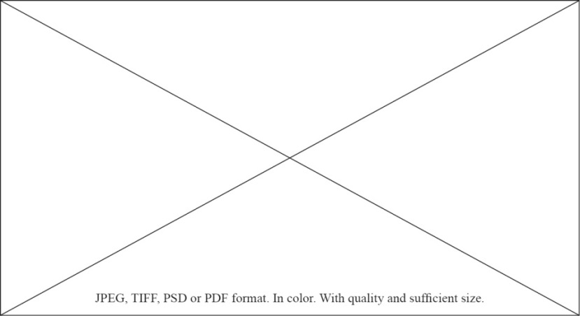
Source: Name of the source, year. Own elaboration (if applicable)

3.2. Citations
The APA style, 7th edition is used. You will find detailed information and examples at ”. https://www.scribbr.com/citation/generator/apa/

3.3. Other information of interest
You will find all relevant information for authors at “Guidelines for authors”.

4. Discussion
This section may be divided by subheadings. Authors should discuss, support and compare the results according to the existing literature (using references from similar studies) and how they can be interpreted in perspective of previous studies and of the working hypotheses. The findings and their implications should be discussed in the broadest context possible. Future research directions may also be highlighted.

5. Conclusions
This section presents the verification of the initial hypotheses posed in the research and provides justification of the interest and novelty of the study for the subject analysed or the scientific discipline from which it has been approached. This section will be worded clearly and precisely. When studies are approached on a local scale, based on case studies, conclusions of a transversal nature should be offered to advance in the general knowledge and facilitate application to other areas of study. This section should also offer a summary of the advancement represented by the research performed, its applied interest and possible lines of work to be developed in the future.

Funding (if applicable)
In this section you should include reference to any donation or financial support from research or administrative institutions (grants, research projects, national support, etc.).

Acknowledgments (if applicable)
In this optional section you can acknowledge any support given which is not covered by the author(s) contribution or funding sections. This may include administrative and technical support, or donations in kind (e.g., materials used for experiments).

Appendix (if applicable)
The appendix is an optional section that can contain details and data supplemental to the main text. For example, explanations or details that would disrupt the flow of the main text, but nonetheless remain crucial to understanding and reproducing the research shown. All appendix sections must be cited in the main text.

References
The references should begin on a new page.
The style to be used is the APA style, 7th edition. You will find detailed information and practical examples at https://www.scribbr.com/citation/generator/apa/
The journal does not publish studies with a high rate of self-citations.
Here are some examples:

Book: Surname, N., & Surname, N. (year). Title. Publisher. DOI or URL (if avaible).
Book with edition or volume no.: Surname, N. (Ed.). (year). Title (edition number ed., volume number vol.). Publisher. DOI or URL (if avaible).
Edited book: Surname, N. (Ed.). (year). Title. Publisher. DOI or URL (if avaible).
Edited book chapter: Surname, N. (year). Title of chapter, entry or contribution. In N. Surname editor & N. Surname editor (Eds.), Title of book (edition number ed., volume number vol., pp. xx‐xx). Publisher. DOI or URL (if avaible).
Journal article: Surname, N. (year). Title of article. Title of publication, volume(number), pp-pp. DOI or URL (if avaible).
- Advance online publication: Surname, N. (year). Title of article. Title of publication. Advance online publication. DOI or URL (if avaible).
- With missing information: If the journal does not use volume, issue or page numbers, omit the missing element(s) from the reference. If the journal article has an article number instead of a page range, include the word “Article” and then the article number instead of the page range.
Newspaper article: Surname, N. (year, Month day). Title of article. Title of Newspaper. URL (if avaible).
Thesis and final projects:
- Unpublished: Surname, N. (year). Title of these/final proyect [Unpublished Type of thesis/work]. Institution that award the degree.
- Published: Surname, N. (year). Title of these/final proyect [Type of thesis/work, Institution that award the degree]. Repository, file or database that hosts it. URL (if avaible).

Full filiation, Country author 1. Contact e-mail. Id orcid. * Corresponding author
Full filiation, Country author 2. Contact e-mail. Id orcid
Full filiation, Country author 3. Contact e-mail. Id orcid

